Football Operator and Optical Soccer Engine (FOOSE)
Sponsored by SoarTech
G30 Final Report
Nathaniel Enos
Patrick Fenelon
Skyler Goodell
Nicholas Phillips
Senior Design Fall 2012
Table of Contents
1.0 Executive Summary 1
2.0 Project Description 2
2.1 Project Motivation and Goals 2
2.1.1 Project Motivation 2
2.1.2 Project Goals 2
2.2 Objectives 3
2.3 Project Requirements and Specifications 5
2.3.1 Sensors 5
2.3.2 System Architecture 9
2.3.2.1 Central Processing Unit 9
2.3.2.2 Hardware controllers 10
2.3.2.3 Sensor Aggregation Hardware 10
2.3.3 Actuators 10
2.3.4 Software 13
2.3.4.1 Table State Interpretation 13
2.3.4.2 Artificial Intelligence Algorithms 14
2.3.4.3 Motion Control Algorithms 15
2.3.5 Table 17
3.0 Research Related to Project Definition 19
3.1 Existing Similar Projects and Products 19
3.1.1 Adelaide University Automated Foosball 19
3.1.2 StarKick Robotic Foosball Table 19
3.1.3 Georgia Tech Automated Foosball 21
3.2 Relevant Technologies 22
3.2.1 Sensor 22
3.2.1.1 Ball Detection 22
3.2.1.2 Player Puppet Detection 30
3.2.2 System Architecture 34
3.2.2.1 Main Processor 34
3.2.2.2 Motor Controllers 39
3.2.2.3 Data Transportation Methods 41
3.2.3 Actuators 42
3.2.3.1 Linear Motion 42
3.2.3.2 Rotational Motion 47
3.2.3.3 Comparison of General Motor Options 52
3.2.4 Software 55
3.2.4.1 Table Physics Model 55
3.2.4.2 AI Algorithms 60
3.2.4.3 Linear Control Algorithms 63
3.2.5 Other Hardware 76
3.2.5.1 Foosball Table 76
3.3 Research Summary 78
4.0 Project Hardware and Software Design Details 80
4.1 Project Overview and Block Diagrams 80
4.2 Sensor Design 82
4.2.1 Overview 82
4.2.2 Block Diagrams 84
4.3 System Architecture 85
4.3.1 Overview 85
4.3.2 Block Diagrams 89
4.4 Actuators 90
4.4.1 Overview 90
4.4.2 Block Diagrams 95
4.5 Software 95
4.5.1 Overview 95
4.5.2 Block Diagrams 97
4.6 Rod Control Board 98
4.6.1 Overview 98
4.6.2 Schematics and Layout 100
4.6.3 RCB Control Loop 110
5.0 Design Summary of Hardware and Software 117
5.1 Hardware Summary 117
5.2 Software Summary 120
6.0 Project Prototype Construction and Coding 123
6.1 Parts Acquisition 123
6.1.1 Foosball Table 123
6.1.2 Other Parts 124
6.2 BOM 126
6.3 Assembly Plan 129
6.4 Final Coding Plan 130
7.0 Project Prototype Testing 132
7.1 Hardware Testing Environment 132
7.2 Hardware Specific Testing 132
7.2.1 Electronic Component Test Plan 132
7.2.2 Mechanical Component Test Plan 139
7.3 Software Testing Environment 140
7.4 Software Test Plan 141
8.0 Administrative Content 143
8.1 Milestone Discussion 143
8.2 Budgeting and Finance 144
8.3 Mentors and Sponsors 145
8.3.1 Soartech 145
8.3.2 Mentors 147
8.4 Bibliography 148
9.0 Appendices 153

1.0 Executive Summary
IBM’s Watson and Deep Blue computers share the distinction of being the first to beat humans at two of their own games, Jeopardy and chess, respectively. They also share the qualities of being the size of a house and costing a fortune. The price of a digital chess grandmaster has come down since Deep Blue’s historic victory, and we can expect the same for Watson. Yet, there is another sport which requires the data synthesis of answering general-knowledge questions, and the sheer processing power of solving chess. In that sport, a computer which can beat a human affordably has not yet been created.
That sport, of course, is foosball.
Long a favorite of arcades and game rooms, foosball, also known as table soccer, is basically a constrained form of regular soccer. Rows of small armless figures are affixed to metal poles which span the width of the field, which are allowed to rotate freely, thereby enabling the figures to kick a small plastic soccer ball. The object of the game is, as in regular soccer, to score by kicking the ball into the opponent’s goal.
The main goal of the FOOSE project is to create a system which will combine advanced optical tracking, artificial intelligence, control systems, and a foosball table in order to provide a challenging tabletop soccer simulation experience for one or two human players.
Objectives of the FOOSE project are to:
- Be able to process the table state in real time, and react quickly
- Take up only slightly more room than a foosball table would anyway
- Achieve construction within a reasonable budget
- Like its progenitor Watson, beat an average human

FOOSE itself will consist of optical sensors and, potentially, other types of sensors to monitor the state of the foosball table. This information will be fed into a processing unit, which will interpret the data coming from the sensors, decide the appropriate response using artificial intelligence, and digest the response into control data which can be fed to controllers and actuators, realizing the AI’s response, and once more changing the table state. This would continue until the player shuts off the table, or a predetermined goal limit has been reached.

2.0 Project Description

2.1 Project Motivation and Goals

2.1.1 Project Motivation
Foosball is one of the most popular home arcade games. It, like few others, has captured a place in the dens and basements of America. The members of this group have grown up playing foosball in various contexts, and, of the members of the group, each is primarily interested in a different aspect of automating the game.
To automate a foosball table is a very wide-ranging endeavor, requiring a background in a variety of disciplines, which helped to spur interest in this as a senior design project. The complete project requires implementing a diverse array of sub-projects which include, but are not limited to, optical image processing and object recognition, artificial intelligence (which also involves analyzing and reducing human foosball strategies), programming, mechanical engineering of linear control systems and actuators, and the electrical communications systems needed to connect all of the above to one another. The sheer breadth of this project means that each member of the team can contribute something according to their strengths, and there is much to talk about and implement.
Additionally, the members of the team had the desire to do a fun project, which would have an easy to work with goal in mind. In contrast to something like (for instance) a method of controlling sewer pumps, an automatic foosball table is something very human and interactive, that everyone can enjoy once complete. This was also a major contributing factor to choosing an automated foosball table as a senior design project.
2.1.2 Project Goals
In its nearly 90-year history [1], the game has changed very little. The prospect of automating half of a foosball table, thereby making it a one-player game, has attracted significant attention in recent years. Admittedly, much of this interest has been in the form of senior design projects (with widely varying budgets) from universities around the world. However, at least one company, Star Kick, in Germany has taken the concept into the commercial sector, where they sell automatic foosball tables to arcades for $27,000.
The range of quality present in such boards is, as could be expected, as variable as their budgets. The Star Kick board is reputed to beat eight out of ten humans it plays against, and a majority of even advanced players. Comparatively, of the two senior design boards (discussed in section 3.2, Relevant Technologies) one was designed in a short time on a shoestring budget, and as a result has very unsatisfying gameplay. The other has an undisclosed budget and a much longer period of time in which to construct it, and is extremely polished and accurate, with the ability to win most of the games it plays.
Given the current state of the art of robotic foosball tables, the motivation of this project is to come down squarely in the middle. This project is intended to combine the strengths and weaknesses of the various tables, improve upon their designs, and, in the end, produce a table with the positive qualities of each.
More specifically, the goals of this project are as follows:
Cheaper
The budget for this project is $1000-1500. That is about a twentieth of the cost of a new Star Kick table, but two to three times that of other senior design projects surveyed.

Smaller
Most of the tables surveyed occupy much more space than the foosball table they incorporate. This project is designed to occupy only slightly more space than the table itself.

Harder
Of the tables surveyed, none with a comparable budget were able to provide a challenging game of foosball to an average human player. This project is designed with this goal more important than the others.
In short, this project’s goal is to provide a challenging foosball experience to an average user, while staying under its limited budget, and occupying less space than other solutions to the same problem.

2.2 Objectives
Per component, the project’s objectives are as follows:
- Camera
  - Must be able to sense the field often enough to enable the system to react quickly to the ball’s movement
  - Must be able to output data over USB to a central processing unit
  - Must be small enough to be mounted on a bracket above the table
  - Must have a high enough resolution to sense the ball’s position to within a given level of precision
- Computer
  - Must have a processor capable of handling artificial intelligence, image interpretation, and motor control output in an acceptable amount of time
  - Must have enough memory to handle artificial intelligence, image interpretation, and motor control output in an acceptable amount of time
  - Must be capable of connecting over the interfaces required by the other subsystems, which may include USB, serial, or parallel
  - Must be running an operating system which is capable of real-time output to control systems
  - Must be compatible with programs used to implement artificial intelligence, image interpretation, and motor control output
- Actuators
  - Must be capable of moving the weight of the foosball table’s rods quickly enough to block a ball at normal to high speeds
  - Must be capable of turning the foosball table’s rods with enough force to kick the ball at high speeds
  - Must be able to be controlled by either a computer or an actuator control subsystem
  - Must occupy a small enough amount of space so as not to interfere with adjacent control rods
- Foosball table
  - Must be a regulation standard foosball table
  - Must be easy to disassemble for transport
  - Must be easily modifiable in order to incorporate the other components of this project
  - Must have a flat surface, without rounded corners (in order to enable LED grid types of sensors)
- Artificial Intelligence
  - Must be able to beat an average player
  - Must be able to accept ball positions and velocities from visual interpreter system
  - Must be able to accept player positions from encoder system
  - Must be able to quickly calculate and output a move given inputs
  - Must appear to a user to be competent and intelligent
  - If possible, should learn from users and from training bank
- Interpreter
  - Must accept image input from camera system
  - Must locate ball within image
  - Must determine ball position and coordinates on foosball table
  - Must run quickly on computer system
  - Must work accurately in potentially variable conditions
- Actuator controller
  - Must interface between computer system and actuator system
  - Must be able to control all actuators in actuator system in real time
  - Must accept serial input
- Sensor compilation chip
  - Must interface between computer system and radial quad encoder system
  - Must properly encode information from encoders into format recognizable by artificial intelligence subsystem
  - Must operate in real time
- Radial quad encoders
  - Must properly encode lateral and radial position of foosball table rod
  - Must output to sensor compilation chip
  - Must operate in real time
- Foosball
  - Must be a regulation-sized foosball

2.3 Project Requirements and Specifications

2.3.1 Sensors
In order to play a game of foosball, an automated system must at least be able to sense the position of the ball and control the position of its rods. Knowledge of the position and rotation of the opponent’s puppets is also beneficial to playing a game of foosball.
Ball Detection
The maximum speed of a foosball in a game between average players is 5 m/s. The distance between rods is 5.875 in, meaning that ball will be able to move between two rods in .03 s. Thus any ball sensing system must be able to determine the position and direction within .06 s. This assumes that the computer will have 2*5.875 inches to stop a shot, because at the goal line each player has 2 rows of puppets. A discrete position sampling system such as a camera can only sense position at each sample, thus 2 samples are needed to determine direction. This means that the frame rate of any camera system would need to be at a rate of once every .03 s or ~30 Hz. A much higher frame rate would be desirable; however, higher frame rate cameras are pricey and subject to budget constraints. A camera system would also need to take individual frames quickly, or else motion blur will make ball identification very difficult. The ball must be tracked to within 1.25 cm in order to make a straight kick, as shown in Figure 2.3.1.1 below.
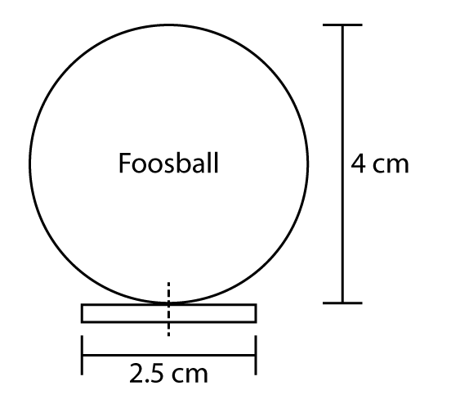
Figure 2.3.1.1: Puppet kicking foosball straight with maximum allowed error

Due to the expected inaccuracy of the mechanical subsystem the tracking subsystem must be able to track the ball to within .25 cm. Assuming a desire to identify the ball on a pixel based image, each pixel should represent at most .25 cm x .25 cm square on the table. The length of the table is 120 cm, meaning a horizontal resolution of around 480 pixels. Optical tracking algorithms can, however, make use of blurry pixels to make estimations on the sub pixel level, so a resolution below 480 could still be acceptable. The desired operating system is Windows, but a camera should work in Linux or Windows; however, a Windows only camera is acceptable. The table should be able to fit within a standard US household and thus should be less than 8ft or 243cm long. The height constraint also places a requirement on the minimum viewing angle of the camera. Requiring at least 7 cm clearance between the camera lenses and the celling and taking into account the 86 cm between the floor and table surface the minimum viewing angle of the camera would need to be 22°, shown below in Figure 2.3.1.2.

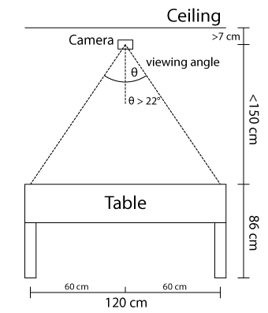
Figure 2.3.1.2: Diagram depicting the minimum required viewing angle of the camera (not to scale)
Given the need to construct a tower over the table to support the camera, a viewing angle of greater than 22° would be desired, as it would reduce the necessary height of the tower. Given the constraints stated above, a summary of required characteristics of a ball sensing camera is given in Table 2.3.1.1 below.

Feature | Desired | Minimum Required
Frame Rate | 120 Hz | 30 Hz
Resolution | 480 x 360 | 320 x 240
Compatibility | Linux and Windows | Windows
Viewing Angle | 40° | 22°
Table 2.3.1.1: Table summarizing the required characteristics of a foosball sensing camera
Puppet Position
Knowledge of the position and orientation of the opponent’s and computer’s puppets is beneficial in playing foosball. The position and orientation of the computer’s puppets is required as an input to a PID loop to control the power given to the drive motors. The position of the opponent’s puppets is beneficial to an AI that could use the information to avoid colliding with the puppets when kicking the foosball. Detecting the computer’s puppets rotation can be achieved using a simple 2 position sensor. The linear position of the puppets is slightly more complex and must be done to within a resolution of 30 increments. The maximum distance traveled by any rod is <15 cm, which is done by the 2nd rod on each end of the board with 2 puppets each. Sensing the position of the rod out of 30 increments would provide accuracy to within .5 cm, adequate for shooting and puppet avoidance. An accuracy of .1 cm would be useful, although not required; this would mean 150 increments on the encoder. As with most sensors, more accuracy useful but is not necessary. Sensing of the opponent’s rotation is unnecessary because it may be assumed that the puppets are attempting to block your shot and are thus in the down position. At a bare minimum, sensors are required on the computer’s rods to provide positioning information to the PID control loops for the linear motors and to provide stop locations for the rotational motors. Rotary encoders are a common choice for this type of sensing as they can be easily attached to a motor drive axle and can be interoperated by a microcontroller. Rotary encoders can be used for both rotational and linear motion through simple gearing. Table 2.3.1.2, below, specifies the desired and minimum required specifications for the puppet sensing encoders.

Feature | Desired | Minimum Required
Computer’s Rotation Resolution | 150 position | 2 position
Computer’s Linear Resolution | 400 position | 30 position
Opponent’s Rotation Resolution | 150 position | -
Opponent’s Linear Resolution | 400 position | -
Table 2.3.1.2: Table summarizing the required characteristics for puppet position
and rotation sensing

2.3.2 System Architecture

2.3.2.1 Central Processing Unit
The processing for this project can be quite intensive. It must be able to handle the image processing, the AI, and the motor controlling. To handle this load, this project requires either a dedicated microprocessor for each task or a single chip with multicore/hyperthreading to be able to handle the parallelized data processing.
For processing the images and running the AI, this project will require a computer with a relatively high clock frequency. Because all of the processing must be done in real time, and low latency is extremely important, this project will require a processor with a minimum clock rate of 2.0 GHz.
The processor must be of the normal x86-compatible architecture, and may need to be x86-64 compatible, if required by the future needs of the project.
For communication with peripheral devices, such as the rod control board and the camera, the processor must have at least 2 serial ports and 2 USB ports, or at least 4 USB ports.
In order to run a standard operating system, the computer must possess at least 1 GB of RAM, but should preferably have 2 GB or more, with more always being better.
The computer must be otherwise compatible with the standard operating systems that may be selected for use in this project, including Windows 7 x86, Windows XP, Ubuntu Linux, and FreeBSD.
The computer must run on a standard power cable, and must possess a power supply capable of powering all the necessary components, which may include the camera and the rod control board.
The computer should ideally be able to boot and run “headlessly”, meaning that it should be able to be turned on and run without interaction or needing a monitor to be connected.
The computer should ideally be small and light enough to be mounted underneath the playing surface, but in any case must be small enough to be unobtrusively placed under the table, connected to all components, without disturbing gameplay in any way.
The computer must have a means of acquiring and loading the software necessary for this project, and must be capable of running them.
The computer must operate properly and reliably, with no hardware failures throughout the life of this project.

2.3.2.2 Hardware controllers
The control algorithm processing in this project will take place in the central processing unit. Thus, the hardware controller must be able to take the output of the central processing unit in the form of a high frequency pulse width modulation signal (PWM). It will then output a PWM signal to control the actuators, operating at 15KHz. The motor controller must be able to handle a 12V output for motor control and handle 40 amps of continuous current for motor output. It will also need to be able to operate in normal room temperatures of 15 degrees Celsius to 32 degrees Celsius.
Summary of Specifications:
- Handle industry standard high frequency (15KHz) PWM input and output
- Provide a 12VDC output for the motor control
- Handle 40 amps of continuous current for motor output
- Operate in normal room temperatures of 15 degrees Celsius to 32 degrees Celsius

2.3.2.3 Sensor Aggregation Hardware
The sensor aggregation hardware is responsible for interpreting the data from the sensors and converting it into useful data for the central processing unit. The sensors that the aggregation hardware is responsible for interpreting include the four encoders measuring the lateral position of the AI opponent and the four encoders used to track the lateral position of the human controlled puppets. The aggregator takes in the encoder data and converts it to a serial output to be read in by the computer.
Summary of requirements:
- i/o ports for 8 optical quad encoders
- 1 serial output port for computer interface

2.3.3 Actuators
In order to meet the design requirements of a semi-automated foosball game that is challenging to an average user, the system must be built with high-quality and well-designed mechanical subsystems. In this section the design requirements and specifications for mechanical actuators are analyzed. Prior studies have shown that an accurate estimate for the maximum speed of a foosball during a regular match is 10 meters per second [2]. Using this value and relevant dimensions from a regulation foosball table, the minimal necessary response time and speed of the actuators can be computed. Following is a diagram of a standard foosball table. The colored ovals are the position of the puppets, with colors corresponding to each player’s team. This project will control four of the rods (one player) in both the linear direction and the rotational direction. The table’s dimensions are 120cm long, 68cm wide, with a range of 8 cm to 15 cm perpendicular distance between rods. The goals are 20 cm wide. Each player controls thirteen players on four rods.
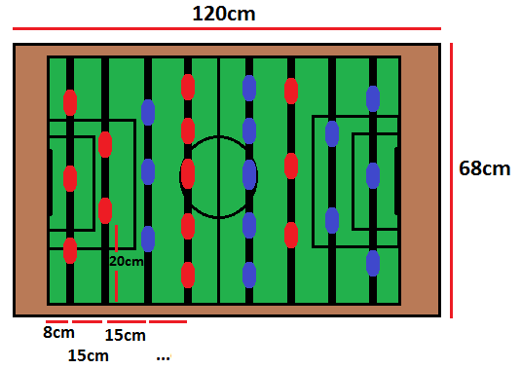
Figure 2.3.3.1: Relevant dimensions for calculating actuator response times

Lateral Motor Requirements
From the measured dimensions of Figure 2.3.3.1 and the speed of 10 meters per second as an approximate maximum speed for the ball, the speed that will be required to move in the lateral direction can be computed. This value will ensure that the electric motors used in the automated foosball table will be able to keep up with the gameplay. However, the requirement calculated for the motors using ideal values is unrealistic to actually implement, given the constraints of the budget. The distance between the poles is $15$ cm and assuming an ideally placed shot, the furthest the poles will have to move is $20$ cm.
$$t=\frac{0.15m}{10m/s}=0.015s$$
$$s=\frac{0.2m}{t}=13.3m/s$$
So, the maximum speed for a lateral actuator on the foosball table is $13.3$ meters per second. In an ideal final motor design, all systems would be required to keep up with this speed to play a perfect game. However, this speed is extremely fast and unrealistic given the budget and physical constraints. Since the perfect system may be impossible to create, the project requirements for lateral motion will be set to a competitive but slightly lower-than-perfect metric.
A more realistic metric for a non-professional but still competitive maximum speed of hits is 2m/s from independent research done by members of this senior design group. Furthermore, instead of calculating for the maximum distance on the board (20cm between the defenders and the wall in a worst case scenario) the average distance between puppets is considered (10cm), which is a more likely distance that will have to be moved.
$$t=\frac{0.15m}{2m/s}=0.075s$$
$$s=\frac{0.10m}{t}=1.33m/s$$
A maximum value of 1.33m/s will be attempted for linear actuator motion.
The complete linear actuator subsystem will require at least one motor per pole, meaning a total of four actuators to control the automatic opponent’s side of the field. Two touch sensors may be installed on each bar at the extreme end of motion. These sensors will prevent the poles from damaging themselves due to any possible software fault or failure.
Summary of Requirements:
- Move between the extreme lateral ranges of motion within 0.25 seconds, in essence approximately 1.0 m/s.
- 4 Motors used, 1 on each non-user game pole, will control the motion of the game pieces.
- 2 tactile sensors will be placed on each end of each game pole to limit the movement of the lateral game pieces. This will reduce damage to the actuator system.

Rotational Motors Requirements
The rotational motor has a number of options for implementation. The selected design must be able to hit the foosball in a manner similar to a human in speed and accuracy. The value of 10 meters per second will be used for comparison against a maximum professional power shot from the rotational subsystem, but a more realistic measure of 2 meters per second will be used for drafting the requirements. Hijkoop, et. al. have determined that the toque needed from a rotational motor to achieve this speed is approximately 13.2N [3]. Therefore, a motor for the rotational subsystem should be able to apply 13.2 N to play an ideal game. Once again, this metric may be beyond the scope of this project. The number is good to use as a starting point, but without gearing and careful calculation a perfect 13.2 N will be challenging to achieve. The requirement to play a satisfactory game of foosball will be a more realistic goal.
The complete rotational motor subsystem will require at least one motor per pole, meaning a total of four motors to control the automatic opponent’s side of the field. The motors may be directly mounted or indirectly mounted to the pole depending on the ratio needed to kick the ball. The entire subsystem must be able to handle the motion of the linear subsystem discussed above.
In order to keep the safety requirement the rotational subsystem may use two tactile sensors to stop motion at the extreme ranges.
Summary of Requirements
- Be able to hit the ball with approximately the same amount of force as a moderate human hit. The ideal is 13.2 N but acceptable will be between 5N – 10N;
- 4 Motors used, 1 on each AI game pole, will control the rotation of the game pieces.
- 2 tactile sensors on each game pole.
- The axial rotation subsystem must be able to follow the motion of the linear subsystem.

2.3.4 Software

2.3.4.1 Table State Interpretation
The table state interpretation describes the subsystem responsible for tracking and predicting the position of the foosball on the table, as well as measuring the position and rotation of all active puppets. These two parts are handled very differently in the code. The foosball tracking is done with a complicated system of inputs which feed into a Kalman Filter trained to predict and track the position of a highly maneuverable and dynamic foosball. On the other hand the position and rotation tracking of puppets is done simply through rotary encoders attached physically to the puppet poles.
In order for a Kalman Filter to work the input needed will include:
- Current Position
- Velocity Estimate
- Acceleration Estimate
- Model Error Covariance
- Input Error Covariance
The position of the ball will be estimated through the raw inputs of the camera and computer vision algorithms (discussed in section 2.3.1). The velocity and acceleration estimates cannot be measured directly through sensors however. In order to estimate the velocity, the difference between two or more frames can be used to measure the instantaneous velocity of the ball from the last measurement. The acceleration can then be estimated using the difference in velocity. However to be more accurate and able to handle large changes in acceleration, like what would happen when the ball bounces from a wall or puppet) the acceleration will be estimated using both a constant acceleration model from the camera estimate and also a white noise estimation model. White noise is a random variable which is not time dependent and generally the mean is 0. When a Kalman filter is used using a white noise random variable as acceleration it is constantly anticipating the change and able to quickly react to a ricochet.
The Model and Input Covariance measures for the Kalman filter are extremely challenging to measure accurately and is commonly cited as a drawback of the Kalman filter method. However previous research has given models to use for similar domains, and to measure these values the senior design group can simply follow the precedent.
Finally in order to keep a competitive game of foosball running there must be some time requirement. If the table state runs too slow then the automated foosball puppets will not be able to react to the ball fast enough to block shots. Judging from the speed of the potential cameras a safe requirement is around 30 Hz.
Summary of Requirements
- Be able to measure instantaneous position.
- Be able to estimate instantaneous velocity and acceleration.
- Update table state model at approximately 30 Hz.
- Be able to measure model and input error covariance.
- Have hardware to measure linear and rotational position of puppet rods.

2.3.4.2 Artificial Intelligence Algorithms
The artificial intelligence (AI) subsystem is the decision maker which takes into account the current table state information (discussed in the previous section, 2.3.4.1 Table State Interpretation) and generates output to the motion control subsystem, discussed in the next section, 2.3.4.3, Motion Control Algorithms.
There are a number of potential AI schemes that could be used in the completion of this project, which are discussed in 3.2.4.2, AI Algorithms Research, and the final design choice, discussed in 4.5, Software Design Details. One of the Phase II (i.e., post-completion, time permitting) goals for this project is to improve the AI from a basic one to one that mimics a human’s play style more closely, and is capable of more advanced movement. However, regardless of which AI algorithm is chosen for the project, there are several clearly-defined requirements that will have to be met.
- At its most basic level, the AI algorithm must be capable of accepting the current table state, which consists of the information specified in the above section, and outputting to the Rod Control Boards the desired move, which will likely be in the form of a rotational encoder position (for linear movement) and whether or not to kick.
- The AI algorithm must not add significantly to the time taken to process a frame. This is to say that the AI should, given a table state, be able to calculate and output a move in around 1ms on the central processing unit.
- The moves output by the AI algorithm must be correct according to the information it’s given. This is to say that while the ball may not be kicked perfectly every time, if the actuators are working properly and the optical system has accurately sensed the ball, the AI algorithm should derive the optimal move.
- The AI algorithm should be able to operate with enough precision to accurately tell the Linear Movement Control subsystem what to do. (More specific numbers discussed below in 2.3.4.3, Linear Movement Control)

2.3.4.3 Motion Control Algorithms
Linear Movement Control
Motion control algorithms will be required for the linear movement control of the robotically controlled puppets. When controlling the motors, it will be required to move each of the rods holding the puppets in both directions at very high speeds for real-time response, and with relatively accurate stopping positions.
To control an optimal automated opponent, the algorithm must be able to transport the puppet 20 cm to block a ball hit by a professional (10 m/s). Because the distance between the rods is 15 cm, the control algorithm must move the puppet 20 cm in 0.015 seconds (average speed of 13.3 m/s, more detail shown in 2.3.3 actuator specifications). The diameter of the foosball is 4 cm. To block a shot, ideally the center of the puppet foot is lined up with the center of the ball creating a tangential contact parallel to the playing rods. This makes the ball stop completely and gives the blocker full control to return a shot in most circumstances. The width of the puppet foot is 2.5 cm. Thus, to create a full contact block the foot of the puppet must be moved to within a 2.5 cm margin of error (1.25 cm from center contact on either side of the ball). The following diagram clarifies:
Figure 2.3.4.3.1: Full Block
From this diagram we can see that the margin of error is 2.5 cm. The foosball player foot can be moved 1.25 cm off either side of a dead-on collision and be considered a full block.
However, it is unreasonable to create an optimal opponent, because the physical game constraints would run the cost of equipment far beyond the projected budget of this project. Thus, the requirements of the linear control algorithms will make the same suboptimal game assumptions as the ones made in Section 2.3.3, Actuator Specifications, which are an average distance to move being 10 cm (which is also half the width of the goal) and an average hit of 2 m/s. Thus it must move the rod 10 cm in .075 seconds. Furthermore, the goalie puppet has twice the distance to block the shot because the closest rod to the goalie is the same team defenders so it will have .15 seconds to move to block a shot. In addition, these calculations assume instantaneous reaction time on the human end of the game, which will give additional time for the control algorithm to put the puppet in place.
Assuming a suboptimal game also changes the requirements for blocking. Although a full contact block is most desired to obtain control of the ball, deflections also act as a suitable defense against goals. Thus, with a 20cm goal, if the edge of the puppet hits 1 cm away from the ball’s center, the deflection angle is great enough such that the ball will still miss the goal (this applies even when the goalie puppet is not centered in front of the goal due to the large deflection angle of a block 1 cm away from the center of the ball and relatively small goal size). Therefore, the margin of error is increased to 4.5 cm (1.25 on each side from the edge of the puppet foot hitting the ball and then an addition 1 cm on each side because the contact can be 1 cm off from the center of the ball and still deflect). The following diagram clarifies:
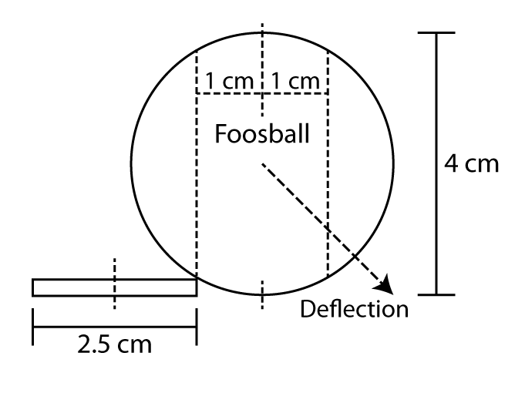
Figure 2.3.4.3.2: Deflection
From this diagram, we can see the margin of error is now 4.5 cm. When the foosball puppet foot is moved 2.25 cm from center of the ball it will deflect the ball enough for it to miss the goal.
Summary of specifications and requirements:
For a full block:
- Move the puppet up to 10 cm in 0.15 seconds with a margin of error of 2.5 cm
For a deflection/blocked goal:
- Move the puppet up to 10cm in 0.15 seconds with a margin of error of 4.5 cm

Rotational Movement Control
For rotational movement control, a very similar discussion could be made compared to linear movement control. However, in this project’s design, the rotational motors will simply move from a down position (block position) to an up position (let ball pass or kick) and will not require a specific control algorithm to monitor speed, position, etc.

2.3.5 Table
In order to ensure the success of the project, the foosball table itself must conform to a strict set of specifications:
- The table must be of the 3-goalie, flat corners type, as this prevents the ball from flying off the table [4]
- The table must conform to standard Foosball table size specifications, which are 30”x56”, with the playing surface being of the size 27”x47” [4]
- The table must have side walls at least 1.5” thick, which allows for more predictable bounce angles
- The control rods must have a coefficient of friction low enough to not significantly reduce their lateral and rotational speed
- The puppets must be firmly affixed to the control rods, and totally immobile relative to it.
- The table’s legs must be capable of being removed without damaging the table, as this is necessary for transport.

3.0 Research Related to Project Definition

3.1 Existing Similar Projects and Products

3.1.1 Adelaide University Automated Foosball
Five engineering students at Adelaide University (Australia), with serious funding and support from Sage Didactic and Rockwell Automation, were able to create a very effective automated foosball table in 2007 as a senior design project. A top level view of the project reveals a well-made machine that provides a fun opponent with the playing ability to “win most games”. [5]
Although not explicitly stated in the sources, it can be assumed that this table had significant funding, likely on the order of tens of thousands of dollars. With its Plexiglas encasing, fine-grained motor controls, and professionally machined parts, it functions with deadly precision and looks great while doing it.
The sensing mechanism consists of 96 LED laser and photoresistor pairs, creating a grid for sensing the location of the ball. This position is then sent to the PC where the student-developed AI processes the decisions. The students used a Softlogix control system along with a Kinetix 2000 motion control platform for controlling the actuators. Also, because both the AI and the control systems were run on the same PC, all communication between them could be done through memory. [6]
Overall, this project sets a great example of what can be done for a senior design project. It functions well and provides an exciting user experience. The only downside is its apparent cost. This project aims to provide a similar experience for a small fraction of the price, thus having to sacrifice some aesthetics and component quality. However, through smart engineering decisions, it is this project’s goal to make a competitive table with significantly less expenditure.

3.1.2 StarKick Robotic Foosball Table
German-made StarKick foosball tables are another great example of an automated foosball table. However, unlike the Adelaide University table which was developed by senior design students and later donated, the StarKick table is a commercially-available foosball table, allegedly the world’s first. It has been sold to a few arcades around Europe and provides a competitive, mechanically-robust opponent that operates in a harsh arcade environment. However, it costs $27,000. As seen in Figure 3.1.2.1, they are very polished consumer-grade tables.
Pending permission from Star Kick, Inc.
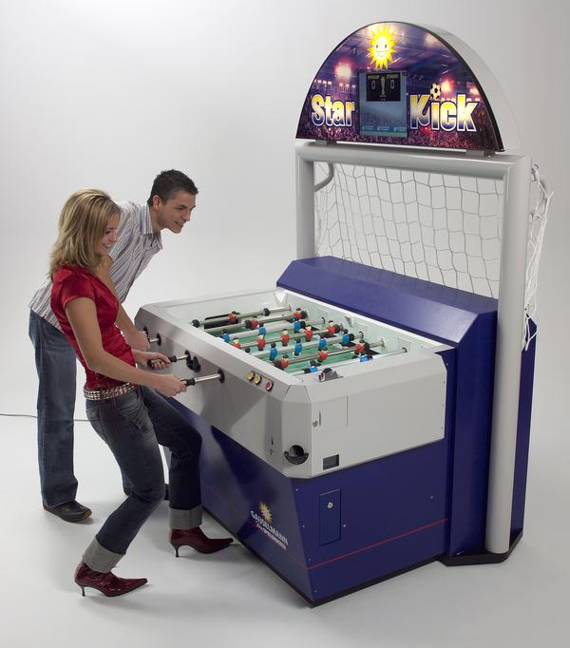
Figure 3.1.2.1, the Star Kick Foosball Table
From a performance standpoint, this table is outstanding. Matched up in 72 games against a wide range of players including beginners, amateurs, and advanced players, it beat out 85% of its competition (2 player teams). It even won more than 50% of its games against advanced players. [7]
Functionally, it works similarly to its Adelaide University counterpart. It has a 300 LED grid which samples the ball location at 50 Hz with a resolution of 384x288 (effective frame rate and resolution after processing). Compared to its prototype, which used a mounted color camera, the LED array allows for operation in a harsher playing environment. The LED grid makes the table more compact, and also more resilient to changes in lighting and ambiguity in the ball’s location caused by obstructions. In addition to ball sensing, the table also has encoders to keep track of the human player’s locations. In the table’s current design, this information isn’t used, but it is planned to be incorporated in the future. [7]
After the sensing information is sent to the computing system, it is processed with the AI decision engine. Star Kick as used a simple greedy AI algorithm capable of the following functions: kick the ball, kick a ball that is stuck on the wall, block the ball, and get out of the way of the ball. During a game, the automatic table works on a simple block and attack tactic, where is predicts the balls movement, moves in front of it, hits the ball toward the human’s goal, and moves its own players out of the way of the shot. Although simple in nature, this tactic, as shown early, is quite effective.
After the decisions are made, actuation is required. Starkick uses a cable driven system for horizontal movement and a belt driven system for the rotational movement.
With this mechanical system, the automated table can shoot the ball at 3m/s, which, compared to an experienced player (typically shooting 6 m/s), is not as fast, but is still fast enough to consistently make goals. [7]
Overall, StarKick is another great example to follow for this project. It is a robust mechanical opponent that consistently beats its human competitors. It has fine motor controls, a functioning AI, and highly accurate sensing. Again, its main disadvantage is the significant cost; $27,000 is more than 20 times the budget for this project. However, with the right engineering decisions, the loss of performance could be mitigated while drastically reducing the cost of production.

3.1.3 Georgia Tech Automated Foosball
Senor design students at Georgia Tech created an automated foosball table which is radically different than those aforementioned. This foosball table would be best classified as a minimalistic robotic foosball table.
In terms of performance, this table could only defeat the most inexperienced players. The reaction time was slow, the kicking speed was low, and the accuracy and defense were both rather poor. This prototype table would not provide the desired competitiveness expected from most human players.
In terms of function, the ball location is determined through a mounted webcam and image processing. This provided a very slow ball recognition time and contributed to significant errors caused by table movement, visual obstruction of the ball when it rolls under a player, and different lighting scenarios.
The limiting factor was reported by one of their team members as the mechanical portions and the webcam quality, not the AI or the processing. [8] However, the main reason why this project is important to consider is that it was completed in three months for only 500 dollars. This sets a great example of the most minimal version of an automated table. Thus with this project, a $1000 table should provide a significant performance increase while still maintaining a reasonable price.

3.2 Relevant Technologies

3.2.1 Sensor

3.2.1.1 Ball Detection

Existing Magnetic Sensing Systems
The use of magnetic tracking was evaluated for use in this project. The requirement for a tracker in this project is that a fast moving ball must be tracked across a limited playing field. To this effect, any magnetic tracking system must use a sensor or grid of sensors to track the position and rotation of a magnet placed in the ball. This will maintain the requirement of play that the ball not be wired to anything and also be able to quickly and accurately track the ball.
Off the shelf systems exist such as the Polhemus motion tracking system, which offers extremely accurate and extremely fast motion tracking. These type of sensors require an approx. 1 cu. ft. base station and a 3 axis magnetometer to be placed on the object being tracked, the data is then relayed off the magnetometer via a wire to a wireless relay (cell phone sized) [9]. The physical setup of the Polhemus tracker is depicted in Figure 3.2.1.1.1, below.
Figure pending permission from Polhemus, Inc.
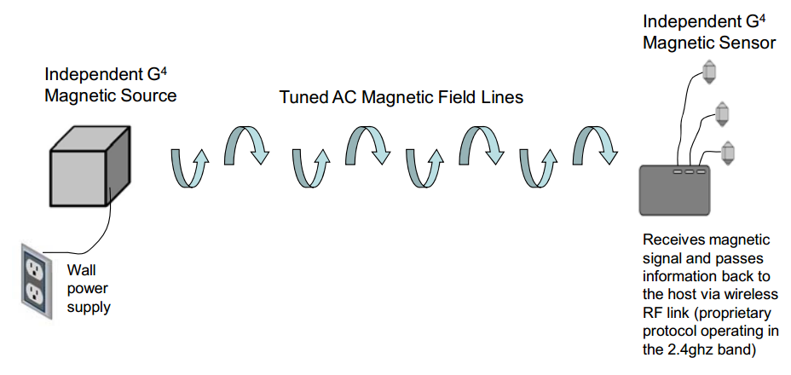
Figure 3.2.1.1.1: Depiction of Polhemus G4 motion tracker
This will not work for foosball tracking because a small but free moving ball is the object that must be tracked. While the existing systems have a relatively small wireless relay, a cellphone sized relay is still too large for use in tracking a foosball because a foosball is considerably smaller than a cellphone.
The cost for these systems is also prohibitively expensive, each system ranges in the thousands of dollars. Our total project budget is less than the cost of obtaining a single off-the-shelf magnetic tracking system.
Given the cost constraints and the size of the tracker, any existing, off the shelf magnetic tracker is an infeasible solution for use in this project.

Custom Magnetic Tracking
In order to meet the requirements of a magnetic tracking system for a foosball, a custom sensing grid was considered. The custom grid setup would consist of several 3-axis magnetometers mounted on custom PCBs that would relay information to a central processing unit. The processor would then in turn use the magnetic field direction and intensity from each sensor to compute the location of a magnet placed in the foosball to be tracked.
A sample set of parts was obtained and tested for use in this type of tracking grid. The MAG3110 was used along with an N48 rare earth magnet. The MAG3110 sensor was purchased from SparkFun for $14.95 [10]; the board was easy to test with because the leads from the chip were brought out to a standard 1/10th inch spacing. The MAG3110 was selected because of its common use in the industry as well as its fast refresh rate (80 Hz [11]) and relative accuracy. The magnet chosen for the test was a cylindrical ¼ in diameter, ¼ in long N48 rare earth magnet.
During testing the background magnetic field created by Earth’s magnetic field registered as 55 uT on the sensor. In order to register a field distortion that was above the background field, the rare earth magnet used needed to be within 8 inches of the sensor, however this could be increased to 3 feet if the magnet was pointed in the direction of the sensor. The rotation of the ball cannot be relied on, thus we would need a sensor within 8 inches of every space on the board.
The limitations on sensitivity would require around 10 to 20 sensors to be placed under the board. Due to the noise of the sensors in excess of 1 uT and the relative price of each sensor chip, $1.73 [12], 4 sensors could be placed near each other on each sensor chip to reduce noise. This would make up for the inaccuracy in the individual sensor.
Price quotes were obtained for the construction of the sensors described above. Due to the size of the MAG 3110 sensor, we would be unable to solder the chip to the board. The small size of the leads on this sensor, 0.22 mm lead size also leads to high production costs, depicted below in Figure 3.2.1.1.2. The cost of manufacturing 15 PCBs varied between $350 and $550. The cost of assembly was in excess of $1200 for 15 PBCs. The cost of the parts was around $100. This put the total cost of sensor creation around $1700. Because this price was nearly twice the project budget, the possibility of creating boards for each sensor was out of the question.
Pending copyright permission from Freescale, Inc.
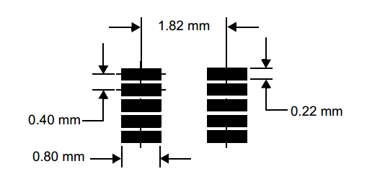
Figure 3.2.1.1.2: Diagram of Freescale’s MAG3110 connection pads
Another possibility was to use the boards from SparkFun as the sensors in our project. This however was ruled out because we would want the noise reduction of multiple sensors, because of the individual cost of $15 per unit, using 4 MAG3110 chips at each sensor location would yield a sensor cost of $15 * 4 * 10 = $600. This was a more reasonable figure than having the PCBs made ourselves; however, the cost was still in excess of half the total project budget. Due to cost, magnetic sensing was ruled out as a method of ball tracking.

Laser Optical Tracking
The possibility of using a series of lasers and sensors placed near the bottom of the board was evaluated for this possible use in the project. The design that was considered would consist of 2 lasers at each end of the table placed behind the goal. A spinning mirror placed at a 45° angle, placed at a height such that the laser would shine out underneath the puppets but above the table and would hit light sensors along the edge of the table.
A variable rotation rate on the mirror could be used to adjust the sampling rate, in addition relatively spaced out sensors would provide accurate sampling of the ball’s position. The ability to add more lasers to provide more accurate sampling made this an attractive idea for ball tracking.
Each laser would need to point between the players and puppets. In the table we purchased, the distance between the bottom of the puppet and the table is 3 mm. This imposes a need for high mechanical accuracy with pointing of the laser. Coupled with the need to determine which laser was shining on a given sensor receiving a signal made this tracking method a very difficult proposition that was likely to fail. As a result, laser optical tracking was ruled out as a ball tracking method.
Infrared LED-Sensor array
The University of Akron foosball table uses an array of 22 LEDs with an associated array of infrared sensors on the opposing side. This would impose the need to design a hardware controller for aggregation of the sensors. The required board wouldn’t need to have any surface mounted components and thus could be made cheaply. The LEDs would need to between sensors, the result would be a minimization of the interference between pairs of LEDs. The position would be equal to the granularity of the array. However an assumption on constant velocity (in between strikes) would allow for much finer approximation of position.
The implementation of an LED array would fit within our budget and time constraints thus is a possible solution to the problem of tracking the position of the foosball on the field.
Infrared LED array-Camera
The Star Kick, commercial automated foosball table uses an array 300 LEDs placed around the edges of the field, below the puppets. The field itself is made from a material that appears solid however lets through infrared light. There is an infrared camera with a resolution of 384x288 placed below the table looking at the field [3]. The LEDs illuminate the underside of the ball which then in turn shines through the field and produces an image in the camera such as the one seen below in Figure 3.2.1.1.3.
The solution developed by Star Kick is a novel, reliable solution that has a relatively low cost because of the simple LEDs and camera used in its implementation. This solution has one drawback, which is that the table must be made of a special material that allows through infrared light so that camera may detect the ball. This is not a viable solution for this project because the table that was purchased for this project is solid and blocks all infrared light.

Permission pending Star Kick, Inc.
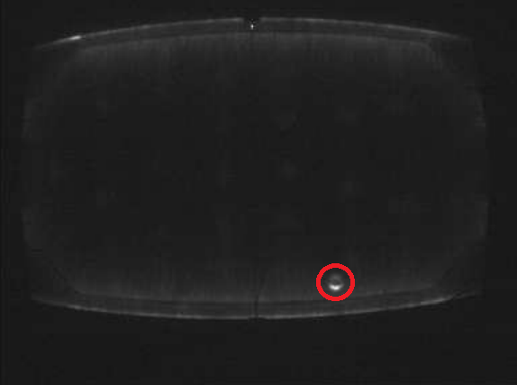
Figure 3.2.1.1.3: Typical image from Star Kick camera, the foosball is circled in red
Visible Light Camera
An obvious solution to this problem is to attempt to mimic how the player tracks the ball. The typical player simply visually identifies the foosball on the field. The computer based solution to this is a camera mounted above the field attached to a processing unit running computer vision algorithms to identify the position of the ball. Two different types of off the shelf consumer camera systems were evaluated for use as a foosball tracker: the Logitech QuickCam® Pro 9000 and the Microsoft Kinect®. The Logitech QuickCam® Pro 9000 is available for $60-$90 while the Microsoft Kinect® for Windows is available to students for $150. Both cameras provide color video feeds as well as the ability to capture still images at higher resolution, however the Kinect® provides a depth map by measuring displacement in an infrared grid.
With regard to simple analysis of color images, OpenCV provides a vast set of image processing algorithms. A Haar cascade can be trained to recognize the ball, this is one of the algorithms that is available in OpenCV. A Haar cascade is an algorithm that reduces a set of alike, training images to light and dark rectangles. These rectangles are arranged in a cascade that is ready to compare an image, or sub image such that the failure to satisfy the first set of rectangles means that the image is a negative. Another possible algorithm for recognition of the ball is a Hough transform that is being used to recognize circles. The Hough transform is much simpler, however it requires more computing power and can only recognize geometric shapes that can described by a limited number of constants, such as a circle.
The Logitech and Kinect both produced similar quality images, shown in figure 3.2.1.1.4.
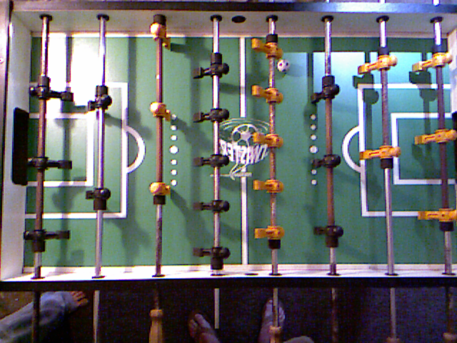
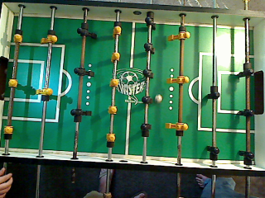
Figure 3.2.1.1.4: Color images captured from
Logitech QuickCam® Pro 9000 (left) and the Microsoft Kinect® (right)
One problem that was noticed during testing was that the ball did not appear as a circle when moving quickly, motion blur produced a streak, shown in figure 3.2.1.1.5. The motion blur produced with the color channel of the Microsoft Kinect® was much less than that of the Logitech QuickCam® Pro 9000.
Figure 3.2.1.1.5: Image capture from Logitech QuickCam® Pro 9000 showing motion blur
The markings on the table such as the circles marking distance in the middle of the board and the circular heads of the puppets would make detection using a Hough transform difficult. In addition to the other sources of circles in the table, motion blur would make the ball not appear as a circle; thus, a Hough transform will be unlikely to yield good results.
The presence of motion blur allows for determination of position, direction and speed from a single frame. This would very useful because cameras evaluated for use in this project operate at 30 Hz, thus at least 2 frames are needed to detect a direction and velocity. The frame rate constraint means the fastest detection of a new direction and velocity would take 1/30 sec + processing time. If an algorithm was implemented that could detect direction from a single frame before the next frame arrived the game could be drastically more responsive and challenging. The problem of motion from blur has been analyzed from an algorithmic point of view by Shengyang Dai and Ying Wu in a 2008 paper titled “Motion from Blur” [13]. The math has been done for this problem however no real-time implementation has been made. If the Logitech camera is used, motion from blur may be used to gather some information about direction from each frame.
Depth Maps
The Microsoft Kinect® also provides a depth map by measuring the displacement in a grid of infrared lights fired from the camera. The processing of the displacements back into a depth map is done onboard the Kinect® and thus would not require any extra computing power to compute. The advantage of a depth map is that table markings are not visible and cannot interfere with detection of the ball. The foosball is clearly visible from the surrounding puppets and board in figure 3.2.1.1.6.
The depth map also has another advantage in that puppets are higher off the board than the ball and thus will not be detected as the foosball, but the puppets can still occlude the foosball. In testing the Kinect® sensor no motion blur was noticed in the depth map sensing, and thus a simple Hough transform could be used to detect the ball after a Canny edge detector was run on the image. An important note to mention: the puppets legs will at some time, if rotated within a very specific angle, will be at a similar height to the foosball. Thus, it will be possible to confuse a puppet foot with a ball. A Hough transform may be able to distinguish this, otherwise a search for parallel objects can be done to distinguish a ball from a puppet.
The use of two cameras is also possible, the Kinect’s® depth map and the QuickCam’s® color map could be combined to provide more accurate foosball tracking, however this would require additional processing power. The use of individual cameras for color and depth would be preferred over the Kinect® only because the bandwidth limitation of USB imposes a limit below 30 Hz when using both depth and color.

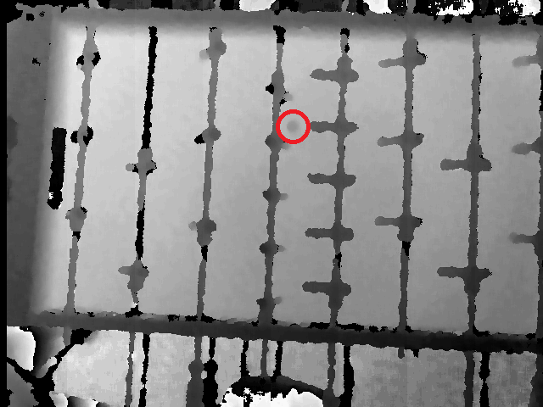
Figure 3.2.1.1.6: Depth map from Microsoft Kinect®: the presence of the foosball is quite apparent in the image and easily differentiable from the puppets.
Sample Normalization
After an image processing algorithm determines the position or several likely positions of the foosball on each frame, these samples must be combined into coherent position and velocity data. The Kalman filter is the primary algorithm being researched for use in this system. A Kalman filter uses knowledge of the state of an object to predict where to look for it next. The filter is also able to remove noise such as a sample showing the foosball as a puppet’s head other side of the field, because this would be inconsistent with the foosball’s last known position and direction. The Kalman filter assumes a state-based dynamic system evolution which is very appropriate for this project, which will be tracking the physical position and velocity from a series of discrete samples.
A common algorithm for use in computer vision is RANSAC or “RANdom SAmple Consensus.” RANSAC is very good at filtering a set of discrete samples into those that fit with a mathematical trend and those that do not. This is particularly useful when using an algorithm that is prone to overidentification of targets, e.g. when a Hough transform identifies 15 different circles in an image and only 1 is the foosball. RANSAC also has the advantage of being very fast, but tunable. The algorithm is non-deterministic and will produce a better answer for each additional iteration it is allowed to run. This is a desirable feature for use in this system because the resultant performance can be increased by making each stage of the final foosball identification algorithm faster.
Conclusion
Optical camera tracking is the strongest candidate for tracking of the foosball because of its low cost and mostly software implementation allowing easy upgrades to the system. A secondary possibility is an infrared grid of LEDs and sensors due to its simplicity and accuracy. The Kinect® also provides an interesting option due to the ability to change between using a color only, hybrid depth/color or depth only tracking method with software only. If a hybrid color/depth is chosen, different cameras with individual USB root hubs would be required due to the bandwidth limitation of USB. The advantage of a hybrid color/depth model is that the motion blur from the QuickCam® could be used to determine direction in a single frame, while the depth channel could be used to provide accurate position information. The best single option however is the Kinect® depth sensor, due to its resistance to resistance to interference and false positives.

3.2.1.2 Player Puppet Detection
This subsection deals with determining the minimal state vector of the rods that control the puppet’s motion. The state vector will contain only the position of the translation along the direction of the rod and the rotation of the control rod. This will tell us exactly where each puppet is located on the field and whether they are kicking, blocking or rotated such that they will be out of the ball’s way.
The first thing to research in this section is to consider what this information would be used for within the AI subsystem, or any other subsystem, and determine if it is necessary to the FOOSE project’s success. The position of the automated rods seems like the most critical component to keep track of. In order to implement any linear control algorithms, and in fact move the control rods to any position without dead reckoning and guessing, this information is needed. The rotation of the automated rods is another question. The rotation information would be useful for confirming the position, and if the rods were given complete 360-degree rotation control without any physical stops, then having an encoder reading the rotation of the pole would be essential. However, if the kicking/rotational mechanical subsystem is instead chosen to be a simple back and forth motion with tactile sensors to stop the motion at the extremes, then adding an encoder would be potentially unneeded.
Whether the subsystem should detect the position and the rotation of the human-controlled rods is another question entirely. In an ideal project, the human rods’ position and rotation would be known so that the AI can react appropriately to the player’s position, and even try to maneuver the ball around the human player’s puppets. However, in the event that the AI is not accurate enough to do this, then the information would be wasted. Furthermore, the rotation of the human player’s puppet is only useful if the puppets are rotated up and the AI could exploit that fact. It might be just as effective and much simpler to assume the human controller rods are always rotated down.
Regardless of which information is chosen to be mined, the most likely way to get this information from the physical world to the controller is using a quadrature encoder. There are many varieties of encoders to consider. There are linear encoders that run from changes in magnetic fields, and there are optical rotary encoders which use a wheel with markings to determine the rotation. Either choice will give the same data back to a microcontroller which can interpret the state. In order to interpret this data into a position, the system will need to decode quadrature encoding.
Quadrature Encoding
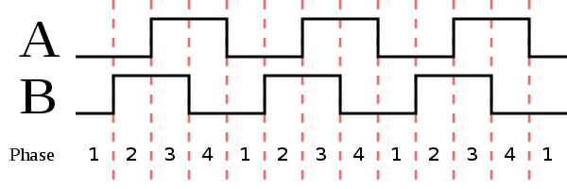
A fundamental part of this research went into learning how to read the signal from an optical encoder and create a counter to keep track of the linear position of the rods. Quad-encoding is a way to read a counter using just two signals. This counter can count up and down depending on the direction of the rotation. As seen in Figure 3.1.2.1, the two signals A and B will count up at each ‘click’ (where a click is some arbitrary amount of rotation or linear motion down the encoder, in order to be an effective encoder this click value is very small.) Each click, however, has two parts, the A peak and the B peak. If A leads B, then this click is counting up and the accumulator in the control board must be incremented. If the B signal leads the A signal, then this is counting down and the accumulator from the board must be decremented. When at any point the control system needs to know the current position of the control rod, it will access the accumulator value that is being modified by the control boards.

Figure 3.1.2.1: Quadrature Signal
A very fast embedded processor will be required to keep track of the encoder’s values, likely this board will use a processor like the Arduino [14] or the Cypress system’s processor [15]. This processor would be fed the input values and keep track of different counters. The quadrature encoding method is very common and there are numerous products of varying quality which all output the same signal. This opens up the option of many different encoders to purchase for this subsystem. A quick comparison of products follows.
MakerBot Linear Encoder v1.2
The MakerBot line is built for roboticists. The core of this board is the AS5306 chip. This particular board is set up to be a linear encoder, as opposed to all other options here which are rotational encoders. This method works by using a magnetic strip which is moved over a static sensor which reads the magnetic field changes. It takes this value and creates the Quadrature encoding to send to the PCB. This is convenient for the foosball table application because it would be easy to attach to the linear actuator system. However, for obvious reasons, this would not be possible to use for rotational encoding.
Website: http://store.makerbot.com/magnetic-linear-encoder-v1-2-kit.html
Features and Specifications
Resolution: 15 microns
Voltage: 5V
Length: 12 inch magnetic strip
Cost: $50.00

US Digital Miniature Optical Encoder
US Digital is a well-known and well trusted distributor of electronics. The applications for this tiny encoder chip are well beyond just the industrial section, including hobbyists and roboticists. This option is a rotational optical encoder, meaning that it has a shaft which rotates and the rotary wheel on the inside of the mechanical subsystem uses an optical sensor to count the quadrature ticks that are sent back to the control board. This sensor has a very tiny shaft which could be a problem for attaching to motors, depending on the selection.
Website: http://www.usdigital.com/products/encoders/incremental/rotary/kit/e4p

Features and Specifications
Resolution: 360 clicks per revolution (1 degree)
Voltage: 5V
Length: NA – rotational
Cost: $29.95
Shaft: +/0 0.20” axial shaft of 0.59” to 0.250”
Shaft Length: Minimum shaft length of 0.375”

Sparkfun Rotary Encoder- 200 P/R
Sparkfun is a distributor for mainly hobbyists, meaning their parts are well documented and have great support for applications. The Rotary Encoder solution provided by Sparkfun comes in two resolution options, the 200 P/R and the 1024 P/R options. Some additional research will be needed to determine how many points per revolution will be needed for an acceptable linear control loop for the different subsystems on the mechanical actuator portion. This option is a larger physical encoder and has an awkward cylindrical shape which could cause mechanical mounting issues, however the benefits are that it comes with several convenient additional resources and documentations which could be useful for the project implementation.
Website: https://www.sparkfun.com/products/10790
Features and Specifications
Resolution: 200/1024 clicks per revolution
Maximum rotational speed: 5000 rpm
Voltage: 5-12V
Length: NA – rotational
Cost: $29.95/$39.95
Shaft: 4mm diameter
Shaft Length: 1cm length

3.2.2 System Architecture

3.2.2.1 Main Processor
Since the FOOSE project requires intensive data compilation and interpretation, it will require some kind of central processing unit. In Section 2.2, the objectives for the central processing unit are listed as requiring a processor and RAM capable of interpreting sensor data and computing the artificial intelligence’s next move in a reasonable amount of time, the ability to connect over serial and USB to the necessary sensors subsystems, and to be running an operating system, if any, which is capable of communicating in real time with the control systems. These objectives must be kept in mind when deciding on a central processing unit for the FOOSE project.
In addition to the objectives which must necessarily be met in order for the FOOSE project to be successful, it is also necessary to take into account ease of programming, setup, and assimilation into the rest of the project, as well as the actual cost of parts required for the component. Within the constraints of the project, the one requiring the lowest amount of work and monetary cost will be the one chosen for use in the project.
Keeping in mind the aforementioned assessment criteria, here are the potential candidates for central processing unit:
- Field-Programmable Gate Array (FPGA)
- AVR Microcontroller and
- Full computer, of which the two primary candidates are
  - An ultra-small-form-factor computer using an Intel Atom processor, and
  - A small-form-factor computer using a Pentium 4 processor
Field-Programmable Gate Array
The first candidate which could serve as the FOOSE project’s central processing unit is the Field-Programmable Gate Array, or FPGA. An FPGA is a microprocessor which contains interconnected, configurable logic blocks, which effectively reproduce a network of Boolean logic gates [16]. The main function of an FPGA is to effectively replicate the job of an Application-Specific Integrated Circuit (ASIC), with the advantages of being dynamically reconfigurable and multipurpose, but the potential disadvantage of being slower, which would depend upon the model of FPGA selected.
FPGA: Sensor Interpretation and AI Computation
The primary question to be asked of an FPGA is whether or not it is capable of performing the computational duties required of it. Fortunately, the question has been addressed in a number of academic papers. Among these, one, researched by senior design students at the Grenoble Institute of Technology in France [17], concerns implementing a modification of the Canny edge detection algorithm, called the Garcia-Lorca implementation, which has been adapted for optimal performance on an FPGA. In their experience using this implementation, they were able to achieve edge detection in real time, when operating on a 512x512 pixel video image being input at 60Hz. This type of video image would be sufficient for the FOOSE project’s needs, so the implementation of this algorithm on their FPGA should not be an issue.
After this, it will be necessary to actually recognize the image of the ball, post-edge-detection. One of the ways that the FOOSE project may implement object recognition is through the use of a Hough transform. A team from Algeria was able to implement a quick Hough transform on a Xilinx FPGA [18]. As the paper is rather old, the FPGA they used seems hard to come by. However, it was a cheap one, which met their needs exactly. Using one of the cheapest FPGAs available today should be able to at least replicate, and more probably improve upon, their performance.
After this, the FOOSE project’s proposed algorithm will implement a Kalman filter to reduce noise from the image and provide object permanence, part of Piaget’s first stage of development. A team from China was able to implement this effectively on an inexpensive FPGA, and obtained sub-millisecond response times [19].
As for the AI, while an official AI scheme has not yet been decided upon, it can be reasonably assumed that the algorithmic complexity of the AI will not exceed the previous (rather intensive) operations, and so a reasonably powerful FPGA should be able to handle its processing requirements.
FPGA: Physical Capabilities and Costs
So, the processing ability of the FPGA has more or less been proven. The practical physical capabilities of the FPGA are now in question. The FPGA used by the French team who implemented Canny is an Altera DE2 Development and Education board.
If this project were to use an FPGA, it would likely be in the form of an integrated development board like the one shown. This board contains an FPGA which was, when used in the Canny project, highly underutilized [17]. The extra capacity should, according to the other sources, be more than enough to implement the other algorithms necessary, and to perform them in a reasonable amount of time. It also has the serial and USB ports necessary to communicate with the sensors used in the project [20].
Addressing the monetary concerns, the DE2 board costs, for academic users, $269, which is within the constraints of the budget [20].
However, the major negative aspects of the FPGA come into play when time costs are considered. Using an FPGA would mean that most, if not all, of the software used would have to be hand-coded, whereas with a full computer, the optical sensing algorithms could be taken care of with freely available software programs. While the FOOSE projects could travel on the shoulders of giants by making use of the research papers cited in this section, most of the authors of the papers have not made their code available, and, while the math is documented in the paper, the code is not. Also, while the code for other processors may be written in a high level language, the development for an FPGA must be done in Verilog or HDL, something that the members of the group have less experience with. This represents a significant additional expense which would not be incurred with other types of development hardware.
FPGA: Conclusion
In conclusion, while the other aspects of the FPGA are good and suitable for this project, the additional time investment represented is simply not something this project can afford. Another type of central processing unit will have to be used in this project.
AVR Microcontroller
The second candidate which could serve as the FOOSE project’s central processing unit is the AVR microcontroller, an inexpensive, commonly used variety of programmable chip. An AVR microcontroller contains reprogrammable memory on which to store code, and a processor which is used to execute the code [21]. For the purposes of this section, an AVR microcontroller with 32KB of program space running at 16MHz will be considered [22], running on a development board with a timing clock, a USB connection, and a serial port [23].
AVR: The Costs and Physical Capabilities
Given the development board seen in [23], the AVR microcontroller will certainly have the physical ports necessary to interface with the sensors and motors in use on this project. Compared to an FPGA implementation, the overall costs of an AVR microcontroller solution are much lower in a variety of ways. Firstly, the complete AVR microcontroller solution consists of two parts (unless more AVR microcontrollers are necessary), which cost a total of $38.79 [22] [23]. This is extremely affordable compared to the $269 previously considered..
Additionally, the time cost of developing for the AVR microcontroller is drastically reduced compared to the FPGA. While AVR microcontrollers can be programmed in native assembly, C compilers are supported for the AVR microcontroller [21], and C is a language the members of the FOOSE project have a great deal of experience in. So, all in all, the costs of using an AVR microcontroller as the FOOSE project’s central processing unit are quite low.

AVR: Sensor Interpretation and AI Computation
However, the most important question to ask is whether or not the AVR microcontroller is actually capable of supporting the functions which it needs to be able to support. Although it may be physically capable, research findings suggest that the AVR microcontroller may not be fast enough at the required precision to be suitable for this project. While even a 16MHz AVR microcontroller can perform execution of C code very rapidly, once the necessary precision increases beyond the 8 bits of the AVR microcontroller, execution slows to a crawl and it becomes difficult to implement real-time algorithms.
AVR: Conclusion
Despite the obvious advantages the AVR microcontroller possesses, of low price and easy development, its lack of speed and precision unfortunately make it unsuitable for use in the FOOSE project. We will have to look instead to the final type of central processing unit currently being considered.
Full Computer
The final candidate which could serve as the FOOSE project’s central processing unit is simply a full-fledged off-the-shelf computer. Running a processor compatible with Intel’s CISC x86 instruction set, and having speeds and RAM capacities much more than either an AVR microcontroller or an FPGA, a computer still has many advantages and disadvantages that must be considered. For the FOOSE project, two physical computers are being considered for use: the small-form-factor computer using a Pentium 4 processor, and the ultra-small-form-factor computer using an Intel Atom processor.
Computer: The Costs and Physical Capabilities
Physically, each of the computers in question comes with a plethora of peripheral options, all of which are already integrated into the computer and do not require any sort of development board or additional chip. Each has the required serial and USB ports, among others. Each of the computers in question are also already owned by members of the FOOSE group, and are willing to be sacrificed for the good of the project. The ultra-small-form-factor computer is extremely small and could be mounted underneath the playing surface permanently once configuration is complete. In contrast, the small-form-factor computer is larger and heavier, and will be much more difficult to mount underneath the playing surface.
The mounting of the computer, is, however, probably not a decisive factor in determining which computer to use. Each computer has an opportunity cost associated with it, as the team member potentially providing the ultra-small-form-factor computer is currently making use of it, while the provider of the small-form-factor computer is not.
Computer: Sensor Interpretation and AI Computation
Several factors must be considered for each computer, and the operating system which is to be used on each must also be chosen. As can be seen in Table 3.2.2.1.1, Computer Specifications, the two computers being considered differ in a variety of ways.
 | Computer Specifications
Computer | SFF | USFF
Processor type | Pentium 4 | Atom 330
Processor speed | 3.0 GHz | 1.6 GHz
Cores | 2 logical | 2 physical
RAM | 1 GB | 2 GB
Disk space | 80 GB | 32 GB
Disk type | HDD | SSD
Serial port | Yes | Yes
USB port | Yes | Yes
Table 3.2.2.1.1, Computer Specifications
One of the most important factors being considered here is single-thread performance. That is to say, how quickly can the processor perform a single task? In this department, even a slightly slower Pentium 4 computer exhibited more than twice the performance of an Atom 330 [24]. The other factors do not matter quite as much; among two computers similar in other respects, thread performance is the most important for the applications at play, here. So, it seems as though the small-form-factor computer has won out. However, there is still one issue left to consider, which is the operating system.
Computer: Operating System
Since this component requires the use of an entire operating system, rather than a simple controller like the AVR microcontroller and the FPGA, it is necessary to minimize the overhead created by such a system. The operating systems which are being considered are Linux and Windows, in their several versions. Each has a number of advantages and disadvantages.
First, the qualities being looked for in an operating system are (as aforementioned) low overhead. It is extremely important that the operating system chosen be able to handle the duties required of it quickly, without waiting for other processes not relevant to this project. Additionally, it must be able to support the serial communications and USB connectors. Given that only modern operating systems are being looked at, this is more or less a trivial requirement. Additionally, the operating system will need to be compatible with all of the software needed to perform the artificial intelligence computation. This will include the OpenCV image processing library as well as the software that may be needed to support the camera systems under consideration. Now to consider the operating systems themselves:
Linux
A generic version of Linux would, for this project, mean something like a command line distribution of Ubuntu, or something comparable. Natively, Linux does not handle real time processing very well, which would make it unsuitable for this project. This is because of its microkernel design, which handles system functions as separate modules rather than as a monolithic block. However, installable modules exist which purport to add realtime functionality to the Linux kernel. One of these is called RTLinux, and is used in many realtime applications that would make the Linux kernel appropriate for use in the FOOSE project. Linux also supports serial and USB communications natively. However, Linux may limit the project’s choice of cameras, as it does not have easy support for the Kinect imaging device, which is under consideration.
Windows
For this project, the most likely version of Windows to use is Windows 7, which is lightweight, fast, and stable. It also will run well on any of the candidate computers which may be selected for use in this project. Windows, unlike Linux, tends to be better at realtime communication with devices, due to its monolithic system architecture. This is one significant advantage. Also, the Windows operating system tends to work better with the Kinect hardware, as both of them are made by Microsoft and natively use and support the .Net framework, which is used to easily code for the Kinect device. All of the software modules that would have been used on Linux are also available on Windows, and often in the form of .Net applications, which the members of this group have a great deal more experience working with. All of these variables tend to indicate that Windows will be the operating system of choice for the FOOSE project.

3.2.2.2 Motor Controllers
The purpose of the motor controller is to provide power and control to the actuators. In the scope of this project, the motor controller will be driving the motors for linear motion of the rods. Most motor controllers are connected between a micro-processing unit and an actuator via pulse width modulation, although other communication methods are possible, including CAN (controller area network). More information about communication methods can be found in Section 3.2.2.3, Data Transportation Methods. In terms of possible choices, the following are the most widely used options for motor controllers in robotics applications:
Jaguar by Texas Instruments, Inc./Innovation First International, Inc. (IFI)
Jaguar is the motor controller specifically desired for the FIRST Robotics Competition, one of the most widely-known youth robotics competitions [25]. This motor controller is widely used in the robotics world because of its multiple interfaces, large voltage and amperage specifications, and widespread tools and documentation. The Jaguar motor controller has the following features, detailed in Table 3.2.2.2.1, Jaguar Specifications:
Feature Title | Feature Value
Voltage Input | 12 V and 24 V
Amp Rating | 40 A continuous
Switching Frequency | 15 kHz
Communication Methods | CAN, PWM, QEI input, Analog input, RS232
Cost | $60.00
Table 3.2.2.2.1: Jaguar Specifications
[26] [27]
Talon by Cross the Road Electronics, LLC
The Talon is a simple and robust motor controller for robotics. It is the lowest cost motor controller and still maintains a wide voltage and amperage load capability. Talons are just recently entering the market and are being manufactured by a much younger company compared to the alternatives for motor controllers. This could suggest that documentation and support will be harder to find if any problems occur during design and implementation. However, the Talon does act as a “no frills” option with nothing but the basics, but everything a controller needs to run. The Talon motor controller has the following features, detailed in Table 3.2.2.2.2, Talon Specifications:

Feature Title | Feature Value
Voltage Input | 6-28 V
Amp Rating | 60 A continuous
Switching Frequency | 15 kHz
Communication Methods | PWM
Cost | $59.00
Table 3.2.2.2.2: Talon Specifications
[28]
Pro Victor 884 by Innovation First International, Inc. (IFI)
The Pro Victor is typically seen as the alternative to the Jaguar for robotics motor controllers. Victors have less communication methods than the Jaguar, but have a smaller footprint and are considered more a little more reliable than the Jaguar [29]. The Pro Victor motor controller has the following features, detailed in Table 3.2.2.2.3, Pro Victor Specifications:
Feature Title | Feature Value
Voltage Input | 6-15 V
Amp Rating | 40 A continuous
Switching Frequency | 15 kHz
Communication Methods | PWM
Cost | $89.99
Table 3.2.2.2.3, Pro Victor Specifications
[30]
Summary of Motor Controller Research
An overall summary of this section’s research is seen below in Table 3.2.2.2.4, Motor Controller Research Summary.
Motor Controller | Advantages | Disadvantages
Jaguar | Has the most options for communication between devices. Can run control loops without use of separate microprocessor. Well known and widely used. Lower cost. | Limited range of voltage inputs. Lower continuous current limit.
Talon | Lowest cost. Highest continuous current limits. Flexible voltage and amperage specifications | Newly manufactured. Limited to PWM communication. No built in fan.
Victor | Reliable. Well known and widely used. | Highest cost. Limited to PWM communication.
Table 3.2.2.2.4, Motor Controller Research Summary

3.2.2.3 Data Transportation Methods
There are multiple options when choosing how to move data around between the components of a system. In this project, a few methods are discussed to see which methods best fit the project’s needs. The types of communication are: Pulse Width Modulation (PWM), Controller Area Network (CAN), and Universal Serial Bus (USB).
Pulse Width Modulation
PWM is the most common method for interfacing with controller motors. It works by sending a digital signal (usually a voltage) to vary the speed of the motor. Most motors simply go forward with a positive voltage applied, reverse when a negative voltage is applied, and don’t move when no voltage is applied. Using a PWM allows for speeds in between to be easily reached and controlled (usually by a microprocessor via a motor controller). The PWM’s duty cycle (percentage of ‘on’) will determine the speed of the motor. In some cases, 50% duty cycle means the motor is running at half speed. In others, the width of the signal tells the motor which direction to spin and how fast. [31]
Overall, PWM is widely used and a great candidate for communicating between the microprocessor, the motor controller and the actuators.
Controller Area Network
CAN, similar to PWM, is used in motor control applications. It is an alternative to using PWM when controlling actuators. The benefits of CAN over PWM is that multiple motor controllers can be networked together so communication between them is easier. The limiting factor to CAN, is that many motor controllers do not support it, so a specific motor controller must be used to take advantage of this communication method. [32]
Universal Serial Bus
USB is one of the most common methods for communication between computer components. The benefit of USB is that it is widely available in many devices, which makes it easy to use for communication among many different devices with a single processing unit. Also, it can supply small amounts of power to external devices. [33]

3.2.3 Actuators
A critical component of the project is the mechanical motion that must occur after the state of the table has been determined through the sensing devices. Regardless of the sophistication of the algorithms and the accuracy of the sensing, if the actuators are not of a high quality then the entire table will fail to function. This section gives an overview of the research and design tradeoffs made to ensure a robust mechanical system.

3.2.3.1 Linear Motion
In order to slide the game poles into position to block a shot or aim a strike downfield, the linear motion subsystem must be fast and accurate. There are a number of existing technologies and research endeavors in the area of linear actuation that must be analyzed in order to decide upon the best approach for the FOOSE project. Some research groups and undergraduate senior design students have created automated foosball tables similar to the one described here, which sets a great starting point for the research. After the existing technology used in this field, this section will take a look into different suppliers and options for linear automation.
The primary metrics for comparison between options for linear motion will be as follows:
- Cost
- Speed
- Physical Complexity
- Control System Complexity

Option 1) Industrial Linear Actuators
The first option for linear actuators is to contact a large company that specializes in industrial linear actuators. This route has been taken by previous engineering design teams with great success [34] [35]. These linear actuators are prefabricated and have the benefit of being professionally designed and tested for industrial applications.
A prebuilt linear actuator would contain both the control and the linear motion rails all in a single assembly. The physical motor to move the poles forward and backward would be designed and built specifically for the motion platform. The physical quality of the assembly is a huge concern for this project and therefore this is an enormous benefit provided by this option.
Many prebuilt linear actuators also have built-in control boards that handle motor controlling and tight feedback loops for the linear control algorithms. This would potentially put two control systems into one, and give us extra computing power by relieving some stress from the central computing device. Off-board control loop processing such as controller area network (CAN) processors sit on the actuator and take in the feedback from encoders or some other sensor and very quickly calculate a control algorithm to respond to the inputs. Running a control loop on a Linux OS from a general Intel chipset will have a huge amount of overhead between receiving inputs and calculating the required error adjustments for the actuators. During the delay the overhead creates, it is very likely that the old data will be outdated and the control loop’s adjustments will be less useful. Without the OS and a dedicated processor for these actuators, the control loop input will be the most relevant and the most useful for controlling velocity and position.
The primary concern with the industrial linear actuator option is that they are not intended for hobbyist or consumer use. Oftentimes it is difficult to find a quote for price anywhere online, and some distributors expect there to be large purchases in bulk from companies, and not small individual purchases from individuals. Finding a supplier for only 4 actuators can be difficult. Along that same issue is the problem of cost. Linear actuators for industries are usually made with a larger budget in mind than this project’s. Although some of the choices from this section might be an ideally optimal choice, they may be unrealistic due to cost.

Kollmorgen R2A Series
This industrial linear actuator has been used in previous projects as a high-quality, extremely robust solution to the linear actuator subsystem [35]. This model comes in three options for movement: Ball screw drive, lead screw drive and belt driven drives. Ball screw is a bit more precise than the lead screw version, but the belt driven drive has the highest speed potential.
A huge drawback to this choice is that they are intended for large scale industry use. This puts them well outside of our budget unless a discount is added or hardware is donated to the group.
Website: http://www.kollmorgen.com/en-us/products/linear-positioners/rodless-positioners/r2a-series/
Features and Specifications
- Max Stroke Length- 72 inches
- Actuator Type- Ball Screw/Lead Screw/Belt Driven
- Max Thrust Force- 450/320 N
- Max Velocity- 30/80 inches per second
- Physical Complexity- Low. Prefabricated.
- Control System Complexity- Moderate. Well Documented.
- Cost- Pending price quote. Likely out of our budget range.

Myostat Coolmuscle Linear Actuators
The Myostat line of linear actuators was used in the highly successful Akron University Automated Foosball Table [34]. These are extremely well suited to our needs. The CoolMuscle line of actuators comes with an on-board control loop processor to ensure extremely accurate positioning. In addition, the package comes with computer software to help engineers quickly deploy their code to the on-board processor.
This system is extremely robust and accurate. If selected, the group would not be required to focus on linear control algorithms quite as much as they would have if a different linear control system were used. The power and speed of the systems certainly helps as well. However, the drawback again comes in on the side of cost. In order to discover the actual price, the senior design group must inquire for a price quote from the company. The Akron University Senior Design team was only able to use this system because they were donated to the team free of charge [34]. If a similar arrangement could be made then this would be a possibility for the project at hand, otherwise this choice is again unlikely.
Website: http://www.myostat.ca/coolmuscle#
Features and Specifications
- Max Stroke Length- 511 mm
- Actuator Type- Lead Screw, Belt Driven
- Max Thrust Force- 820 N
- Max Velocity- 500 mm per second
- Physical Complexity- Low. Prefabricated.
- Control System Complexity- Moderate. Includes computer software and extensive documentation.
- Cost- Pending price quote. Likely out of our budget range.

ServoCity SDA4-263
Servo City caters to a more hobbyist environment than the previous two sources investigated. This is great in terms of affordability and potential for the project. There could be a concern in quality of the resulting linear actuator. If this product is inaccurate then the entire project would be critically impacted.
However even more concerning is the speed of this linear actuator. The stroke speed is very slow compared to previous options analyzed. Although a competitive player could still be programmed with a slower linear actuator response, it would be preferable to have the fastest and more responsive component in this subsystem as possible.
Website: http://www.servocity.com/html/560_lbs__thrust_linear_actuato.html
Features and Specifications
- Max Stroke Length- 24 inches
- Actuator Type- Ball Screw
- Max Thrust Force- 560 lbs
- Max Velocity- 2.63 inches per second
- Physical Complexity- Moderate. No assembly required, however the design of the linear actuator would require modifications to make it work for our needs.
- Control System Complexity- High. Contains no on board processing.
- Cost- $399

Option 2) Rack And Pinion
A rack and pinion solution to the linear control method would avoid the precision-engineered solutions from the industrial actuators and instead put more assembly responsibility onto the senior design group.
This design consists of a strip of jagged material along the path that the linear motion occurs on. To move the pole up and down the stretch, there is a gear drive that latches to the jagged material. This design can be seen in Georgia Tech’s Senior Design project [36]. This design would likely be the least expensive and give the senior design group the most flexibility for modifications. However, the previous team that experimented with this method noted that for future projects they would recommend a design with more capability for speed. If the rack and pinion moves too fast, then it is more likely to slip and lose accuracy.
Likely, the Rack and Pinion will be a prototype design; however, the design must be watched carefully for the issues brought up in Georgia Tech’s project [36].
McMaster Rack and Pinion Gears
If the project group decided upon a Rack and Pinion approach, the most likely option for a supplier would be McMaster-Carr. Their distribution center includes a vast selection of rack and pinion gears and gear racks. They provide all different sizes and qualities ranging from low-pressure plastics to high-quality steel-finished bore gears.
These options are extremely bare, without much in the way of bells and whistles. They would require a very large degree of construction from the senior design group in order to get them working. This would be a major concern of the rack and pinion approach.
The final hesitation is that the last design project that used rack and pinions as a method of linear motion complained about their unreliability and a lack of speed. This is countered by the extreme simplicity of implementation. It is likely that the rack and pinion method will be prototyped as a potential replacement option.
Beyond the Rack and Pinion from McMaster, this option would also require one motor from the list of potential general motors. See the end of section 3.2.3.3 for more information.
Website: http://www.mcmaster.com/#rack-and-pinion-gears/=k7iqfk
Features and Specifications
- Max Stroke Length- 4 feet
- Actuator Type- Rack and Pinion
- Max Velocity- Dependent on General Motor Selection
- Physical Complexity- Moderate, but a lot is dependent on having robust hardware to get it work.
- Control Complexity- High, there is no pre-build control loops to use. All must be hand constructed.

Option 3) Chain or Belt Driven System
The chain and belt driven subsystem is similar to the rack-and-pinion style linear actuator described in the subsection above. Instead of using gears, which may realistically slip under too much torque, the option is to use a chain or a belt as the linear driving force and relying on a separate structure to guide the motion in a straight line. This style of motion would lack the industrial precision of a prefabricated linear actuator and would put more responsibility on the senior design group to construct a solid mechanical rail.
This method would have a moderate simplicity compared to rack and pinion for construction, but it would provide the benefit of having a much lower price than the industrial prefabricated options. There is still the need to construct a rail system with a belt or chain, which is certainly not trivial. However, it would be less likely to slip and would have more accuracy compared to the rack and pinion.
Suppliers of the linear rails are many and extremely varied. However, the best solution to finding a monorail mounting would be to visit a local hardware supplier such as The Home Depot or even a big box retailer to purchase adequate-quality sliding rails for this project. Chains and belts can similarly be procured through general stores.

3.2.3.2 Rotational Motion
After the linear actuator subsystem has moved the poles into position to block a user’s shot, the next step is to return the attack by kicking towards their goal. The rotational subsystem is entirely in charge of generating the force for the kick, and also has some responsibility for aiming the kick. This system must be very well in tune with the linear control subsystem in order to time the kick at the same point in time that the linear control is positioned directly in front of the ball.
From Section 2.3.3, the requirements for a rotational motor are to be able to hit the ball with approximately the same amount of force as a moderate human hit. The ideal is 13.2 N, but the acceptable will be considered to be between 5N – 10N.
These results follow from work done in earlier work [37] where they calculate the amount of force required to hit at a professional level of 10 meters per second. Separate research done by members of this senior design team has instead indicated that for a moderate player, this maximum speed is much closer to 5 meters per second for an average/fast hit. This reduces greatly the force needed to be applied by the motor. The assumption made by the group of senior design students has been verified separately by Akron University’s 2011 Senior Design group [38]. In their calculations, the amount of torque needed by the system is as low as 0.333 Nm to have an acceptable kick. In the project presented here, the goal will be around 3-5N for a sufficiently powerful low-end motor.
The two primary options researched for rotational motors are connecting either a stepper motor, which would have precise control on the motor’s position, or connecting a standard DC powered motor, which would use limit switches to control the kicking motion.
The benefit of a stepper motor would be the extreme control that it would provide over the kicking motion. Stepper motors would get to the positions required quickly and accurately. Depending on the quality of stepper motor, however, it would be possible to lose power due to low torque. The benefit of a standard DC motor would be purely in its simplicity. It would require no more than a relay to turn on and off, and it would only stop by the touch sensor input. The drawback is the lack of control in the kick.
Option 1) Stepper Motor
Stepper motors are a versatile motor for their speed, power and accuracy. Instead of simply giving a DC signal to the motor, they frequently come integrated with a controller that will guide the position of the shaft to a specific location instead of spinning with no destination.
The increased complexity certainly does not come for free, however. The extra precision comes at a cost. On average, the stepper motors tend to cost significantly more. The question becomes whether the extra accuracy is worth the extra investment.
The kicking style of the puppets is the deciding factor on this decision. If, in order to kick successfully and accurately, the kick requires extremely precise control over the force imparted to the ball, then a stepper motor would be a valuable choice. The stepper motor would also be useful for slight precise nudging kicks instead of full powered slams. If the strategy selected by the artificial intelligence section requires this style of precision then a stepper motor would probably be a better choice to fulfill it. The main drawback is again the price, but also it is possible that there is less torque from certain stepper motors. These will be key points in the analysis.
Sparkfun ROB-09238
Sparkfun is a distributor of hobby-oriented electronic motors and sensors. As a result, this stepper motor is potentially a lower-quality option. The voltage and torque used in operation of this option are both lower than more expensive, more professional options. However, a potential benefit of this option is the chance that it will offer a simpler interface into the rest of the control boards.
This particular model has only 4 wires input in order to control it. Two wires in the stepper motor control the power, as signified by the power and ground on the datasheet. These lines only need to be connected up to the power supply to obtain movement. However, to control precisely the position, which is the main point of the stepper motor, the other two wires are used as two phased signals. This works similarly to the pulse-width modulation (PWM) input style. The two phased inputs must be timed correctly to indicate to the motor what position to rotate to. In order to translate to this signal the options are to purchase an easy stepper translation board from Sparkfun or to create a unique board just for this project. Either option is doable and affordable.
Website: https://www.sparkfun.com/products/9238
Features and Specifications
- Step Angle: 1.8 degrees
- Input Style: 2 Phase, 4 wire input
- Voltage Rating: 12 V
- Current Rating: 0.33A
- Maximum Torque: 0.016NM
- Cost: $14.99

McMaster NEMA DC Stepper Motors
The option to purchase through McMaster is a very different route. Instead of a hobbyist market, this would be looking at more industrial grade parts. The benefit of this distributor, however, is that they not only distribute in large quantities, but also small quantities as well, for a fair price. This is good for a project like the one proposed here.
The NEMA series from McMaster is a small frame stepper motor that comes with a suite of drivers that can move the motor accurately, to within 0.9 degrees per step. These stepper motors also come with an array of choices for model types. The frames come in different sizes, but for each size there are also several different levels of available torque that the motor can output. This is useful because in the specifications, Section 2.3.3, it was determined that an adequate motor for the rotational subsystem should have at least approximately 5 Nm of torque.
Website: http://www.mcmaster.com/#stepper-motors/=k7j0xk
Features and Specifications
- Step Angle: 0.9 degrees
- Input Style: Separate NEMA motor controller required. Depends on motor controller.
- Voltage Rating: 12-40 VDC
- Current Rating: 0.6 – 8.0 A
- Maximum torque: 0.19 – 34.00 in-lbs
- Cost $86.67 - $653.02

Option 2) Motor with tactile sensor response
Another option for the rotational hardware design is the option to use simple, generic DC motors, brushed or brushless, and instead of relying on an onboard processor for the location calculations, there would be two tactile sensors which would sense the limits of motion. In this model the kick would always be full-powered. Instead of a motor controller to control the speed of the movement, and instead of a complicated optical quad encoder control system to limit the position, the entire movement could be controlled by a relay. The relay would have to stop motion once the tactile sensors are pressed, but this is a very simple option.
The primary benefit of this option is the simplicity. This would require no complicated control algorithms or sophisticated hardware fabrications. The simplicity is a huge benefit that makes it very likely to be chosen for the final design. Simplicity has its own drawbacks, however. There is very little control between the two touch sensors. This would not allow for delicate nudge-style kicks between players. If the artificial intelligence strategy requires this form of ball control for then this method of rotational actuation would be much less likely.
Another benefit of this option would be in the price category. Touch sensors are very cheap and generic motors do not cost very much to acquire. Hobbyists and professionals alike have need for these components so they are available from a number of locations. To see a more in-depth analysis of the generic motors see Section 3.2.3.3 for a tradeoff.

Tradeoff 1: Direct Drive vs. Indirect Drive
Rotating the control rods has two options for implementation. The generic motor selected could be either connected directly to the pole via some rigid mechanical coupling or the rotational energy can be transmitted through an indirect drive using gears. Figure 3.2.3.2.1 shows a comparison of the two options. The primary consequences of this design decision are in the complexity of design and construction and in the gearing factors which would change the amount of force and torque delivered to the pole.
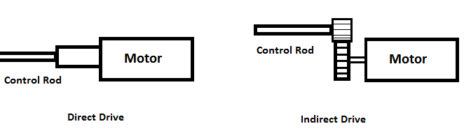
The direct drive could be simpler to construct. Any form of rigid connection could be used to graft the driveshaft of the motor to the control rod to kick. However, if there are any problems with alignment or with kicking a solid unrelenting object, this solid connection is more likely to pop off and need to be replaced. The direct drive also may not have enough torque for the specifications set out in Section 2.3.3. If there is a problem with the torque, then the motor would have to be replaced, as there is no way to increase that in a direct drive method.

Figure 3.2.3.2.1: Comparison of Direct Drive vs. Indirect Drive

The indirect drive would require a significant amount of hardware precision from the senior design group. If a gear were to be off by just a small degree, the entire setup would likely jam and fail. It would also require a large amount of physical space to set up the gears and the mechanical mounting for the gears. The benefit of the indirect drive, however, is that one can easily tune the torque and power tradeoffs of the motor without changing the physical properties of the motor. Gearing can increase speed for a tradeoff in torque and vice versa.

Tradeoff 2: Axial Subsystem Location
The entire axial subsystem consists of a single motor and, potentially, two limit switches. There is a choice to either mount the entire subsystem on the linear sliding actuator, or to instead mount the hardware off the actuator and translate the rotation to the control rod through a gearing or hex shaft system.
The tradeoff for this option is similar to the tradeoff between direct and indirect drive to the shaft. Inevitably, if an off-actuator rotational location is selected then an indirect drive shaft would be necessary for the other choice. The similarity in the tradeoff is also in that an off-actuator system would be preferable in a system where hardware assembly skill and cost were of no consequence.
Having the rotational subsystem off of the linear actuator would reduce the amount of weight required for the linear actuator to move which would assist in both the amount of power needed by the linear actuator and also in the control given by the linear control algorithms.
The drawback of the off-actuator system is that it would be much more complicated to construct. Very precise hardware fabrication methods must be used in order to accomplish the off-actuator task. In some designs that use this method, like the one by Hijkoop, [35] precision machining was employed to create the hex-shaft and linear slide that couple perfectly to accomplish this.

3.2.3.3 Comparison of General Motor Options
In many of the designs discussed in this section, there is a need for a general DC-style motor. In this section, a number of affordable options for general motors are considered. This information will be used to select motors in the design section. General DC Motors come in several varieties, which are identified primarily by their voltage requirements and the output given by that voltage. Another option to select between different DC motors is the option to get brushed or brushless motors. Brushed DC motors are more standard and, as a result, less expensive. The most inexpensive of options would be a low-quality brushed DC motor. Brushless motors, on the other hand, use slightly more complicated technology to remove a physical component in the motor’s engineering. This can create more precision control of the motor.
Depending on the application of the general motor in the architecture of the overall project, different features will be needed. For this section a number of general specifications and features are presented to assist with later decisions.
3-24VDC Motor- General Hobby Motor
In this category is the plainest of the plain. Simple 3-24V DC motors from surplus supply stories have no warranties or guarantees on the quality of the motor, but this is the least expensive and most common variety of motor to find sitting around. This is a very likely candidate for prototyping and testing.
Features and Specifications
- RPM
  - 6VDC- 2950 rpm
  - 12VDC- 3970 rpm
  - 24VDC- 8370 rpm
- Weight: 0.4lbs
- Torque: Unlisted
- Cost: $4.95
Sparkfun Servo- Large Full Rotation
Sparkfun remains a distributor to investigate, due to their worldwide distribution and very competitive prices. For the rotational general motors they have a few varieties of servos and motors that could have use for the foosball table automation. However, the motors from this website tend to be lower powered than the options from other sources. This could be a problem, depending on the exact application and the availability of gearing. A primary option from this supplier is a standard full-rotation servo. It is extremely standard with a 3 pin PWM input cable and a small drive shaft. More information on the ROB-09347 can be found on the distributor’s website.
Website: https://www.sparkfun.com/products/9347

Features and Specifications
- Operating Voltage: 4.8 – 6.0 VDC
- Top operating Speed: 60-70 rpm
- Torque: 4.8 kg-cm
- Dimensions: 42 x 39.5 x 22.5 mm
- Weight: 44 g
- Cost: $13.95

CIM Motor
CIM motors are a classic for hobbyists and roboticists. They have a somewhat awkward shape and are larger than other options for actuation; however, they make it up in their speed, power and reliability. A CIM motor can take in general DC voltage with no motor controller or regulator, making it very convenient for use. It is also very resistant to high amperage and burning out when in a stall state.
This option is a higher cost than some other generic motors; however, it is still well within the budget proposed for this project.
Website: http://www.andymark.com/CIM-motor-FIRST-p/am-0255.htm

Features and Specifications
- Operating Voltage: 12 VDC
- Top Operating Amps: 2.7 A
- Top operating Speed: 5,310 rpm
- Torque: 2.42 Nm
- Dimensions: 2.5 inch diameter, 4.34 inch long body
- Weight: 2.82 lbs
- Cost: $28.00

AndyMark 9015 Series
This is another option for a generic motor controller. AndyMark is a company that specializes in motors and controllers for competitive sport robotics. This motor quality is similar to the CIM motor discussed above; however, the difference is that this motor is slightly smaller and has lower power requirements.
A huge benefit of the AndyMark-series motors is that they tend to come with pre-attached and adjustable gearboxes on the shaft. This could help change the speed or torque of the motor to better fit the needs of the rotational or linear actuator system. However, getting the correct gearing ratio is something that must be fine-tuned and carefully designed. This would put pressure on the senior design team to select the correct ratio.
Website: http://www.andymark.com/Default.asp

Features and Specifications
- Operating Voltage: 12 VDC
- Top Operating Amps: 1.2 A
- Top operating Speed: 16,000 rpm
- Torque: 428 m-Nm
- Dimensions: 3.19 inches length
- Weight: 0.5 lbs
- Cost: $13.00

3.2.4 Software

3.2.4.1 Table Physics Model
Within the CPU/Software side of the project, there must be some concept of the table state. The table state can be defined as the minimum number of variables needed to fully define the physical state of the system being modeled. In this case the system is a game of foosball. So the state can be described in terms of a number of moving components. In foosball there are only two main moving objects, first is the foosball and second are the game poles that the puppets are mounted to. This means that the game state being tracked within the computer during gameplay will consist of 8 rod positions, 8 rod rotations and the x, y position of the ball. In order to be more accurate about the game state it may also be necessary to keep some running tracker of the ball velocity and acceleration.
The state of the table cannot be known immediately and consequently the system will require a number of sensors to determine the table state. Due to the controlled nature of the puppets and the rods they are connected to it is very easy to directly measure the rods’ states. Each rod will be directly connected to a sensor which can directly read the position and rotation of the rod. More information about the sensor subsystem which detects the rod state can be found in section 3.1.2.1. The ball on the other hand is a very different issue. The ball cannot be mechanically measured in the same way the rods can be. The ball is free to move around the table and can only be indirectly sensed. Indirect sensor input is more likely to have large amounts of noise which can disrupt the table state. As a result more research will be devoted to methods of creating a steady table state observer.
In a matrix form the ball state can be described as follows:
$$\left[\begin{aligned} x \\ u \\ y \\ v\end{aligned}\right]$$
In the state matrix x and y represent the real x & y coordinates of the ball on the field and u & v represent the x and y velocities of the ball. This matrix will be used in several of the models that follow.
In order to play a competitive game of foosball it may be necessary to do more than just keep a running track of the current game state. It would be necessary to be able to project into the future and tell where the ball is going to be when it has moved several seconds into the future. In order to predict in such a way there is a need for some understanding of the physics of the system. In this case there are many ways to create a physics model of the table state to help the AI in predicting the table state. A small amount of research and some derivations for the table states follow.
Constant Acceleration Dynamics Model
The first simple route of research is into the basic dynamics equations which are taught in school. In this method of state tracking the acceleration, velocity and instantaneous position are used to predict the next in discrete steps. The two main equations used in this method are simple linear relations of those three variables:
$$x=x_{0}+v_{x}*dt+\frac{1}{2}*a_{x}*dt^{2}$$
$$y=y_{0}+v_{y}*dt+\frac{1}{2}*a_{y}*dt^{2}$$
$$v_{x}=v_{x}+a_{x}*dt$$
$$v_{y}=v_{y}+a_{y}*dt$$
The velocity required for these equations can be estimated using several contiguous frames of motion. The position would be the previous position observed in the recent image captures. The acceleration of the ball is the extremely tricky part to discern in this particular setup. The ball will have some deceleration related to friction and air resistance when it moves in a straight line with no interruption. However the more important factor of acceleration is going to involve the extreme spikes in acceleration due to collision with the walls or the many puppet obstacles that litter its path through the table.
One way to handle this problem would be to write up a simple model that assumes no acceleration and quickly waits to update the velocity whenever a divergence from the expected velocity is measured. This would work in many situations however the problem occurs when the ball is bouncing around rapidly in a short period of time. The velocity calculations may not have enough time to stabilize and create an accurate estimation of the true velocity of the ball.
The positive points of this method include that it is extremely simple to implement and grounded in some very solid math. It is difficult to mess up an implementation of this style within the software subsystem, and would likely be completely written extremely quickly. This method would also give a noticeable improvement over the simple instantaneous readings of the ball. Even if it would be slightly inaccurate it would still give a small prediction into the future that the AI could use to line up a block before the ball is there. The primary draw-back, as mentioned already, is that it is probably too naïve of a solution to be really accurate. Highly maneuverable motions like bouncing off of walls and puppets and even the slight curvature of the table floor would throw this model off.
Kalman Filter Ball Observer
The Kalman Filter is a mathematically derived optimum filter for estimating the motion of linear random variables. What this all means is that the Kalman Observer works to take in a number of different sensors or even sensor reading from different points in time and it will create the best possible estimate of the true position given noise uncertainty. The Kalman Filter is derived from a linear stochastic model that predicts the motion of some observable stochastic variable. Part of the genius comes from using a model that understands some physical property of the system at hand that it can use to predict where the variables should be at in some point in the future. This model that lies at the heart of the Kalman Filter can be the exact same as the static dynamics model that we used before. However the difference now is that his model generates another estimation of the ball’s position that can be compared to the measured position of the ball from the sensors.
A short description of how the Kalman Filter would be used in our project follows. All sensor inputs will be represented as random variables in the normal form. As shown in Figure 3.2.4.1.1, this form will represent the variable as a mean and a variance which represent the predicted value and the confidence of that value respectively. In this figure it can be seen that the variable of the Kalman filter takes the shape of a bell curve.
The trick of the Kalman Filter comes from the fact that no matter how uncertain we are with our measurements, we can always increase the confidence with a combination of two different stochastic values. Figure 3.2.4.1.2 demonstrates the geometric interpretation of this fact. In this figure it can be seen that using the combination of different values allows for a new variable with significantly smaller standard deviation. This allows for a higher amount of certainty.

Pending Permission from Navtech Seminars & GPS Supply.
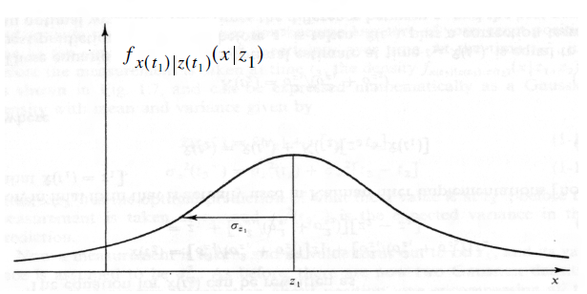
Figure 3.2.4.1.1: Form of the stochastic variable for the Kalman Filter.

Pending Permission from Navtech Seminars & GPS Supply.
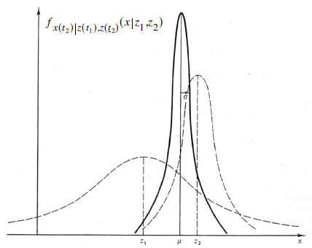
Figure 3.2.4.1.2- Illustration of Kalman Filter’s combination of stochastic variables.
Kalman’s optimizations can be described by the following set of equations where $x_{k}^{-}$ represents the state matrix described in the introduction and $z_{k}$ represents the sensor inputs. $A$ and $B$are transition matrices from one state to the next discrete state. $P_{k}$ is the model uncertainty. $Q$ is the model covariance and $R$ is the sensor covariance. $H$ is a matrix relating sensor input to actual physical position and is used in the calculation of an innovation factor.
Predictor Step (Before Measurement)
  - $x_{k}^{-}=A{\hat{x}}_{k-1}+Bu_{k-1}$
  - $P_{k}^{-}=AP_{k-1}A^{T}+Q$
Update Step (After Measurement)
  - $K_{k}=P_{k}^{-}H^{T}{\left(HP_{k}^{-}H^{T}+R\right)}^{-1}$
  - ${\hat{x}}_{k}={\hat{x}}_{k}^{-}+K_{k}(z_{k}-H{\hat{x}}_{k}^{-})$
  - $P_{k}=\left(I-K_{k}H\right)P_{k}^{-}$
These discrete update steps will estimate the position of the ball. The A and B matrices will be defined as follows:
$$A=\left[\begin{matrix}\begin{matrix}1 & dt \\ 0 & 1\end{matrix} & \begin{matrix}0 & 0 \\ 0 & 0\end{matrix} \\ \begin{matrix}0 & 0 \\ 0 & 0\end{matrix} & \begin{matrix}1 & dt \\ 0 & 1\end{matrix}\end{matrix}\right]$$
$$B=\left[\begin{matrix}\frac{∆t^{2}}{2} & 0 \\ \begin{matrix}∆t \\ \begin{matrix}0 \\ 0\end{matrix}\end{matrix} & \begin{matrix}0 \\ \begin{matrix}\frac{∆t^{2}}{2} \\ ∆t\end{matrix}\end{matrix}\end{matrix}\right]$$
Finally the covariance terms are defined as follows:
$$R=\left[\begin{matrix}r_{b}^{2} \\ r_{b}^{2}\end{matrix}\right]$$
$$Q=\left[\begin{matrix}\begin{matrix}\frac{1}{2}aδt^{2} & 0 \\ 0 & aδt\end{matrix} & \begin{matrix}0 & 0 \\ 0 & 0\end{matrix} \\ \begin{matrix}0 & 0 \\ 0 & 0\end{matrix} & \begin{matrix}\frac{1}{2}aδt^{2} & 0 \\ 0 & aδt\end{matrix}\end{matrix}\right]$$
With these equations, the design team could implement a very accurate Kalman Filter which would be able to predict and update the state matrix for the ball’s position with near optimal results.

3.2.4.2 AI Algorithms
While an integral subsystem without much room for error, the artificial intelligence (AI) subsystem is a highly variable part of the FOOSE project. In contrast to components such as the linear actuators, which must simply move one of the control rods along an axis, the AI subsystem has room for an extremely wide variety of styles and methods. At its simplest, the AI algorithm might simply kick the ball towards the opponent’s goal at every chance it gets. This is akin to the method used by amateur human foosball players, and its extreme simplicity is paired with a reasonable amount of efficacy. Less simple, but more effective (and impressive!) means of running an AI algorithm might involve taking into account the positions of the opponent’s puppets, or even taking steps to route around them. Such AI methods would be extremely interesting, but would probably exceed the abilities of the hardware in this project’s price range.
Information Taken Into Account
Apart from the AI algorithms themselves, it’s necessary to note that the algorithms could operate with different sets of information. While all of them examine the Table State and output a Move, the Table State could consist of a variable set of objects. Necessary pieces of information are the ball position and heading, and the positions of the robotic player’s puppets, but less certain to be included are the states of the opponent’s puppets. While some advanced algorithms require that information, many simple but successful ones do not. For instance, although the Star Kick board is commercially sold and has the hardware to examine the opponent’s puppets, its AI does not take this information into account when calculating a move [3]. Therefore, when an algorithm takes in the “table state”, it is important to remember that the “table state” could consist of different things.
Greedy AI
The greedy AI is the aforementioned extremely simple AI. The algorithm for it would read as follows:
- Acquire ball position and heading from Table State Interpretation
- Locate nearest controlled puppet to projected location
- Calculate the distance needed to move the puppet into the path of the ball, kicking if possible.
- Output calculated move to Rod Control Board of correct rod
- Repeat constantly based on updated table state
The greedy algorithm is represented below in Figure 3.2.4.2.1:
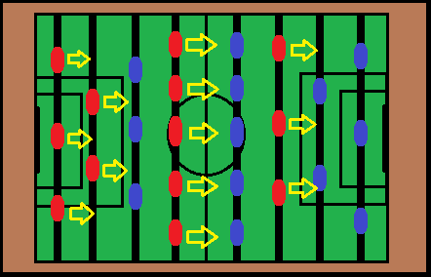
Figure 3.2.4.2.1: Greedy Algorithm Representation
This method has many advantages over some of the other potential methods. Primarily, it is easy to code. This presents a huge time benefit over other methods. Also, it is reasonably effective. Assuming responsive motors, it is not hard to imagine how dominating even this simple algorithm would be. In independent research among amateur and advanced human foosball players, it was found that most amateur foosball players used essentially this algorithm for deciding shots. However, with slow, human reaction times, this algorithm is easily beaten by advanced players. Since superhumanly fast motors cannot be counted upon as components of this project, it may be necessary to use a more advanced AI to compensate.
Pathfinding AI
This is the other major type of AI being considered. Unlike the greedy AI, which does not require the opponent’s puppets’ positions, this algorithm would require them. It would use a series of steps akin to the following:
- Acquire ball position, heading and opponent’s puppet positions from Table State Interpretation
- Examine the table and find a navigable path around the opponent’s puppets to the opponent’s goal
- Use the nearest puppets to execute the path, moving as needed (for instance, hitting the ball with the side of the puppet rather than simply kicking it)
- Output the calculated move(s) to the correct Rod Control Board(s)
- Repeat pathfinding constantly based on updated table state
The pathfinding algorithm is represented below in Figure 3.2.4.2.2:

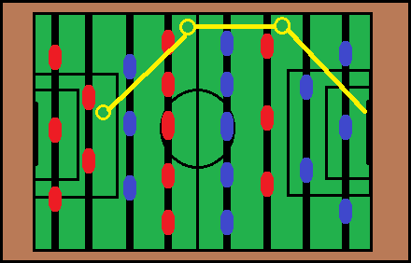
Figure 3.2.4.2.1: Pathfinding Algorithm Representation
This algorithm is obviously a good deal more complicated than the greedy one, since it is more involved than simply finding and kicking. This involves the more sophisticated method of looking for an open route to the goal, and using intermediate computer-controlled puppets to guide the behavior of the ball and avoid opponent’s puppets. Even within this algorithm, there is some variability in the information which can be considered. While it may be easier to simply model straight-line paths between computer-controlled puppets in the course of the pathfinding, it may be more useful to take into account bouncing off of the walls, for instance. If the pathfinder were able to use moves that involved bouncing, it would provide a more challenging user experience, which is one of the goals of the FOOSE project. On the other hand, at its most minimalistic, the pathfinding algorithm could denote something like the greedy algorithm, except with the ability to detect whether an opponent’s puppet will be in the way of a kick. Even this low-level pathfinding AI could be able to improve performance by not essentially handing the ball into the opponent’s control.
Generic Tactical Advantages
Despite the rather uninspiring title of this section, there are numerous ways in which the AI’s performance can be enhanced without directly changing the way it decides what to kick. One of the simplest effective means of performance enhancement is something many human players do, raising and lowering the puppets based on the current position of the ball. This allows the AI to get out of its own way when kicking, and also to prevent the ball from moving too far even if it is not detected in time. Such a system would need to be considered by the AI, although it should be easy enough to implement, since the ball’s position only needs to be considered in one dimension (raise puppets ahead of it, lower those behind it).
It may also help to move the lowered puppets behind the ball constantly. The motors may not enjoy constantly operating, but moving the goalie control rod back and forth is a time-honored human defense strategy, and it makes sense to have the AI do the same thing. Such a strategy would also be relatively easy to code, and should be quite effective for something so simple.
Another simple way that the performance can be improved is by moving the control rods together in order to block a larger area in a coordinated fashion. The computer will have a distinct advantage over even a four-armed player in this area, as the computer can consider the positions of all the rods more or less simultaneously. In this way, the computer can prevent easy scoring by the opponent.

3.2.4.3 Linear Control Algorithms

Introduction
Linear control algorithms are used as an intermediary between the central processor’s AI subsystem and the actuators’ movement. In the scope of this project, the purpose of these algorithms is to take the desired position, speed, etc. of the robotic player from the AI and translate that into physical movement of the actuators, which simply take in a voltage signal, usually in the form of pulse-width modulation (PWM) or CAN, or similar communication method. In short, most control algorithms involve moving the puppet in the desired direction, sampling its current position and/or speed, determining how far off the puppet is from the desired location, and then moving again to limit this difference (referred to as the error). Thus, the control algorithms are responsible for getting the puppets where they should be and minimizing the error at which this will occur.
Before further discussion, a concise definition list shall be given for the purposes of clarity:
- Controlled Variable: the controlled variable is the variable that is measured and controlled. It is typically the output of the system and is the variable that has a desired value.
- Control Signal or Manipulated Variable: the control signal or manipulated variable is the variable that is changed in order to affect the controlled variable and achieve the desired result.
- Plant: any piece of equipment that performs a function. This includes a heating furnace, chemical reactor, pneumatic pump, etc.
- System: a system is a combination of components acting together to perform a certain objective.
- Disturbances: any signal that adversely affects the output of the system. Can also be referred to as noise.
- Feedback control: feedback control is an operation that reduces the difference between the actual output of a system and the desired output, while in the presence of unpredictable disturbances.
- Closed-loop control system: a closed loop control system is one where feedback is present. This means that the output of the system has an effect on the control action.
- Open-loop control system: an open-loop control system is one where feedback is not present. This means that the output of the system is not measured and fed back into the system and thus has no effect on the control action.
[39]
Summary of Control Algorithm Design
The first step of designing a control system is to create a mathematical model of the system (assuming specifications have already been given). This model will relate the controlled variable to the manipulated variable. However, this model will often exclude many nontrivial factors such as loading effects, nonlinearities, noise, etc. Thus the actual performance of the control system will be worse than the predicted performance. However, a well-designed control system will handle these unaccounted variables and still meet the design specifications.
The second step of the design process is to analyze the mathematical system and, if necessary, design a proper compensator and adjust its parameters to gain the desired control response. The compensator is responsible for altering the overall behavior of the system to gain the desired result.
The final step is to implement the mathematical model in the real world, testing first the open-loop system and then the closed-loop system. In this final step adjustments will have to be made to make up for lost performance due to unaccounted variables.
The ultimate goal of designing the control system is to create a system that meets the performance specifications and at the same time works reliably and can be created within an acceptable budget.
Methods for Creating a Mathematical Model of the System
The most important step of analysis of the control system is creating a reasonable mathematical model. [39]. When creating a mathematical model, the laws of the corresponding field are used (i.e. Newton’s laws for mechanical systems, Kirchhoff’s law for electrical systems). The goal when designing a mathematical model is to create the simplest model that still meets the accuracy requirements of the project. This is important because there is an inherent tradeoff between complexity of the model and the accuracy it can obtain.
Mathematical modeling method 1: Transfer functions
Transfer functions are commonly used to model systems in terms of their outputs and inputs. A transfer function is defined as the Laplace transform of the output of the system divided by the Laplace transform of the input of the system. Or symbolically:
$$G\left(s\right)=\frac{L\left(output\right)}{L\left(input\right)}$$
$$G\left(s\right)=\frac{Y\left(s\right)}{X\left(s\right)}$$
The benefit of using the transfer function representation is that dynamic systems, which are usually represented as a series of differential equations, can be modeled in the Laplace domain as a polynomial in terms of the complex variable ‘s’. This makes analysis and manipulation much more convenient. The downside to the transfer function model is that they are limited to linear time-invariant differential equation systems, meaning they cannot be used to represent a system that is modeled by a differential equation with a coefficient that is a function of time or a system that has a nonlinear term. Furthermore, transfer function analysis is used for single-input, single-output systems. All of these limit the complexity of the model and thus the amount of accuracy of the control system, but lead to a simpler system that is more convenient to work with.

Mathematical modeling method 2: Modeling in State space
While the transfer function approach is considered convenient, often it is not possible to model desired systems using this approach. For example, many applications in the real world have multiple inputs and outputs with nonlinear components and time variant terms. Thus a more complex modeling method is required for these types of systems, specifically the state space method.
The state space method consists of a series of state-space equations that are made up of input variables, output variables, and state space variables. State space variables are the smallest set of variables that determine the behavior of the system for any given time. With these state-space equations, the state space method is able to model much more complex systems using matrix approaches for analysis and manipulation of the system.
For the scope of this project, a transfer function approach will be selected as a proper mathematical modeling technique. This will be done for simplicity purposes and because our system (foosball rod control) can be accurately modeled with linear time-invariant differential equations, with single inputs and single outputs. Thus the rest of the research explained will pertain specifically to transfer function methods and will omit methods of control system design using state space methods.
Step 2: Analysis of Mathematical models and design of compensators
Method 1: Root Locus
In control theory, the transient response of a closed-loop system is related to the location of its closed-loop poles (the zeros of the denominator of the transfer function of the system). Using the root locus method allows for a visual approach to plotting closed-loop poles and determining stability of a system and its response at different gain levels.
For example the root locus plot of the function:
$$G\left(s\right)=K(s+3)/(s^{4}+7s^{3}+22s^{2}+13s)$$
This plot is shown in Figure 3.2.4.3.1.
From this plot, seen in Figure 3.2.4.3.1, many observances can be made. It can be realized that at a certain level of gain (K) the poles of the plot cross the imaginary axis, which will cause the system to become unstable. Also, every point on the lines shown correspond to a transient response that can be achieved just by tuning the gain. However, there are many times when simply altering the gain will not achieve the desired response. For this situation a compensator must be designed, which adds open-loop holes and zeros to the system altering the root locus and forcing the system to obtain a specific desired response.
More specifically, adding poles to the open-loop transfer function lessens the stability of the system (pulling the root locus to the right) and slows down the settling of the response. Adding holes, on the other hand, will increase the stability of the system (pulling the root locus to the left) and speeds up the transient response. This is equivalent to adding a derivative control element that incorporates the speed and direction of response in the control (an anticipation aspect of control).

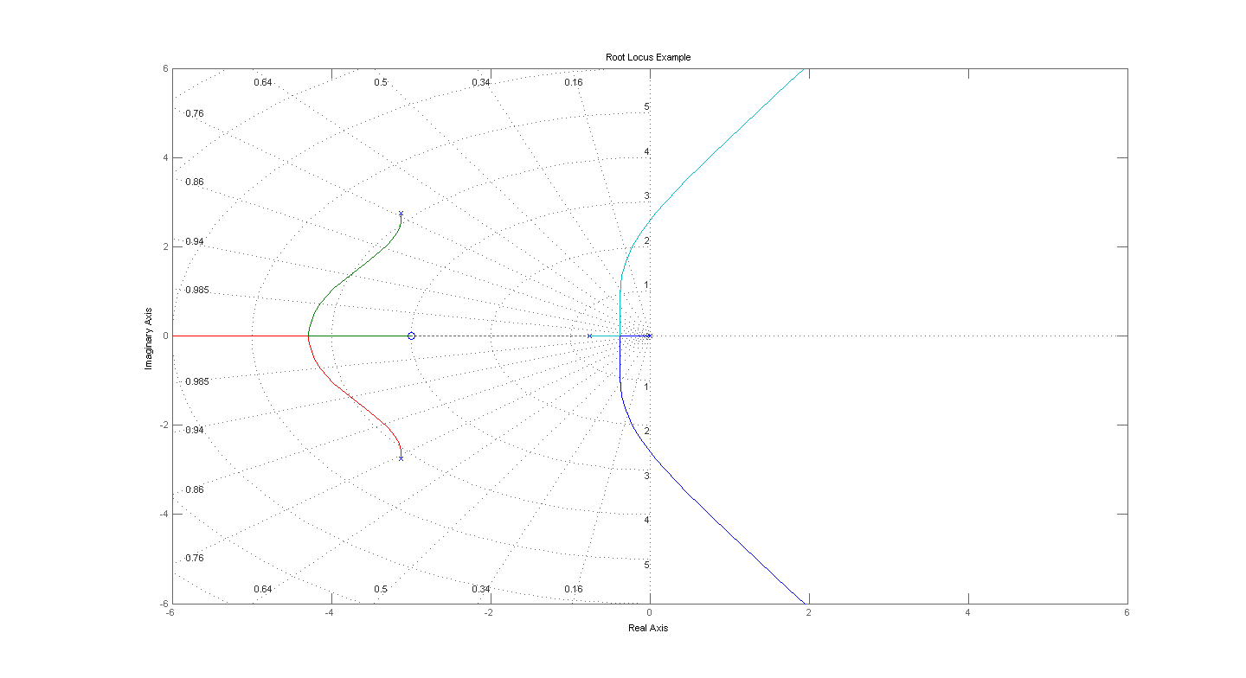
Figure 3.2.4.3.1: Root Locus Plot Example
The most common compensators, however, are typically lead, lag or lead-lag compensators, which are designed to obtain an exact desired location of dominant poles in the root locus plot.
In general, the root locus design approach is quite effective in situations where specifications are explicitly given in terms of time-domain quantities (i.e. damping ratio, maximum overshoot, rise time, etc.).
[39]
Method 2: Frequency-Response
Frequency response analysis and design refers to designing control system by looking at the steady-state response of a sinusoidal input to a system and adjusting the response as necessary. Frequency-response design is advantageous because results can be obtained without explicit mathematical models of a system. One can simply get results from a physical system by inputting a sine wave and observing the resulting output. This is a commonly used method for determining the transfer functions of complicated components experimentally.
Another advantage of frequency-response design is that by using Nyquist stability criterion it is possible to determine the stability of the system simply from the response characteristics – again, no mathematical modeling is necessary for this analysis. Furthermore, using frequency response methods allows for design around unwanted noise and many of its design approaches can be extended into some nonlinear control systems. Thus frequency response design becomes quite convenient for designing unknown systems. Furthermore, it is also quite useful when designing systems with high frequency noise. [39]
The disadvantage of frequency response design comes from its focus on the steady-state response of the system. This leaves the transient portion of response neglected in the design process; however, there still exist methods to obtain the desired transient response by altering the frequency-response characteristics.
An important note to mention is that the frequency response design method and the root-locus design method are not mutually exclusive. It is possible, and frequently done in the practical world, to use both methods while designing a system. The two methods of design complement each other. When using frequency response approach, the focus of design is on the steady-state requirements (steady-state accuracy, phase margin, gain margin, etc.) and the transient response is understood indirectly from the frequency response. After designing to meet the steady-state requirements, the transient requirements must be tested and, if they are not met, the compensator must be redesigned until these requirements are met (or until they are found to be mutually contradictory).
When conducting frequency response design there are two possible approaches: one using polar plots and the other using Bode diagrams (gain vs. frequency diagrams). Bode is typically the preferred method because when the compensator is added a whole new diagram must be plotted for polar plots, but with Bode diagrams the new plot can be added to the original.
The common approach to the design on the Bode diagram is the following:
- Adjust the open-loop gain until the steady-state accuracy requirement is met
- Plot the magnitude and phase curves of the uncompensated open loop (after open-loop gain is adjusted)
- If the specifications of the phase and gain margins are not met, then a compensator must be added to reshape the curves
- After the compensator is added, other requirements are tested and are attempted to be met (unless found mutually contradictory)
[39]
When designing compensators, the most common types include:
- Lead compensators:
  - lead compensators focus on improving stability margins by offsetting the phase lag of a system.
- Lag compensators:
  - lag compensators focus on improving steady-state performance by offsetting the phase lead of a system.
- Lead-lag compensators:
  - for improving both stability and stead-state response, a lead-lag compensator can be added
- Complex pole compensators:
  - for complex systems where lead and lag compensators don’t yield satisfactory results, complex poles can be added as a compensator.
Overall, the frequency-response method of control system design can be quite convenient and effective when used to design systems with specific steady-state requirements or in environments with high frequency noise.
[39]
Method 3: PID Controllers
PID controllers are by far the most popular method of control for industrial controllers today. More than 50% of industrial controllers use PID or modified PID methods of control [39]. The reason for this is that PIDs are quite general and can be applied to most control systems. In addition, PID controllers are often the easiest way to handling controlling a plant when a mathematical model is not known or cannot be readily obtained. They work solely through adapting to feedback and can be tuned on-site. Many firms have developed their own methods for tuning PIDs; a few of the more common methods will be discussed in this project.
PID controllers consist of three main components: A proportional component (P), an integral component (I) and a derivative component (D). These components are altered through their corresponding weight controlled by variables Kp for proportional control, Ti for integral control, and Td for derivative control. A block diagram of a PID Loop is given for further elaboration, labeled Figure 3.2.4.3.2.
This block diagram shown in Figure 3.2.4.3.2 shows the PID controller. The challenge in getting the appropriate response is selecting the correct values of Kp, Ti, and Td, known as PID tuning. Methods of tuning include the Ziegler-Nichols Rules for tuning and the computational optimization approach for tuning and, as stated previously, many more. These two mentioned methods will be the ones discussed in this project.

$$K_{p}(1+\frac{1}{T_{i}s}+T_{d}s)$$
Plant

Figure 3.2.4.3.2: Block Diagram of PID Controller
[39]
Ziegler-Nichols Rules for Tuning
The Ziegler-Nichols method for tuning can be applied for both known and unknown systems by looking at the step response of the system, but are most commonly applied for systems with plants with unknown mathematical models. Thus the Ziegler-Nichols method can be applied experimentally by putting a step response into a system and measuring its response on an oscilloscope.
The downside to the Ziegler-Nichols method is that it often creates a system with an inflated maximum overshoot. So after the tuning method is complete, fine tuning must be done to minimize this overshoot. In general, the Ziegler-Nichols method can be used for a quick and readily available method to find educated guesses for parameters. Then fine tuning methods can be applied to complete the tuning process.
Taking a look at this tuning process, first one must experimentally determine the step response of the plant. If the plant does not contain integrators nor does it contain complex-conjugate poles, the step response will appear as follows, shown in Figure 3.2.4.3.3.
The factors that determine the tuning parameters for the PID loop come from the terms delay time L and time constant T, labeled in the graph. These values are found by drawing a line tangent at the inflection point of the S-shaped curve and tracing it down to where it intersects with the time axis. L is the value between the point time = 0 and the x-value of the intersection point of the tangent line with the time axis. T is the value between the x-value of the intersection point of the tangent line with the time axis and the x-value of the intersection point with the line c(t) = K. K is the high value of the step function. From the values T and L the tuning parameters Kp, Ti, and Td are found using the following table, Table 3.2.4.3.1.

Pending approval from Pearson Education, Inc.
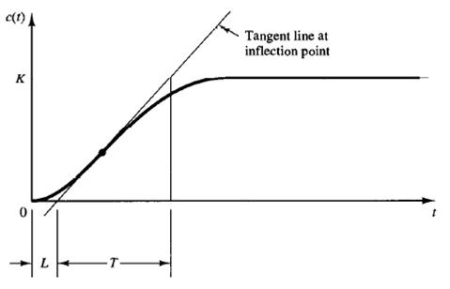
Figure 3.2.4.3.3: S-shaped Response Curve

Type of Controller | Kp | Ti | Td
P | $$\frac{T}{L}$$ | $$∞$$ | 0
PI | $$0.9\frac{T}{L}$$ | $$\frac{L}{0.3}$$ | 0
PID | $$1.2\frac{T}{L}$$ | $$2L$$ | $$0.5L$$

Table 3.2.4.3.1: Tuning Parameter Values
From this table, the values of the PID parameters are selected given a reasonable beginning point in the tuning process. However, in many cases, a system will contain complex poles and integrators which will create oscillations in the response. Thus this first method cannot be used for tuning. In this case a second method must be used.
The second method consists of setting Ti = ∞ and Td = 0 (proportional control). Then Kp is increased from 0 to a critical value Kcr at which the output begins to show sustained oscillations. The period at this point is also measured and is labeled Pcr. For example, in an electrical system the following graph (Figure 3.2.4.3.4) could occur:
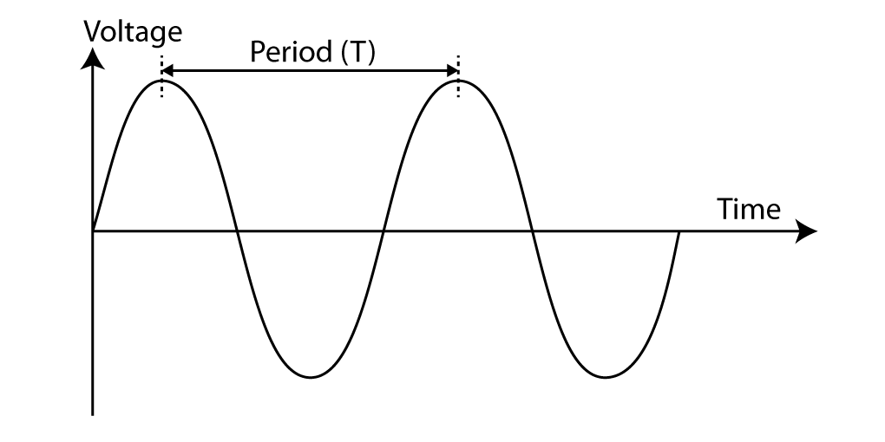
Figure 3.2.4.3.4: Sustained oscillation with period T = Pcr

This graph shows a system at critical gain Kcr. From this graph we can obtain the period (T). This is the value of Pcr. Using Kcr and Pcr, the following table is used to determine the values of the PID parameters:
Type of Controller | Kp | Ti | Td
P | $$0.5K_{cr}$$ | $$∞$$ | 0
PI | $$0.45K_{cr}$$ | $$\frac{1}{1.2}P_{cr}$$ | 0
PID | $$0.6K_{cr}$$ | $$0.5P_{cr}$$ | $$0.125P_{cr}$$

Table 3.2.4.3.2: Further Tuning Parameter Values
In more complex systems this table is used to determine the starting points for the tuning method.
One important reminder is that the Ziegler-Nichols tuning rule is used as a starting point for determining PID parameters. Rarely do these values give the optimal values of the PID compensator. Thus another method must be applied for fine tuning of the PID. For this we look at the computational optimization approach.

Computational Optimization Tuning Method
This approach uses a computational tool, such as MATLAB to explore within a search space of the PID parameters to find all of the values of the parameters that meet the specifications (e.g. max overshoot less than 10%, settling time lass than x, etc.). Reasonable ranges must be given so unreasonable gains are not found as solutions. Also, this limits the number of possible computations that must be computed. This is why it is valuable to use a coarse tuning method such as the Ziegler-Nichols method to gain an estimation as a starting point and then searching a range around estimated parameter value; if a solution is not found, the range can then be extended. It is important to note that, depending on the specifications, some systems may never give a specific desired response with a standard PID compensator, in this case this approach will yield no solution. Another important decision that must be made when using a computational approach is the step size. As the algorithm tests each value of the parameter, it does so with a finite granularity. The smaller the step size, the finer the granularity and the more computations the algorithm must make. Therefore, the length of acceptable computation time determines the granularity the search algorithm will have when looking for the optimal set of parameters within the given search space.
The basic structure of a standard computational optimization tuning algorithm is as follows:
- Evaluate the closed-loop transfer function at the given parameter value (the value of the parameter is a variable that increments through the function)
- Determine the step response of the closed-loop transfer function
- Calculate the values defined in the specifications
- If the values meet the specifications save the values of the parameters and the values of the specifications
- Increment the inner most parameter (assuming a nested loop structure) and continue
- After all possible parameters are found within search space, sort saved parameters by value
This algorithm will return a list of possible parameter values that satisfy the specifications. It is then up to the user to determine which trade off must be made to select the optimal values. Another approach is to apply a specific weighted score to each specification based on its importance and aggregate the results into single score for each set of parameters. Then the algorithm will return the highest scoring set, which will be the optimal solution at the given granularity.
One downside to this algorithm is if it is searching through a three dimensional search space (one dimension for each parameter value), using a 3rd order nested loop makes searching at any granularity and range very limited because the computation size will increase very rapidly as range and granularity increase. Therefore, if a greater range and granularity is desired, a more intelligent search method must be used, such as a genetic algorithm for exploring the search space. In a genetic algorithm, possible parameters are randomly generated and ranked (similarly to the method used at the end of the aforementioned standard computational approach). The top ranking parameters are saved, the others abandoned, and new parameters are generated from the best using a “copy with error” method. This process is continued until an optimal solution is found. Genetic algorithms have been found to be extremely effective in efficiently exploring large search spaces to obtain optimal parameter values.
Another downside of this method is that a mathematical model of this system should be known. Without a model the computer program cannot obtain a closed loop transfer function and step response. So unless these can be found efficiently using automated testing and measuring equipment, a mathematical model is required.
Overall, however, the computational optimization approach can be quite useful for fine tuning of PID parameters when the system can be expressed accurately with a mathematical model.
[39]
Manual Tuning Method
The manual tuning method consists of using heuristics to obtain a desired response from a system. This is the most simple and straightforward method for tuning PID loops. Advantages include its simplicity and the fact that a mathematical model is not necessary for this process; one can just simply try a set of parameters, measure the response, and then adjust until the desired response is reached. However, mathematical models can be useful (if they are accurate) to give good starting points. This method works well when systems are relatively simple, or for systems that cannot be tuned using the Ziegler-Nichols tuning method. In this case, it acts as a good replacement for coarse tuning.
The downsides of the manual tuning method is that it can become quite time-consuming if not done correctly. One could spend an eternity testing every possible combination of parameters trying to find the right set. This is work best kept for a computational approach. While manually tuning, only coarse tuning should be done. Additionally, manual tuning is far from optimal even when done very well. Without running through an unreasonable number of parameter combinations, finding an optimal response is not likely.
Although this method can be classified as a brute force, or trial and error method, it does not consist of blindly guessing parameters. Many heuristics exist to achieve decent results very quickly and easily. The heuristics are described relative to the parameter of the PID loop.
Assuming the PID controller has the following transfer function:
$$\frac{K_{d}s^{2}+K_{p}s+K_{i}}{s}$$
A proportional controller (Kp) will reduce the rise time and will improve the steady-state error (though it will never eliminate it). An integral control (Ki) will eliminate the steady state error but will make the transient response worse. And finally, a derivative control (Kd) will increase the stability of a system by reducing the overshoot and improving the transient response. A summary of the effects are in the following table, 3.2.4.3.3:
Control Variable (value Increased) | Effect on Rise Time | Effect on Overshoot | Effect on Settling Time | Effect on Steady State Error
Kp | Decrease | Increase | Small Change | Decrease
Ki | Decrease | Increase | Increase | Eliminate
Kd | Small Change | Decrease | Decreases | Small Change
Table 3.2.4.3.3: Control Variables and Effects
[40]
From this table, it is possible to quickly and manually tune a PID loop through an iterative process of testing and improving. If the initial test has too much overshoot, then the derivative control can be increased (increase Kd) to reduce the overshoot. This process can be continued until a reasonable response is found.
After using a manual tuning method, it is often useful to use a fine tuning method to optimize the response more efficiently. A computational optimizing approach is definitely possible if an accurate mathematical model of the system can be found.
Summary of control system design methods
Below, Table 3.2.4.3.3, contains a summary of the control system design methods discussed in this section. It includes all of the discussed methods for controlling systems: the root locus method, the frequency response method, and the PID control method. It includes both the advantages and disadvantages of each method to aid in making a decision that best meets this project’s needs.

Control Design Method | Advantages | Disadvantages
Root Locus | Good for when explicit specifications are given in terms of time domain analysis. Uses a graphical approach to visualize the response. Good for designing transient responses. | Accurate Mathematical Model required.
Frequency Response | Good for design with specific steady-state response requirements. Does not need mathematical models. Good for unknown systems. Good for environments with high frequency noise. | Only directly focuses on transient response.
PID | Most commonly used in industrial settings. Extremely general, can be applied to almost any control environment. Straightforward design. No mathematical models necessary, but having one is useful for tuning. | Having an accurate mathematical model is useful for tuning. Tuning of PID loops takes a lot of time and effort.

Table 3.2.4.3.4: Summary of control system design methods

3.2.5 Other Hardware

3.2.5.1 Foosball Table
When selecting a proper foosball table for this project, several factors were considered, including price, sturdiness, quality of rods and bearings, table weight, modularity, quality of the playing field, type of the playing field, and suitability for modification.
Price
Price was a decisive factor in selecting a foosball table. Given the project’s tight budget and quality-focused objectives, most of the money would need to be spent on high-quality sensors and responsive, accurate motors. The foosball table is a cost that should be minimized while still meeting all of the aforementioned objectives. In the beginning, it was thought that purchasing a new foosball table would be in the project’s best interest, because it would be the highest quality, require little work to prepare it for modification, and be easy to find and purchase. This, however, quickly revealed itself to be a poor course of action. This was because new foosball tables, at the quality required, can cost anywhere from $500 to $2000 [41]. Given the project’s budget, this price was prohibitive. So, the only other option was to look for a high-quality used foosball table.
Sturdiness
Sturdiness was also a crucial factor in selecting a proper foosball table. The table had to be robust enough to be modified, perhaps heavily, without concern for the integrity of the table. It is possible that the design would require drilling into the field to add sensors, so the surface had to be strong. The arms will be computer-controlled, which need to be able to malfunction without causing damage to the table. A strong frame would make this damage less likely. Finally, thick side walls result in a better angle of deflection which is crucial for accurate passing [42]. Accurate, predictable deflection will be important to the performance of the autonomous player.
The quality of build materials was also a concern when choosing the foosball table. A table made from cheap plywood would not be able to stand up to energized games in any case. Given all of the transportation and modifications required for the project, high quality materials were going to be a necessity. Research showed that respected brand names of Foosball tables are Tornado, Dynamo, and Tournament Soccer.
Quality of Rods and Bearings
The table’s rods are the project’s interface with the game, so they are clearly a vital factor in the project’s success. The most important aspects of the rods are their weight and resistance to rotational and longitudinal movement.
It is important for the rods to be light enough for the motors to accelerate and decelerate rapidly, but heavy enough to allow for good control. The selected table had a (subjective) comfortable balance between control and ease of acceleration.
Resistance is another important aspect of the table that had to be considered. Too much resistance would make mechanically rotating and moving the rods difficult without expensive motors. Furthermore, rusted rods would potentially cause inconsistent resistance and slipping, leading to inaccurate movements disrupting the performance of the autonomous player.
Table Weight and Modularity
The physical weight and modularity of the table were other concerns during table selection.
Weight is important because the table has to be easily transported up and down stairs, fit into the apartment where construction takes place. As nicer tables tend to be heavier, usually around two hundred pounds, [43] it was necessary to strike a balance between sturdiness and transportability.
Modularity was also important to consider. Being able to disassemble the table into pieces was essential for portability. The table must be able to be transported by a normal vehicle and fit through regular doors and stairwells.
Quality of Playing Field
The quality of the playing field is another important factor to consider. A low quality foosball table will have inconsistencies in the field, potentially leading to erratic movement and dead spots, [42] both of which inhibit normal play and disrupt the gaming AI.
Type of Playing Field
The type of playing field is as important as its quality, given the nature of the project. Generally, there is not much variation in playing fields, with the exception of the two major design types: those with elevated corners and a single goalie, and those with flat corners and three goalies.
It was determined that the project required flat corners, so that the entire field is flat. This makes sensing and tracking the ball much simpler, because it is not necessary to work around the curved corners, and the ball stays in a constant plane. This type of playing surface also allows the project to potentially employ means of tracking that would have been impossible with curved corners, such as laser tracking grids.
Accessibility for Modification
For this project, a table that can be easily modified is crucial. Specifically, the project requires access to the underside of the playing field. Some tables have supports and other materials blocking access to the playing field from underneath. This would cause problems because a potential plan for sensing the ball position uses an array of magnetic sensors drilled into the playing field from underneath.

3.3 Research Summary
In conclusion, the research conducted by the FOOSE project team members was all-encompassing, and impacted every aspect of the design to follow. To briefly recap each section:
- Several other teams have created similar automated foosball tables, and this project is informed by their successes, failures and major design decisions
- While a number of sensor technologies were evaluated for use in this project, the optical camera came out on top as the most feasible all-around
- Some type of quadrature encoder is likely the most suitable puppet position sensor
- A full x86 computer will be the best central processing solution
- While several motor controllers have been evaluated, each has advantages and disadvantages
- Data links will need to be of various kinds, suitable for each application
- The actuators, one of the most important components of this project, also have too many options to have an obvious choice, but at least the tactile rotational sensors have more or less been settled upon
- Some mathematical models have been considered for the table state interpreter, but it remains to be seen which one will work best
- The greedy AI will at least be the first AI in production on the table, and can be enhanced in several ways
- The PID loop can be tuned using a variety of techniques
- The foosball table itself has a lot of ideal qualities to look for
All in all, the research summarized here will be integral while moving forward in the design phase.

4.0 Project Hardware and Software Design Details

4.1 Project Overview and Block Diagrams
This section is intended to convey, at a high level, the overall structure of the hardware and software subsystems, their interconnections, and their functions. Each of these subsystems will be covered in more detail in the sections to follow.
Hardware
As seen below in Figure 4.1.1, Hardware Block Diagram, the hardware system of the FOOSE project comprises a number of subsystems.

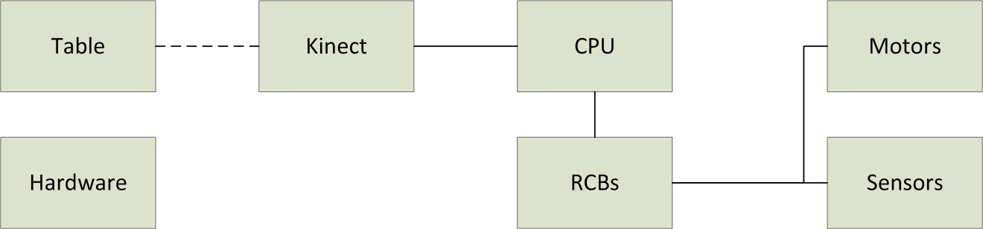
Figure 4.1.1: Hardware Block Diagram

In general, the discussion of these systems will follow the logical progression from input to output, which is to say from current table state to executed move. This progression can be easily traced on the block diagram itself.
First, somewhat trivially, is the foosball table itself. Nearly all of the hardware components are physically connected to the table, and the current state of the table is needed as an input to the FOOSE system.
Second is the camera, the physical manifestation of the optical tracking subsystem. This will be a Microsoft Kinect, chosen for reasons discussed in other sections. This is mounted above the table and observes it, taking a color picture and depth map and outputting them to the computer.
The computer, an off-the-shelf x86 desktop, then processes the sensor input, locating the position and heading of the ball. It then calculates the next move and outputs this to the Rod Control Boards.
The Rod Control Boards (there is one RCB for each rod, for a total of four) take in the next move from the computer and current position information from the quadrature encoders. They act as an interface between the central processor and the motors, outputting the correct PWM commands to the motor controllers.
The actuators themselves take in input from the motor controllers and, indirectly, the RCBs, and are set up so as to physically move the table’s control rods, thereby outputting the desired move. Attached to the linear actuators are quad encoders, which the RCB uses to calculate the current linear position of the control rod.
The outputted move, of course, changes the table state, and the process begins again.
Software
Focusing on software, the block diagram is a little bit simpler. This can be seen in Figure 4.1.2, Software Block Diagram.
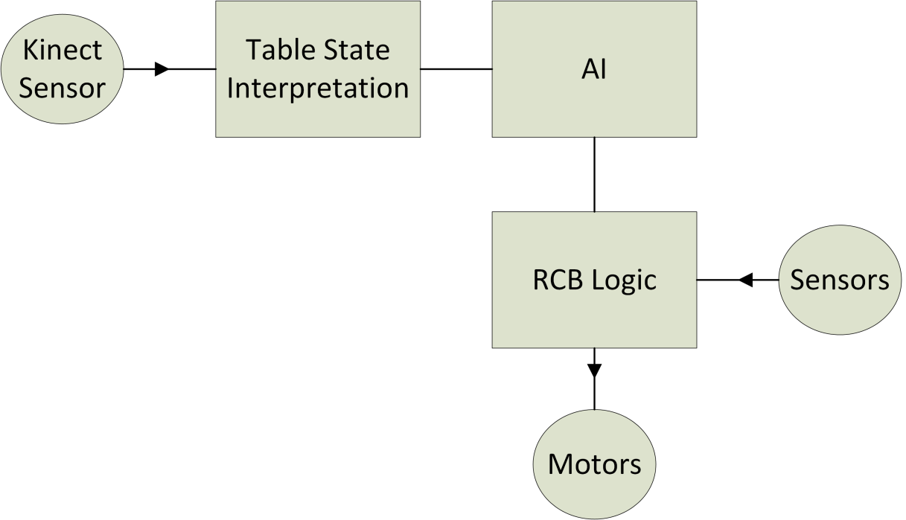Figure 4.1.2: Software Block Diagram

The first input to the software system is the visual and/or depth field data from the optical sensor subsystem, which is the Microsoft Kinect. On the hardware level, this information is fed into the computer. From the perspective of software, it is fed to the table state interpretation algorithm.
The table state interpretation algorithm will use edge detection and some other means to determine the location of the ball within the sensed table. It will also employ a Kalman filter, which can be used to provide location prediction and velocity information. This information will be fed to the artificial intelligence (AI) subsystem.
The AI subsystem (still physically located on the central processing unit) is responsible for generating an appropriate response to the current table state, which, for it, includes both the output of the previous subsystem and feedback on the current puppet positions from the RCBs. It will do this, at least initially, by using a simple greedy algorithm for determining the move (i.e., whenever possible, kick the ball towards the opponent’s goal). This move will be in the form of a quad encoder position that a certain rod needs to be at. This move gets output to the RCB of the correct rod.
Once the RCB receives the move command, it determines which direction the rod needs to move in, and commands the motor to move in that direction until the correct quad encoder value is reached. It may also order a kick or a certain rotational position, according to what commands it has received from the computer. Additionally, it must periodically feed the current position of the rod it controls back to the AI subsystem, so that that system has the most accurate information in order to compute the best move. The software system ends with the embedded programs on the RCBs, from which is outputted direct commands to the motor controllers.

4.2 Sensor Design

4.2.1 Overview
The primary sensor chosen for this project is a Kinect, used to sense the table state, including ball position. Secondary sensors include (per control rod) a radial quad encoder and 2 tactile sensors.
Kinect
The Kinect was chosen because of its cheap depth sensor that could be used to identify the ball based on height level and shape as discussed in Section 3.2.1.1.
The Kinect has a viewing angle of 30°, which is within the requirement for camera base sensors as stated in Section 2.3.1. With a viewing angle of 30°, the Kinect must be mounted centered over the table at a height of between 104 and 115 cm, as shown below in figure 4.2.1.1.
The Kinect cable is 10 ft. long, just long enough to reach around a mounting structure and attach to a computer mounted under the table. The Kinect requires an AC power supply which is attached to the Kinect at the end of its cable. Because of the requirement for power for the RCBs, motors and computer; an AC power source should be available under the table.
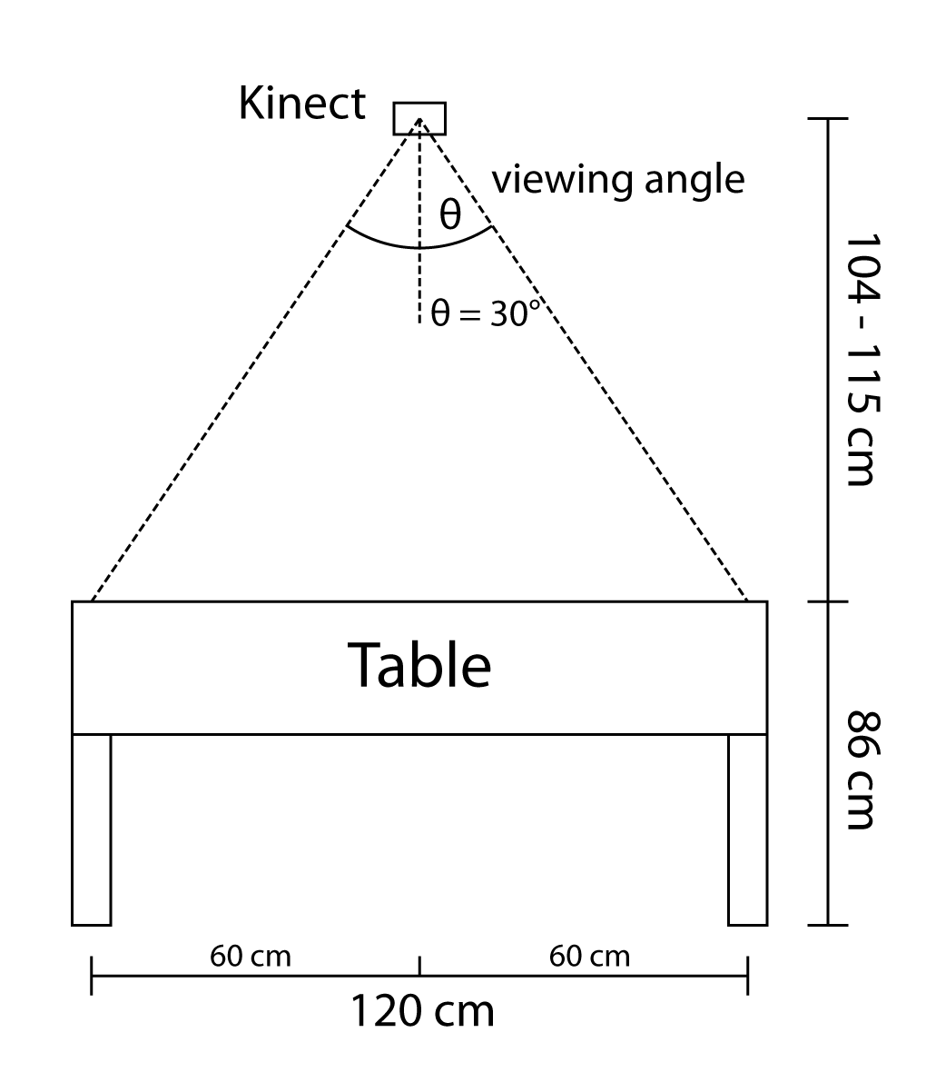
Figure 4.2.1.1: Kinect mounting position with minimum and maximum height
Rod Position Sensors
The position of the computer’s control rods must be sensed to within a high enough degree of accuracy to control the motors. The design rationale for the accuracy of sensors is discussed in section 4.6.1. The decision is to be able to have fine control and thus sensor readings over the linear motion of the rod. For rotational motion, 2 position sensors will be used because an “up” state and “blocking” state, with the ability to transition between them, is sufficient to kick and block a foosball.
It is important to note that each of these sensors, discussed in this section, will occur 4 times in the final product, one set for each of the computer’s rods.
The rotational sensors for each rod will be comprised of 2 momentary push button sensors. One button will be depressed when the rod is in the “blocking” position (or when puppets are down) and the other button will be depressed when the rod is in the “up” position (or when puppets are 90° behind), and shown in figure 4.2.1.2 below. The “up” state will be used when a friendly kick is happening behind the rod and when it’s preparing to kick the ball, more spin up time on the rod will increase kick speed. These sensors will be “dumb” buttons and have 2 leads, with no pull up or pull down circuitry. To compensate for the lack of pull up and pull down resistors, circuitry must be added at the end point of theses buttons, which is the rod control boards, the electrical design decisions for these tactile sensors are discussed in section 4.6.2.
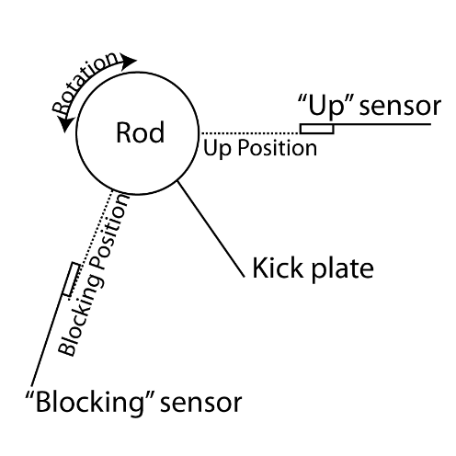
Figure 4.2.1.2: Rotational tactile sensor positioning
The linear motion of each rod will be sensed by a rotary encoder attached to the motor responsible for moving the rod. This will provide a convenient attach point for the encoder as well as a high revolution per linear movement ratio, allowing cheaper encoders to be purchased. The target revolutions per second is 83 revolutions per second, as discussed in section 4.6.1. The encoder must also be able to sense direction, not just movement speed, with this number in mind a rotary encoder that fit the need was selected. A rotary quad encoder from SparkFun®, COM-10932; this encoder has 200 pulses per revolution and is able to handle the required speed of 83 revolutions per second or 5000 revolutions per minute. This radial quad encoder has 3 channels with internal pull up and pull down resistors, making circuit design easier. The choices made for electrical integration of this encoder are discussed in section 4.6.2.

4.2.2 Block Diagrams
The following figure, 4.2.2.1, shows the overall connection scheme for the sensors to be used in this project. Note the bottom diagram shown will be replicated 4 times, once for each rod.
This diagram includes two components, the optical sensing for the ball tracking and the encoder/tactical sensors for determining the location and angle of the rod/puppets.
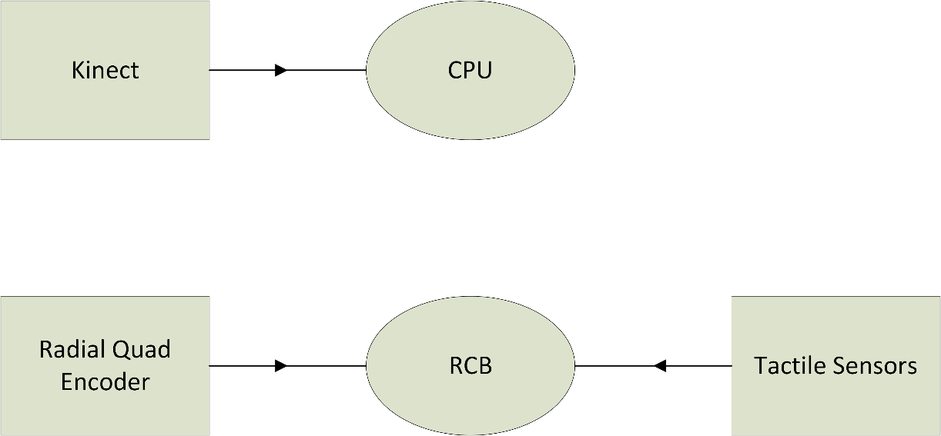

Figure 4.2.2.1: Diagram of sensors involved in this project

4.3 System Architecture

4.3.1 Overview
Main Processor
After finishing the research for the central processing unit, it was decided, at least provisionally, to use a full x86 computer, namely the small-form-factor IBM Thinkcentre. The reasons for this were several, and are discussed in more detail in the relevant research section, 3.2.2.1, Main Processor. First, the thread performance of the Thinkcentre is better than that of the other options. This is critical for a time-sensitive, necessarily low-latency device such as this. Second, it is a readily available computer that the members of this group already have access to, so it does not need to be purchased or waited for, and configuration can begin immediately. Third, the members of this group have three of these computers, so in the event of a hardware failure or malfunction, replacement parts will be available instantly without budget impact. This is a major advantage for an experimental project like this one. Last, this computer meets all of the necessary requirements for connectivity; it has the necessary USB ports and serial ports which may need to be used in the completion of this project.
Motor Controller
After all of the research was conducted, it was decided to select the Talon speed controller. The reason this motor controller was selected was because of its significantly lower price which was compounded by the fact that four of them had to be purchased. Also, this controller is able to handle a wide range of voltage and current loads. It meets all of our electrical and mechanical specifications while costing the lowest amount, making it the best choice for this project.
Block Diagram of Motor Controller:
High Power PWM to Motor
Low Power PWM from RCB

Motor Controller

Power from Power Supply

Figure 4.3.1: Motor Controller block diagram
In this diagram we see the basic block box view of the motor controller. It will take in a lower power PWM from the rod control board which will contain the proper signal to actuate the motors to the correct location. This PWM from the board however, is not high power enough to actually move the motors, thus the motor controller will take the PWM and step it up to the proper voltage and power required to gain the necessary torque and speeds out of the motors. Because stepping up the voltage and power will require additional power the motor controller will require its own supply of power. After the PWM is stepped up the motor controller will connect to the actuators which will make the rod move linearly.
This project will require four motor controllers in total. One motor controller for each automated rod. The control for each rod will work independently and will be synchronized by the CPU.
Data Transportation Methods
Several data transportation methods were available to communicate between all of the different components of the project. All of the unique connections include:
- Optical Sensor to CPU
- CPU to Rod Control Board
- Rod Control Board to Motor Controller
- Motor Controllers to Linear Motors
- Rod Control Board to Relay
- Relay to Rotational Motor
- Encoders to Rod Control Board
- Tactile Sensors to Rod Control Board
Each connection had its own communication method decided. All of the connections are labeled in the System Architecture block diagram at the end of this section (4.3.1 System Architecture Block Diagrams).
Optical Sensor to CPU
The optical sensor to CPU will be communicated by universal serial bus (USB). This is the standard connector for the Microsoft Kinect and allows for easy integration and communication between the camera and the CPU. No additional converters are required to use this camera for the purpose of this project.
CPU to Rod Control Board
The CPU will communicate to the Rod Control Board (RCB) via USB. This serial communication method will allow multiple communication features required between the CPU and RCB including:
- Power from the CPU to the RCB to run the board
- Desired location of the rod from the CPU to the RCB
- Current location of the rod from the RCB to the CPU
- Desired kick state from the CPU to the RCB
- Current kick state from the RCB to the CPU
It is important to mention that there will be four rod control boards, one for each rod. Thus, the CPU will communication with each one via USB separately, providing power and information while receiving feedback of current status at the same time.
Rod Control Board to Motor Controller
The rod control board (RCB) will communicate with the motor controller through a low-powered pulse width modulation signal (LPPWM). This signal will come from the control algorithm which runs on the RCB. This pulse width modulation will contain the desired information of which direction the motor should spin and at what percentage of the max speed, however this PWM will not contain the necessary power to actually power the motor.
Additionally, there are four rod control boards and four motor controllers (one for each rod) so this communication method will be duplicated and each RCB will communicate independently with its corresponding motor controller, in parallel.
Motor Controllers to Linear Motors
The motor controller will communicate with the linear motors through a high powered pulse width modulation (HPPWM). The signal coming from the RCB does not contain the necessary voltage (12 V) to power the motor, so the motor controller must step this signal up to the proper voltage and power to obtain the desired torque and speed for the motor.
Because there are four motor controllers and four linear motors (one for each rod), this communication method will be duplicated and each motor controller will communicate with its corresponding linear motor independently and in parallel.
Rod Control Board to Relay
The RCB will communicate with the relay through in the simplest manner, a single bit lower power DC signal line (LPDC). The RCB will just communicate a 1 or 0 (the desired kick state, 1 = kick state (puppet held back) and 0 = hold state (puppet held down)). This signal is responsible for controlling the relay which will power the rotational motors for the kicking action.
Because there are four RCBs and four relays (one for each rod) this communication method will be duplicated so each RCB will communicate independently with its corresponding relay.
Relay to Rotational Motor
The Relay will connect to the rotational motors through a simple high power DC line (HPDC). Because the rotational motors do not require speed and position monitoring/control algorithms, they can be operated through a simple wire connection which allows for the motors to spin full speed in one direction or the other.
Because there are four relays and four rotational motors (one for each rod), this communication method will be duplicated so each relay will communicate independently with its corresponding rotational motor.
Encoders to Rod Control Board
The encoders will communicate with the RCB through the quadrature encoder interface (ECI). Through ECI, the encoder can communication its current location and the direction it has moved in either direction to the RCB. This allows the RCB to count the rotations of the encoder and determine the location of the rod.
Because there are four encoders and four RCBs (one for each rod), this communication method will be duplicated so each encoder will communicate independently with its corresponding RCB.
Tactile Sensor to Rod Control Board
The Tactile sensors must also communicate to the Rod Control Board anytime the puppet is in its extreme state, either full down (kick state 0) or fully up (kick state 1). This will ensure that the rotational motor will not continue to spin while in the stop position, which would cause permanent damage to the motor. Thus to communicate between the tactile sensors and the RCB there will be a simple 2 bit low power DC signal (one for each tactile sensor).
Because there are four RCBs and eight tactile sensors, this communication method will be duplicated so each RCB will communicate with its two corresponding tactile sensors (one RCB and two tactile sensors per rod) independently.

4.3.2 Block Diagrams
The overall system architecture block diagram is listed below as Figure 4.3.2.1.
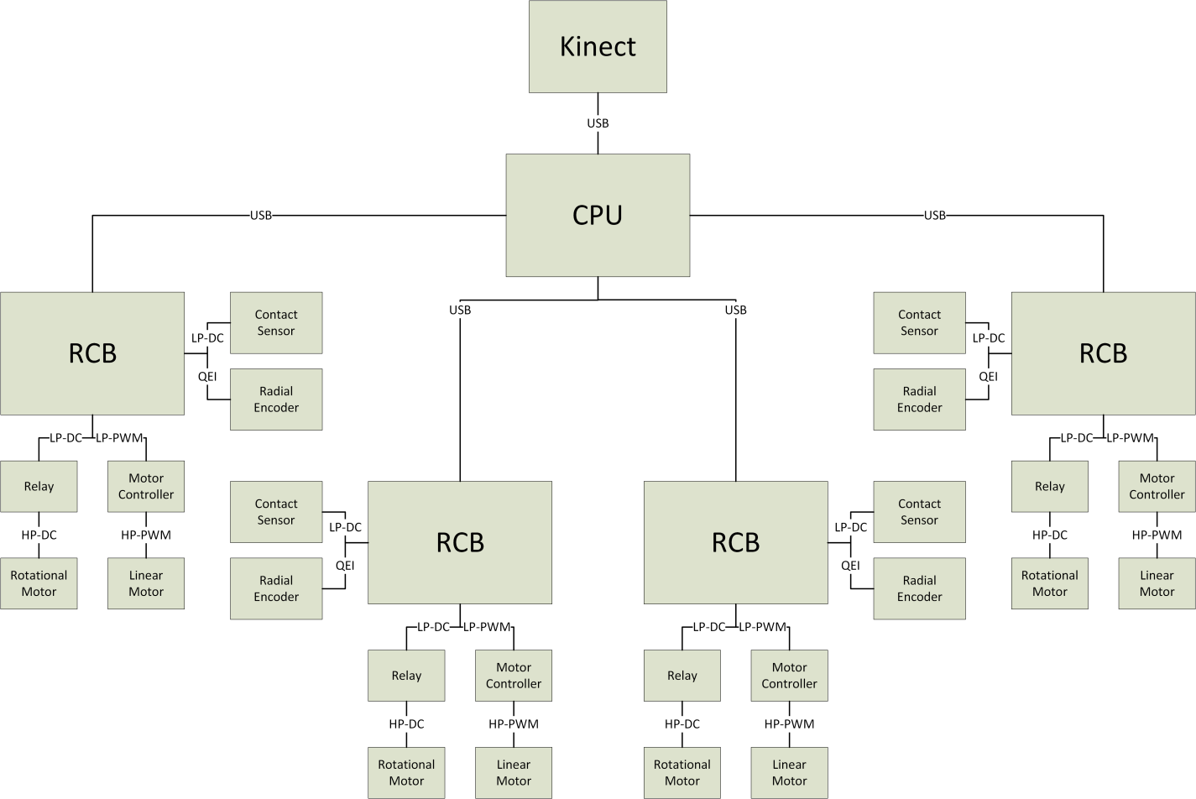
Figure 4.3.2.1: System Architecture Block Diagram

4.4 Actuators
The final version of the actuator design takes into account the research from section 3.2.3 and the project requirements from section 2.3.3. This section details all design decisions required for the physical construction of the automated foosball table’s hardware. This will include the linear and rotational subsystems, the drawer-slider linear motion subsystem, the encoder and tactile sensor mounting, camera and camera cage mounting and the side-table platform attachment.
A rendering of the initial rough design of the actuator can be seen below in Figure 4.4.1, SolidWorks Rendering of Actuator Design.
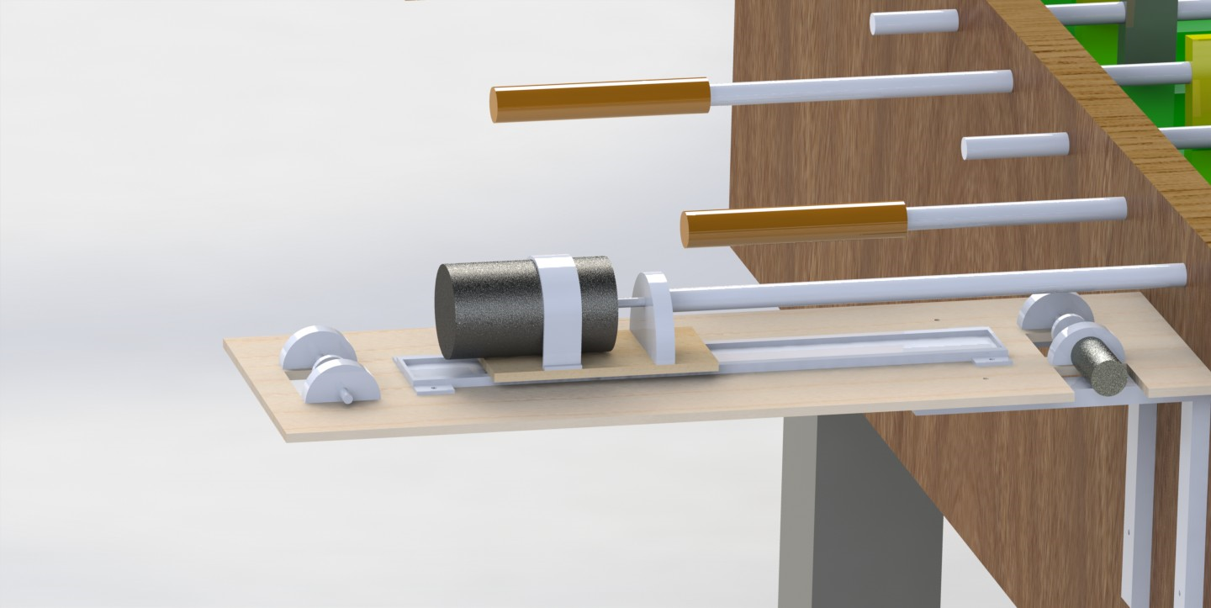
Figure 4.4.1:SolidWorks Rendering of Actuator Design
Each subsystem will be described in detail and then block diagrams showing the location and interactions of that piece in the greater-design will be shown. Any data transfers or necessary power/signal inputs will be discussed in this section. The ultimate goal is for at the conclusion of this section, a reader can reproduce and build the project described here.

4.4.1 Overview
The following design details will be discussed in detail in this section:
- Linear Subsystem Electronics
- Rotational Subsystem Electronics
- Linear Subsystem Mounting
- Rotational Subsystem Mounting
- Final Platform Mounting
- Camera Cage Mounting

Linear Subsystem Electronics
The linear subsystem will control movement of the rods back and forth to position the puppets in front of the foosball. The electronics of this section include a motor controller and power supply to feed and manipulate the power to the actuator and then finally a motor decision to purchase for the final assembly. The design decided upon for the linear subsystem was a roller based linear slide with drawer slides and a belt attached to the motor.
Through many options the final decision for a power supply was to take a standard power unit from a desktop computer and use that DC power to move the motors on the table. This is convenient due to both the low price and the availability of PC power supplies around in the market. It will allow the team to plug the table into a wall outlet and get the power straight from there without more effort from the senior design team. There may be safety concerns with a large power supply like this being used, however with standard safety precautions from the team this should not be an issue.
For the motor controller the design called for a robust high-voltage controller which dictated the decision to use the Cross the Road’s Talon speed controller. This motor controller can take 6-28VDC which is perfect for the decision of a PC power supply as the energy supply behind the work. More information on the motor controller decision can be found in section 4.3.1.
Finally the motor to use for the linear subsystem was decided to be a general 12VDC brushed motor from the Skycraft surplus supplier. This decision was made due to the price and the fact that the motors from this supplier fit perfectly fine into the specifications requested from the Chapter 2 requirements and specifications. These motors come in many sizes, shapes and electronic specifications.
Rotational Subsystem Electronics
The motors connected to the end of the control rods and attached to the platform of the linear subsystems will be used to rotate and kick the foosball. This particular subsystem has the same power supply requirement as the linear subsystem and therefore the same solution. A PC Desktop power supply will be taken as the supply for the motors in this subsystem. This is primarily because it is a price-efficient and readily-available component to supply a constant convenient 12V DC power. The Rotational subsystem has different requirements when it comes to motor controller and motor selections.
The motor controller for the rotational subsystem has different needs from the linear subsystem. The linear subsystem requires careful control on the rod’s position, speed and acceleration. In the kicking case the design team has decided that the best option is to simply kick at full power without any careful control loops. Since this does not need a controller like the Talon to regulate and amplify the motor speed, a relay switch can be used to control the power to the kicking subsystem. Since this is the case, a Spike Relay has been selected to control the power to the kick.
The motor for the kick is a tradeoff battle between selecting high torque or high speed. A high speed kick obviously would be useful because the ball would potentially be able to get a more professional level speed in a power hit. However on the other side of the coin is the argument for high torque hits. Torque would accelerate the rod faster and potentially be able to impart higher energy on the foosball in a kick. The tradeoff has led the team to seek a high power motor. For this role, a CIM from the supplier AndyMark has been selected.
Linear Subsystem Mounting
Because the linear subsystem was chosen to be a belt-driven rotation there are more mechanical construction decisions to be made by the senior design team. The linear subsystem will be built into a piece of plywood with a chain looped around as the source of movement. A sliding rail used in desk drawers will be mounted on the plywood as the linear rail to constrain the motion to the area desired. Figure 4.4.1.1 shows an image of the desired subsystem.
Notice in Figure 4.4.1.1 that the linear subsystem is mounted straight onto a 25” x 8” piece of plywood which is held up against the side of the foosball table. The sliding rollers are then simply screwed down to the plywood to keep them stable. The desk drawer style roller extends 16” down the plywood to allow for the entire range of movement needed on the longest rod. These rollers are very easy for assembly, especially considering that they are created with consumer construction in mind.
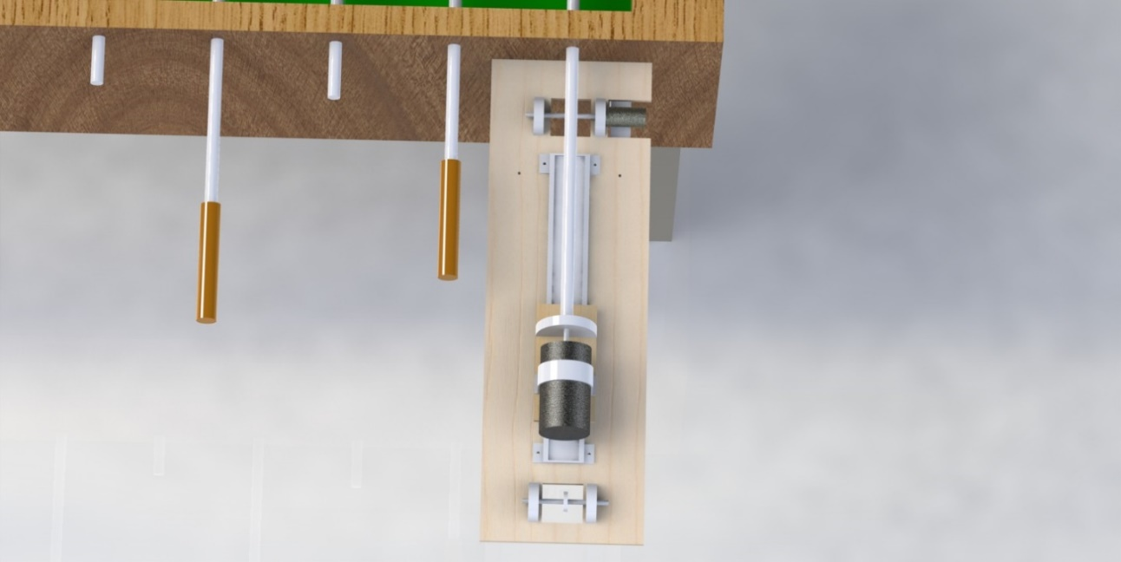
Figure 4.4.1.1: Top View of the Actuator. For emphasis on the linear motion.

On top of the roller is a single plywood platform. This platform is mounted to the roller in the way that a desk drawer would be mounted, however instead of a desk it is only a small piece of wood mounting. This again, like the slides mounted on the plywood, can simply be screwed down with no need for machining or any more complicated mechanical fabrication. The plywood platform is the home of the rotational subsystem which will be discussed in the next subsection.
The final important part of the linear subsystem to note are the chain mountings on both sides of the plywood. These rods are used to loop chain or belt around which then go back around and connect to both sides of the platform on the drawer slider. The effect of this setup is that the platform will move back and forth with the rotation of the 12V motor mounted at the end of the subsystem.

Rotational Subsystem Mounting
Referring back to Figure 4.4.1.1 on the top of the platform is the rotational subsystem. The mounting decision was to simply place the entire motor on the top of the moving platform to rotate the rods. This decision was made because it is much simpler to construct on a prototype level. The CIM motor selected is mounted straight on the platform and held down by a 2.5” diameter mounting bracket. A simple mount is used to hold on to the 5/8” control rod on the foosball table and the 1/4” motor output shaft.
The tactile sensors will be simply attached to the rod and extra pieces of plastic will be tied down to activate the sensors at the necessary angles. This will allow for the brute force implementation of kicking desired for the rotational subsystem.

Final Platform Mounting
The entire platform is located on a specialized 25” x 8” piece of plywood. In order to mount the plywood there will need to be very strong brackets holding the system up like a shelf. Figure 4.4.1.2 depicts the mounting of the complete subsystem to the side of the foosball table.
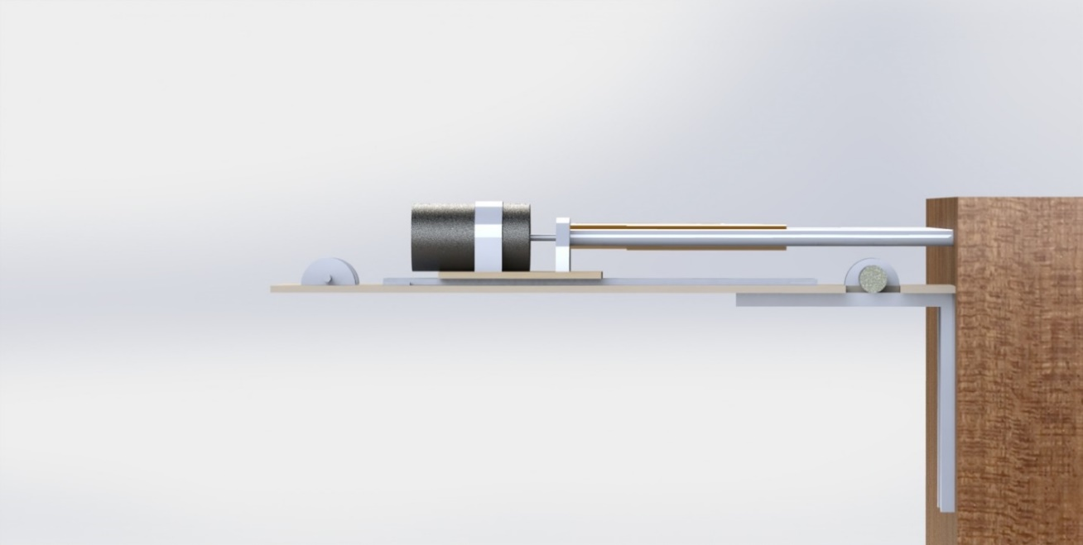
Figure 4.4.1.2- Side view of mounting. Notice the 8”x 8” bracket for mounting to the foosball table.

Note that if the weight of the subsystem is too much for simple brackets then legs may be attached at the extreme points of the plywood for extra support. If this auxiliary plan is taken then all 4 kicking subsystems would be consolidated into a single full length piece of plywood instead of 4 individual pieces.

Camera Cage Mounting
The final design decision involves the cage that must be constructed to hold the camera for ball tracking. The camera selected for use is a Microsoft Kinect which is a slightly heavier camera than some other options. This will require a sturdier cage to support the camera with minimal bouncing that would interfere with the camera tracking.
The decision is to mount the camera using 2”x 4” standard stock wood from a home-improvement department store. This wood is sturdy and tall enough to hold up the supports needed for a camera and the camera itself. The wires to the camera would be wound through these supports back to the CPU on the underside of the foosball table itself.

4.4.2 Block Diagrams
Below, in Figure 4.4.2.1, is the blueprint for the rod actuator subsystem.
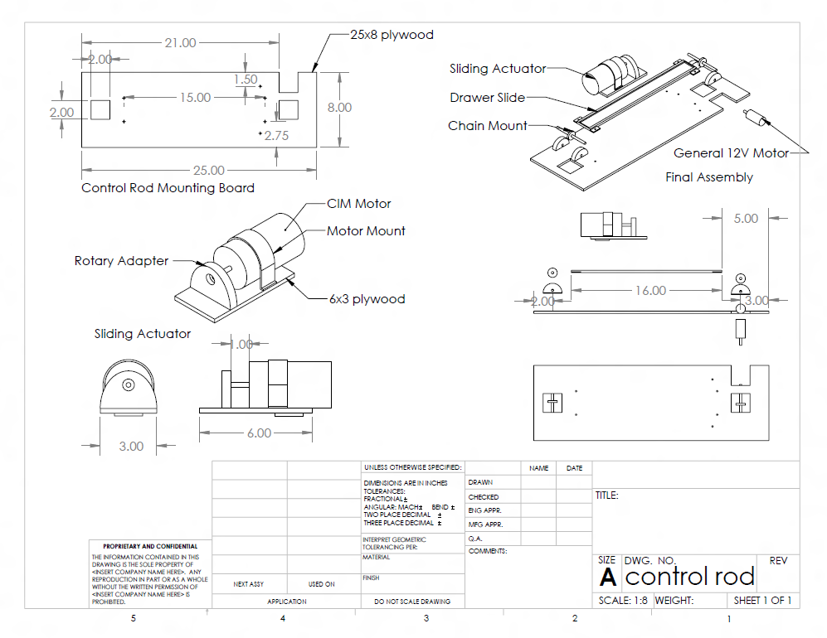
Figure 4.4.2.1: Rod Actuator Subsystem

4.5 Software

4.5.1 Overview
This section will only concern software running on the central processing unit. Software running on the Rod Control Board will be detailed in Section 4.6.3, RCB control loop.
The software subsystem consists of several components. First, accepting input from the Kinect, is the Table State Interpretation (TSI) subsystem. Second, receiving input from TSI, is the Persistence Filter. Next is the AI subsystem. Each of these subsystems has been discussed in detail in Section 3.
Each of these algorithms will be programmed using the C# programming language on Microsoft’s .Net framework version 4.5. This framework is compatible with many relevant libraries, which will allow programming of the various computer vision algorithms to be much easier.
Table State Interpretation
The algorithm chosen for the TSI subsystem is as follows, with annotations detailing the rationale for their use. Note that this algorithm is run per frame, and is intended to operate at 30 frames per second on the central processing unit.
- Receive frame of color picture and depth map from Kinect sensor.
- Run Gaussian filter on depth map to smooth edges and reduce the effect of the rather low resolution used by the Kinect.
- Find the foosball table:
  - Run Canny edge detection on the depth map. (Canny is the fastest edge detector available, and is part of common computer vision libraries)
  - Run a Hough transform on the Canny output to find the edges of the playing field.
  - Feed the table location information into a persistence filter to prevent sudden changes.
- Find the playing field’s depth level. This will be the lowest level within the bounds of the table (which have just been found).
- Find the puppets. This will be done by locating the highest level within the bounds of the table.
- Determine, using the difference between the puppet height and the playing field height, the range in which the ball most probably exists.
- Use this information to color the depth map. The map will be colored such that the closer something is to the ball’s height, the brighter it is, and vice versa.
- Run a Hough transform for circles bounded by the radius of the ball, in parallel with blob detection (using the color picture). These two pieces of information can be combined to find objects which are both circular and blobs, which will at least be a candidate for the ball. Also at this stage, candidate objects existing in parallel with other candidate objects are most likely puppets (since puppets must rotate together, and there are no rods with only one puppet). This allows for the elimination of some false positives.
- The information discovered in the previous step is the set of candidates for the ball, and is output to the Persistence Filter.
Persistence Filter
The persistence filter picks up where the previous algorithm left off, and is intended to reduce the impact of noise by discarding illogical candidate balls.
- Accept input from TSI subsystem.
- Run the RANSAC algorithm on the last 30 frames (i.e. one second) of TSI output. This should reject most candidates not fitting in with past data.
- Pass the one most likely candidate to the Kalman filter.
- The Kalman filter forms a mathematical model to predict the future position of the ball and eliminate erroneous conclusions.
- From the Kalman filter is output one single ball position for each time step, regardless of whether the ball was occluded for the current frame.
- Output conclusion to the AI subsystem.
Artificial Intelligence
The AI subsystem accepts input from the persistence filter, and generates and outputs an appropriate response to the RCB. In its preliminary incarnation, the AI subsystem is a simple, greedy algorithm without much sophistication.
- Accept ball’s current position from the Persistence Filter.
- Using current knowledge of puppet positions, locate nearest puppet on nearest rod to ball.
- Issue command to appropriate RCB to move puppet to the ball’s location and block or kick.
- Also, based on ball’s position and heading, raise and lower puppets so as to allow the ball to pass freely to the opponent’s goal, but be blocked from entering robotic player’s goal.

4.5.2 Block Diagrams
Below, in Figure 4.5.2.1, is the class diagram for the FOOSE project software system.

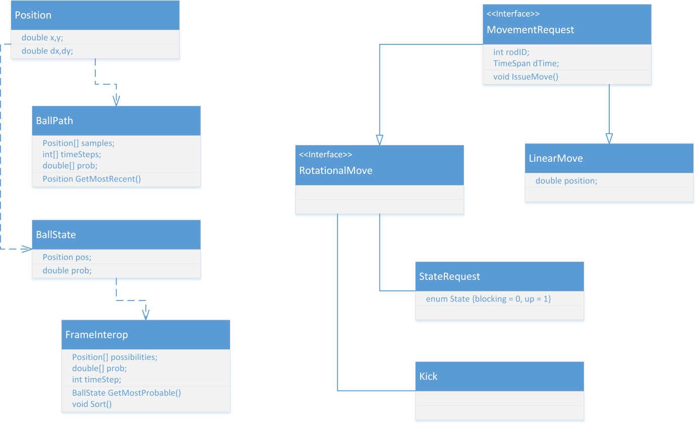
Figure 4.5.2.1: Software Class Diagram

4.6 Rod Control Board

4.6.1 Overview
Each rod has an array of sensors and motors to control its motion. To integrate all of this it was decided that a rod control board or RCB would be designed and used for each rod. This minimized the amount of design work that had to be done, because 1 board would be printed 4 times and attached to the sensor for each board. It also minimizes the prototyping costs because it reduces the chance of an error by reducing the overall complexity of the board. Using a board for each rod also has the advantage of being more robust, because only the control of a single rod will be lost if a board malfunctions. This also simplifies the software interactions on the board because only one set of signals from each of the sensors must be processed.
Board I/O
Each rod on the table has 2 motors and 2 sets of sensors. Both linear and radial motion are treated separately and thus each have their own motor and sensor set. The linear motion has a motor and rotary encoder to sense position, while the radial motion is controlled by a motor and 2 tactile sensors that determine whether or not the rod is in the forward or back position.
The linear motion of the rod is controlled by a high-power electric motor with an external variable current driver. The decision to use an external driver was in response to the difficulty of handling heat dissipation in high-power PWM circuits. To sense the linear motion, a 200 pulses/revolution quad rotary encoder will be attached to the motor axle. A quad encoder was chosen because we need to know the direction of motion, not only the speed. Quad encoders have 2 or 3 channels; the one selected for use in this project has 3 channels. The first 2 channels are named A and B and are simply offsets of each other, meaning when A is driven from low to high the direction of motion is the level of B, low for clockwise, and high for counterclockwise. The distance traveled is simply the number of pulses on channel A. The third channel is a Z channel which is driven high every revolution to mark the starting position of the encoder. The position of the rod will be used as an input to the PID loop controlling the motor. Because the gearing ratio between the motor and drive chain is currently unknown, the maximum radial speed is estimated at 5000 RPM and thus the rod control board must be able to count the revolutions at this rate. With a 200 pulses/revolution rotary encoder with 3 channels, the maximum rate of rising or falling edges is 100,000 edges/sec. This is most likely an overestimation of the actual speed, but it is a good target for design.
$$\frac{5000\frac{rev}{min}}{60\frac{sec}{min}}*200\frac{pulses}{rev}*3 channels*2\frac{edges}{pulse}=100000\frac{edges}{sec}$$
The rod will be able to be held in 2 rotational states and transition between these states quickly (for a kick) and slowly (for adjustment). The 2 states will be “up” and “blocking” (or forward). The “up” state will allow a previous row of puppets to kick through the friendly row without potentially stopping the ball. It will also serve as the starting position of a kick. The “blocking” position is the state where the rod will attempt to stop incoming kicks from the opponent’s puppets; this state will be end of the kicking motion. The radial motion of the rod is controlled by an electric motor, because the decision was made that full speed control of the kicking motion was not required; thus the motor will have 5 states. The 5 states will be: “off”, “full forward” (for a kick), “full reverse” (get ready to kick), “slow forward” (adjust position to “blocking” state) and “slow reverse” (adjust position to “up” state). These 5 states do not require a PWM circuit and can be controlled by a series of relays. Because of the lesser need for heat dissipation, the control of the kicking motor will be completely handled by the rod control board.
Each rod will have 2 tactile sensors to determine which of the 2 states (if any) the rod is in. The tactile sensors are “forward” and “up” which will be depressed when the rod is in the “blocking” or “up” positions, respectively. If one of the buttons is not depressed, or the wrong button is depressed; the rod control board will activate low power mode and drive the rod to the desired position. The procedure for kicking a ball will be to drive the motor full reverse until the “up” tactile sensor is activated. The drive will then change to “full forward” until the “forward” tactile sensor is activated, at which time the motor state will be changed to the ”off” state.
Given the above information on sensors and drivers the rod control board must communicate with and control, the I/O diagram for the rod control is given in figure 4.6.1.1, below.
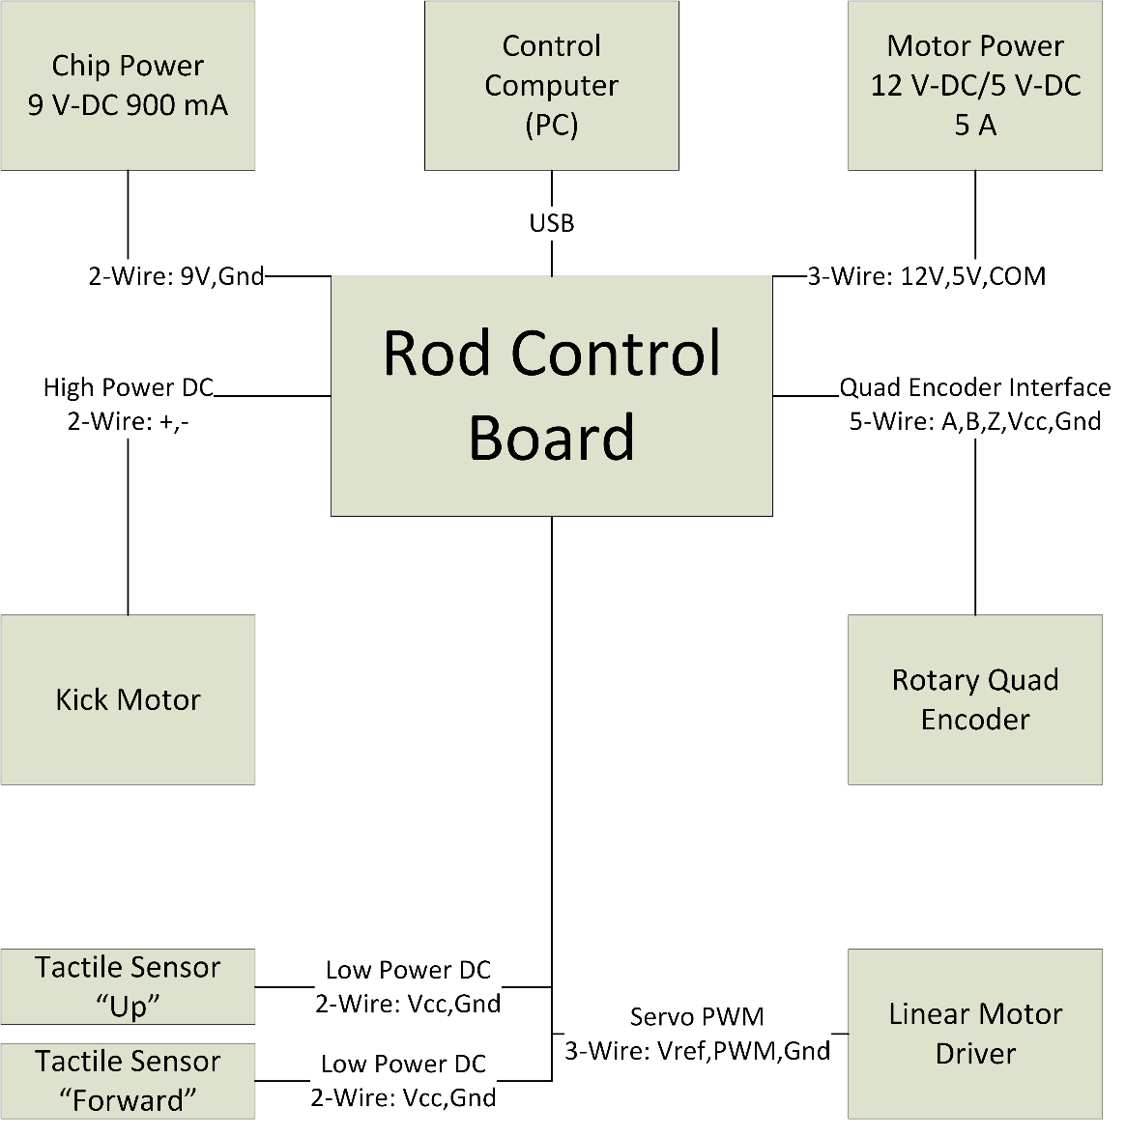
Figure 4.6.1.1: Rod control board external inputs and outputs.

4.6.2 Schematics and Layout
The board can be broken down into the design for each of its subsystems: USB interface, Quad encoder counter, kick motor control and power supply. The design of each of these systems will be addressed independently and then integrated.
USB Interface
The rod control board must be able to communicate over USB to the control computer. USB was chosen because of the quantity of RCBs (four). Serial is out of the question due to common computers today having 0, 1 or at most 2 serial ports. A daisy chain serial connection was possible, but dismissed because of the desire to have independent RCBs for robustness. This project attempts to minimize cost and to that effect a microcontroller with integrated USB would reduce cost. The PIC18F4550 was the only readily available microcontroller with an integrated USB controller that was also available in a DIP pin format. The choice was made to have many components with pins in DIP format to allow for easier soldering. This particular microchip can be run up to 48 MHz, meaning there will be plenty of clock cycles left over for other computations, however CPU interrupts to handle USB I/O will mean these operations could be delayed. Because of the nature of a PID loop, an endless loop that may only provide a thousand updates a second, the extra clock cycles on the PIC can be used for the PID loop. The PID loop for this project will be further discussed in Section 4.6.3, RCB Control Loop. This also removed the delay of having to relay the rotary encoder information to the computer and wait for a response to adjust the motor speed. The PIC also has 24 I/O lines, more than enough for our needs. The PIC also has 2 PWM modules, so it will be used to drive the linear motor controller. A 10 MΩ resistor was connected from the PWM line to ground to drain static during board power down and prevent inadvertent driving of the linear motor.
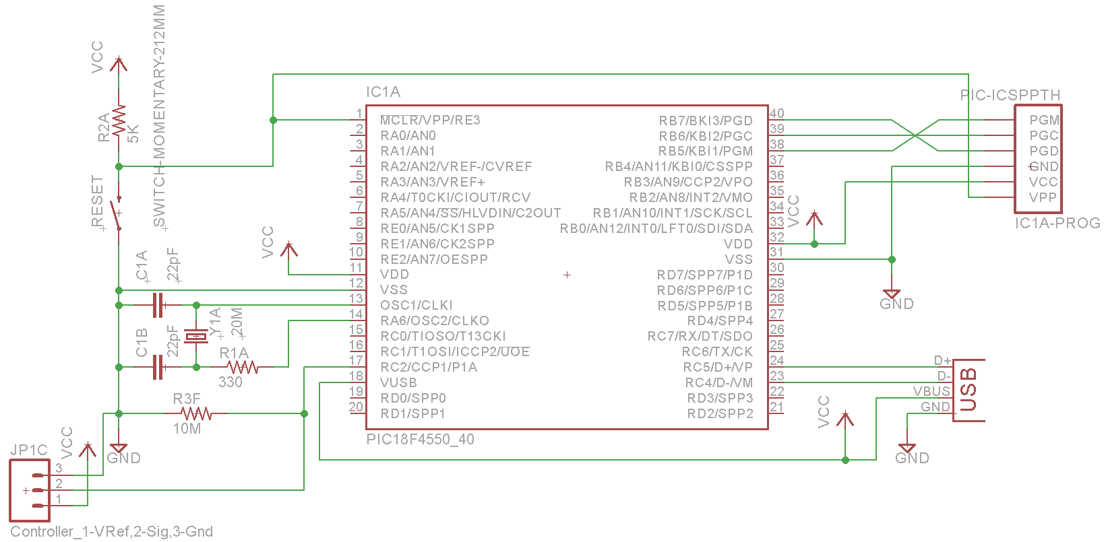
Figure 4.6.2.1: Basic hookup of PIC18F4550 and the beginning of the RCB schematic.
The PIC needs I/O pins exposed for re-programming, reset switch, external clock input, USB, power and connection to the RCB’s other micro controllers. Using the datasheet provided by Microchip® on this microcontroller, the following schematic was produced, shown in figure 4.6.2.1, above. A program header and USB connector was chosen from Sparkfun to connect to the PIC.
Quad Encoder Counter
The quad encoder leads must land in a microchip to have the low-high edges counted, as discussed earlier in this section a max rate of 100,000 edges/sec was chosen as the design goal. Because of the expected interrupts to handle USB I/O on the PIC controller; it was decided to have a dedicated microchip for counting the quad encoder pulses. The ATTiny84 was chosen to fit this role because of its cheap cost, high available clock rate and appropriate number of I/O pins. It is also available in a DIP 14 package, making soldering easier. The ATTiny84 has an internal clock that can drive the processor at 1 MHz; however because of the potentially high rate of interrupts from the quad encoder, the decision was made to drive the processor at 20 MHz, so it would have plenty of extra clock cycles for interrupts.
The I/O method chosen for the ATTiny84 is SPI, however the SPI modules on the PIC and ATTiny84 only allows for transmission of 1 byte at a time, so a more complex protocol over SPI is needed. The PIC will be the master and will request data from the slave (the ATTiny84). The PIC will not need to send any data to the ATTiny84 and thus the MOSI line does not need to be connected. A 24-bit integer will be needed to represent the position of the encoder, this will be divided into 4 6-bit sections. To each of these a 2-bit header will be added to represent which of the 4 sections the byte contains, this forms a “packet”. This encoding format is show in figure 4.6.2.2, below.
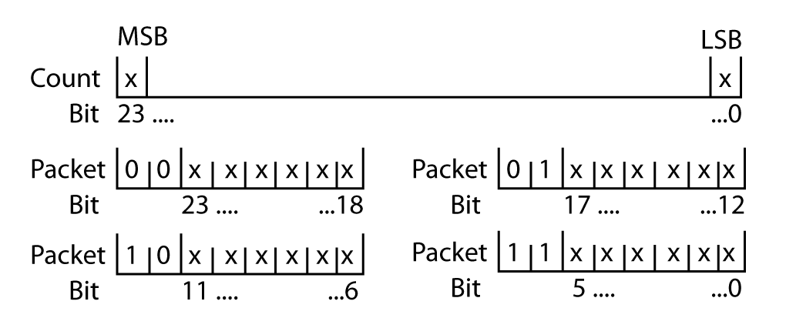
Figure 4.6.2.2: Interface format for dividing 24-bit count into bytes.
The encoder ticks will be handled by integrated external interrupt lines on the ATTiny84. After the handling of the interrupt 3 bytes in the memory of the ATTiny84 will represent the current encoder count. A second 3 bytes in the memory of the ATTiny84 will represent the value of the encoder known to the PIC. The loop for the primary code on the encoder counter will compare these 2 different values and pick the most significant 6 bits that differ. To those 6-bits, the correct 2-bit header will be added and then if the SlaveSelect (pin 10) is low the packet will be placed in the SPDR register, waiting for the PIC to request it. It is necessary to check the SlaveSelect because the value of SPDR must not be edited while being transmitted to the PIC. An interrupt will be wired for SlaveSelect, and on the falling edge the 3 bytes representing the PIC-known count will be updated to reflect the successful transmission of the 6 data bits in the SPDR.
Using a previous design for basic AVR hookup, the following schematic was made to connect the ATTiny84. The encoder chosen has internal pull-downs; however if a change is made to the choice of rotary quad encoder; static may build up on the A, B and Z channels and would render counting impossible. To account for this possibility, a 10MΩ resistor is wired to each channel and connected to ground to drain static. The RCB also needs to include connection points for the rotary encoder. Screw terminals were chosen to allow quick change of an RCB or encoder. These screw terminals are also reflected in the design. The final schematic for the encoder counter is shown below in figure 4.6.2.3.
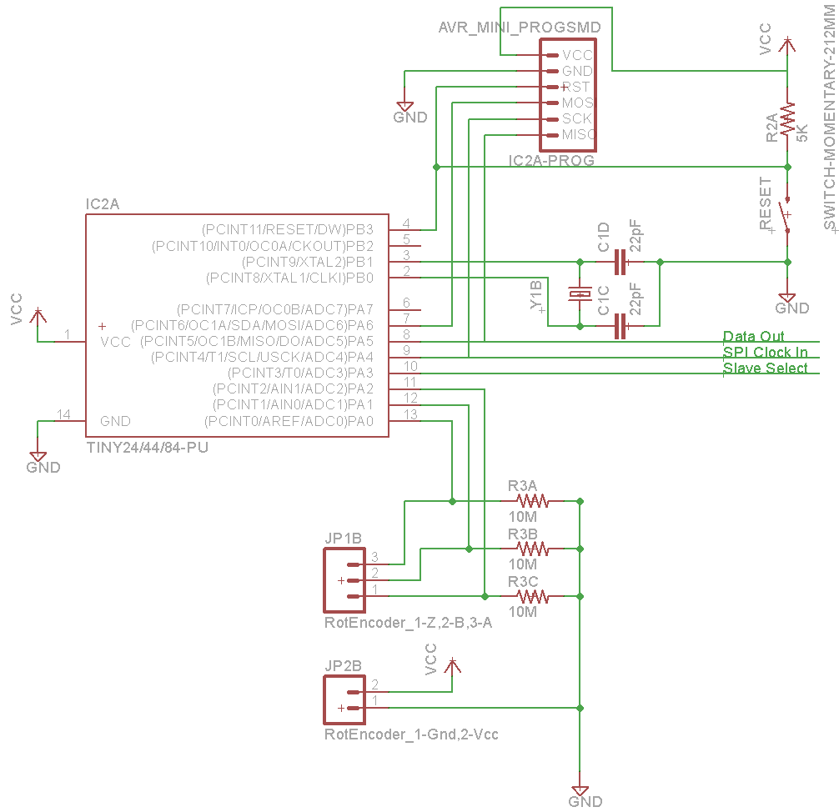
Figure 4.6.2.3: Encoder counter schematic, including programmer and reset button.
Kick Motor Control
The kick motor, or radial rod control motor, is to be controlled on-board. To handle the high current, relays were chosen. The JQX-15F was chosen because of its 20 amp rating, and low driving voltage of 5V, compatible with the on-board power source.
However one problem with controlling the motors with the RCB is that the radial motors will be prone to stalling when the ball gets caught under the puppet trying to kick it. Some early research showed the stall current on electric motors being chosen for radial motion to be in excess of 100 amps. Because electric motors are inductors, this current is not instantaneous but is instead developed over a second or so, giving time to correct the stall if detected. To detect stalls, a current sensor on the motor drive line can be used. When the current goes over a threshold for normal operation the motor can be driven in reverse to let the ball roll away. The relays chosen for use in this board are rated for 20 amps; meaning we have until this threshold to detect an overcurrent and disconnect the relay. The ACS712-30A Hall-effect sensor was chosen to help detect this current. The ACS712-30A is rated for up to 50 amps and can measure current up to 30 amps. The data sheet for the sensor suggested a 1nF filtering capacitor be placed between the +FILT pin and ground; this capacitor was incorporated into the design.
The driving current for the relays is 200 mA at 5V. To supply this current level at 5 V, 30 Ω resistors were placed between Vcc and the relay. 200mA is far too great a current for a microcontroller to drive so the current from a microcontroller had to be stepped up. The path was sent through a 2N3904 transistor, a commonly available, bi-junctive transistor. Bi-junctive transistors were chosen to allow for more or less driving current in a relay if necessary by simply changing the resistor between the microcontroller and transistor. The gain value of this transistor is 300, meaning in order to achieve a current of 200 mA, an input current of around .7 mA was necessary. To achieve this current across a potential of 4.3 V, a resistor of 5K was chosen which will yield a current of .86 mA, more than enough current to drive the relays. The relay network with current sensor is shown in figure 4.6.2.4, below.
To sense the position of the rods, 2 tactile sensors were used. When using “dumb” components, one must be careful about attempting to sense an off state because static can build up on the sensor line and prevent a clean reading. To combat this, a 10 MΩ resistor was attached to the sensor line and driven to ground to drain any excess static. The lines were connected to the microcontroller via a 5 KΩ resistor to prevent damage to the microcontroller.
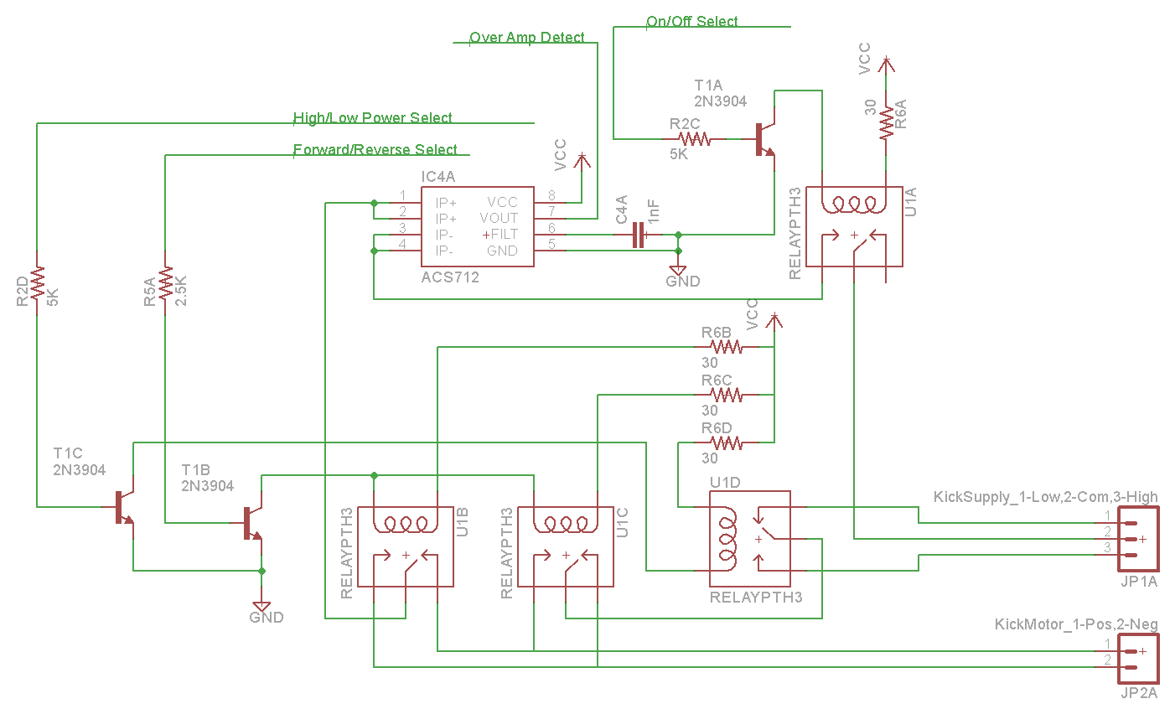Figure 4.6.2.4: Depiction of relay network to switch between kick motor driving 5-states, also show is integration of a Hall-effect sensor to detect over current before damage occurs.
Again, when analyzing the requirements for the kick subsystem, the decision was made to have an independent microcontroller. Again, an ATTiny84 was chosen to fit the role. This ATTiny84 is responsible for the switching of the relay network and detecting the rod rotational state, as well as cutting off the current if it rises past a given threshold. To allow for faster current checking, this ATTiny84 will also be driven at 20 MHz by an external crystal. The wiring of the ATTiny84 is very similar to the ATTiny84 encoder counter. The final wiring is shown in figure 4.6.2.6, below.
Power System
The power provided by USB is more than adequate to power the microcontrollers and their sensors. However, the 4 relays required to switch the kick motor drive the required current beyond 800 mA. This is almost double what standard USB is able to provide. Enter an external power supply to make up the difference. A standard TI µA7805CKC voltage regulator was used to supplement the power supplied over USB. Again a standard reference circuit was used for power regulation, with one change: the large capacitor before and after the voltage regulator was increased from 10 uF to 100 uF to allow for more robust operation. The large capacitor was deemed necessary because of the very high but short demand of current from the 3 microcontrollers during each of their clock cycles. If these cycles were to align, it might cause a sudden drop in voltage resetting the circuit. The disadvantage of this design is a longer power-on time, but there is no requirement on power-up time for this board. To indicate power, a standard 5mm red LED was added in series with a 5 KΩ resistor to limit current to under 1 mA. The final power system design for this circuit is shown in figure 4.6.2.5, below. The external supply used is a regulated AC to DC wall adapter providing 900 mA at 9 V-DC from Sparkfun.
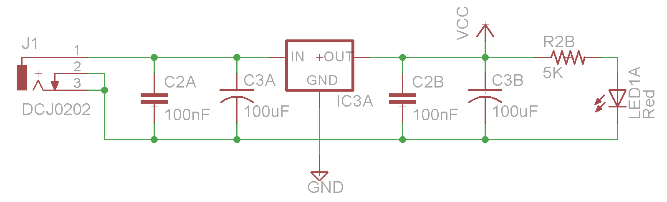
Figure 4.6.2.5: Power regulation system for relay control board
Integration
To integrate all the subsystems described above, a common ground and a common voltage supply of 5 V was used. A supply voltage of greater than 4.0 V was required for each microcontroller because of the fast clock speed specified in the RCB design, thus 5 V was chosen as a common supply. Each of the 4 leads from the kick control subsystem was wired to an appropriate input pin on the kick control microcontroller. Two leads were wired between the kick control microcontroller and the PIC interface chip, one for telling the board to perform a kick and the other to specify the desired resting position: “up” or “blocking”. A common reset line was connect to allow reset of all microcontrollers via a single reset button. The VUSB line was tied to Vcc to allow the system to be powered off USB only for testing, when the relays weren’t necessary. This also allows the capacitors on the voltage regulator to do double duty as a regulator for a USB based power supply. The final integrated circuit is shown in figure 4.6.2.6 below.
Layout
The decision was made early on to use DIP components whenever possible to allow for easy soldering, however SMD resistors and capacitors can be easily soldered with an iron and flux. So SMD resistors and capacitors were used to reduce PCB size. The relays fit quite nicely in a tessellated fashion and allowed for the current-limiting resistors for each relay to be placed in a small gap between the relays. The screw terminals were all put on one side to allow ease of wiring, the Hall-effect sensor was placed near the relays to prevent the need for large traces to go long distances. Standard interconnect size of 10 mil worked to connect most components however the relay network was interconnected with 100 mil traces to allow up to 3 amp continuous current (these paths will not need to say on for more than a fraction of a second, and thus can handle higher, short duration current). The traces supplying power to the transistors to switch the relays were increased to 20 mil along with most of the power subsystem. The final dimensions of the PCB are 4.00x3.15in, compact enough to be placed wherever it is required to be placed. The draft layout is shown in figure 4.6.2.7 below.
Revisions to this board layout are likely. The layout may be revised to utilize space under the voltage regulator, which can currently be bent down to reduce its high profile. The utilization of this space would allow for easier assembly because the ATTiny84 chips could be spaced out more. Due to space considerations mini AVR programming headers will need to be used, possible improvements would be to allow a single header to be used to re-program all 3 microcontrollers, this however is not well documented and would require testing to validate the design. A soft design requirement that was not met is the need for mounting screw holes on the corners of the board, the compactness of the design will make it difficult to find space for such holes. The existing crystals on the board may be replaced by SMD crystals to reduce the required space, however this would utilize previously acquired 20 Mhz crystals.
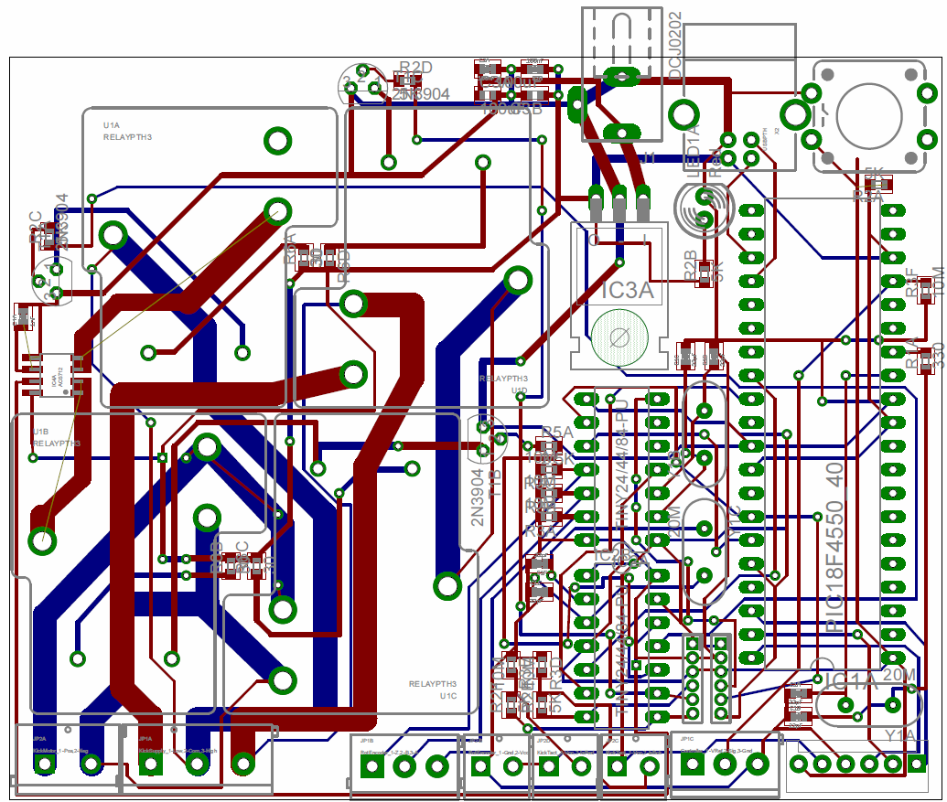
Figure 4.6.2.6: RCB Layout
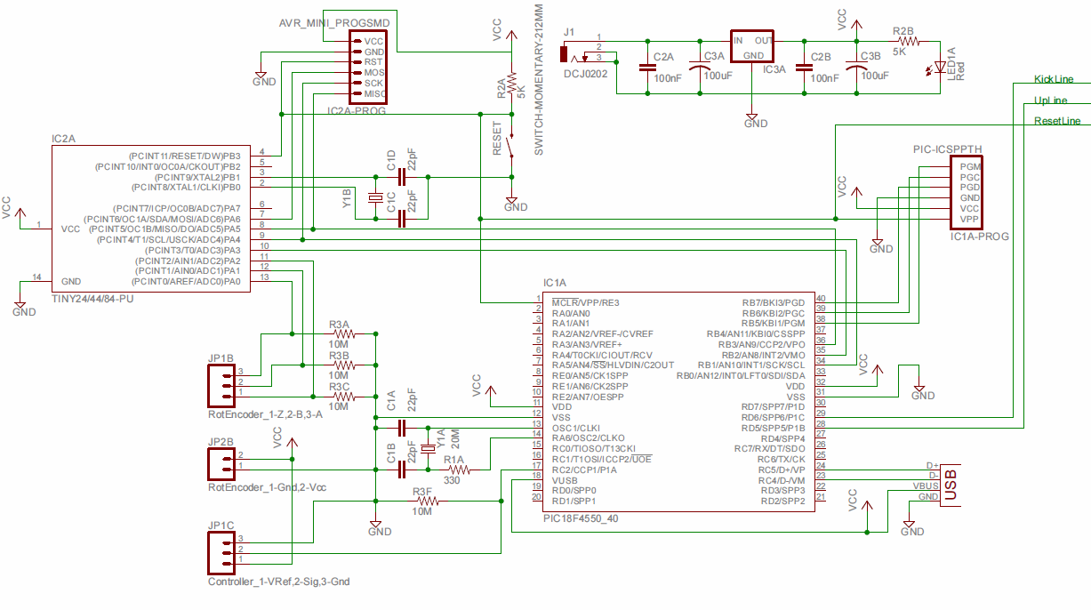
Figure 4.6.2.7a: RCB Schematic Page One
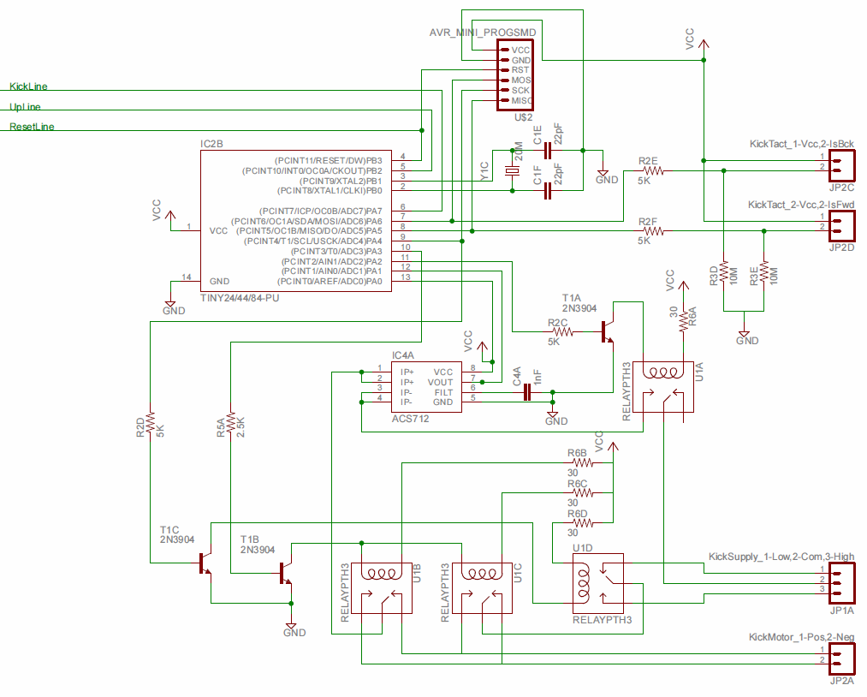
Figure 4.6.2.7b: RCB Schematic Page Two

4.6.3 RCB Control Loop
Control Design Method
Upon researching many different methods to design a control system for the actuators the PID method was selected as the best option. The reason for this is because it is so general it can be used for nearly any system with ease. Also, because they are so commonly used in the industrial environment, additional research and assistance is readily available in case any problems are found during the implementation process. Furthermore, PID controls are extremely effective in getting the desired response and can be tuned using well-known and effective methods.
Method for Tuning the PID
For tuning the PID compensator two methods will be used. One for coarse tuning and then another for fine. The Ziegler-Nichols rules for tuning cannot be applied to this control problem. Unfortunately, this system does not fit into the standard responses used for the Ziegler-Nichols method. It is not possible to obtain an S-shaped curve or a sustained oscillation just with proportional control because there is no damping in the system (friction is ignored in the model). Thus, the manual tuning method will be used for coarse tuning. This will give a good starting point for parameter values. After coarse tuning, the loop will be implemented. If the desired results are not achieved, the computational optimization approach will be used for fine tuning the system. These results will be found through mathematical modeling and simulation in MATLAB.
Mathematical Model of the System
Beginning with assumptions, this mathematical model will assume frictionless sliding. This is justified because the rods are well lubricated and any additional friction will be accounted for in post implementation tuning. Furthermore, friction is a nonlinear phenomenon which cannot be easily modeled using the previously discussed methods, which only apply to linear systems. Thus, friction will be accounted for after implementation. Also while modeling, zero initial conditions will be assumed. It will be assumed that the rod is stationary before any control action is implemented. In the real world, the rod will most likely be in constant movement, however the initial conditions cannot be predetermined so they will be assumed to be zero and will be accounted for after implementation.
$$a$$
$$F$$
Rod

The model can be modeled by a simple kinetics problem of a rod accelerated by a single force, F.
Using kinetics to model the movement of the rod:
$$F=Ma$$
Where ‘F’ is the force acting on the rod, ‘M’ is the mass of the rod, and ‘a’ is the acceleration of the rod.
Now finding the open-loop transfer function of the uncompensated system:
$$F=Ma$$
$$F=M\ddot{x}$$
Taking the Laplace transform and assuming zero initial conditions:
$$F\left(s\right)=Ms^{2}X(s)$$
$$\frac{X\left(s\right)}{F\left(s\right)}=\frac{1}{Ms^{2}}$$
A PID compensator is then added to the system which will yield the following block diagram:

$$\frac{1}{Ms^{2}}$$
$$K_{p}(1+\frac{1}{T_{i}s}+T_{d}s)$$
$$X(s)$$
$$F(s)$$
$$Z(s)$$

Now finding the closed-loop transfer function of the system with unity feedback:
$$Closed loop=\frac{Open Loop}{1+Open Loop}$$
$$\frac{X\left(s\right)}{F\left(s\right)}=\frac{\frac{K_{p}\left(1+\frac{1}{T_{i}s}+T_{d}s\right)}{Ms^{2}}}{1+\frac{K_{p}\left(1+\frac{1}{T_{i}s}+T_{d}s\right)}{Ms^{2}}}$$
$$\frac{X\left(s\right)}{F\left(s\right)}=\frac{K_{p}\left(1+\frac{1}{T_{i}s}+T_{d}s\right)}{Ms^{2}+K_{p}\left(1+\frac{1}{T_{i}s}+T_{d}s\right)}$$
$$\frac{X\left(s\right)}{F\left(s\right)}=\frac{K_{p}T_{d}s^{2}+K_{p}s+\frac{K_{p}}{T_{i}}}{Ms^{3}+K_{p}T_{d}s^{2}+K_{p}s+\frac{K_{p}}{T_{i}}}$$
Now we let KpTd = Kd and Kp/Ti = Ki so the equation becomes:
$$\frac{X\left(s\right)}{F\left(s\right)}=\frac{K_{d}s^{2}+K_{p}s+K_{i}}{Ms^{3}+K_{d}s^{2}+K_{p}s+K_{i}}$$
Now the equation matches the form used in the manual tuning method, so we can use the Table 3.2.4.3.3 to assist in the manual tuning process.
Calculation of Mass of the Rod
The mass of the rod is an important component to this model. It is the primary constant that comes into effect during the control. The mass, however, is not widely distributed by the manufacturers so it must be calculated from its dimensions and material. The dimensions are as follows:
- 41 ½” Long
- 1/8” Thick Steel
- 5/8” Wide Rod
A picture is given for clarity, Figure 4.6.3.1
The mass of the rod can be accurately measured by first finding the volume of the rod and then using the density of steel to find the mass.

Figure courtesy XtremeGameRoom.com
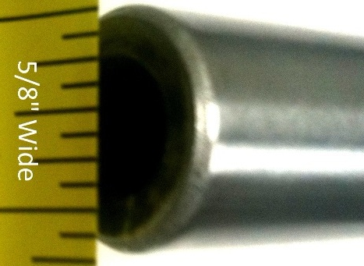
Figure 4.6.3.1: Control Rod End
The volume of the rod consists of a hollow cylinder found with the following equation:
$$V={Lπ(r}_{o}^{2}-r_{i}^{2})$$
Where ‘L’ is the length of the rod, ‘r_{o}’ is the radius of the outer cylinder (total radius), and ‘r_{i}’ is the radius of the hollow cylinder (inner radius).
Substituting the values from the dimensions into the equation yields:
$$V=(41.5)(π)(({\frac{5}{16})}^{2}-{\left(\frac{3}{16}\right)}^{2})$$
$$V=8.14851 in^{3}$$
The density of steel is typically around 7.859 g/cm^3.b
Converting to metric units and multiplying density by volume yields the mass of:
$$M=7.859\frac{g}{cm^{3}}*133.53 cm^{3}$$
$$M=1049.4 grams$$
Tuning the PID Loop
Using MATLAB to simulate step responses, the manual tuning rules are applied to find a good starting point for PID parameters.
Starting with the open loop response of the uncompensated system:

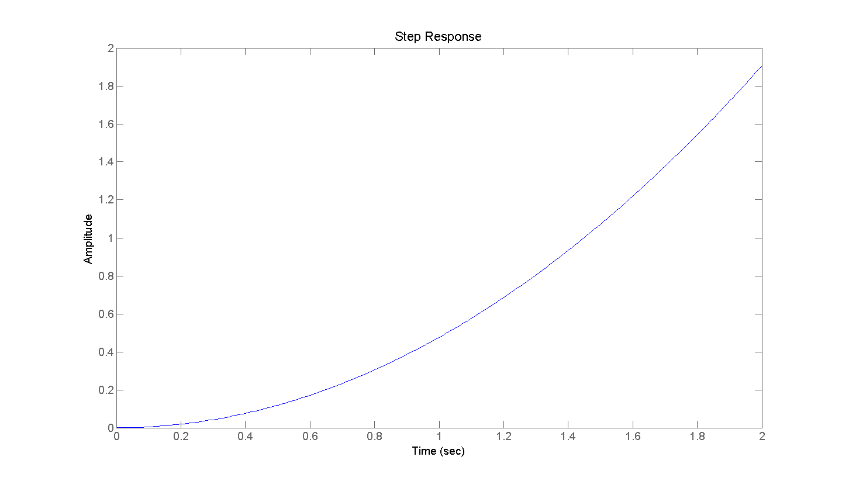
Figure 4.6.3.1: Open loop response of uncompensated system.
From Figure 4.6.3.1, we can see that the system is inherently unstable. This is because friction is ignored and a constant force is being applied to an object moving in free space, which will lead to a constant acceleration. Thus the PID loop will require derivative control to compensate for this.
After plotting the uncompensated system, the PID compensator is added to the system and the closed loop step response is found. Starting with unity parameters yields:
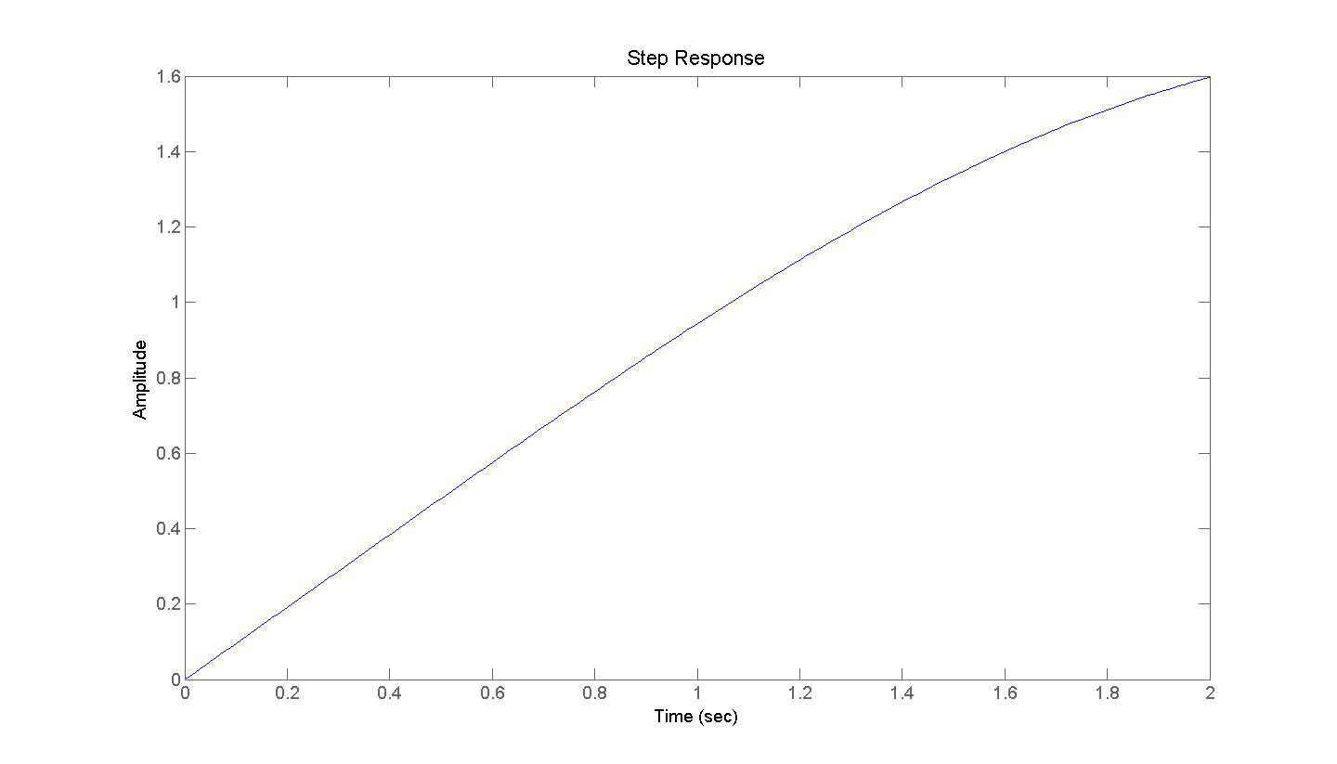
Figure 4.6.3.2: Step response of closed loop system with unity PID parameters
From Figure 4.6.3.2 we can see that the control is far from ideal. Thus the manual tuning method is applied to find appropriate PID parameters, which yields the following step response:
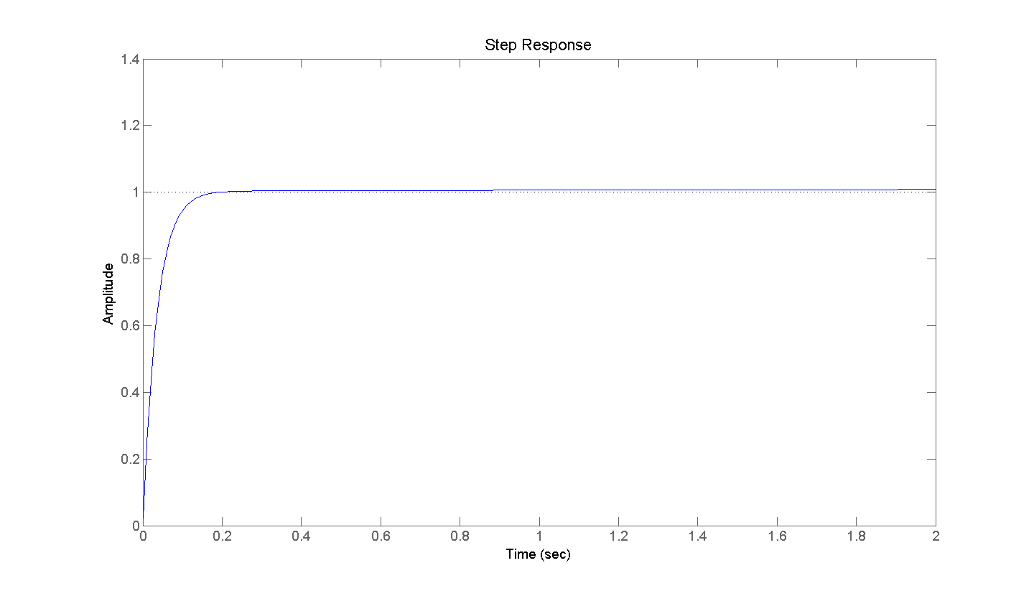
Figure 4.6.3.3: step response of close loop system with tuned PID parameters
From this figure we can see that good starting values have been met. There is good rise time to get the players in the correct position fast enough, virtually no overshoot so the players won’t pass too far past their desired location, and very little steady-state error so the automated player will be able to block the ball consistently.
The selected PID parameters were:
$$K_{p}=3$$
$$K_{d}=30$$
$$K_{i}=3$$

5.0 Design Summary of Hardware and Software

5.1 Hardware Summary
The summary of hardware includes the following design topics:
- Sensors
- System Architecture
- Actuators
- Rod Control Board
Sensors
This project consists of two main components that must be known in order to operate: the location of the ball and the position of the automated opponent’s rods in both the linear and rotational dimensions. For detecting the ball, the camera will be the Microsoft Kinect. For the linear position of the automated opponent’s rod, a quadrature encoder will be used (Sparkfun COM-10790). For the rotational position of the automated opponent’s rod, two simple tactile sensors will be used to determine if the puppet is up or down (Skycraft Button SK4843).
System Architecture
The system architecture consists of main processing unit, the motor controller, and the data transportation methods. The main processing unit will be the small-form-factor IBM Thinkcentre, an off the shelf CPU. The motor controller will be the Talon speed controller. The data transportation methods will be PWM for communicating with motors and USB to communicate to peripheral devices with the CPU.
Actuators
The actuators consist of a motor for rotation (kicking) and a motor to drive the linear motion of the rod via a rack and pinion. The motor for rotation will be the FIRST CIM motor (am-0255). The motor for the linear motion will be a general off the shelf motor from local hobby shop Skycraft.
Rod Control Board
The rod control board will be custom-designed to best fit the project’s needs. It will act as an interface between the CPU and peripheral devices, such as sensors, motor controllers, and external relays. The schematic of the rod control board is as follows:
Figure 5.1.1a: RCB Schematic Page One
Figure 5.1.1b: RCB Schematic Page Two

5.2 Software Summary
The software is divided into the following sections
- Microcontroller code (RCB)
  - Encoder counter
  - Interface controller
  - Kick controller
- Main processing
  - Table state interpreter
  - Persistence filter
  - AI
Microcontroller Code
The microcontroller code will be entirely run on the RCB. The code will be divided into 3 different sections, corresponding to each microcontroller on the RCB.
Quad Encoder Counter
The encoder counter will only be responsible for counting the pulses from the quad radial encoder and then relaying this information via one way SPI to the interface controller. The pulses will be counted by interrupts on each channel. When an interrupt fires, the function will update the position value to reflect the change. The position of the encoder will be a 24-bit integer that will start at 2²³ to allow for motion in either direction.
The interface format will be 1 way SPI to the interface circuit. This controller will be the slave and will allow the interface circuit to request information whenever it needs it. Because of the limited transmission register size of 8 bits; the 24-bit count value will need to be divided. The count will be divided into 4 6-bit sections and have a 2-bit header attached to each, forming a transmission packet. The most significant changed packet will be on the transmission register at all times. This will be controlled by a while loop running whenever an interrupt is not being processed.
Interface controller
The interface controller will be responsible for serial IO via USB to the main computer as well as IO with the other microcontrollers on the RCB and with direct PWM control of the linear motors. The PID loop will run on this processor as in infinite loop. At the start of each loop it will retrieve an update via SPI from the quad encoder counter. It will then process the PID loop and update the PWM value. The US B IO will be handled via interrupts and rotational commands will be signaled to the kick controller in the interrupt function.
The PID loop running on the interface controller has been tuned and the initial values that will be used are P = 3, I = 3, D = 30; these offer a good starting point for the software.
Kick controller
The kick controller will check the 2 lines connected to the interface controller. The primary loop will control state and use low power forward and reverse mode to keep the rod in the “up” or “blocking” state. The command to kick will be handled by interrupts and the interrupts function will take control until the kick has been completed.
Main Processing
The majority of the processing for this project will take place on a general purpose PC, all of this code will be written in the .NET 4.5 framework. The code will be divided into three main modules, table state interpreter, persistence filter and AI.
Table State Interpreter
The TSI or table state interpreter will have several tasks that must be completed to have normalized ball position values.
The first stage will be to run a Gaussian blur to account for the Kinect’s randomized sampling pattern. Then Canny will be run to identify edges in the images. A Hough transform for lines will be run to identify the position of the table and locations of the rods. This will be used in a later stage to normalize the ball position values.
The second stage will use depth to eliminate any blobs where the ball cannot be; making the assumption that the ball will be touching the surface of the table.
The next stage will be blob identification via a circular Hough transform or a secondary Gaussian blur. From these blobs, the regular spacing and vertical orientation of the rods will be used to eliminate the false hits caused by the puppet’s feet. The remaining blob(s) will be the ball; any blobs here will be reported to the next phase.
The next phase uses the orientation of the table to normalize the position of the detected balls. The class used to pass this information will be a FrameInterop, depicted in figure 5.2.1.
Persistence Filter
This filter is divided into 2 algorithms, RANSAC to eliminate false positives and a Kalman filter to add persistence and utilize the physical motion of the ball to limit its possible location. The RANSAC filter will store an array of BallPath, depicted in figure 5.2.1, representing a frame buffer worth of samples. The function of RANSAC is to decide which of the positions from the FrameInterop. RANSAC will then pass a single BallPath to the Kalman filter which will update its record and make a prediction about position and velocity at this time step. The output from the persistence filter will be a single BallState.
AI
The AI will attempt to make appropriate actions given the BallState input. At first a basic greedy algorithm will be used to block and shoot the ball in the forward direction. This will then evolve into a more complex algorithm as time allows. The output from the AI will be several MovementRequest classes, depicted in figure 5.2.1. The MovementRequest has functions that allow execution of the request (which will push the request off to another thread and send the command at the appropriate time (specified by dTime). The serial communication modules will be contained within MovementRequest and offer a transparent means to issue commands to the RCBs.
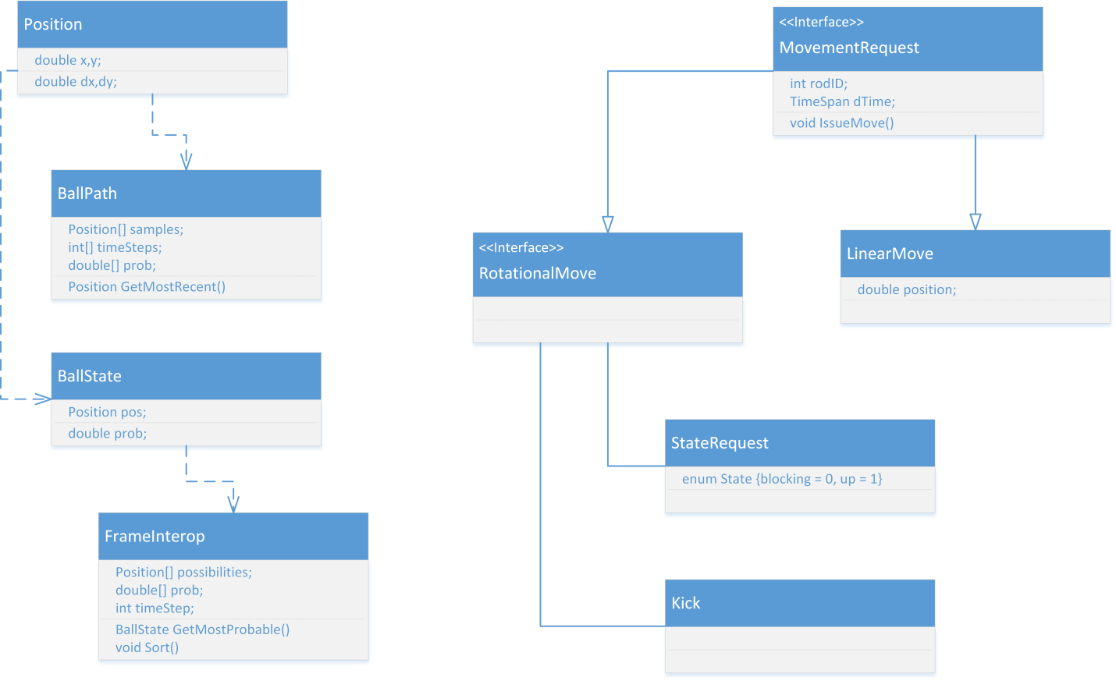
Figure 5.2.1: Class Diagram

6.0 Project Prototype Construction and Coding

6.1 Parts Acquisition

6.1.1 Foosball Table
The foosball table itself is certainly one of the most important physical components of the project. It is the platform on which everything else is built. The requirements for the table have been discussed point-by-point in Section 2.3.5 Table, and the research has been reported in Section 3.2.5.1.
Craigslist was selected as both a market survey and the easiest way to find a locally-obtainable used table. Looking into the used market allowed for, compared to buying a new table, dramatically lower prices, options for negotiation, and the ability to thoroughly inspect the table before purchasing it (in contrast to purchasing from an online retailer).
After shifting focus to the online market, a very high quality Tornado-brand table was located and selected for investigation. Though listed online at $60, the price was negotiated down to only $40. The downside to this purchase was that this table had spent a significant amount of time outside (in a screened-in porch) by a pool, which led to a great deal of rust forming on the rods. With the thick layers of rust, extensive cleaning and lubrication was required before the table would be suitable for modification and use in this project. Overall, the price goal of $60 was met, while still meeting all of the other table specifications.
The purchased table is a nationally-recognized Tornado brand, and a very well built tournament-grade model at that. That indicated (and testing confirmed) that the table would be sturdy and well-built enough to meet the project’s needs.
The selected table does not use bearings to mitigate friction, but rather has plastic guide holes for the rods to slide through. This proved to be sufficient for this project. On purchase, there was significant rust on the table’s rods from having been left exposed to the elements. However, after a thorough cleaning process which included removing the rust from the rods and applying a silicone lubricant, the rods proved to meet the necessary specifications of low rotational and longitudinal drag.
The selected table is light enough to carry up a flight of stairs, but heavy enough to provide a steady playing field to an energetic game of foosball. It is important that the table remain relatively steady under normal operation, as shaking would result in the ball rolling faster or slower than expected and thus making the kinematic algorithms less accurate.
The purchased table has easily removable legs which dramatically improve its transportability.
Upon purchasing the table it was examined and playtested for inconsistencies to ensure that it was suitable for normal use. Being a tournament quality table, it easily met all of the project’s playing field needs.
The selected table has flat corners, which enables the consideration of alternate ball tracking mechanisms, such as LED grids or laser trackers.
The purchased table has a field easily accessible from both sides, which will greatly aid modification, regardless of the final design.

6.1.2 Other Parts
Starting in the spring 2013 semester the senior design group will begin acquisition of the parts needed for assembly of the project. This section discusses the current plan for obtaining these parts, organized at a subsystem level.
Each subsection will discuss the parts specified in the Bill of Materials and discuss the timetable of when this part will be needed by.
Mechanical System Parts Acquisition
The mechanical system is made up of both the electronic hardware that will physically move the control rods and the mounting hardware which will hold everything together. The mounting hardware is entirely made up of things that can be purchased off-the-shelf from a local hardware store. The plan will be to purchase these from a local hardware distributor as the need for prototyping with them arises.
The electronics are more difficult and will likely require specialized ordering. While local distributors like Skycraft will be great for prototyping and finding good deals, it will be hard to depend on them for any specific parts. The nature of a surplus store will make it possible that they will not always have what we need in stock. Online distributors to check for deals include Amazon and Ebay which both have excellent deals on high-quality used linear actuators and servos. However, these sources have the same problem as going to a surplus store: there is a real possibility that the store will not have the desired product in stock. The final fall back would be to get the product new from the original distributor. These sources are either AndyMark for the CIM motors or Sparkfun for the servos. A list of the parts and sources is below in Table 6.1.1.

Summary
Part | Source for Part  (bold shows guaranteed source) | Approximate Date
Plywood | Hardware Store | 1/7/13-1/14/13
Linear Motion Slide | Hardware Store or Skycraft | 1/7/13-1/14/13
Misc. Mounting Brackets Misc. Screws | Hardware Store and Skycraft | 1/7/13-1/14/13
Linear Motion Motor | Skycraft or Ebay or Sparkfun | 1/14/13-1/21/13
Rotational Motion Motor | Skycraft or Ebay or AndyMark | 1/14/13-1/21/13
Table 6.1.1: Necessary hardware components and the sources to acquire them from. An approximate date of acquisition is given based on the current Milestone timeline.
Electronics System Parts Acquisition
Part | Source for Part  (bold shows guaranteed source) | Approximate Date
Encoder for Linear Motion | Sparkfun | 1/28/13-2/4/13
Tactile Sensor for Rotational Motion | Sparkfun or Skycraft | 1/28/12-  2/4/13
TALON Motor Controller | AndyMark or Sparkfun or Skycraft | 1/14/13-  1/21/13
SPIKE Relay | AndyMark or Skycraft | 1/14/13- 1/21/13
PWM Wire | Skycraft | 1/13/13- 1/21/13
USB Cable | Sparkfun | 1/13/13- 1/21/13
18 Gauge Wire | Skycraft | 1/13/13- 1/21/13
The electronics system is made up of the processors and wiring that goes between the RCB, camera and central processor. Also included in this section are the sensors that will be needed to create the table state estimation. The common distributors for this area that the research group has looked into includes Sparkfun Electronics, ServoCity, McMaster, AndyMark, US Digital and some local distributors like Skycraft and used parts from Amazon or Ebay. The primary deciding factor in the acquisition decision is the price, since it has been decided that used parts will be acceptable for this prototype setup.
Table 6.2.2: Necessary electronic components and the sources to acquire them from.
Luckily a number of the electronic parts have been donated or are already owned by the group. These electronics will not be included in the acquisition plan. A summary is in Table 6.2.2.
RCB Parts Acquisition
The custom made PCB for this project, called the Rod Control Board (RCB), will require a number of subcomponents that will be soldered to a printed silicon board that will be ordered from 4PCB with a student discount to make it within the budget of the project. The board will be designed using the Eagle software before sent to 4PCB. The board is made up of 26 separate types of components which will all be soldered to the board. The 26 parts can be seen in the bill of material and will all be acquired through Sparkfun during the first week of the Spring Semester so that breadboard based prototyping may begin quickly.

6.2 BOM
Below is the Bill of Materials for the project. The first table is the BOM for everything except the RCB parts, and the table after that considers only the RCB.

Subsystem | Design Decision | Cost | Quantity | Total Cost | Acquired | Our Cost
Sensor-Camera | Microsoft Kinect | $150.00 | 1 | $150.00 | X | $0.00
Sensor-Linear Motion | Sparkfun COM-10790 | $29.95 | 4 | $119.80 |  | $119.80
Sensor-Rotational Motion | Skycraft Button SK4843 | $2.00 | 8 | $16.00 |  | $16.00
Architecture- CPU | IBM Thinkcentre | $100.00 | 1 | $100.00 | X | $0.00
Architecture- OS | Windows XP | $0.00 | 1 | $0.00 | X | $0.00
Connection- Kinect to CPU | Standard Cable | $0.00 | 1 | $0.00 | X | $0.00
Connection- RCB to CPU | USB Cable | $3.95 | 4 | $15.80 |  | $15.80
Rod Control Board | See Design Below | $72.53 | 4 | $354.26 |  | $302.60
Motor Controller | TALON | $59.99 | 4 | $239.96 |  | $239.96
Relay | SPIKE Relay | $34.95 | 4 | $139.80 |  | $139.80
Actuator- Linear Motion | General Motor | $12.00 | 4 | $48.00 |  | $48.00
Actuator- Rotational Motion | CIM (am-0255) | $28.00 | 4 | $112.00 |  | $112.00
Power Supply | Desktop PC PowerSupply | $34.99 | 1 | $34.99 | X | $0.00
Construction | Plywood | $11.65 | 1 | $11.65 |  | $11.65
 | Drawer Slides | $12.00 | 4 | $48.00 |  | $48.00
 | Belt | $15.00 | 1 | $15.00 |  | $15.00
 | Misc Mounting Brackets | $30.00 | 1 | $30.00 |  | $30.00
 | Misc Screws and Glue | $10.00 | 1 | $10.00 | X | $0.00
 |  |  |  | TotalPrice: | $1,445.26
 |  |  |  | UnaquiredPrice: | $1,098.61
Rod Control Board Parts | Unit Cost | Quantity | Total Cost | Acquired | Project Cost
Fabrication | $33.00 | 4 | $132.00 |  | $132.00
AVR-ATTiny84-Dip14 | $2.95 | 8 | $23.60 | X | $0.00
PIC1F4550-Dip40 | $11.39 | 4 | $45.56 |  | $45.56
Sparkfun PRT-00139 | $1.25 | 4 | $5.00 |  | $5.00
Sparkfun COM-00107 | $1.25 | 4 | $5.00 | X | $0.00
Sparkfun COM-00534 | $0.95 | 12 | $11.40 | X | $0.00
Sparkfun PRT-00119 | $1.25 | 4 | $5.00 |  | $5.00
Sparkfun COM-09190 | $0.50 | 4 | $2.00 |  | $2.00
Sparkfun COM-10924 | $2.95 | 16 | $47.20 |  | $47.20
Digikey 620-1191-1-ND | $3.72 | 4 | $14.88 |  | $14.88
Cap-0603-22pF | $0.01 | 24 | $0.24 | x | $0.00
Cap-0603-100nF | $0.01 | 8 | $0.08 | x | $0.00
Cap-0603-100uF | $0.01 | 8 | $0.08 | x | $0.00
Cap-0603-1nF | $0.01 | 4 | $0.04 | x | $0.00
Resistor-0603-330 Ohm | $0.01 | 4 | $0.04 | x | $0.00
Resistor-0603-5K Ohm | $0.01 | 24 | $0.24 | x | $0.00
Resistor-0603-10M Ohm | $0.01 | 24 | $0.24 | x | $0.00
Resistor-0603-2.5K Ohm | $0.01 | 4 | $0.04 | x | $0.00
Resistor-0603-30 Ohm | $0.01 | 16 | $0.16 | x | $0.00
Sparkfun PRT-08432 | $0.95 | 4 | $3.80 |  | $3.80
Sparkfun PRT-08433 | $0.95 | 4 | $3.80 |  | $3.80
Sparkfun PRT-08084 | $0.95 | 4 | $3.80 |  | $3.80
Sparkfun PRT-08235 | $0.95 | 8 | $7.60 |  | $7.60
Sparkfun COM-09590 | $0.35 | 4 | $1.40 | x | $0.00
Sparkfun PRT-10112 | $0.95 | 8 | $7.60 | x | $0.00
Sparkfun PRT-00116 | $1.50 | 1 | $1.50 | X | $0.00
Sparkfun COM-00521 | $0.68 | 12 | $8.16 |  | $8.16
Sparkfun TOL-00298 | $5.95 | 4 | $23.80 |  | $23.80
Total: | $72.53 | Total: | $354.26 | Total: | $302.60

6.3 Assembly Plan
Due to the large number of complex subsystems in this project here will need to be a logical structure to the final assembly. Smaller subsystems will have priority early in the semester and the construction will slowly build itself up into the larger final components.
Hardware Prototype Plan
Due to concerns about the challenge of constructing the mechanical structure attached to the foosball table, one of the first priorities is to construct a prototype for the rod control. First the 25”x8” plywood will be cut to size and latched against the side of the foosball to determine the necessary bracketing method. If two or more brackets from Home Depot are insufficient to hold the plywood up, then additional leg supports may be connected at the ends. On top of the plywood, the linear motion slides will be attached to test the connection to the rods and the platform. A small 3”x8” piece of plywood will be mounted to the end of the linear slide to act as the platform for the larger CIM motor which controls the rotational subsystem. The CIM motor will be bound down using a 2.5” diameter U bracket. Additional attachments may need to be connected if the test results indicate the single bracket is insufficient for this component. In order to connect the drive shaft of the CIM to the end of the control rod a stabilizing mount and a shaft mate for 5/8” for the control rod to 1/16” to the drive shaft. The final component of the prototype will be a belt driven system to move the platform along the linear slide. The belt will be connected to both ends of the small platform and around two pulleys that go underneath the plywood. The general motor connected to the end of one pulley will provide the power.
Figure 6.3.1 shows a rendered depiction of the first hardware test setup.
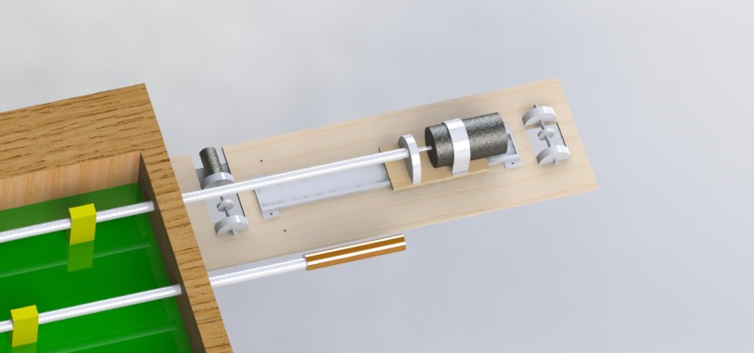
Figure 6.3.1: A top rendering view of the hardware prototype plan
Camera Cage Assembly
The camera must be mounted directly above the foosball table in order to have an appropriate view of the playing field and to simplify the conversion from the image coordinates to real-world coordinates. Prototypes have shown that the camera must be mounted a minimum of 4 ft. above the field to see a complete view of the playing area. The camera cage will be constructed to hold the camera in this position. The cage will be constructed of PVC pipes or 2”x4” planks. Either material will be mounted to the four legs of the foosball table and have two cross-beams across the top of the table. The camera then will hang down from this mount. The wires leading to the camera will be led down the side of the cage mount.
RCB Assembly
The PCB for the RCB will be printed using 4PCB’s student printing discounts. The design includes 26 separate components and 225 individual soldered additions. The design is delineated in detail in section 4.6.1.
Electronic Architecture Assembly
The first component, already acquired, for the electronic system is the small-form-factor IBM Thinkcentre, which acts as the central processing unit for the computer-vision ball detection algorithm and the data acquisition from the RCB. The Thinkcentre will be attached to the bottom of the foosball table playing area to hide it from view in a convenient electronics hub. Once the RCBs have been assembled and the mechanical actuators subsystems have all been constructed, the Thinkcentre will be connected to the RCBs using standard USB connections. The test plan from section 7.2.1 will be used to ensure proper connection between the RCB’s PIC processor and the CPU. The final component of the electronics hardware is the Kinect camera which will be mounted to the structure discussed in the earlier hardware assembly instruction. The Kinect will also be connected to the Thinkcentre via USB cable packaged with the sensor.
In order to route power to all components the PC power supply will be mounted to the bottom of the foosball table near the CPU. Coming from the power supply will be 12V, 5V and 3.3V leads which will be distributed to the necessary locations. The 12V leads will power the motor controllers for the linear motion and the relays connecting to the Rotational motion. The 5V will lead to the AVR and PIC processors as well as some sensors which will need additional power. The 3.3V leads will finally supply power to some of the smaller sensors around the board.

6.4 Final Coding Plan
The modules for this project are divided into 2 major components, the microcontroller code and the main computer code. Because of the vastly different environments required to program each, they will each be addressed separately.
Microcontroller Code
The microcontroller code for the AVRs will be written in Eclipse IDE and then be compiled with GCC-AVR and burned to the board using an off the shelf, previously acquired AVR programmer. The preferred development operating system for this is Linux; however, a desire to keep things consistent will impose a requirement to use Windows to program the AVR chips.
The microcontroller code for the PIC chips will be written in MPLAB by Microchip and burned to the PIC microcontroller. A “PICSTART Plus Flash” by Microchip® will be used to burn the PIC controller. The MPLAB IDE is cross-platform and will run in Windows®.
The burning process for the microcontroller will involve attaching programming leads to each RCB and re-flashing each microcontroller on each board. A total of 12 microcontroller will need to be flashed.
General Purpose Computing Code
Microsoft® VisualStudio® 2012 Ultimate will be used to program the primary computer, including the table state interpreter and AI algorithm. Microsoft® .NET® 4.5 will be used to take advantage of the latest code optimizations and features in the new SDK for the Kinect®. Microsoft® .NET® will also simplify the process of serial I/O because prebuilt, buffered serial I/O classes already exist in .NET®. Because of the inconvenient position of the computer, being mounted under the table, the VisualStudio® remote debugger will be used. The remote debugger has the ability to deploy and remotely control and debug applications running anywhere on a local or remote network. In order to provide a robust debugging system to allow improvements to the computer vision subsystem, a simple web UI will likely be developed to allow monitoring of the images captured by the Kinect® remotely. This remote UI will also allow analysis of the results for testing purposes by marking the determined positions of the ball on the images returned.
To address the requirement of a remote debugging and control infrastructure that will be carrying high-resolution images very quickly, the requirement of gigabit Ethernet is imposed on the control computer. The computer selected for use in this project already has gigabit Ethernet and thus this requirement will only need to be considered if replacing the main computer.

7.0 Project Prototype Testing

7.1 Hardware Testing Environment
In order to conduct the hardware tests, the senior design team requires a large space with a number of specialized tools. The foosball table itself is fairly large and must be contained in a space that can hold it as well as have enough room to move around the mechanical parts and mount them to the table. If needed, the table can be moved to a team member’s garage for mechanical prototyping; however, the first plan is to construct and assemble most of the prototypes in a large room in a team member’s apartment.
The tools required for mechanical testing include a number of measuring implements for mechanical spec checking. Multimeters and oscilloscopes will be on hand during the mechanical testing to debug electronic bugs. In order to conduct the mechanical component test plan the room must have adequate power, in the form of power outlets, within distance of the table to plug the power supply and all testing equipment or power tools.
When tests are run on individual mechanical components they will be initially attached to the defender (second from goalie) control rod on the foosball testing for initial testing. This pole will the first prototype test pole due to it having the greatest stroke length and the greatest distance between puppets. This will give the first tests the benefit of being on the most challenging rod, so once moved to poles with less stroke and higher tolerance for error, they will still be able to perform at the needed level. Tests will involve small simulated games to test the functionality and performance of the mechanical subsystem. Before the electronic system is fully operational though the tests will likely be run using mechanical switches directly between a power supply and the electronics to simply test the effect of the power on the system with no control.
The following sections outline specific tests that will be run during the testing phase:

7.2 Hardware Specific Testing

7.2.1 Electronic Component Test Plan
The only electronic component in this project that we are designing and therefore must test is the rod control board, discussed in detail in section 4.6. The interaction between our components and off the shelf components will be tested later, once isolated tests on the rod control board are completed.
The communication of the rod control board is designed to be one directional and may be tested as such. The 3 signals that can be sent to an RCB are “go to a linear position”, “go to a resting radial position” (“up” or “blocking”) and “perform kick.” Because of the modularity of these commands they may be tested individually.
Radial Motion
To test kick control, a series of LEDs can be setup in place of the kick motor control line, this will be used to avoid potentially breaking components with malfunctioning software. Once setup, the commands for “up”, “blocking” and “perform kick” can be sent, this will require human interaction with the tactile sensors to give the microcontroller the correct time to stop. The following tests must be performed and passed to consider the rod control board’s radial motion control complete.
- Basic stay in “up” mode test
This test will be used to test what will happen if gravity rotates a rod out of the “up” position. When this happens, the rod should return to the “up” position.
  - Starting Setup
    - Tactile “up” sensor depressed
    - Move to “up” state command sent
  - Actions
    - Tactile “up” sensor released
  - Expected Results
    - Rod should rotate back to the “up” position in slow movement mode
  - Actions
    - Tactile “up” sensor depressed
  - Expected Results
    - Rod should stop rotating
- Basic stay in “blocking” mode test
This test will be used to test what will happen if gravity or an opponent’s kick rotates a rod out of the “blocking” position. When this happens, the rod should return to the “blocking” position.
  - Starting Setup
    - Tactile “blocking” sensor depressed
    - Move to “blocking” state command sent
  - Actions
    - Tactile “blocking” sensor released
  - Expected Results
    - Rod should rotate back to the “blocking” position in slow movement mode
  - Actions
    - Tactile “blocking” sensor depressed
  - Expected Results
    - Rod should stop rotating
- Move to “up” state from “blocking” state
This test will simulate a need to raise a row of puppets in preparation for a kick by another rod.
  - Starting Setup
    - Tactile “blocking” sensor depressed
    - Move to “blocking” state command sent
  - Actions
    - Send “up” command
  - Expected Results
    - Rod should rotate back to the “up” position in slow movement mode
- Move to “blocking” state from “up” state
This test will simulate a need to lower a row of puppets in preparation for to block an opponent’s kick.
  - Starting Setup
    - Tactile “up” sensor depressed
    - Move to “up” state command sent
  - Actions
    - Send “blocking” command
  - Expected Results
    - Rod should rotate back to the “blocking” position in slow movement mode
- Move to “up” state from null state
This is an important state to make sure the microcontroller will not lose a command if sent while performing another action. It will test what will happen if a command to go to “blocking” mode comes in when moving back to the “up” position when gravity moves the rod out of position.
  - Starting Setup
    - Tactile “up” sensor depressed
    - Move to “up” state command sent
    - Tactile “up” sensor released
  - Actions
    - Send “blocking” command (before move to “up” is complete)
  - Expected Results
    - Rod should be rotating to the “up” position
    - Rod should then begin rotating to the “blocking” position in slow movement mode (before move to “up” position is complete)
- Kick from “up” state
Basic test of kicking.
- Starting Setup
    - Tactile “up” sensor depressed
    - Move to “up” state command sent
  - Actions
    - Send “kick” command
  - Expected Results
    - Rod should move forward in high speed mode
  - Actions
    - Depress “blocking” sensor
  - Expected Results
    - Rod should move backwards to the “up” position at slow speed
  - Actions
    - Tactile “up” sensor depressed
  - Expected Results
    - Rod should stop moving
- Kick from “blocking” state
Basic test of kicking, but now in blocking mode
- Starting Setup
    - Tactile “blocking” sensor depressed
    - Move to “blocking” state command sent
  - Actions
    - Send “kick” command
  - Expected Results
    - Rod should move backwards in high speed mode
  - Actions
    - Depress “up” sensor
  - Expected Results
    - Rod should move forward in high speed mode
  - Actions
    - Depress “blocking” sensor
  - Expected Results
    - Rod should stop
Linear motion
The only electronic component in this project that we are designing and therefore must test is the rod control board, discussed in detail in section 4.6. The interaction between our components and off the shelf components will be tested later, once isolated tests on the rod control board are completed.
The communication of the rod control board is designed to be one directional and may be tested as such. The 3 signals that can be sent to an RCB are “go to a linear position”, “go to a resting radial position” (“up” or “blocking”) and “perform kick.” Because of the modularity of these commands they may be tested individually.

Radial Motion
To test kick control, a series of LEDs can be setup in place of the kick motor control line, this will be used to avoid potentially breaking components with malfunctioning software. Once setup, the commands for “up”, “blocking” and “perform kick” can be sent, this will require human interaction with the tactile sensors to give the microcontroller the correct time to stop. The following tests must be performed and passed to consider the rod control board’s radial motion control complete.
- Basic stay in “up” mode test
This test will be used to test what will happen if gravity rotates a rod out of the “up” position. When this happens, the rod should return to the “up” position.
  - Starting Setup
    - Tactile “up” sensor depressed
    - Move to “up” state command sent
  - Actions
    - Tactile “up” sensor released
  - Expected Results
    - Rod should rotate back to the “up” position in slow movement mode
  - Actions
    - Tactile “up” sensor depressed
  - Expected Results
    - Rod should stop rotating
- Basic stay in “blocking” mode test
This test will be used to test what will happen if gravity or an opponent’s kick rotates a rod out of the “blocking” position. When this happens, the rod should return to the “blocking” position.
  - Starting Setup
    - Tactile “blocking” sensor depressed
    - Move to “blocking” state command sent
  - Actions
    - Tactile “blocking” sensor released
  - Expected Results
    - Rod should rotate back to the “blocking” position in slow movement mode
  - Actions
    - Tactile “blocking” sensor depressed
  - Expected Results
    - Rod should stop rotating
- Move to “up” state from “blocking” state
This test will simulate a need to raise a row of puppets in preparation for a kick by another rod.
  - Starting Setup
    - Tactile “blocking” sensor depressed
    - Move to “blocking” state command sent
  - Actions
    - Send “up” command
  - Expected Results
    - Rod should rotate back to the “up” position in slow movement mode
- Move to “blocking” state from “up” state
This test will simulate a need to lower a row of puppets in preparation for to block an opponent’s kick.
  - Starting Setup
    - Tactile “up” sensor depressed
    - Move to “up” state command sent
  - Actions
    - Send “blocking” command
  - Expected Results
    - Rod should rotate back to the “blocking” position in slow movement mode
- Move to “up” state from null state
This is an important state to make sure the microcontroller will not lose a command if sent while performing another action. It will test what will happen if a command to go to “blocking” mode comes in when moving back to the “up” position when gravity moves the rod out of position.
  - Starting Setup
    - Tactile “up” sensor depressed
    - Move to “up” state command sent
    - Tactile “up” sensor released
  - Actions
    - Send “blocking” command (before move to “up” is complete)
  - Expected Results
    - Rod should be rotating to the “up” position
    - Rod should then begin rotating to the “blocking” position in slow movement mode (before move to “up” position is complete)
- Kick from “up” state
Basic test of kicking.
- Starting Setup
    - Tactile “up” sensor depressed
    - Move to “up” state command sent
  - Actions
    - Send “kick” command
  - Expected Results
    - Rod should move forward in high speed mode
  - Actions
    - Depress “blocking” sensor
  - Expected Results
    - Rod should move backwards to the “up” position at slow speed
  - Actions
    - Tactile “up” sensor depressed
  - Expected Results
    - Rod should stop moving
- Kick from “blocking” state
Basic test of kicking, but now in blocking mode
- Starting Setup
    - Tactile “blocking” sensor depressed
    - Move to “blocking” state command sent
  - Actions
    - Send “kick” command
  - Expected Results
    - Rod should move backwards in high speed mode
  - Actions
    - Depress “up” sensor
  - Expected Results
    - Rod should move forward in high speed mode
  - Actions
    - Depress “blocking” sensor
  - Expected Results
    - Rod should stop
Linear motion
The linear motion must also be tested, however because most of the control is happening on external controllers, less testing is needed. The testing setup will be a voltage probe will be attached to the PWM output of the rod control board and ground.
The initial setup action of the board should be to slowly move the rod in one direction until the rotary movement in the encoder stops, thus we should rotate the encoder slowly and stop. There should be a low positive voltage on the readout. Then once the rotation on the encoder stops, the voltage should go to negative in the opposite direction. Again, once the motion stops the voltage should change to zero. The sequence described above will be sufficient to test initialization sequence of the linear motion actuators. These steps will also be used to before testing of the motion control.
To test the motion control algorithms, the initialization sequence will be done; however the starting and ending positions on the rotary encoder must be remembered because these will serve as the reference points to the controller.
The first test will be moving to a position that we are already at, the rotary encoder should be set to center position and the command to move to center should be sent, the voltage should remain at 0v.
The second test will be basic movement test, the encoder will be set to the rightmost position and then the command to move to the center will be sent. The voltage should rise until the encoder is approx. half way to the center, at which time is should go to negative and rise to 0 when the target I hit. This test can be repeated with target over shoot and under shoot.
The third and final test is a drift test, after a successful completion of the first test, the encoder should be rotate to another position the voltage should be driven (negative or positive) until the encoder returns to the proper position when it should return to 0.
Trouble shooting
If the microcontrollers are not behaving as expected they will be debugged with a Saleae® logic8® a high speed, low cost digital oscilloscope. This has the advantage be being able to read serial debug data off a single pin on each microcontroller and observing inter chip communication busses.
Conclusion
Once these tests are completed, the RCBs may be connected to their final intended components and tested again in place.

7.2.2 Mechanical Component Test Plan
The mechanical subsystem is composed of the linear and rotational subsystems that will both need to be tested independently. This section lists a number of tests that will be run to verify correct functionality of each subsystem.
Mounting Support
Tested System: The mounting of the rod control subsystem to the side of the foosball table.
Test Description: Depending on the weight of the control board and motors used on the rod control subsystem the mounting system may need different amounts of support. It is possible that the initial setup will be ineffective for long duration holding of the table. In order to test this small weights between 5-10 pounds will be added to the very end of the control board. This test will simulate extra weight from a person bumping into the system and all the extra wear and tear from prolonged hanging.
Test Actions: If the test fails, then the mounting subsystem may require additional supports in the form of support bars from the bottom of the table to the end of the platform or even as far as table legs for the end of the platform.
Rotational Motion/Kick Strength
Tested System: The rotational subsystem is comprised of the motor attachment to the platform on the linear slide and the adapter between the 5/8” pole shaft and the smaller drive shaft on the output of the motor.
Test Description: The primary attribute to be tested is resilience and durability, to ensure that the kicking subsystem will not damage itself or fail during operation. The motor will be wired to a power supply directly with a single mechanical switch as the control. The kick will be done full force forward and backwards repeatedly. The subsystem will be checked for wear or damage. A sub-goal of the test will be to investigate the force of the kick. A ball will be placed in front of the puppet and the kick will be recorded on camera. The velocity of the kick can be measured and compared to the requirements of this document.
Test Actions: If the kick is damaging itself or showing signs of wear the mechanical subsystem may require better mechanical stops to stop this from happening. These stops are discussed in section 4.4.1. If the kick power is too low then the motor will be re-evaluated and possibly geared for greater speed or greater torque depending on the need.
Linear Motion/Slide Speed
Tested System: The linear slide comprises the sliding rails that the platform containing the rotational subsystem rides on. This slide must be able to move between the full stroke specified and with great enough speed to play a competitive game.
Test Description: A mechanical switch will be wired between a power supply and the motor to test the motion. Full motion strokes will test the physical stops on the end. The movement will be recorded on a video camera so the speed of the movement can be calculated and compared to the requirements laid out in section 2.3.3.
Test Actions: If the slide is moving below specification then the motor used in the subsystem will be re-evaluated and potentially changed. If the slide motion is not moving along the entire stroke or the platform is moving with more friction than anticipated either more lubricant or a change of slide design will be considered.

7.3 Software Testing Environment
There are 2 different kinds of software in this project, the software on the microcontrollers in the rod control boards and the software running on the PC. The testing of the microcontroller software is covered in section 7.2.1, electronic component testing. The testing of primary software modules will be addressed here.
Every software module on the computer will be running in the .NET framework®, and thus can all be tested from one environment. Because VisualStudio® is being used for component coding, its test manager will also be used for testing. The unit test manager provides an easy to code interface that can be test all components within a solution or test individual functions. The added bonus of using the test manager is that tests can be run locally where we are coding the modules and then be run on the remote machine to validate speed testing.
The software can be divided into 3 modules with clear I/O: table state interpreter, persistence filter (Kalman filter) and the AI. These are the modules that will be unit tested in addition to any other sub-component that may be particularly complex or prone to failure.
Once unit testing of the individual components is complete, the functional testing of the entire project may begin.

7.4 Software Test Plan
The plan is to individually test the table state interpreter, persistence filter (RANSAC/Kalman filter) and the AI separately, since they have well defined I/O.
Table State Interpreter
The table state interpreter acquires its input from the Kinect. In order to modularly test this module the input must remain constant for the output to be monitored for correctness. The video stream from the Kinect can be divided into frames, which then can be dumped in their binary format using a standard .NET serializer to the hard drive. When it’s time to test the module, these images can be loaded from the hard drive and run through as if it were running live.
This module will output one or more high probability matches for the ball, this will dynamically adapt the threshold for ball detection. It can be dynamically adapted because we know there will likely be one ball on the playing field. Because of this dynamic threshold multiple test images will have to be used. Some images that will need to be included in the test library are (with respect to the ball) plainly visible, partially visible (partly occluded by puppet or rod) and completely occluded. A third test image where no ball is present may be added if desired.
The output of this module will be one of several possible matches for the ball relative to the table. In order to normalize the foosball position to the table, the table must first be identified. To test these algorithms, images where the table is off center and skewed will also be included in the test library.
Persistence Filter
The output from the table state interpreter will be one or multiple matches to the ball. A series of these outputs will form an input test case for the persistence filter. To test the RANSAC part of the algorithm, images where multiple balls register on each frame will be used. To test the Kalman filter part of the algorithm data sets with few balls per frame but where the ball changes path frequently will be used. In addition a test set will need to include a case where no ball is registered in every few frames, the output of the Kalman filter should be able to extrapolate where the ball is.
The output from the persistence filter will be a single ball position even when the input is no ball. This ball position will be data feed for the AI.
AI
The AI will need to have many sets of data from the persistence filter. The output from the AI will be the desired “moves” of the rotational and linear motors. Because the timing and exact values of position will change as the algorithm improves, the result of the unit tests will have to be validated by hand.
Integration Testing
Once all components have been tested individually unit tests that start with video and end in the output from the AI will be used to test inter-component communication. Functional testing with an actual human opponent will be used once the integration tests have been finished.

8.0 Administrative Content

8.1 Milestone Discussion
The following timeline, shown in figure 8.1.1 below, has been laid out in order to reach our goal of a working table by the end of March 2013, in time to complete senior design.
Figure 8.1.1: Project completion timeline
The timeline was laid out paying particular attention to having hardware ready before software because the limiting factor for quality of project will be the hardware controlling the table.

8.2 Budgeting and Finance
Referencing the Bill of Materials, the cost of each product can be found in section 6.2. As shown by this table, it can be seen that the total cost of the project (excluding the cost of parts already acquired) is $978.57. Our initial project budget was proposed at $1,000. Thus our projected budget puts us within our ideal range for cost. Likely many problems will occur during the construction and testing phases of this project. Many common issues that occur to cause extra expenses include:
- Realization of incorrect design decisions, leading to additional parts being purchased
- Inaccurate quotes on materials.
- Increased necessary supply. This will be most likely during the construction of mounting equipment (e.g. not realizing that an additional bracket set will be needed)
- Destruction of working materials (e.g. burning out motors and PCB boards)
- Change in design requirements
Because these mistakes are extremely common in a real-world environment, and because this is a learning project where incorrect designs can be discovered after purchases have been made, a 30% buffer is designed into the budget to cover any of these expenses. This puts the maximum allotted budget at $1,500.
Funding for this project will come primarily through SoarTech Inc. SoarTech has donated $500 to the FOOSE project team to cover many of the basic expenses of the construction. More information about SoarTech can be found in the Mentorship and Sponsors section of this documentation (8.3.1 SoarTech).
The rest of the funding will come from the members of the group. With a total project cost, after accounting for previously acquired parts, the project comes out to $978.57. SoarTech has generously covered $500 of it, leaving $478.57 remaining for the four group members to split equally. This comes out to $119.65 per group member of additional expenses. However, this is using the ideal scenario in which the project expenses is exactly as predicted. In the case of the budget reaching its maximum limit of $1,500, the remaining balance for the group members becomes $1,000 or $250 per group member of additional expenses. These additional expenses will be paid for out of pocket.
One final possibility for funding comes from a post-project sale. After the project is completed and constructed it will be possible to sell the final product (foosball table and automated hardware) to a prospective buyer. This will subsidize the out of pocket cost per member through a rebate. A few prospective buyers have already been found and the final performance achieved by the project will determine its final selling value. Moreover, the value of the FOOSE project will not include any technical support. Most mechanic/arcade games will come with guarantees and technical support options; however, in this project all of the creators will be graduated and no longer supporting the upkeep of the project. Therefore, the publically available documentation will be the sole source for any technical problems that arise after sale.

8.3 Mentors and Sponsors

8.3.1 Soartech
SoarTech is the sole sponsor for this project. SoarTech is a small company that specializes in commercial applications of the Soar Architecture, which was created at Carnegie Mellon. The Soar Architecture is a programming language that is designed to create rule-based artificial intelligence algorithms. Thus, SoarTech is a company that finds financial opportunities to implement AI in real-world applications, typically military in nature. With a specialty in applications of AI, SoarTech created an outreach program to fund some local engineering senior design teams. After sending in a proposal which included an executive summary, expected block diagrams, budget analysis, and a milestone table, among other documents, this project was granted a $500 sponsorship to help fund expenses.
In addition to funding, SoarTech has been kind enough to offer mentorship as well, in the form of specific one-on-one feedback and group feedback in the form of presentations and question and answer forums. For example, on November 14th, 2012 the members of this project presented a current working design of the project along with plans for implementing the design. During the presentation, the project design was rigorously questioned and analyzed by more than six engineers who specialize in software design and implementation. This was a very productive feedback session; new ideas for ball detection, AI design, table physics modeling, and more were exchanged. All-in-all, SoarTech’s mentorship has been extremely helpful and the members of this project greatly appreciate the feedback its employees have offered.
The following is a short written statement given by SoarTech after the presentation:
This past Wednesday the two University of Central Florida Electrical and Computer Engineering Senior Design teams that SoarTech is sponsoring as part of the Orlando community outreach came to the office and presented their current working designs and plans for how they would be going about implementing them. The “No Touch” Chess team is developing a voice controlled self-actuating chess board with 2-player and 1-player versus AI modes. The “FOOSE” automated foosball table team is developing an AI controlled opponent that will actuate one of the foosball teams.
Both teams are very ambitious and we look forward to seeing how their implementations progress this spring!
Picture courtesy SoarTech, Inc.
Figure 8.3.1.1, Presentation at SoarTech Oviedo office, 11/14/12.
From left to right: Nathaniel Enos, Nick Phillips, Skyler Goodell, Patrick Fenelon
The above picture was taken directly after the presentation and feedback session at SoarTech. This group is extremely thankful for SoarTech’s generosity and proud to be associated with its employees.
Special thanks must be given to Joshua Haley, of SoarTech. Josh has been the lead contact and liaison between SoarTech and FOOSE and a great mentor for this project. As a recent UCF graduate (Class of Spring 2012) with a major in computer engineering, he has been a great contact and has given much guidance.
The greatest thanks must be given to SoarTech. Without their funding and guidance this project would not have been possible. The members of this project greatly appreciate the generous donation of time and resources given by all of the employees involved in this outreach program.

8.3.2 Mentors
Joshua Haley
Joshua Haley has been a great help for this team and this project. He has been the lead contact between FOOSE and SoarTech, leading to this team’s sponsorship. In addition to heading communication, he has also given feedback for our project. As a recent University of Central Florida graduate (class of spring 2012) his experience with computer engineering and previous senior design projects is invaluable. His specialty is software, as an employee for SoarTech he is well versed in practical applications of artificial intelligence. He has also given advice on image processing techniques and problems that might be encountered along the way. Overall, Josh has been extremely helpful for this team.
Brandon Parmeter
Brandon is a fourth year electrical engineering student at the University of Central Florida. He is also the captain of the underwater vehicle division of the UCF robotics club, on the team he specializes in peripheral design and electronic fabrication. His experience in robotic design and control is invaluable for this team. He has given insight into real-world problems and performance from different kind of robotic components, specifically about actuators, motor controllers, and sensors. In this project, many of the design decisions have been reviewed by Brandon to ensure no major aspect has been missed, no part purchased for too much, and no optimal solution left unconsidered. In a team full of software and electrical specialists, a mentor like Brandon, a specialist in robotics has been extremely helpful.
Ryan Moorin
Ryan Moorin is a mechanical engineering student at Valencia College with 8 years of experience designing components for competitive robotics. He has provided valuable support to the project in the form of advice for possible mechanical subsystems that he has experience with. He has offered support in fabricating small parts or designing and debugging components in the mechanical subsystem. Next semester Ryan will likely be one of the mentors keeping an eye on the mechanical structure to give the essential mechanical engineer’s opinion on our design.
Dan Richardson
Dan Richardson is a mechanical engineer working at Disney. He has provided advice on the mechanical subsystem via email to the senior design group. Dan will be a contact for advice and review on the mechanical design and decisions in the spring 2013 semester as the team works on building the table.

8.4 Bibliography

[1] | H. S. THORNTON, "Apparatus for playing a game of table football". United States of America Patent 205,991, 1 November 1922.
[2] | R. Janssen, J. de Best and R. van de Molengraft, "Real-Time Ball Tracking in a Semi-automated Foosball Table," RoboCup 2009: Robot Soccer World Cup XIII, pp. 128-139, 2010.
[3] | E. G. Hijkoop, "Technical University of Eindhoven," 25 December 2007. [Online]. Available: http://www.mate.tue.nl/mate/pdfs/8876.pdf. [Accessed 17 November 2012].
[4] | foosball.com, "Questions to the Expert," foosball.com, 2011. [Online]. Available: http://www.foosball.com/content.php?page=87. [Accessed 13 November 2012].
[5] | Sage Didactic, "Robotic Foosball- YouTube," 9 January 2008. [Online]. Available: http://www.youtube.com/watch?v=KFAfwtsxarU. [Accessed 20 October 2012].
[6] | D. Quick, "Man vs Machine foosball," Gizmag, 2 July 2008. [Online]. Available: http://www.gizmag.com/automated-foosball-table/9568/. [Accessed 20 October 2012].
[7] | T. Weigel, "KiRo – A Table Soccer Robot Ready for the Market," in Proceedings of the 2005 IEEE International Conference on Robotics and Automation, Freiburg, Germany, 2005.
[8] | J. Topolsky, "DIY robotic foosball table is ready to throw down," Engadget, 26 December 2007. [Online]. Available: http://www.engadget.com/2007/12/26/diy-robotic-foosball-table-is-ready-to-throw-down/. [Accessed 22 October 2012].
[9] | S. Rodgers, Just Turn It On and TRAK: A White Paper on G4™ Motion Tracking Technology, Polhemus, July 2011.
[10] | SparkFun Electronics, "Triple Axis Magnetometer Breakout - MAG3110," SparkFun Electronics, [Online]. Available: https://www.sparkfun.com/products/10619. [Accessed 15 October 2012].
[11] | Freescale Semiconductor, "Xtrinsic MAG3110 Three-Axis, Digital Magnetometer," October 2012. [Online]. Available: http://cache.freescale.com/files/sensors/doc/data_sheet/MAG3110.pdf?fpsp=1. [Accessed 30 October 2012].
[12] | Digi-Key Corporation, "MAG3110FCR1 Freescale Semiconductor," Digi-Key Corporation, [Online]. Available: http://www.digikey.com/product-detail/en/MAG3110FCR1/MAG3110FCR1CT-ND/3524267. [Accessed 30 October 2012].
[13] | S. D. a. Y. Wu, "Motion from Blur," [Online]. Available: http://vision.eecs.northwestern.edu/research/IP/Blur/Motion_CVPR08.pdf. [Accessed 30 October 2012].
[14] | Arduino, "Arduino Uno," Arduino, Inc., 23 November 2012. [Online]. Available: http://arduino.cc/en/Main/ArduinoBoardUno. [Accessed 24 November 2012].
[15] | Mouser Electronics, "Development Boards & Kits," Mouser Electronics, Inc., [Online]. Available: http://www.mouser.com/search/refine.aspx?Ntk=P_MarCom&Ntt=146302706&N. [Accessed 24 November 2012].
[16] | Xilinx Inc., "What is an FPGA? Field Programmable Gate Array," Xilinx Inc., [Online]. Available: http://www.xilinx.com/training/fpga/fpga-field-programmable-gate-array.htm. [Accessed 20 November 2012].
[17] | R. R. R. Ponneela Vignesh, "Performance and Analysis of Edge detection using FPGA Implementation," International Journal of Modern Engineering Research, vol. 2, no. 2, pp. 552-554, 2012.
[18] | K. A. a. O. D. Samir Tagzout, "Hough Transform Algorithm for FPGA," 2000. [Online]. Available: http://perso.telecom-paristech.fr/~polti/robot/docs/Hough/Hough%20Transform%20Algorithm%20for%20FPGA%20.pdf. [Accessed 20 November 2012].
[19] | G. C. a. L. Guo, "The FPGA Implementation Of Kalman Filter," in Proceedings of the 5th WSEAS Int. Conf. on Signal Processing, Computational Geometry & Artificial Vision, Malta, 2005.
[20] | Altera Corporation, "DE2 Development and Education Board," Altera Corporation, [Online]. Available: http://www.altera.com/education/univ/materials/boards/de2/unv-de2-board.html. [Accessed 20 November 2012].
[21] | Atmel, Inc, "8-bit AVR Microcontroller with 4/8/16/32K Bytes In-System Programmable Flash," February 2009. [Online]. Available: http://www.sparkfun.com/datasheets/Components/SMD/ATMega328.pdf. [Accessed 20 November 2012].
[22] | SparkFun, Inc, "AVR 40 Pin 16MHz 32K 8A/D - ATMega32," SparkFun, Inc, [Online]. Available: https://www.sparkfun.com/products/209. [Accessed 20 November 2012].
[23] | SparkFun, Inc, "40 Pin AVR Development Board w/USB Connection," SparkFun, Inc, [Online]. Available: https://www.sparkfun.com/products/32. [Accessed 20 November 2012].
[24] | A. L. Shimpi, "Zotac's Ion: The World's First mini-ITX Ion Board," AnandTech, Inc, 12 May 2009. [Online]. Available: http://www.anandtech.com/show/2765/5. [Accessed 20 November 2012].
[25] | FIRST, "FIRST At A Glance," FIRST, 19 October 2012. [Online]. Available: http://www.usfirst.org/aboutus/first-at-a-glance. [Accessed 21 November 2012].
[26] | VEX Robotics, Inc., "Jaguar Motor Controller," VEX Robotics, Inc., [Online]. Available: http://www.vexrobotics.com/products/vexpro/217-3367.html. [Accessed 21 November 2012].
[27] | Texas Instruments, Inc., "Board Data Sheet: Brushed DC Motor Control Module," 9 February 2010. [Online]. Available: http://www.ti.com/lit/ug/spmu046b/spmu046b.pdf. [Accessed 21 November 2012].
[28] | Cross the Road Electronics, LLC, "Talon User Manual: Brushed DC motor controller Version 1.1," 9 September 2012. [Online]. Available: http://www.crosstheroadelectronics.com/Talon_User_Manual_1_1.pdf. [Accessed 21 November 2012].
[29] | FIRSTIntern, "Control System Basics," instructables, 20 August 2012. [Online]. Available: http://www.instructables.com/id/Control-System-Basics/step5/Motor-Controllers/. [Accessed 21 November 2012].
[30] | The Robot MarketPlace, "IFI VEX Pro Victor 884," The Robot MarketPlace, [Online]. Available: http://www.robotmarketplace.com/products/IFI-V884.html. [Accessed 21 November 2012].
[31] | P. Hood-Daniel, "Microcontrollers - Introduction to PWM (Pulse Width Modulation)," NewbieHack.com, 29 December 2011. [Online]. Available: http://www.youtube.com/watch?v=mVx02s1fHIY. [Accessed 29 November 2012].
[32] | FIRSTIntern, "Control System Basics," instructables, 20 August 2012. [Online]. Available: http://www.instructables.com/id/Control-System-Basics/#step1. [Accessed 29 November 2012].
[33] | USBCable.com, "USB Cables," USBCable.com, [Online]. Available: http://www.usbcable.com/usbbasics.htm. [Accessed 29 November 2012].
[34] | K. Najjar, "Team Foosbot," 7 May 2012. [Online]. Available: http://teamfoosbot.blogspot.com/. [Accessed 10 November 2012].
[35] | E. G. Hijkoop, "Designing a foosball table actuator.," 25 December 2007. [Online]. Available: http://www.mate.tue.nl/mate/pdfs/8876.pdf. [Accessed 10 November 2012].
[36] | M. Aeberhard, S. Connelly, E. Tarr and N. Walker, "Single Player Foosball Table with," 10 December 2007. [Online]. Available: http://www.eskibars.com/projects/foosball_robot/final_rpt.pdf. [Accessed 10 November 2012].
[37] | R. J. d. B. a. R. v. d. M. Janssen, "Real-Time Ball Tracking in a Semi-automated Foosball Table," RoboCup 2009: Robot Soccer World Cup XIII, pp. 128-139, 2010.
[38] | A. Alsalihi, K. Najjar, B. Van Scoy and J. Zifer, "Automated Foosball Table Project Design Report," 28 November 2011. [Online]. Available: https://uakron.edu/dotAsset/1e2fb3d4-8c59-475e-9473-ed98b2504f17.pdf. [Accessed 10 November 2012].
[39] | K. Ogata, Modern Control Engineering, Upper Saddle River, NJ: Prentice Hall, 2010.
[40] | SHARIF UNIVERSITY OF TECHNOLGY, "Introduction to PID Control," [Online]. Available: http://ee.sharif.edu/~industrialcontrol/Introduction_to_PID_Control.pdf. [Accessed 21 November 2012].
[41] | Thompson Sporting Goods, "Tornado Foosball Tables," Thompson Sporting Goods, [Online]. Available: http://www.foosballstore.com/display/scat/price/77.cfm. [Accessed 13 October 2012].
[42] | JustFoosballTables.com, "Foosball Tables Buying Guide," JustFoosballTables.com, [Online]. Available: http://www.justfoosballtables.com/foosball-tables/foosballbuyingguidearticle.cfm. [Accessed 13 October 2012].
[43] | FoosManchu, "Foosball Tables," FoosManchu, 2003. [Online]. Available: http://www.foosmanchu.com/tables/index.html. [Accessed 13 October 2012].

9.0 Appendix- copyright requests

Copyright requested from Altera
Copyright requested from Freescale Semiconductor
Hello Jack,
I am a student an the University of Central Florida working on a senior design project that is considering use of the MAG3110 3-axis magnetometer.
I would like to ask for your companies permission to use schematics, drawings and diagrams from the document cited below in the documentation pertaining to my project.
"3-Axis, Digital Magnetometer"
Document Number: MAG3110
Rev 5, 05/2011
Thank you for your time.
--Patrick Fenelon
Copyright requested from Pearson Education
To Whom It May Concern,
I would like to obtain permission to use a few of the figures in your book, “Modern Control Engineering”, fifth edition by Ogata. Specifically the figure I am interested in is figure 8-3 and many of the other figures of chapter 8 showing the different tuning methods of the PID compensator. I am currently a student at the University of Central Florida working on senior design documentation. I would be using these figures in the research portion of this paper to discuss the different methods of control design. All of the figures used will be cited properly giving credit to the authors and publishers. Once complete, these designs will not be sold or used for financial gain. They will only be used for the academic paper. Also, once the design is complete it will be publically available.
Please let me know if I may use a few of your figures, I would greatly appreciate using them for clarifying my documentation.
Thank you for the time,
Nathaniel Enos

Copyright requested from Polhemus, Inc.
Hello Polhemus,
I am a student working on a senior design project and I am considering use of the G4 tracker in my project. The project is currently in initial research stage.
I would like permissions to use the images in the document titled "Just Turn It On and TRAK: A White Paper on G4™ Motion Tracking Technology" in my documentation on the project, subject to any stipulations you may imply.
Thank you for your time and I look forward to hearing back from you.
--Patrick Fenelon

Copyright granted by SparkFun, Inc. under Creative Commons license
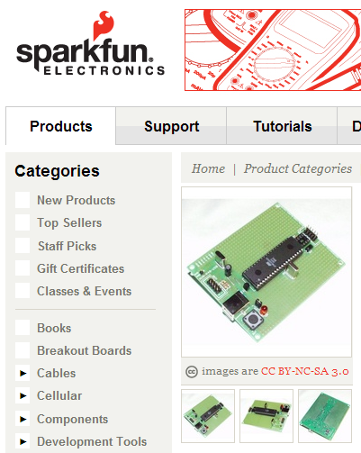

Copyright requested from Star Kick, Inc.
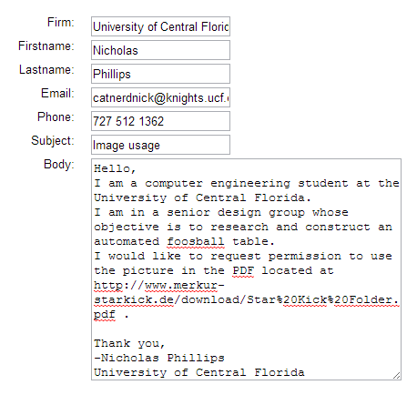
Copyright granted by Xtreme Gameroom, LLC
Subject: Request for Use
Hello Nathamiel
You may use the picture, any other info you may need just ask. any link back to out site would be appreciated.
Thank You
Fred Thornbury
Xtreme Gameroom
Sincerely,
Xtreme Gameroom LLC

