Initial Project and Group Identification Document
September 17, 2013

Game Qube

Group 33
Stephen Monn
Matthew Dworkin
Omar Alami

University of Central Florida
Dr. Samuel Richie
Senior Design I

Narrative Description

This project consists of an LED volume display cube that a person can play video games on using the IR motion controls of a Wii Remote. Past LED cube project creations have mainly focused on showing pre-defined animations. This project intends to further those ideas so that a user will be able to control what is shown on the cube in the same way that a video game player has control over his character. A complete list of games to be played on the cube is undetermined, but the final product will at least include “Pong” and/or “Checkers” due to their AI components.
The main goal of the project is to allow a player to play a classic game in a brand new way by playing it on an LED cube. In order to accomplish this, the cube needs to be large enough to house the number of LEDs necessary to replicate the intended game but small enough so that it is portable. Each LED in the display will be able to be one of eight different color combinations. With respect to the system required to make the cube function, it will include a microcontroller, LED control software, and an input device that will act as a controller for the game’s player. The system will also utilize the small infrared camera of a Wii Remote to track the positioning of the player’s controller so he/she can point to a specific location in a three dimensional array of LEDs. Finally, the system will be powered by a standard AC wall outlet and the cube will be connected to a control device utilizing LEDs with a common cathode. When completed, the LED cube system should be portable and easy to use for anyone who might want to use it regardless of knowing the internal workings.
This project requires extensive knowledge of both hardware and software design. In order to complete the physical LED cube display, the physical structure of the LEDs, the logical control over them and the interface to the display must be designed from the ground up. The software includes designing unique games that work in a 3D space as well as low level software interfaces for input purposes and a small operating system to choose between the different applications and games. The software design will also involve designing a custom rendering pipeline, as well as the software interface to output to the custom LED display. Other considerations for this project include integration of LCD screens rather than LEDs. Using a physical cube with at least three LCDs and head tracking software could emulate 3D objects using perspective and allow interaction and games to be made.However, the main constraint for this idea is expense of the LCD screens and the need of an external computer to provide the rendering capabilities.

Overall Goals and Objectives are:
- All entailed LED Cube in one portable structure.
- Complete control of each LEDs lighting.
- User control of LEDs using an input device.
- User controlled classic games playable on LED cube.
- Motion based input controls.

Specifications and Requirements

- Pixel Resolution: 10 x 10 x 10 = 1000 LEDs
- LED Volume Dimension: 10’’x10’’x10’’
- Base Dimension: 12’’x12’’x4’’
- Visible Sides of Cube: Top, All Sides (not Bottom)
- Cube Material: Acrylic, Wood
- LED Type: RGB
- LED Control: Shift Register, Microcontroller
- LED Refresh Rate: 60Hz
- Microcontroller: minimum 8 pin I/O ports and 180kHz clock speed
- Color Depth: 3bit
- Operating Temperature: 10-30 Degrees Celsius
- Input Voltage: 120V AC at 60Hz (Standard Wall Outlet)
- Input: IR Positioning Camera, Wii Remote
- Software: Multiple(2-3) fully playable games such as Checkers, Pong, and/or snake with a 3D twist. These games must be controllable by a user and must be fully functional to play alone.

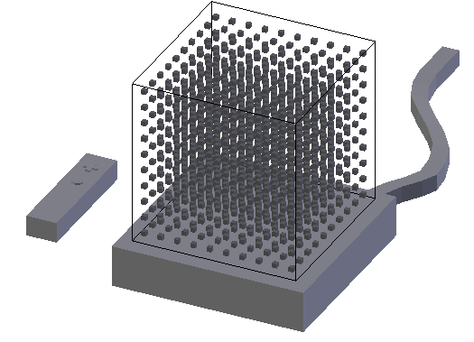
Basic Conceptual Rendering

Block Diagram

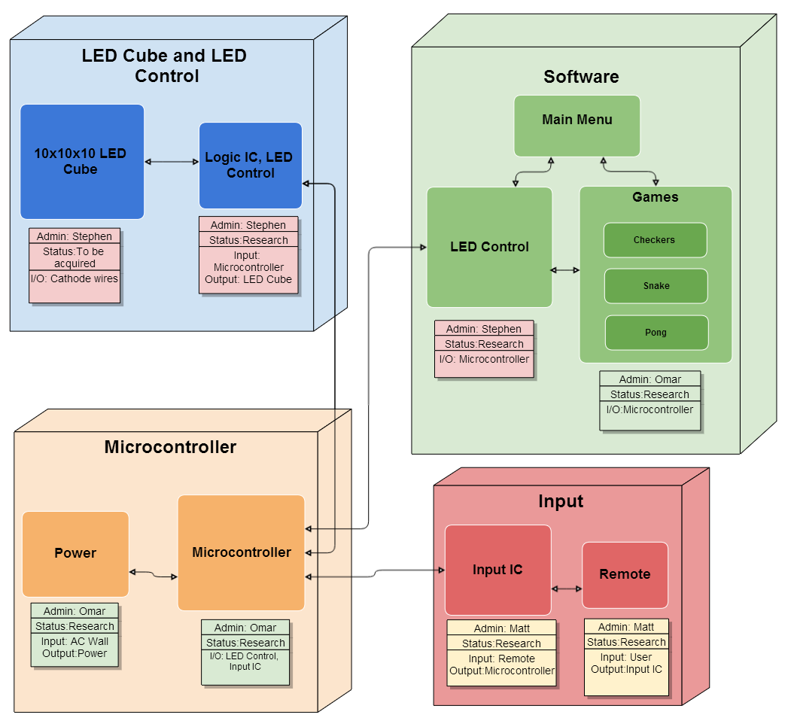

Milestones

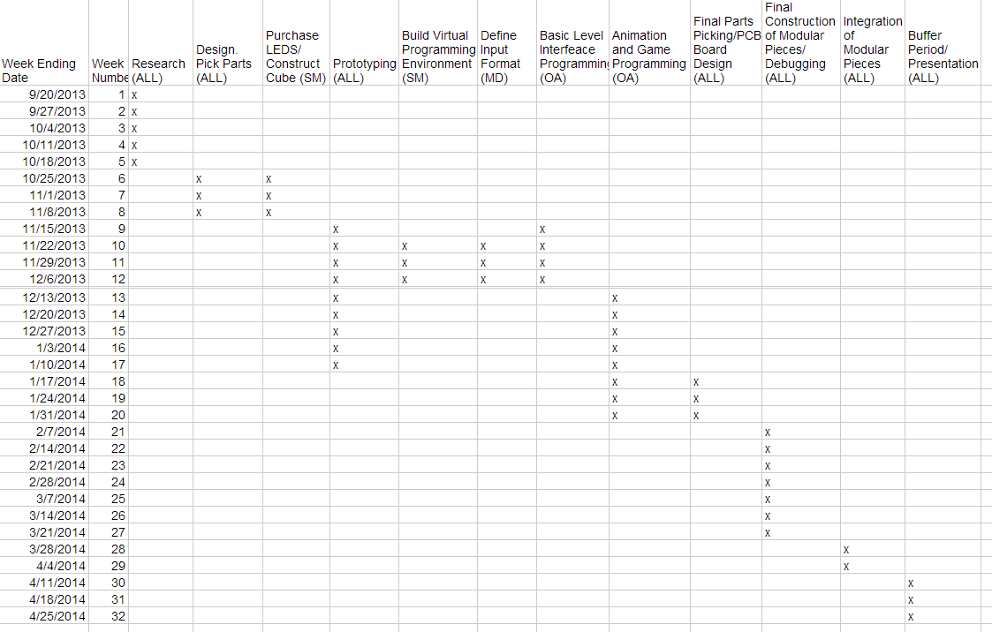

Project Budget

Item/Description | Cost
LEDs | $70
LED Logic Devices | $30
Core Microcontroller | $30
Connectors/ Cables | $20
Input Logic Devices | $30
Input IR Camera | $30
PCB Boards | $60
Overall Construction | $30
Total | $300
All expenses are to be divided up evenly between all three group members.

