|  |
| --- |
| **Transformer Monitoring System** |
|  |
| Bradley Tanner  Charles Payne  Jon Rowe  Robert Howard |

# Table of Contents

|  |  |
| --- | --- |
| 1. Executive Summary 2. Project Description    1. Project Motivation    2. Goals and Objectives    3. Project Requirements and Specifications 3. Research    1. Power Supply       1. Methods          1. Tap          2. Solar Panel          3. Battery Power          4. Wind Turbine          5. Induction Coil       2. Voltage Regulations    2. Sensor Development       1. Voltage Sensor          1. Direct Method          2. Indirect Method       2. Current          1. Direct Method          2. Indirect Method       3. Temperature Methods          1. Contact Sensors          2. Infrared Sensors          3. Mathematical Calculations    3. Logic Circuitry       1. Microchip Ideas          1. Basic Requirements          2. MSP430          3. FPGA          4. Atmel AVR Microcontroller       2. Interactions with Components    4. Communication and Information Technology       1. Expectations of the Communication System       2. Methods of Transmitting / Receiving Signals          1. Wired Communication Technology          2. Wireless Communication Technology    5. Computer Programming       1. Computer Language       2. Program Interactions with User       3. Methods of Implementing Input Data 4. Hardware and Software Design Details    1. Power Supply       1. Inductive Power Pickup       2. Implementation of Power Supply          1. Bridge Rectifier          2. Backup Batter Power          3. Voltage Regulators    2. Sensor Details       1. Implementation of Voltage Sensor       2. Implementation of Current Sensor       3. Implementation of Temperature Sensor       4. Method of Calculating Phase Angle    3. Logic Circuitry       1. Station Identification and Data Updates       2. Data Transmission       3. Stored Data       4. Microchip Interactions with Hardware       5. Overall Microchip Design    4. Wireless Communication Details       1. Implementation of Wireless Protocol       2. Flow of Information       3. Connectivity with the Device       4. Connectivity with Computer Program    5. Computer Programming       1. Overall Interface Design       2. Interface Methodology using C-Sharp       3. Software Data Flow & Security Protocol 5. Design Summary of Hardware and Software    1. Power Supply    2. Sensors    3. Microprocessor    4. Communication    5. Software 6. Project Prototype Construction    1. Mounting    2. Grounding    3. Transformer Monitoring System Connectivity    4. Mounting the Processor to the Printed Circuit Board    5. PCB Layout and Schematic 7. Project Prototype Testing    1. Power Testing    2. Sensors Testing       1. Current Sensor       2. Voltage Sensor       3. Temperature Sensor    3. Logic Testing       1. Testing Overview       2. Test Set 1       3. Test Set 2       4. Test Set 3       5. Test Set 4       6. Test Set 5       7. Testing Procedure for State Changes       8. Test Set 6       9. Test Set 7       10. Reprogram and Refresh    4. Wireless Network Testing       1. Radio Communication Test       2. Microcontroller Communication       3. Central Hub Station Communication    5. Software Testing       1. Filing System       2. Build Mode       3. View Mode       4. Daemon and Sentry 8. Administrative Content    1. Milestone Discussion    2. Budget and Finance Discussion       1. Product Cost       2. Development Cost   Appendices | Page 1  Page 3  Page 4  Page 7  Page 8  Page 9  Page 9  Page 11  Page 13  Page 16  Page 17  Page 18  Page 21  Page 21  Page 26  Page 26  Page 26  Page 28  Page 28  Page 30  Page 31  Page 32  Page 33  Page 34  Page 35  Page 36  Page 36  Page 37  Page 37  Page 39  Page 39  Page 41  Page 48  Page 48  Page 50  Page 51  Page 52  Page 52  Page 56  Page 56  Page 57  Page 58  Page 59  Page 61  Page 62  Page 63  Page 63  Page 64  Page 66  Page 66  Page 68  Page 72  Page 72  Page 77  Page 79  Page 81  Page 82  Page 83  Page 88  Page 91  Page 92  Page 92  Page 92  Page 93  Page 93  Page 93  Page 94  Page 96  Page 97  Page 100  Page 102  Page 104  Page 105  Page 106  Page 107  Page 107  Page 108  Page 108  Page 109  Page 109  Page 110  Page 112  Page 112  Page 113  Page 113  Page 114  Page 115  Page 116  Page 116  Page 117  Page 118  Page 119  Page 121  Page 122  Page 126  Page 126 |

# Executive Summary

The Transformer Monitoring System is defined as a group of components built together in order to sense and monitor various parameters of a pole-mounted transformer or ground transformer that are vital to its functionality. This device is attached to an existing transformer’s lines with minimal effort and remains nonintrusive to the lines and its components. Since pole-mounted transformers and ground transformers are the most common types of transformers out in the general public, the device is cost effective such that the practicality of placing one on every transformer is reachable. Given that the device is not connected directly to the transformer, the method for powering the device and monitoring the transformer’s parameters was a problem initially that had to be tackled. In order to draw power to the device without the use of any internal power source, induction coils were used. This inductive power pickup is wrapped around the low side of the transformer (120V), so that cost can be kept down due to less insulation needed. Realizing that the voltage going through the induction coils can be far greater than what is needed to power the device; a couple voltage regulators were used to limit the amount of voltage going into the device. To achieve the desired results, Diodes Incorporated AP1186 regulators were used. Although the device draws power from the lines in order to prevent system failure if power is out, the device has a battery backup located inside of the system.

Overall the transformer monitoring system has the capability of monitoring the transformer’s voltage, current, temperature, and possibly the phase angle. The voltage sensor is constructed from scratch to meet our needs and consist of a plate, an op-amp, two capacitors, and four resistors. A Rogowski coil was used to monitor the current going in to and out of the transformer. This option came about due to the fact that the current across the lines varies drastically over time and as such the Rogowski coil has the capability of measuring such broad ranges. Methods for monitoring the temperature of the transformer ranged almost as drastically as the current in the lines. After many considerations, a thermal infrared sensor was chosen: the MLX90614ESF-AAA Infrared Temperature Sensor 90◦ FOV. This sensor was placed on the device such that it has a direct line of sight to the transformer. Finally, the last parameter that the device measures are the phase angles of both the high side and low side of the transformer.

Once all of the sensors obtain an accurate reading from the power lines, the information travels to the microprocessor inside of the device. Texas Instruments’ MSP430-F2013 has been chosen as the ideal microchip. This component can be considered the brain of the device and as such it has a lot of responsibilities it must uphold. There are two main functions that it has: connect every piece of hardware together at a central point and relay information at the correct time to the wireless component. All of the sensor measurements are attached to several analog input pins, except for the temperature sensor which is connected to the digital input pin. XBee, the wireless component, requires four pins of the microprocessor: two digital input pins and two digital output pins. Finally, the last pins that are required for the device to work properly are the inductive power/battery pin and the grounding pin. Another function the microprocessor has is its ability to analyze the data from the sensors and determine when to relay it to the wireless. When working properly, the microchip relays the information every thirty minutes; however, if there are any problems with the inputs or outputs of the transformer, the time will decrease. Basically, if the voltage, current, or temperature of the transformer exceeds a caution value then the information will be sent every thirty seconds. Likewise, if they exceed a thresh hold value then the information will be sent every five seconds instead.

After the data flows from the microprocessor, it reaches a point where now the wireless component has to transmit the data from the device to the central hub. The wireless component chosen is the XBee Zigbee Pro 2.4 model. This model has the capability of sending data over a range of about one mile and allows for a mesh network to be established. Since the central hub could be located ten miles away from the actual device itself, the mesh network is highly desirable. It works by bouncing the information from device to device until it reaches the central hub. Once the central hub receives the information collected by the device several computer programs then processes that information, stores it in a database, and displays it in a nice, neat, organized manner on a computer screen for the user to see. Two programs were created: a daemon program written Java and a web application written in PHP & JavaScript. The daemon program insures that data is transferred from the Xbee receiver to the database; whereas, the web application displays that data from the database for the user to analyze.

As a general statement, the transformer monitoring system is a safe and easy approach to help combat any loss in power over the lines and any power shortages through its preventive monitoring measures. Important environmental aspects that were considered when developing this device, was the fact that it will be located outside and near high power lines that emit strong electrical and magnetic fields. Due to these things, it needed to weather any conditions that Mother Nature threw at it as well as any side effects that may have occurred from either of the fields. Figure 1.0-1 shows a block diagram of the device along with who was responsible for which section.

Current Sensor

Voltage Sensor

Heat Sensor

Wireless

Central Hub

Microprocessor

Brad

Brad

Robert

Charles

Jon

Robert

Power

Brad

Figure 1.0-1 Block Diagram of Transformer Monitoring System

# 2.0 Project Description

### 2.1 Project Motivation

Envision a world where technological breakthroughs have created a systematic, smart grid system where transformers can talk to each other as you or I talk to one another. A world where even the slightest faults and failures of our electric power lines are noticed within a matter of seconds as opposed to hours or even days. This world may seem practical years from now, but with today’s technology the future is coming sooner than one might expect. Initiatives from the United States Government to create a smart grid system have already been placed into motion. In 2003, the U.S. Department of Energy, Office of Electric Transmission and Distribution, released a document describing the nation’s vision for revolutionizing electric power in North America through the development of a Smart Grid by 2030. This is their vision:

“Imagine the possibilities: electricity and information flowing together in real time, near-zero economic losses from outages and power quality disturbances, a wider array of customized energy choices, suppliers competing in open markets to provide the world’s best electric services, and all of this supported by a new energy infrastructure built on superconductivity, distributed intelligence and resources, clean power, and the hydrogen economy” (“Grid”).

In order to achieve such idea, the U.S. Government passed the Energy Independence and Security Act of 2007 which created the Federal Smart Grid Task Force. This task force is responsible for the “…coordination and integration…” of any activity “…related to Smart Grid technologies, practices, and services” (“Department”). As the framework behind the Smart Grid begins to mature, the time for individual engineers and engineering companies to construct the devices that will drive this Revolution is now. With our motivation set in stone, we present the Transformer Monitoring System (TMS).

The device is a real time, mounting device that monitors a single transformer. This device paves way for a smarter grid system and allows citizens to enjoy the simple necessities of the new era of technology without the fear or stress of prolonged electrical down time. As of now, the power companies rely heavily on the responses of their customers to provide critical input for when a transformer is blown or power is out. This is not an effective way of determining when a transformer needs maintenance or needs to be replaced, for the down time is reliant on the customer’s ability to call the power company. To illustrate, an elderly couple lives in the country with only a cordless home phone installed. All of a sudden a lightning storm rolls in and strikes the only transformer in the vicinity, causing all of the power to be lost inside of the elderly home as well as the only phone they can use. The elderly, who rely on electricity to keep their emergency air pumps running, now have to worry about not having enough back up battery power left in their system to stay alive. With no working phone, they cannot just call the power company to fix their electric problem; instead, they are forced wait for help.

The power company may have realized that one of the transformers is not responding appropriately in a given sector, but a problem they face is they do not have any means to figure out exactly where to send their service men. This means that the elderly couple could have to wait hours for electricity to be restored; however, they do not have the luxury of time due to the fact that their back up battery system only has a life time of one hour. After an hour has passed, the elderly couple is now forced to weather the storm and drive into town or to nearest neighbor, which could be miles away. If our system was properly installed, then the power company would have known the precise location of the downed transformer as well as key information about the transformer right before it was destroyed. This would have saved the elderly couple from all of the anxiety they had to endure. Though the outcome of this little story is taken to the extreme, a scenario like this could occur and when it does our device will be there to keep the public at ease by knowing help is on the way.

### 2.2 Goals and Objectives

The overall goal of the Transformer Monitoring System is to effectively and accurately read and record valuable information about either pole mounted transformers or those which lie on the ground. Once recorded, the information is sent through wireless connections to a central hub computer which would be located at the electric company’s transfer stations or substations. Installed on the computer is the daemon program that transfers the data to database located on the electric company’s server. The web application then presents all of the information in a nice, neat, organized fashion, so that the electric companies can easily detect a failure in their power lines. Several key goals of this entire device are that it needed to be extremely affordable, due to the large quantity of transformers in a given radius, and small enough to fit on the same pole as the transformer. Besides those two goals, the device is broken up into five categories, each with their own goals and objectives: Power, Sensors, Logic Hardware, Wireless, and Computer Programming.

Power to the device is the most critical aspect of this project and as such has a large amount of expectations and regulations that it had to follow. For instance, our device draws a minute amount of power from the power lines itself to run our system. Due to the dangers that come with working with high voltage power lines and the possibility of external contact, safety was the number one objective. Our method of attaching to the power lines needed to be safe to the unaware public as well as to the nature around it. Basically, we could not have our system explode if a bird lands on it, in addition we could not kill the bird either. Another important aspect of the power system is that it had to be reliable and non-intrusive to existing power lines. Reliability is always an important goal of any product and as such, our device needed to stay within a certain range of voltage, current, and temperature. Any high values of the three would end up destroying the internal components of our device and possibly cost the electric company valuable time and money. As mentioned our device needed to be non-intrusive to the existing power lines due to the fact that any disturbance created by our system will ultimately cause signals to be lost and power levels to be distorted. The final aspect of our power system is the backup power structure which allows our device to consistently send signals to our central hub long after the main power has been disconnected.

A monitoring system is effective so long as the sensors within it are accurate and exact. Due to this, for our system to fully live up to a professional standard the sensors had to be extremely precise at reading in the desired information. Altogether there are three sensors that read: the voltage and current across the lines and the temperature inside of the transformer. The goal was to attach a coil to both the input line as well as the output line in order to record both the high side and low side of the voltages and currents. Like the power system, the sensor devices needed to be safe and also non-intrusive to the existing power lines. A couple major concerns were the possibility of arcing between the coils and the creation of a ground or short within the transformer. If either of these things were to happen then there would be a catastrophic failure at the site, so our system needed to be able to insure these dilemmas do not occur. Because of the high voltage and current constantly running through the power lines, our sensors had to be able to handle an extreme number of voltages and amperes for a long period of time. Also, the sensors needed to be able to step down those extreme values in order to not destroy the internal components of transformer monitoring system. Another goal for the sensor devices was to read the internal temperature of the transformer externally without breaching the transformer’s outer extremities. Finally, the sensory system had to be easy to install and replace. The objective was to treat the coils as clamps that can easily be inserted and removed from the power lines without the need to detach the lines from the transformer itself. This allows for quick replacement if a sensor failure arises.

Once information about the transformer has been measured, the information goes through various internal components of the device. These components have two primary goals that they had to meet. First, the components needed to have a logic aspect to it that would determine if the information from the sensors has exceeded their threshold values. If there were such an incident, the logic component would alert the wireless elements and start the emergency cycle. The second primary goal was that the components needed to relay the information, without any lose in accuracy, to the wireless elements. This step was extremely important due to the fact that if any of the data became corrupt or altered in any way then the detection system and alert mechanism would not work successfully. Since microchips of today cost only cents to make, we tried to keep the total cost of the entire package under a few dollars. Also, another goal we tried to accomplish was to have the microchips easy to remove and install. These features make it possible for the customer to swiftly and easily replace any damaged part of the logic circuitry at a cost effective value.

After the information has been passed through the logic components, the information then needed to be sent to the other transformer monitoring devices or to the central hub wirelessly. For this to work properly, the wireless communication needed to be fast and reliable during severe weather conditions. Thunderstorms and lightning strikes in the area should not interfere with the communications being sent out. Since the devices are placed in outdoor locations, the signals also encounter various noises from other external sources, and as such, our wireless communication device takes that into consideration. This filtering of the signal does not, under any circumstances, alter or change the information that it is trying to relay. In addition, this component had to have some way of identifying the signals coming in from any of the other devices in the area. Given that the information about several devices might be transferred from a single device, the wireless communication component also needed to send the appropriate amount of information back to the central hub. Once the information is sent back to the central hub, the wireless receiver had to store the information about each of the devices in a logical and uniform format for the daemon program to read from. Lastly, the wireless device needed to be able to send and receive signals from far distances, due to the fact that transformers might be spaced out by the mile as opposed to the foot.

The final aspect of the device is the computer programming where the user will be able to view the information about the transformers. Since the client will spend the majority of the time using this portion of the device, the primary goal here was to achieve a high level of customer satisfaction. To accomplish this, the program needed to take the information given by the wireless receiver and display the information in a neat, organized fashion that meets professional standards. This allows the user to easily see where problems within a transformer grid system occur and thus allow for a speedy response to the particular problem. If one of the transformers were to malfunction, then the program needed to alert the user through both sight and hearing. Sight could be anywhere from a warning sign flashing on the screen to various animations; whereas, hearing could be a siren blasting through the speakers on the computer. Given that our program ended up using a small amount of processing power to keep the transformers’ information up to date, the overall size of the program had to be kept at as small as possible. This ensured that the client would be able to install and run the program without too much interference to everyday activities on the machine.

To conclude, the Transformer Monitoring System should be able to meet all of the various goals and objectives mention above. These goals and objectives ensured that our device system runs effectively and proficiently in any situation that it might encounter in the real world. During the research and development phase of this project, we also kept in mind any goals that our clients – our colleagues, professors, and government – wanted us to follow. As a final statement, our primary objective was to establish a technological link between the electric companies and the existing power lines which paves way a new era of smart gird technologies to better service mankind.

**2.3 Project Requirements and Specifications**

The transformer monitoring system has many different specifications and requirements for the various components included in this design. Overall requirements for the device are: it meets Government regulations; it is small to the point where one person can hold and install it; it is lightweight, no more than 20 pounds including all sensors and equipment; it is watertight so that no water can reach the interior of the project box; it does cost less than $200 per unit; and works well in residential neighborhoods. The device as a whole is able to handle readings from Orlando Utility Council’s residential transformers rated at either 50KVA or 100KVA. It is also able to handle temperatures up to 150⁰ C. Further specifications and requirements may be divided up into four main parts: Power & Sensors, Logic Hardware, Wireless, and Computer Programming.

The sensors have a minimal impact on the performance of the transformer. The sensors do not create a potential or form a ground that could lead to an electrical arc or short circuit of the power line. The voltage sensors are accurate to within 10 Volt of the measured value. They are capable of measuring up to 7,200 ± 100 Volts from phase to ground. Similarly, the current sensor can measure current within 1 Amp of the actual measurement. Ranges for these sensors are 90 to 150 amps. The voltage and current sensors are able to withstand the outdoor environments along with the box. The temperature sensor is mounted on the outer extremities of the device box with line of sight to the transformer. This will allow the infrared sensor to pick up a good heat reading. All sensors used in the device needed to be easy to install, easy to remove, and easy to replace. The sensors perform all these requirements while still maintaining the ability to effectively step down voltage and current, so that accurate readings may be delivered to the microcontroller. The power for the transformer monitoring box is capable of transferring power from the power line to power for itself. It uses a negligible about of parasitic power, never consuming more than 1 Watt. The power must be reliable. Reliability means that the battery does not heat to the point of failure, and power delivered to the battery will never rise above the voltage that it is rated for. The battery is also able to continue transmissions for one hour after power has been lost to the substation.

The microcontroller fulfills all other requirements listed in the main project requirements and specifications. The microcontroller is capable of receiving all voltage, current, and temperature readings. The microcontroller has the capability of calculating the phase angle of the transformer, and will compile all four pieces of information (voltage, current, temperature, and phase) into one string of information to be sent to the hub station. It is also capable of handling universal asynchronous receiver / transmitter (UART) communications and has enough digital I/O pins available after the sensors are connected to make a four pin connection to the communications card. The device is far less than five dollars, and can be easily replaced and programmed.

The communication system is capable of quickly sending and receiving data from nodes closest to it. The data rate from any monitoring system box unit is never lower than 30 kbps. The communications system handles existing noise on the medium it chooses. The system can transmit and receive signals between the hub station and a device unit for up to one mile. TMS box units greater than one mile from the hub station do not directly communicate with the hub station; but instead, bounces off other device units that are closer to the hub station, if necessary. This means the communications system has the capability of routing a command sent by the hub station software if the software request information from a node greater than a mile away. The communications system does not cause any harmful interference to other devices as defined by the FCC. All devices used for communication are approved by the FCC. The communications system cost less than $40 for each device box unit.

The hub station software fulfills all other requirements listed in the main project requirements and specifications. The hub station software is written in languages proven by academia and industry to produce a working interface. The interface does resemble existing program layouts for simplicity of use. The software is able to accurately display values that have been reported to it by the device units. The hub station receives information from the network through a UART standard or some other simple method. The software keeps a record of all receiving values for as long as the user would like for historical purposes. The software needed to include a database to keep track of the information received. Multiple programs and multiple programming languages were accepted to be used for development of the software suite. The software has the ability to detect when threshold values have been breached, independent from a specific notification from the communications system. In the event that a threshold value has been passed, the interface blatantly displays a warning sign and where on the network that the warning occurred. Furthermore, the hub station software can request information when necessary from any of the device units connected to the network.

# 3.0 Research

**3.1Power Supply**

The purpose of this section is to supply the proper power to the logic board, transmitter, and sensors as needed. In order for this part to meet the overall design objectives, this device had to be:

* Lightweight &Compact.
* Easy to install
* Cost Effective
* Supply a constant DC voltage, within specification requirements
* Safe & Non Intrusive

There are a few methods which could have been implanted in order to achieve these goals. Creating a tap device that connects one of the power lines going into the transformer and stepping down the voltage. To use a photovoltaic panel to create a self sustaining power source to the unit. A battery power source that could be recharged and replaced as needed. Since the power poles are usually high, a wind turbine is another way of creating a self sustaining power source. With the power lines supplying AC power, an induction coil could be placed around the line inducing the necessary power to the circuit. All of these methods are discussed in detail in the following section.

**3.1.1Methods**

**3.1.1.1 Tap**

The idea of tapping is to make a physical conductive connection to one of power lines connected to the transformer. This section will explore some of the various methods that could be used to make this connection. For efficiency the tapping method will assume tapping the 240V low side of the transformer. Once this connection is made the 240V will then have to be stepped down to the required voltage for the unit. This could be done using either a very high impedance resistor or a step down transformer. Since the resistor would have to be very large to accommodate its cooling and the fact that its impedance will vary with changes in ambient temperature, the resistor will not be considered as a viable option. The advantages and disadvantages will then be reviewed to ascertain the usefulness of the tapping method.

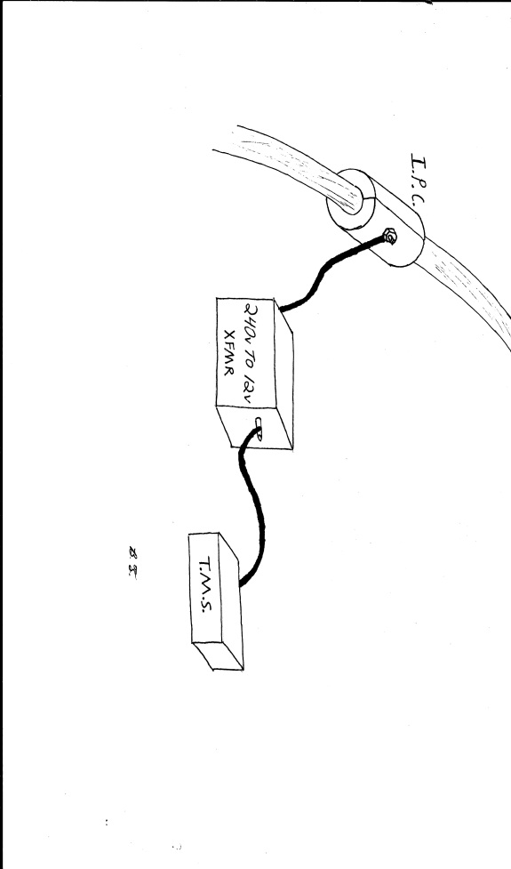There are only two methods of tapping that will be considered for this purpose: insulation piercing connectors and a power distribution block. The insulation piercing connectors use a device that ranges from $15 to $50 dollars depending on the voltage rating. These devices usually tend to already meet UL rating standards. The basic designs of these devices comprise of a conducting material that pierces the insulation of the cable, creating a connection between the conductor and a screw fastened output. A shell is then placed around this to insulate the conductor both from electrical shorting and the weather elements. The power distribution block method comprises of the single phase line fastened to a conducting material that can handle the high voltage and current. The cables going to both the homes and the monitoring device will then be fastened to the conducting material. To protect the distribution block from the weather and electrical grounding, an insulating case of sufficient dielectric strength must be placed around this device. Figure 3.1-1 shows a visual representation of how the insulation piercing connectors get connected.

Figure 3.1-1 Diagram of using insulation piercing connector for tapping power line

Once the power line has been tapped a transformer has to be placed between the tap and monitoring device to bring down the 240V to 12V used by the monitoring device. Two types of commercially available transformers can accomplish this task, magnetic core and electronic transformers. The commercially available magnetic core type transformer will give the reliability and viable price range ($40-$60) to be within the objectives. Most of these transformers step down the voltage to 24V secondary when attached a 240V primary leading to the need of secondary voltage regulation circuit to convert the AC output power into DC. The electronic transformer priced between $10 and $50 is more within the budget, with some supplying a DC output. This means there is no more need for an AC to DC circuit with this option.

The advantages of using the tap method are few compared to the disadvantages. One of the most prevalent advantages of tapping the power line is its simplicity of concept. With a direct connection to the power line the causes of total loss or diminished power gets narrowed down to corrosion, physical damage, or loss of power in the line. The corrosion damage can be prevented by the wise selection of materials while taking into consideration of the type of environment it is to be operated. Both the physical damages and loss of power in the line cannot be totally prevented, but can only be minimized. With the simplicity of the design and the use of commercially available parts, this method could lead to very high-quality reliability depending on the quality of the components used.

The disadvantages of the tap method are cost, weight, and number of parts needed. With the tap connectors costing on average $35 and the transformers about $40, the cost of just getting power of the right voltage range to the monitoring device is around $75. The objectives that need to be met with the power supply are being light and compact as possible. The transformers tend to be around a cubic foot volume and a few pounds in weight. Though not terribly big or heavy, there is a thought that this could be lighter and smaller. The components needed to supply power to the monitoring device are a tap, transformer, and possibly an AC to DC circuit, again the thought that this could be improved upon is there.

**3.1.1.2 Solar Panel**

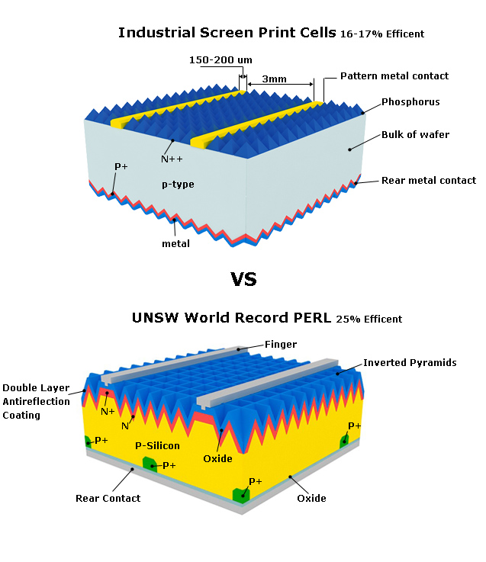Though photovoltaic cells have been around for quite some time now, they have finally reached an efficiency that makes them useful in compact sizes. The general idea for use in this application is to attach photovoltaic cells of adequate size to the power pole with the output of the cells going to the monitoring device. Since solar cells will only produce power during day light hours it is imperative that the cell array be of sufficient size to not only power the device but have a surplus of energy to be stored for later use during low or no light conditions. The two types of photovoltaic cells under consideration are thin film and crystalline silicon cells. Crystalline silicon cell technology is as the name implies, based on either polycrystalline or monocrystalline silicon with a thickness that makes them rigid. Where thin films are flexible and do not necessarily contain silicon to obtain a photo electric effect. Figure 3.1-2 shows the cross section of the solar cells mentioned.

Figure 3.1-2 Cross Section of Si Solar Cell, reprinted with permission by Honeybee Solar Inc.

Monocrystalline or polycrystalline solar cells are typically the most efficient commercially viable photovoltaic solar collectors. Traditional crystalline panels are also readily available and are considered the workhorse of the solar power market. Monocrystalline panels are also the most reliable out of the other solar cell technologies (Solarpowerfast.com). With efficiencies reaching 25% the need for a big panel is not needed for this application, which gives the possibility of being mounted high on the power line pole. Since crystalline silicon is used almost in all electronic devices crystalline silicon tends to be in demand leading to high market costs (Harris, William). These types of panels are already in use in similar applications, with an observant eye while driving down an urban road. Small panels of with an area of a few square feet can be seen attached to power poles , sign poles, and around cross walks

The term thin-film solar technology encompasses a few different types of solar cell construction. “There are three main types of thin-film solar cells, depending on the type of semiconductor used: amorphous silicon (a-Si), cadmium telluride (CdTe) and copper indium gallium deselenide (CIGS)” (Harris, William). Amorphous silicon refers to the use of using amorphous silicon as the basic p-n junction and is usually deposited using chemical vapor deposition. By introducing GeH4 or CH4 during the deposition process the creation of multi-junction cells occurs, improving the performance of the solar cell (Wronski, C.R.). This technology is well understood and is similar to the rigid crystalline type photovoltaic cells. Cadmium telluride and copper indium gallium deselenide technologies involve using layers of their respective materials to create a p-n junction, with a substrate layer conducive to the application as illustrated in figure 3.1-3. Both technologies involve the use of cadmium, which is high toxic with the potential to accumulate in food chains. This fact can be viewed as a blemish on a technology that considers its self as clean (Harris,William).

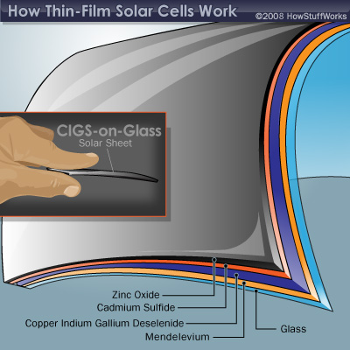

Figure 3.1-3 Cross Section of Thin Film Solar Cell, reprinted with permission by HowStuffWorks pending

The projected maximum energy usage of the monitoring system is 12V at 1.5A which gives 12 watts and a need to supply an energy surplus to charge a backup power unit for later use during low or no light conditions is present. The thin film technologies are at an inherent disadvantage due to their decreased efficiencies compared to rigid crystalline panels. The idea behind using a thin film photovoltaic cell over a traditional rigid crystalline silicon cells is the benefit of being able to wrap the film over the monitoring box or having the ability of easier and more versatile mounting options making the system as compact as possible and more appeasing to the eye. Another drawback to using a solar panel as a primary power source is depending on the environment of the location which causes it to not be a viable option. If the location of the transformer is in a shaded area or experiences cloudy weather for extended periods of time, the backup power source will become depleted causing the monitoring system to become inactive. This is the primary reason solar cells were not be considered as a viable primary power source. Solar panels will only work if the location receives a fair amount of sun light and is dependent on environmental conditions that are beyond control. Figure 3.1-4 shows how the solar panels would need to be placed in order for the idea to be practical. This fact is in direct violation of one of the basics concepts of the project, to create a system that is designed to be as versatile as possible. The cheapest 20 watt panel is $50, which is more costly then some of the other options available. This also contradicts another goal to keep the cost of the project as low as possible.

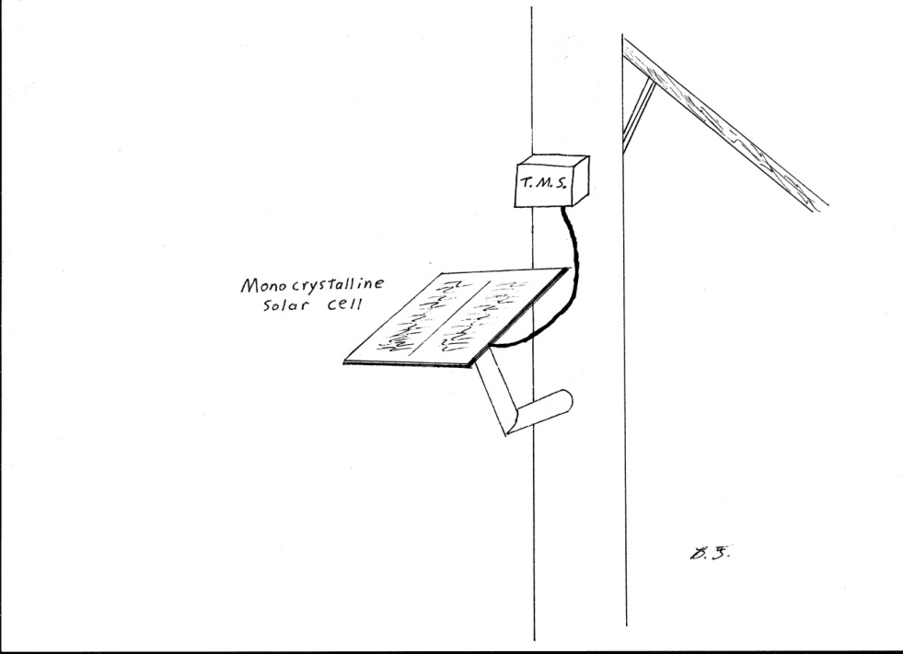

Figure 3.1-4 Diagram of using a Pole Mounted Solar Panel

**3.1.1.3 Battery Power**

The monitoring system will need some sort of alternate power source. Lose of power can happen to any of the other power supply methods. In the case of the power line having a loss of power, the tapping and inductions methods will not supply power to the monitoring system. In using solar panels as an alternate power supply, the panels will not be able to supply any power or not enough during night or low light conditions i.e. cloudy days, or winter months. Using a wind turbine generator only creates power when there is wind present, which will also need a backup source of power for a no wind condition. Since the need for a backup power source is apparent and a simple battery seems to be the most cost effective approach, the choice to be made is choosing which type of battery would be the best fit between cost, reliability, and size.

Using a few non rechargeable batteries would be good for cost, but the fact is that they will lose about three percent of their charge per year when stored at twenty degrees Celsius (Energizer). Even if a brief low power or no power condition is present then the battery will have to supply power to the monitoring system. This will eventually lead to the batteries losing their charge over time and having to perform maintenance on the system just to change to the batteries. Alkaline non rechargeable batteries tend to get hot and leak when subjected to a voltage that is greater than the charge that is present in the battery. This will then justify the creation of a circuit that detects when the power from the main power source drops below a critical value and switches over to the batteries. For these reasons non rechargeable batteries were not be considered a viable source of alternate power for the monitoring system.

Given that a non rechargeable power source has a severe drawback, the next step is to look at rechargeable sources. This is given higher consideration because the primary power source can be easily designed to charge the alternative power source under normal running conditions. While during a low or no power condition from the primary power source, the alternative power would have to supply power for only a relatively short amount of time. One approach to this could be the use of a capacitive type power source. Unfortunately, for the capacitor to store enough power to supply power to the monitoring system under a low or no power condition. For the capacitor to store enough energy to run the device for the time needed to send an error message and relay other messages from elsewhere in the grid, the capacitor would have to be quite large and expensive or a few decent sized ones would have to be connected together. Either way this would be more expensive than typical rechargeable batteries. Along with the fact that a typical industrial capacitor would take up much more space than the normal lead acid battery. Since no clear advantage of using a capacitive type alternative power source is present, the use of capacitors as a power source was not be considered.

The other types of batteries that could be of use are the rechargeable types these include; lead-acid, lithium ion, nickel cadmium, and nickel metal hydride. The standard 12V lead acid sealed batteries that are commercially available from several manufactures can usually be found for around ten dollars. These batteries usually have a rating of around 1.2 Amp/hours. The MSP430 micro-controller draws about 200 µA and the Xbee transmitter draws about 270 mA under normal operation. Since the power usage of the other components was not known at the time, we assumed a normal current draw of 1A with a maximum current of 1.5A while charging the battery. The 12V lead acid battery with an 18 A/H rating will supply plenty of power for the monitoring system. This is more than enough capacity to supply the system with time to transmit and relay any messages that the system has to.

The nickel cadmium battery invented in 1899 by Waldmar Jungner, has advanced a long way to the modern NiCd battery available today. It provides many general advantages that would be an ideal fit for this application. These include simple charging cycle, economically priced, and good low temp performance. However the flawed traits of relatively high memory loss and self-discharge compared to other battery types. This presents a severe problem for this application because the battery must be able to stay charged for long periods of time to supply power at any given time. The move forward to nickel metal hydride has improved the short comings of NiCd by improving capacity and memory loss. Though the high self discharge trait is still a problem and adding the requirement for a complex charging algorithm further complicates the power supply design. This is said because not only does it take a charging algorithm to charge the battery, nickel metal hydride batteries do not take well to overcharging. So the power supply must constantly monitor battery charge and decide if charging is needed; then, disconnect the battery from the circuit to avoid possibility of overcharging it (“Nickel-based Batteries”). The lithium ion battery is the name given to a whole section where the main active component is lithium; this name is misleading because each type of lithium battery has its own unique characteristics.

After contemplating over the table shown in figure 3.1-5, the comparison and reasoning for selection is as follows. The standard voltages of each cell ranges from 3.3V to 3.8V. Since the voltages are relatively close and can be connected in parallel to obtain a desired voltage, the output voltage of a cell is not much of a factor in the decision processes. With the premise that the batteries will only be discharging during a low or no power condition of the primary power supply, life cycle over a few hundred would meet the requirements of a low maintenance and reliable alternative power supply. All four types of the lithium ion batteries meet this requirement, however the higher life cycles of the lithium phosphate and NMC battery cells are at an advantage over the other two types. With the monitoring system being mounted in the outdoors and exposed to direct sunlight and heat from the transformer, operating temperature limits are of some importance. Again, both the lithium phosphate and NMC battery cells are at an advantage over the other two types. With operating temperatures having the possibility of becoming high in an over current condition, the battery must be able to keep stable voltage. The lithium phosphate cell has the clear advantage over the other three with a thermal runaway temperature of 270 degrees Celsius. With operating temperature, cycle life, and thermal runaway taken into consideration the choice of battery was the lithium phosphate. Though the table states that cost of lithium phosphate cells is high, an 11.1V battery with a 4000 mA/H reserve sells for less than twenty dollars, which is within the budget and has enough energy to supply the monitoring system for a longer time than needed. This means that even though it stores more energy than needed, that surplus counteracts temperature and memory loss that occurs over time which leads to longer maintenance intervals on the battery pack.

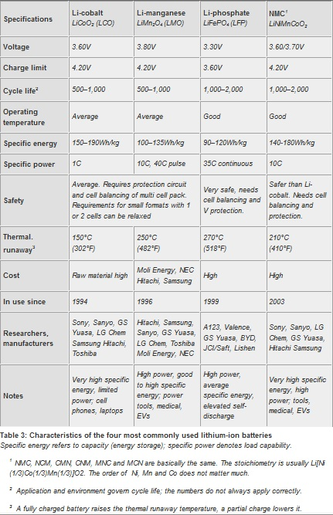

Figure 3.1-5 Table of General Battery Characteristics, reprinted with permission by Battery University

**3.1.1.4 Wind Turbine**

The use of a small wind turbine generator to power the device is possible if executed properly. Wind generators have been in use in the marine industry for many years, with good reliability and come in a variety of commercially available power outputs. The plan of implementation of this power supply would be to pair a wind generator with a high capacity quick charge battery. To maximize efficiency the wind generator would have to take advantage of the height of the power poles. Mounted at the top of the pole and above the power lines, the generator would have the best possible chance to access an unobstructed breeze. The battery will have to be of a sufficient size to power the monitoring system for extended periods of time because depending on the location, wind of sufficient speed could be intermittent. With the monitoring system drawing a projected total of .5 amps and supplying surplus power of 1A for charging the battery, the generator would have to be able to produce at least 1.5amps.

One possible combination is the use of a wind turbine that is designed to charge batteries or other low power applications and a battery type to be selected in another section of this document. The Aerogen 2 and Rutland 504 wind turbines will be used as a reference for creating an informed opinion as to the possible potential of wind power. Both of these units have a turbine diameter of less than two feet and need more than a 6 MPH wind to start producing usable power. Maximum power is delivered in a very strong wind (over 30 knots) in the range of 50 to 60 watts or a little over 4 Amps. Though this is enough to power the device while charging the battery, most inland places do not experience a constant wind that strong. This gives the assumption that a 1 to 2 Amp output is to be typically expected. Taking general aesthetics into consideration, the site of wind turbines humming along on top of every transformer could be viewed as unsightly and disturb some of the population. The deciding factor of not using a wind turbine to power the system is cost. Both generator units cost upwards of $500 dollars, this would use more than the total proposed budget.

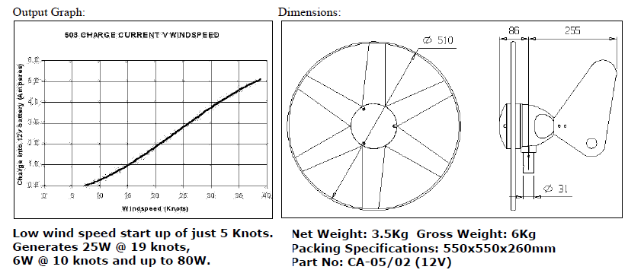

Figure 3.1-6 Output and Dimensions of Rutland 503 Turbine, permission by Marlec pending

**3.1.1.5 Induction Coil**

Since this device will be attached to a transformer with a current carrying power line, making use of the inherent electro-magnetic field is common sense. Using an inductor to harness the EMF of the power line has the benefits of: low cost, non intrusive and constant power. An inductor is nothing more than a coil of cheap common wire, a few feet at most for this application. It’s non intrusive in the sense that it is a small device, unlike a wind generator or solar cells. This process entails clamping the inductive coil over the insulator of the line, this helps with overall reliability and safety. This is preferred over the tapping method because the insulation is not damaged in piercing the insulation for direct conductive contact. Since the power line will have current flowing under normal operation, the only time the inductor will not be supplying power to the device is when there is no power in the line. Conditions like lack of sun light, wind or rain will have no effect on the inductors ability to supply power, unlike solar panel or wind turbines.

A few considerations must be taken into account for the implementation of this method. The inductive coil must be properly insulted from the environment; this includes picking insulation that will provide years of service without degradation. Since one of the goals of this project is to design a system that is easy to install. The coil must be designed in such a way that it can be clamped on around the line. Having an installer hand wind a wire coil over an active power line is both unsafe and could lead to an inaccurate output if improper installation of the coil occurs. Another aspect to consider is that the AC voltage output of the coil will change depending on the current load of the line, so a circuit must be designed to minimize the changing voltage induced. One possible way to avoid a low voltage condition is to design the coil to produce a voltage higher then what is needed. The inductive coil will be designed with a low current state to induce a sufficient voltage. Under normal load of the line a high voltage will be present in the coil, that high voltage can then be limited with a voltage regulator circuit. The advantage to this design is that the device will be less dependent on the current of the power line to stay within a nominal value.

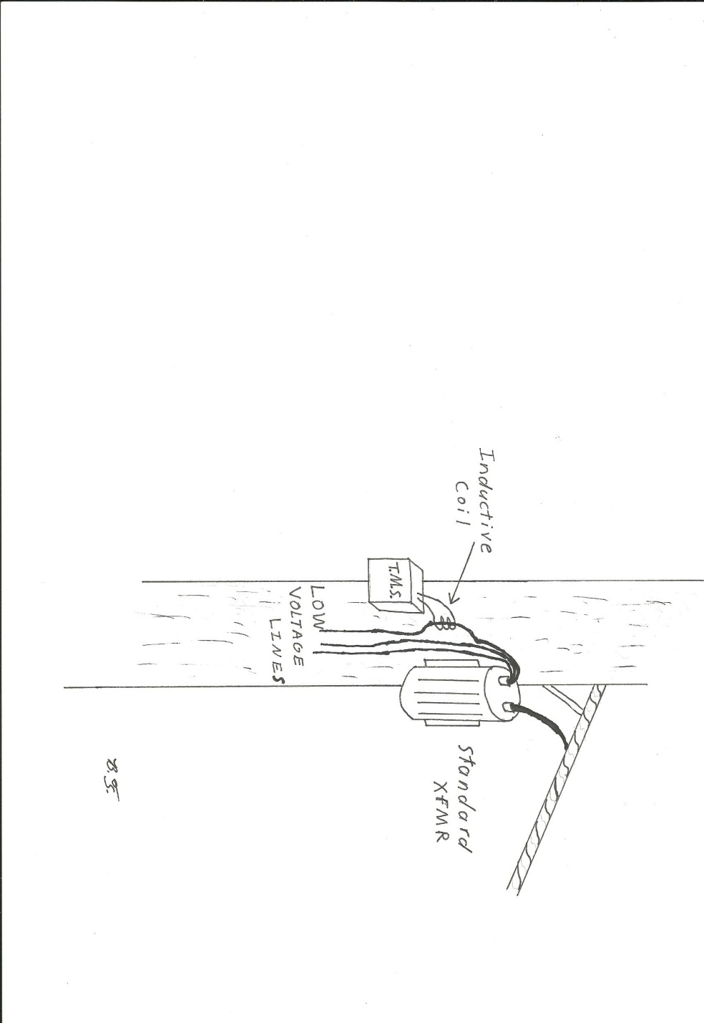

Figure3.1-7 Use of an inductive coil for supplying power

**3.1.2Voltage Regulations**

Since the power coming from the inductive coil will be in AC, there needs to be a rectifier and regulator circuit for the voltage. With both the MSP430 and Xbee chip require a range of 2.7v to 3.6v with good all around efficiency at 3.0v. Rectifying the AC signal can be accomplished either through the use of a full wave bridge rectifier made of rectifier diodes or with a commercially available bridge rectifier IC. This section will discuss the advantages and disadvantages of both. The full wave bridge rectifier circuit schematic is commonly available and is widely used for educational purposes. This circuit makes use of four rectifier diodes; since we wish to have a 3.0v output the optimal rectifier value would be 4.7v, so we will be using the closest available rectifiers of 5V. The Xbee and MSP430 combined draw a total of .2204 Amps under active conditions, also the charging the battery and other devices need to be summed for a more thorough analysis. On the Digi-key website, a 5v rectifier will supply a forward current of 30Amps, more than enough for our application. The one problem that occurs with building a full wave bridge circuit is smoothing the DC output. This can be done using a capacitor and the following ripple voltage equation.

$$V_{DC}=\frac{2V_{max}}{π}$$

$$V_{Ripple}= \frac{I_{Load}}{fC}Volts$$

Solving this equation assuming the load current an average of 0.3 Amps and the frequency is equal to twice the supply frequency of 60 Hz. Using a commercially available 1F capacitor, the voltage ripple works out to be 2.5mV. With the circuit able to produce the correct voltage within a thousandth of a percent and enough current to power the device, it is time to calculate the costs. On Digi-key the diodes sell for $8.50 each needing four the total cost of diodes of $34, for cost efficiency this will not due.

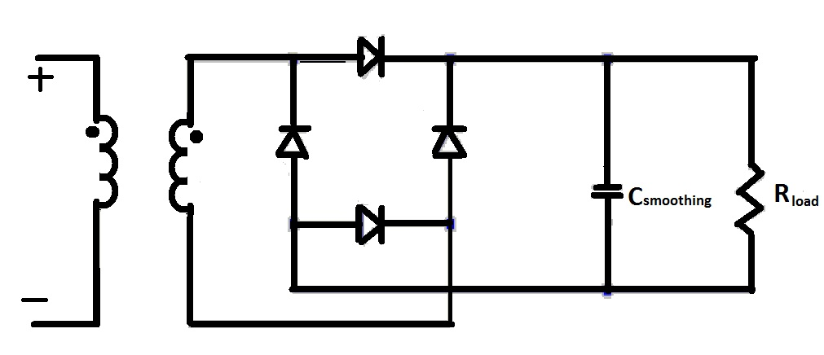

Figure3.1-8Full Wave Rectifier

The other way to supply DC power to the device is through the use of a commercially available bridge rectifier IC. One such example of this device is the Fairchild DF005S, using this device simplifies design and installation. This is because the leads of the inductive coil are connected to one side to the chip with the rest of the circuit on the other. This device and similar devices are rated for over an amp of average current and a max surge current of 50A; this gives plenty of room for errors and surges coming from the power line. Another critical condition that must be met is the devices ability to handle the high operating temperatures of being next to a power line exposed to direct sunlight on hot days. With both the Vishay and Fairchild DF005S chips able to handle an operating junction temperature up to 150® C or 302® F, this should be give plenty of room for heat capacity. Though neither of these devices actually regulates the voltage, the more basic of these devices will rectify and pass up to 50V through it. This high voltage passed by the rectifier will destroy the rest of the circuit where no more than 6.6V can be present at either the MSP430 or Xbee chip pins. This gives rise for a need to design a voltage regulator circuit between the rectifier and the rest of the circuit.

Voltage regulation can be done two ways just like rectifying AC to DC, building the circuit with zener diodes or using a voltage regulator IC. A voltage regulation circuit is again quite common and easy to design with a few basic formulas. This circuit as seen below is built from a couple power transistors, a standard resistor, and a zener diode. The first step is to select a transistor to act as Q1, this can be a standard transistor but the base current (IB1) needs to be known from the datasheet. The second transistor Q2 needs to be able to flow the desired output current from the collector to emitter. The second step is to select a zener diode with the proper voltage drop; this can be found using the Vzener equation below. The third and final step is to determine the proper value for the resistor; by using the R equation below the resistance value is found but some consideration must be taken in selecting a resistor that can handle the power dissipated during operation.

$$V_{zener}= V_{out}+ V_{BE1}+ V_{BE2}$$

$$V_{out}=desired output voltage$$

$$V_{BE}=base emitter voltage drop of transistor$$

$$R=\frac{{(V}_{source}- V_{zener})}{( I_{zener}+ I_{BE1})}$$

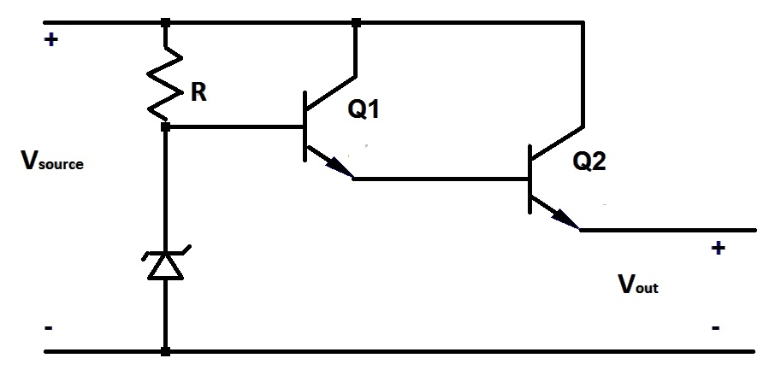

Figure3.1-9 12V to 3V Convertor Circuit

The alternative to building a regulator circuit is to buy a voltage regulator IC. We will not be using the IC packaged voltage regulators for two reasons. The first being, from a search of various integrated circuit suppliers the price for a 3V regulator ranged from $2.66 to $5.98 with less than an average current output of 1A; the monitoring system would need more than one to supply enough current to power the logic board and charge the backup battery. Building the circuit out of two transistors, a zener diode, and a resistor would be considerably cheaper because the part costs are much lower. The second reason building the circuit is more effective is, various types of transistors that flow more than 1A are more common and seem to have better thermal characteristic than IC packaged regulators.

**3.2 Sensor Development**

The main purpose of the monitoring system is to monitor the voltage, current, and temperature present in the transformer. With this in mind, some sort of sensor must be designed or bought to measure each parameter. For the sensors to comply with the overall design objectives, the sensors must:

* Be as cost effective as possible.
* Fast sampling rate – enough to accurately measure voltage / current waveforms
* Be as compact as possible.
* Be as light weight as possible
* Be as easy to install as possible.

The methods to be explored for the development of the sensors can be placed into two categories direct and indirect contact. The direct contact methodology for the voltage and current sensors implies that a conductive connection is made, while a physical thermal conduction connection is inferred with the temperature sensor. The indirect methodology implies that no conductive connection is made for the voltage and current sensors, thus the power line is electrically isolated from the monitoring system. For the temperature sensor to be considered indirect no contact can be made between the transformer and the sensor. For safety and reliability, preference will be given to the indirect methods because of electrical isolation from the monitoring system.

**3.2.1 Voltage Sensor**

**3.2.1.1 Direct Method**

There exists two different ways directly measure the voltage of the power line. The first conductive contact method of detecting voltage is the standard way used by power companies. This method commonly involves using two insulation piercing connectors to make a fused conductive connection to the power line. A precision step down transformer known as a potential transformer would then be used to attain a more reasonable voltage for measurement purposes; for our purposes this output voltage will be somewhere in the range of +/- 1V. Since most of the analog to digital converters that the group has been researching can only read voltages in the 0V to 4V range, a proper DC offset must be introduced. An example of this DC offset is 2V, the AC waveform to be measured will then range from 1V to 3V. After the research of a few analog to digital converters, the unit must have its’ pin leads connected across a resistive load. The disadvantages of this method are like the tap method of supplying power to the monitoring system. The cost of the step down transformer is not justifiable when there are more cost effective options available. The potential transformer relies on the current of the primary coil to induce the voltage on the secondary coil. The correct voltage is then calculated using the formula below. This will lead to a problem when trying to calculate the phase angle between the voltage and current waveforms, since both voltage and current measurements were measured from the current.

$$V_{P}= \frac{V_{S}N_{P}}{N_{S}}$$

$$V_{P}=voltage on primary$$

$$V_{S}=voltage on secondary$$

$$N_{P}=number of primary turns$$

$$N_{S}=number of secondary turns$$

The other direct contact method again uses an insulation piercing connector to create a circuit to the monitoring system. Instead of using a step down transformer, the voltage will be fed into a commercially available high power AC Hall Effect voltage transducer. The Hall Effect will accurately recreate the voltage waveform with a known time delay. These devices are offered with the output either in an analog voltage signal or an analog current waveform. Due to a wide selection of analog to digital converters, including the integrated ADC’s on the MSP430 chip, detecting voltage waveforms the transducers with a ranged voltage output will be considered. Using an insulation piercing connector is easy to install and can provide years of reliability. The problem is it creates an opportunity for catastrophic failure for both the power grid and the monitoring system if the insulation were to fail from the high voltage. The most prominent reasons this method will not be considered as viable is; the few prices found for a high voltage transducer are over $150. This option is too expensive for the objective of maximizing the cost effectiveness of the monitoring system. The other reason is the Hall Effect relies on the magnetic field caused by the current waveform as can be seen by the equations below. This will lead to the same problem of measuring phase angle as the first proposed direct method.

$$β=\frac{µI}{2πr}$$

$$µ=equalvant permeability$$

$$I=current in power line$$

$$r=the distance between the center of the power line and coil$$

$$ΔV_{H}= \frac{IβR_{H}}{t}$$

$$R_{H}=Hall Coefficient$$

**3.2.1.2 Indirect Method**

There are also two different ways to implement a nonconductive contact voltage detection sensor. One commercially available option is to use a Hall Effect with magnetic compensation voltage transducer that makes use of a clamp on open loop coil for ease of installation. The theory behind the magnetic compensation to create an accurate voltage wave is as follows. As current passes through the power line it creates a magnetic field proportional to the magnitude of the current as shown by the equation above for β. This magnetic field is then balanced by a magnetic field generated by the transducer’s secondary coil current. The current is created by a hall device to exactly counteract the power line’s magnetic field. The secondary coil current is then an exact representation of the voltage present in the power line. This device is limited in its use because it requires a very small current (typically micro-amps) to be present in the power line (LEM). This could only be accomplished by tapping the power line for measurement, though this will make the method similar to a direct method but have the advantage of maintaining electrical isolation. Orlando Utilities Commission typically uses 7,200 volts (phase to ground) in their residential primary power lines, in order to achieve a 1µA current the resistor would have to be 7,200MΩ with an excellent temperature co-efficient. This seems un-reasonably to have such a high value custom built resistor and the fact that if the resistor shorted from contamination, the excessive flow through the power line could cause severe damage. If the resistor became failed to create an open circuit the monitoring system would detect a faulty no current condition in the power line.

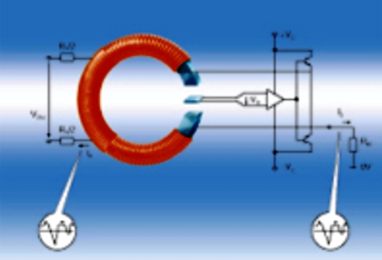

Figure 3.2-1 Diagram of Closed Loop Hall Effect Current Transducer, reprinted with permission by LEM pending

The second way to detect the voltage on the line without conductive contact is through the use of a capacitive voltage sensor. These sensors vary greatly in operation, characteristics, and cost. The simplest of these circuits is a coupled capacitor circuit; two capacitors are connected in series with a voltage sensor connected between them. This type of voltage detector is cheap and commonly used in voltage detectors designed for home use. Unfortunately, this type of circuit can only detect if a voltage is present and not accurately produce a waveform because the capacitors will build up a charge because of stray inductance from the power line over time offsetting the sensor calibration. There are sensors that prevent this offset through a more complicated circuit. Even though these sensors are on the market, they are beyond the budget of this project by at least five fold.

After much research of what is available of the market and theories of operation, the idea of designing a capacitive voltage sensor circuit came to be.The theory behind this device uses the concept of a coupled capacitor connected in series. A small plate placed closest to the power line will act as the first capacitor. Finding the capacitance of the plate using the equation below will allow us to calculate the charge of the plate at any given value of charge present in the line. Using the known charge, the change in voltage can then be determined using the ΔV equation. This change in voltage on the first capacitor will create a slight change in voltage on the second capacitor. This change in voltage will then be feed into an op-amp to increase the gain of the analog signal. Attached to the output of the op-amp will be a resistor load; the leads of the ADC will be set to measure the voltage drop across this load resistor. If designed properly this should give an analog signal that can easily be detected. This sounds simple enough, but there are a few considerations to take into account. The conductive plates that will become the capacitor can steadily buildup a charge from stray capacitance; this can be prevented through the use of a resistor. This resistor will dissipate the DC offset charge, but will then create a RC circuit in front of the op-amp. The resistor must be of a proper value that creates a time constant for the circuit that allows for a sufficient frequency sampling of the 60Hz signal that is present in the power line. Since one of the purposes of the voltage waveform is to measure phase angle, the time delay of the signal reaching the MSP430 must be taken into account.

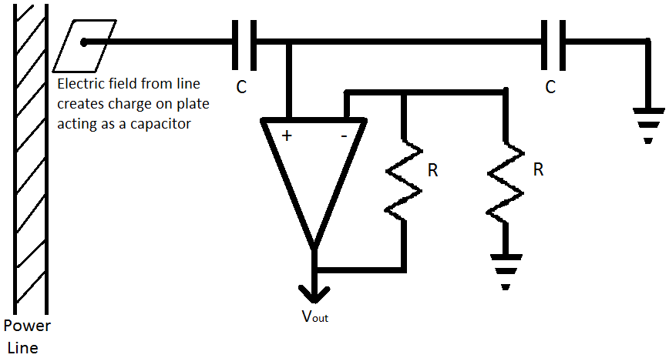

Figure 3.2-2 The Initial Design for the Capacitive Voltage Sensor

The other voltage transducers on the market will measure a voltage wave from but are not designed for applications where the exact voltage waveform is needed for phase angle calculations. The problem with this type of device for this type of application and why it cannot be used for calculating the phase angle is because of its method of measuring the voltage.The strength of the magnetic field is proportional to the magnitude of the current present in the power line at a given time which can be calculated with the β equation below. An inductor relies on a changing magnetic field to induce a voltage on its coils, with the amount of voltage equal to the $V_{coil}$ equation below. The reason why this type of voltage transducer will not work is that it uses the current waveform to derive the voltage in the power line. Even though the transducer might be able to measure an accurate voltage, the voltage waveform will always be in phase with the current.

$$β=\frac{µI}{2πr}$$

$$µ=equalvant permeability$$

$$I=current in power line$$

$$r=the distance between the center of the power line and coil$$

$$V_{coil}= - N \frac{ΔΦ_{β}}{Δt}=- N 2πr \frac{Δβ}{Δt}$$

$$N=number of turns of the coil$$

$$r=the distance between the center of the power line and coil$$

For this project though, if a capacitive voltage sensor circuit cannot be designed with acceptable accuracy of voltage at a precise point in time. The objective of measuring phase angle will have to be dropped due to; the high cost of a commercially available the capacitive voltage transducers and the safety considerations of the direct contact methods. If the phase angle calculation is dropped from the project objectives, the voltage will be measured in the following way. The current sensor will be using an inductor to detect the amount of current in the power line. This voltage waveform will then be converted to a digital signal by the MSP430. With the calculating power of the micro-controller, the $V_{line}$ equation below will be implemented to attain the voltage present in the power line. Though the phase angle measurement will be dropped, there are some advantages to this. With both the voltage and current measurements coming from one sensor instead of two, the production costs will be lowered. The system as a whole will become simpler with only one sensor per line this means: Reliability increases dues to decreased complexity, installation will be less time consuming, and training installers will be more efficient, costing less.

$$V_{line}= \frac{V_{s}}{N_{s}}$$

**3.2.2 Current**

**3.2.2.1 Direct Method**

The simplest circuit for designing a current sensor that will interface with the MSP430 is a voltage divider. This circuit consists of only a few resistors connected in series with the leads to the analog to digital converter on the MSP430 across one of the resistors. Due to the resistors being exposed to a wide range of ambient temperatures and its dependency on its temperature co-efficient (equation below), maintaining an accurate resistance value for calculations will be difficult. Even the more stable version of this circuit that makes use of the high input impedance of an operational amplifier will not be able withstand the high voltages present in the power lines without the use of a voltage divider circuit. This will then present the same problem from the changing resistivity of the resistors at various temperatures. The change in resistivity can be calculated if a sensor is used to measure temperature, but a potential problem still exists. There is no electrical isolation from the high voltages or current present in the power grid.

$$R= R_{0}\left[1+α\left(T- T_{0}\right)\right]$$

$$R_{0}=initial resistor value$$

$$T_{0}=initial temperature$$

$$T=current temperature$$

$$α=temperature coefficient$$

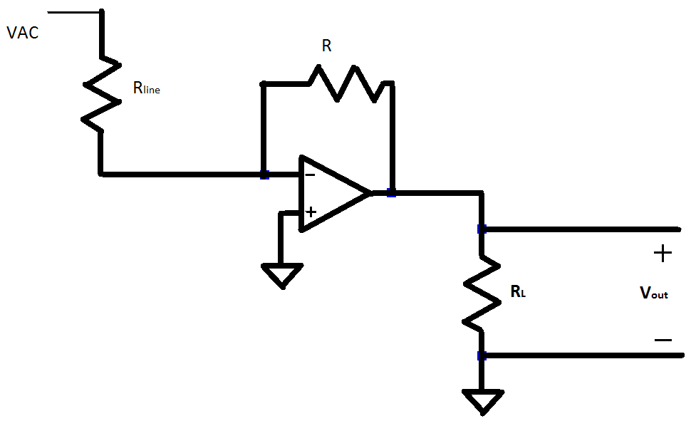

Figure 3.2-3 Current to Voltage Converter with Line Resistor

**3.2.2.2 Indirect Method**

The indirect method of measuring can be implemented by either buying a current sensor or building one. Two types of commercially available sensors are on the market, one is an inductive coil called a current transformer and the other is a toroid called a Rogowski coil. One of the disadvantages of using a current transformer is the cost; these device typically price according to how much current they can measure, so the price range required for the project is around $30 - $50. The prices are within budget but a more practical alternative can be attained. The construction of the current transformers is also a disadvantage. These transformers are a closed loop coil with the line to be measured passing through the center. This setup requires the technician to disconnect the power lines from the transformer in order to properly connect the current sensor. This technique is possible but the simpler installation method would be the use of a Rogowski coil type sensor along with the cost savings, this makes the Rogowski coil a more viable option.

The Rogowski sensor consists of a wire wrapped around a flexible tube, with one of the end wire leads passing back through the center of the coil. This tube is then wrapped around the current carrying line to be measured in a single loop. The voltage induced in the coil is then sent through an integrator. One of the advantages of using a Rogowski coil is the ease of installation since the power line does not need to be disconnected. The characteristics inherent to the Rogowski coil are also advantageous. Since it is an air core transformer it has a fast response to current changes, which helps with giving an accurate waveform. The Rogowski coil also has a highly linear response to transient currents compared to iron core transformers (Ward, D. A., and J. La T. Exon). Since these coils have a linear response they can measure a wide range of currents, most that are commercially available measure currents from 25 to 3500 Amps. This has an added benefit for the monitoring project, with the typical currents present in the residential power lines ranging from 90 to 417 Amps (Casios,Steve). The monitoring system can be designed with one type of current sensor, with only the calibration changing with the varying power line applications. On the commercial market Rogowski coils are sold by cable length and priced accordingly. The choice to design Rogowski coil specifically for this application is due to a couple of problems. The commercial devices come with an integrator box attached to the cable with an output of +/- 6V; this presents a problem in interfacing the device to the MSP430. The other problem is cost and size, there seems to be two distinct applications for these devices. One for measuring currents on a circuit board with very small loop lengths measured in millimeters. The other comes with loop lengths of over 16 inches; this is considered excessive for this project application of trying to measure a power line with less than a 2 inch diameter. The cost of these devices on the market is also out of the planned budget, since these devices cost over $120.

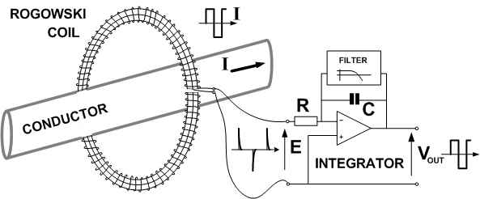

Figure3.10-4 Diagram of Rogowski Coil, reprinted with permission bypemuk.com

**3.2.3 Temperature Methods**

One of the most important measurements that our system requires to accurately maintain any transformer is temperature. Any increase in temperature could indicate a myriad of problems ranging from internal insulation corrosion to overall system malfunction. Due to this it is important to find a way to accurately measure the temperature inside of the transformer and possibly the rise in temperature at the windings connector. Overall there are three categories that can be broken down into various methods when it comes to measuring temperature: direct contact, non-contact, and mathematical calculations (only possible if the specifications of the transformer were given). For this aspect of the research non-contact temperature readers will only consist of infrared heat sensors. The following sections detail the possible solutions to measuring temperature of the transformer.

**3.2.3.1 Contact Sensors**

The first category of temperature sensing is direct contact sensors, or sensor devices that measure their own temperature based on the surface temperature that it resides on. Generally there are three types of contact temperature sensors: thermocouples, RTD, and thermistors (“Temperature”). Thermocouples are devices that join two wires, composed of dissimilar metals, to both ends and measure the current flow through a thermoelectric circuit when one end is heated. Resistor temperature detectors (RTD) measure the change in temperature of a metal object based on change in resistance of the object. Basically as the metal heats up, its resistance level increases and by comparing the data the temperature can be determined (“Contact”). Finally, thermistors follow the same path of the RTD sensors except that the semiconductor material used to make the devices is more sensitive to temperature changes. Though all of these devices act in a similar manner, they each have their own advantages and disadvantages that must be accounted for.

As mention thermocouples measure the current flow through a thermoelectric circuit. Due to the simplicity of this device it is extremely easy to use and very cost effective. However, since the component is allowing current to flow through it freely it acts as an electrical conductor. This can be a bad thing if placed in an area with a large build up of static electricity. Another important advantage thermocouples have is their usefulness for a wide range of temperature fluxes (“Temperature”). Objects outside can experience extremely wide ranges of temperature changes due to the nature of its surrounds and as such our device will need this ability to read any temperature at a given interval. One side effect of this ability is that thermocouples are less sensitive to smaller temperature changes than some other components. Finally, the last advantage they have is that they are self powered. Two small electrical conductors inside of the sensor generate small amounts of current when exposed to temperature and this is what ends up powering the sensor. A drawback to this is that thermal lag is generated throughout the component and thus this type of temperature sensor generally requires it to be connected to a temperature controller in order to compensate for the lag (“Temperature”). The last disadvantage is that thermocouples tend loose accuracy as the number of times used increases. Moisture can affect the overall accuracy as well, for it degrades the resistance in the insulation between the wires. This is extremely important to keep in mind since our device will be tested in Florida where moisture is forever present.

Resistor temperature detectors (RTD) fair a little better than its counterpart thermocouple. Unlike thermocouples, RTDs have a higher repeatability percentage and therefore tends to be more accurate at reading temperature (“Temperature”). This advantage is extremely desirable; for it means that our device can be more self sustaining and require less maintenance to continue running. Another important aspect to RTDs is their innate ability to be impervious to electrical noises. Since the sensor will be placed inside an area with huge amounts of voltage, it needs to able to negate any effects that the electric / magnetic field might have on it (“Temperature”). Along the same lines, RTDs can withstand the vast amount of vibrations that the transformer might release. Though this type of sensor might seem like it has everything our device might need, it tends to be a lot more expensive than any of the other temperature detectors. One reason for this jump in price is that RTDs are most commonly made up of Platinum, whose cost varies greatly on time and economic issues in the nation. Lastly, RTDs require a power source in order to function. Despite the fact that our device will be drawing power from the electrical lines that it is connect to, trying to further supply power to a component located outside of the main container could prove difficult and even hazardous.

The last type of contact temperature sensors are thermistors. Recall that they act similar to RTDS and that the main difference between them is that thermistors are developed with semiconductor material. Because of the material used to create such sensors, they are extremely sensitive to any amount of temperature so long as the temperature falls within a certain range (“Understanding”). This leads to the first disadvantage, which is that the temperature range is very narrow. As mentioned earlier our device will be placed outside where the elements could cause temperatures to flux along with any fluctuation already present due to the transformer itself and its lines. In addition, high temperatures tend to cause the sensor to fail completely. Although this disadvantage is enormous in the overall grand design, thermistors are extremely inexpensive. With our budget at only $200 this advantage means that we can spend more money on other essential parts such as the voltage and current sensors or even the wireless component. One final disadvantage to thermistors is their non-linearity. For this reason, they are not as standardized as the other two and therefore experimental data and graphs are hard to come by (“Temperature”).

For the most part, the advantages that contact temperature sensors have overwhelm their disadvantages, but these components will probably be our last resort. The main reason is that our overall idea is to have the device suspended above the transformer, held up by the electrical lines. In order to use a contact sensor we would have to place the sensor onto the transformer then drop a line from the box to the sensor in order to collect the data and / or supply power. Though the idea is possible, it is not practical to have a wire hanging down where a bird or other animal might mistake it for something else. Instead non-contact sensors will more than likely be the path we take.

**3.2.3.2 Infrared Sensors**

One of the methods that were mentioned before is infrared heat sensing. To understand why this option is a possible candidate for our temperature sensor, one must look at how it works. Infrared radiation is defined as “invisible radiation in the part of the electromagnetic spectrum characterized by wavelengths just longer than those of the ordinary visible red light and shorter than those of microwaves or radio waves” (Dictionary). Infrared sensors are designed to pick up these kinds of wavelengths without making contact to the object. How this translates to heat is that as temperature rises on an object the infrared radiation that is being emitted increases / decreases proportionally. Figure 3.2-5 represent what infrared picks up that the naked eye could not:

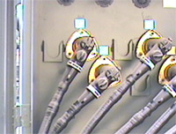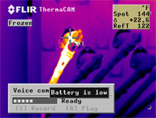

*\*These pictures are of a power transformer with an overheated connector* (*[*COLVIN*](http://colvininfrared.com/spec.cgi?ref1=2)*)*

Figure3.11-5 Infrared Sensor of Transformer Connection, reprinted, pending permisson by colvininfrared.com

This option for detecting any heat issues that could occur inside or around the transformer has many advantages. The biggest advantage infrared heat sensors possess is the ability to measure the increase in temperature while never making contact with the transformer. Recall that one of the objectives for measuring the temperature is that this component must not breach the transformer’s outer extremities, which means this option is viable. Another advantage to using infrared heat sensor is that the device can determine the inner core temperature as well as the surrounding temperature of the transformer, whereas the contact thermometers can only read surface temperature. This feature is nice in detecting the remaining life expectance of the insulation inside (“How Sensors”). As time goes on, the insulation corrodes and thus more heat is expelled. With infrared sensors this increase in heat can be detected before the transformer suffers from cataclysmic system failure. Also since this component is non-contact the entire package can be stored inside of our device instead of hanging outside. This would allow us to not worry about any other safety protocols we would have to follow since the device will be securely tucked away. Finally, the last advantage heat sensors have is their ability to accurately measure the temperature of the actual object while taking into account any other ambient heating sources. This however is only achieved under certain circumstances, which leads us into the disadvantages.

Though infrared technologies have caused humans to see things that they cannot see themselves, these devices still have disadvantages to them. As mentioned, infrared sensors are very accurate at measuring the temperature of a given object; however, each infrared sensor has their own conditions for this to hold true. Take for instance the MLX90614ESF-AAA Infrared Temperature Sensor 90◦FOV (Pololu). This component will only give accurate readings if the sensor is in thermal equilibrium and under isothermal conditions. With our device outside in the elements, it cannot be assumed that the overall package will remain in thermal equilibrium or even under isothermal conditions. Reliability then becomes a problem. Another huge disadvantage of using any infrared technologies is that they tend to be very pricy. One of our specifications is that our entire device needs to fall under $200. For the most part, the voltage sensors and current sensors will take up the majority of that budget; therefore, the temperature sensor needs to very cheap. The infrared temperature sensor mentioned above cost around $20 without shipping cost and taxes. Though that number may seem small, in all actuality it is a lot compared to the price contact thermometers cost.

Overall the advantages and disadvantages are great and before we can decide to use this type of temperature sensing several questions need answered. Can we sacrifice some accuracy at times in order to place the component inside of our device? If not, then can we further better our design to ensure that this component will always be accurate?Lastly, will we have enough money left over in our budget to buy such a component? These questions are extremely important to answer when deciding to use an infrared heat sensor in this project. These questions are extremely important to answer when deciding to use an infrared heat sensor in this project. If these questions cannot be answered, then the final method in determining temperature is by mathematically calculating it.

**3.2.3.3 Mathematical Calculations**

Mathematical calculations can be used to determine not the temperature, but instead a rise in temperature for a transformer. Basically temperature rises occur as power loss is dissipated in the form of heat. If given some properties of the transformer, then this rise can be calculated without any special temperature reading component. The parameters needed are:

* Current value (I)(amps)
* Resistance of the coils: Primary (RP) & Secondary (RS) (ohms)
* Frequency (f)(kilohertz)
* Flux density (B)(kilogauss)
* Material grade (K)(constant)
* Surface area (AT)(centimeters squared)

Once our voltage and current sensors are in place every parameter listed above will be given. Theoretically speaking, the next steps would be to just plug the values into a couple of equations and the rise in temperature is calculated. The following steps show the equations needed and the order in which these equations should be found (Wallulis)

Step 1: Calculate the Power Loss at Winding Coils (PW)

Step 2: Calculate the Power Loss at Transformer Core (PC)

Step 3: Calculate the Change in Temperature (∆T)

$$∆T= {\left({P_{W}+ P_{C}}/{A_{T}}\right)}^{0.833}$$

Although this method of determining what the temperature rise is within a transformer may seem like three easy steps, there are many problems to this. First, frequency and flux density are never constant due to the fluctuation of voltage and current coming into the coils. Though the manufactures give spreadsheets with varying flux densities and frequencies already determined at different voltage and current values, the implementation of such spreadsheets would be extremely difficult. Second, not every transformer has the same parameters as one another, so the calculations would need to be changed for every different transformer our system is used on. This is a huge problem, since this would take precious time away from the power company using our system. One great aspect of this method however, is the ability to determine an increase in temperature without the need to purchase any new components. This method is completely free and would allow us to keep our device under the budget limit that was set. A question that needs to be answered then, “Is not spending money worth the hassle to individualize every temperature equation for every device we build?”

**3.3Logic Circuitry**

The microprocessor is an important element in any device that requires logical computations and signal processing. Microprocessors were first incorporated into electronic devices in the early 1970s. These devices were very basic in functionality and included items such as the four function calculator (“Microprocessor”). Moore’s law states that the number of transistors that can be placed on an integrated circuit doubles about every two years (“Excerpts”). The past forty years have certainly been a testament to that law as we now have very small processors that can perform more functions than computers the size of warehouses that existed in the early 1970s. These processors enable devices we use every day. From the electric toothbrush that one uses to brush their teeth when they wake up in the morning, to simultaneously tracking 1000+ airborne targets in the E-2D Advanced Hawkeye, the microprocessor is an integral component in today’s modernized world. Monitoring a high voltage transformer will definitely require the use of such a device. While the parameters being monitored will require a bit more processing then the electric toothbrush, they will not need the extreme amount of processing power as an AWACS (Airborne Warning and Control System). Fortunately there is a very wide array of processors on the market to choose from.

**3.3.1Microchip Ideas**

**3.3.1.1 Basic Requirements**

The microprocessor must be able to perform all of the functions required to process information from the sensors and send that information to the Zigbee wireless network. It must be able to convert the analog signals from the transformer sensors into a quantifiable digital signal. The microprocessor will be stored in an outdoor environment and will be subject to extreme temperatures and humidity. It will be stationary and therefore will not need to withstand large amounts of shock and vibration. The microprocessor should consume a minimal amount of power. Normally it can receive its power from the line, but in an outage situation it will need to run for at least one hour on a rechargeable backup battery. During the design phase the processor will need to be able to be simulated to ensure that it will perform the necessary functions for power monitoring. Ideally, the processor will be able to be simulated on a computer with all possible scenarios to ensure that it will work under all conditions after field deployment.

Ideally the processor will have embedded analog to digital converters to eliminate the need to mount extra parts on the transformer monitoring system’s circuit board. These converters will have to be able to accept a range of 0V - 3V. By choosing a processor with onboard analog to digital converters, the robustness of the transformer monitoring system is greatly improved because it will have fewer connections on the circuit board. However, there are some disadvantages to this design. If any of the analog to digital converter on the transformer monitoring system’s circuit board fails the entire processor will need to be replaced. However, any processor that only performs the tasks required by the transformer monitoring system will be relatively cheap to replace. The benefits of fewer parts, a smaller circuit board, and fewer connections greatly outweigh the cost of replacing an entire processor. Therefore a microprocessor with onboard analog to digital converters will be chosen.

The processor will need four analog inputs, three digital inputs and two digital outputs. The four analog inputs will be used to monitor the input and output voltage and current. If the device is built to support a set of three transformers mounted to a single pole for three phase input and output it will need 12 analog inputs. The processor must also be able to accept a digital signal from the temperature sensor. This sensor will require connection to a digital input on the processor. It should be able to sample this data and send it to the Zigbee wireless network to be stored at a central hub. Normally it will send this data every half hour unless a critical value is exceeded. If a critical value is exceeded it will immediately send the data. Figure3.3-1 summarizes the microprocessor requirements.

|  |
| --- |
| Requirement Summary: |
|  |
| 4 ADC converters at high resolution (≥10bit) |
| 0-3V analog input range |
| 6 digital I/Os |
| >1KB of memory |
| Low Power Consumption: <0.5mA |
| Temperature range: -30 – 75 Celsius |
| Small Footprint: < 0.4 x 0.4 cm |
| Minimize pin count |

Figure3.3-1 Requirement Summary

**3.3.1.2 MSP430**

Texas Instrument’s MSP430 is a widely used processor for a variety of applications. These processors have some of the lowest power requirements in the industry (“MSP430 Offers”). This is an important feature in the design of a transformer monitoring system because in the event of a power outage, this device will need to function for at least an hour on a small rechargeable battery. The MSP430 can come with onboard analog to digital converters; this is necessary for the transformer monitoring system because of the analog signals coming from the voltage and current sensors.

The MSP430 has certain development tools such as Launch Pad, GRACE, and eZ430 greatly simplify the development process. The eZ430 USB development tool includes all the hardware and software to develop a project in a USB stick. The eZ430 provides full emulation capability with the option of programming and detaching the removable target board to integrate into the power monitoring system (“MSP430 USB”). Texas Instrument’s GRACE software is a graphical peripheral configuration tool that will help to enable and configure the ADCs, DACs, timers, clocks, serial communication interfaces, etc. The software allows one to interact with the features of the MSP430 by interacting with buttons, drop-down menus, and text fields. Once the device is configured, code can easily be created and uploaded to the processor (“Grace (BETA)”). The LaunchPaddevelopment tool can be used with the MSP430 Value Line series. The integrated DIP target socket allows all 14 and 20-pin Value Line devices to be inserted into the LaunchPad for programming, debugging, and monitoring. LaunchPad also includes software development environments for writing and debugging software. The LaunchPad has integrated buttons, LEDs, and extra input/output pins. Programs developed on the LaunchPad can be migrated to higher end devices than those found in the value series (“MSP430 LaunchPad”). All of these tools are useful for emulating the transformer monitoring system and testing the response of the system to various inputs before deploying the device to the actual transformer.

**3.3.1.3 FPGAs**

Field programmable gate arrays (FPGA) have some advantages and disadvantages when compared with the microprocessor. An FPGA is basically an integrated circuit with many gates that can be programmed to perform a variety of logic functions. The FPGA was created to eliminate the need for a vast amount of logic components on a circuit board (“FPGA”). It replaces them with a single chip that can perform any logic operations set by the programmer. These functions can even be programmed on a desktop computer and then uploaded onto the device. The software used to program the device can be a schematic where one places and connects logic devices to perform the desired tasks (Figure 3.3-2). The logic on the chip can also be programmed using a programming language such as Verilog or VHDL.

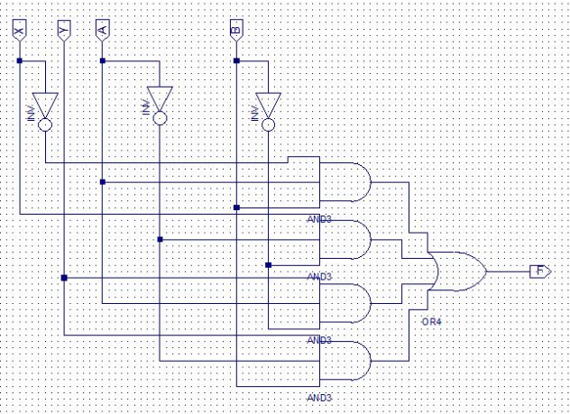

Figure3.3-2 FPGA Schematic Design

FPGAs’ can be quickly programmed to perform many basic to advanced logic functions using millions of logic gates (“Clive”). Some FPGAs use volatile memory. This would be very disadvantageous to the transformer monitoring system. The transformer monitoring system requires that the device maintains its functionality throughout power loss. If the microprocessor loses power and later regains it, immediate functionality will need to resume. When a volatile FPGA is programmed it will continue to function until it experiences power failure. Once power is restored the memory has been erased and it will need to be reprogrammed. The FPGAs are a set of logic gates and can only be programmed as logic arrays making programming a long and tedious process. Microcontrollers can be easily and quickly programmed using various programming languages to perform a variety of functions. They can easily send a serial signal to another device. FPGAs would require extensive programming to perform the constant calculations that we need to compare values. FPGAs also use more power than microcontrollers (“Difference”) and in the event of a power outage, they would deplete the transformer monitoring system’s backup battery at a faster rate. The processor used in our transformer monitoring system will need to be able to send and receive signals to and from the XBee wireless network. Microprocessors are typically better for communicating with devices such as the XBee. The microprocessor uses less power, and is easier to program than the FPGA. Therefore, we will use the microprocessor in this design instead of the FPGA.

**3.3.1.4 Atmel AVR Microcontroller**

The Atmel AVR microcontroller comes in several different models. Some of the primary goals in microprocessor selection for the transformer monitoring system were low power consumption, high resolution analog to digital converters, and to minimize extra pins. The Atmel microcontrollers with at least 4 analog to digital converters had a large excess of pins that would not be needed for the transformer monitoring system. Also when compared to the MSP430 processors the Atmel processors consumed more power (“Various”). Power is a major factor in the design of the transformer monitoring system because in the scenarios where the processor will be required to perform most frequently it may be running off of the battery backup power. Therefore the MSP430 is a better match for the transformer monitoring system than the Atmel ATR microcontroller.

**3.3.2Interactions with Various Components - Overview**

The microprocessor will interact with other componets on the circuitboard. It will receive and send signals to and from multiple decives as show in Figure 3.3-3.

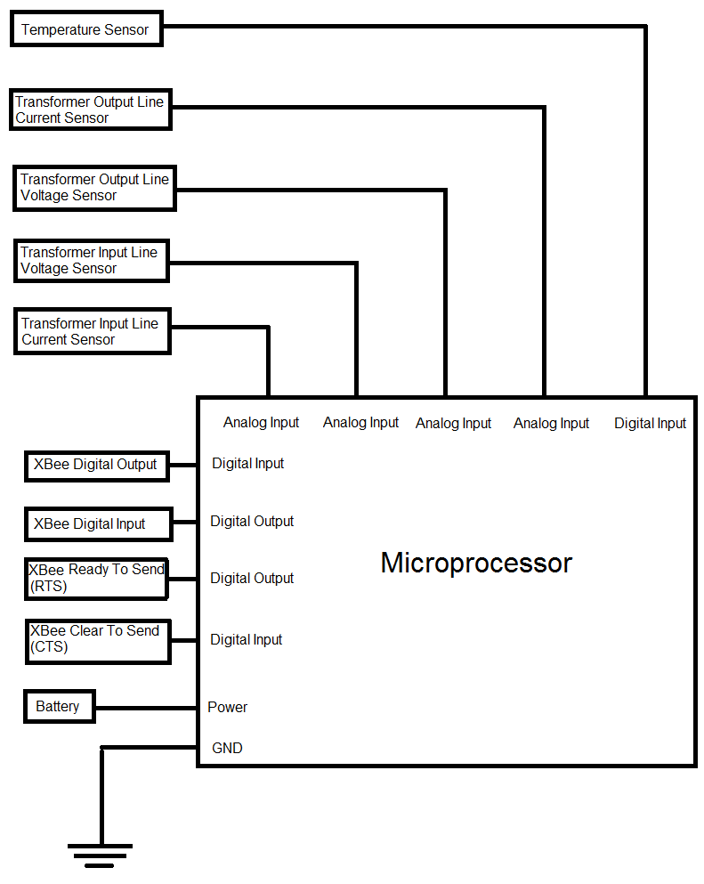

Figure3.3-3 Microprocessor Schematic

**3.4Communication and Information Technology**

The birth of new technologies has given rise to the need for information flow. With recent advances made in the way we communicate, we are able to monitor systems that would have been difficult in the past. The need and identification for more robust information technology systems is known. The communication portion of the system must be robust, stable, and able to smoothly handle information flow. A monitoring system depends on the idea of a stable communication system.

**3.4.1 Expectations of the Communication System**

The object of the project is to produce a device not only capable of monitoring a power transformer, but also of making sure that the health status of the transformer can be read and interpreted by a monitoring station. The design of the transformer monitoring system intends to preserve the longevity of this system by opening up room for expansion. The design must incorporate a setup of devices where several different transformer monitoring stations are able to communicate with each other. Each transformer must also be allowed to accept communication that changes certain values such as the threshold voltage, current, and temp. There will also exist the ability for a hub station to change the identification number of the transformer for reporting purposes. For a demonstration, the device should communicate with a central hub station.All these devices must be able to relay information to a central hub, and each system must be able to function if any of the other two cease to function. Provided with sufficient funding, the demonstration will consist of two monitoring boxes that must both be able to communicate to the central hub station. The information given and relayed by these devices must be short and brief, which is possible due to only three readings being transmitted at a time. This means that the communication system is free to be a low data-rate system, saving the team intense communication costs. This describes the basic requirements set by the team for defining a communication system. Shown below is an initial idea of how the communications system may be setup.

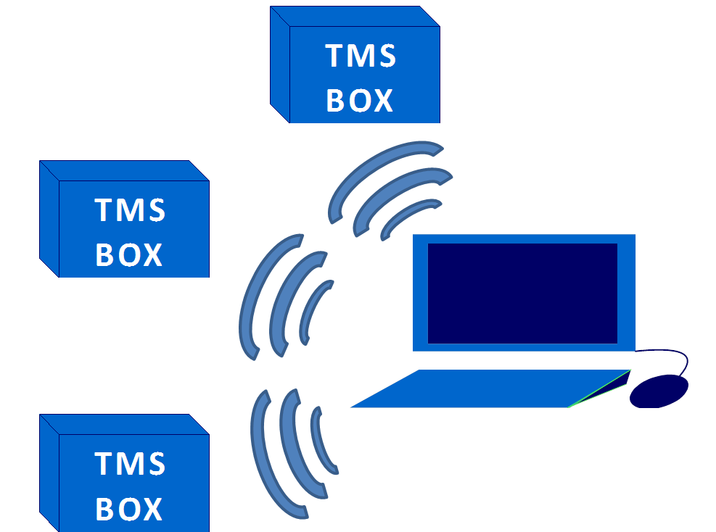

Figure3.4-1 Visual representation of an initiatl expected outcome.

Concerning data rates, our system transmits very little. We are not concerned with streaming video or sending images. The project is concerned only with certain numerical values. These values include voltage, current, and temperature. The values are expected to be reported as floats. We are assuming that no more than one line of information is sent per second. Line is defined as the numerical designation of the transformer accompanied by the voltage, current, and temperature measurements as mentioned before, all while using a small amount of power. With a clear set of goals established for the communication system, we are able to start researching for components that best suit our needs. An initial goal would be to have a system that can support at least 16 transformers, but we realize that funding for the project will most likely allow for one device unit and one central hub station. These must all be able to communicate with each other, and there are certain characteristics for each monitoring box that we must take into consideration while researching. A list of the basic generalized requirements for the communication system can be shown in Table 3.4-1.

|  |  |
| --- | --- |
| Category | General Requirements |
| Bit Rate | Very low (no constant stream of any information) |
| Transmit Distance | 1 mile |
| Power | Low |
| Cost | < $40 |

Table 3.4-1 General Requirements

**3.4.2 Methods of Transmitting Receiving Signals**

For electrically-based communication, two paths exist. The transformer monitoring system design has the option of either wired or wireless technology. Wired technology options may exist through power lines, other already present wiring, or added external wiring. Wireless technology is prevalent everywhere from cell phone networks to WiFi. Both of these technologies have been used for applications similar to ours. Therefore, communication research for our device must be first divided into two parts, wired and wireless communication. The benefits and downfalls of both are explained in sections 3.4.2.1 and 3.4.2.2.

**3.4.2.1 Wired Communication Technology**

Most information that travels to our homes comes through wire-based technology. This opens up the opportunity for a wired device communications system based on existing technologies frequently used across the country. Home phone lines, cable television lines, and even power lines are capable of transmitting data. A digital subscriber line (DSL) is able to run using existing phone lines. It typically can provide around 6 Mbits/s to an end home user while still providing phone service, which means that phone lines are able to be used more efficiently by supplying different services (high-speed-internet-access-guide.com). Most homes and businesses are capable of downloading at high speed rates over the phone land lines, because it is understood that most connections download more than they upload. The proper terminology for the technology most commonly used is then asynchronous DSL (ADSL) which is commonly referred to regular DSL. An attractive component to DSL is that many service provider stations are able to deliver over two miles, which is more than one mile that is required for the device system (dslreports.com).

Similarly, cable television lines are able to also supply internet given the proper use of bandwidth of the line. The speeds are considerably higher for this kind of communication, because the lines are already designed for content that requires higher bandwidth. Bright House Networks in central Florida claims speeds up to 40Mbit/s for download time, and up to 5Mbits/s for upload speed (brighthouse.com).Also like DSL, typical services are designed to provide more download than upload speed. Both DSL and cable internet exist and work in the field, and it is not unusual to see them share the same poles that ourdevice is required to be mounted to. Both technologies also claim to have speeds that are far more than necessary for the device. A large disadvantage to DSL is that it requires stations every few miles. The range for a station to a transformer fits into the requirements for one device, but ideally the device stations should be able to communicate with each other. This way, a transformer 5 miles away from a monitoring hub may able to communicate with the hub by relaying off other device boxes. Therefore, DSL is impractical for use in the device communications system. Cable technology, along with DSL, is able to deliver many more times the data rate than what is necessary for the device. Using either technology would be a waste of unnecessarily large data rates, and they would not fit in with the low-cost low-power requirement for the device.

Another wired option to consider is using power lines themselves, which have been proven capable of transmitting data. From below a kilohertz to over a megahertz, there is a wide range of data rates that power lines are able to utilize. One of the most useful applications of power line communication is the ability to carry internet. A white paper written by the Ratepayer Advocate group in New Jerseydescribes how “Broadband over Power Line” (BPL) communication is typically efficient, cheaper, and just as fast as typical internet lines, especially in an urban environment (Mehta, Satish). However, this technology is difficult to test given the device budget. Communication throughout household electrical wiring is also possible. HomePlug is a technology also utilizes power lines in establishing communication networks. Most often used in home networks, a HomePlug “adapter” is capable of being placed in the power outlet of a home (homeplug.org). The adapters are able to use the wiring already existent in the household for communication. Local area networks serve as data carriers for a LAN. The HomePlug AV2, due this year, claims to have communication speeds of up to 600Mbit/s, making it a very formidable contender to existing wireless technology. All the technologies described in this section show that information can be made to travel across lines that were originally designed for some other purpose. However, there is a major flaw for DSL, cable internet, and power line technology if used in our device and the flaw would also be associated with a novel wired communication system designed by the group. A primary purpose of ourdevice is to transmit health information at specific intervals, with increasing intervals in the case where something goes wrong. The project is to account for problematic conditions like severe weather. On occasion, severe weather may cause damage to the transformer where it no longer correctly functions, or power lines may physically separate from the transformer, making communication impossible. Because of the unreliability of wired technology during harsh weather, wired communication alone has been ruled out for the device.

An option that exists for wired communication during undesirable weather conditions is to have a backup wireless communication system that accomplishes the same task. Making a system that predominantly communicates using wires and only wirelessly communicating while the system is down does not work for our device, because the costs associated with both systems together is outside the scope of the project. The team has decided that wired communication would be inefficient for what are goals are. Given that the device is designed for Florida conditions, our design requires a system that is able to transmit information even if the transformer ceases to function, or even the pole it is mounted on falls. Because of this, we have ruled out wired communication.

**3.4.2.2 Wireless communication technology**

Several options exist for wireless communication devices. Also, several topics need to be accounted for in order to establish the guidelines for a working system. The type of network, the network distances which dictate power, and the type of device, must be decided upon. It is also important to keep in mind the primary goals of the communications system. The hub station is to receive voltage, current, temperature, and transformer number parameters. The hub station should also be able to receive all of the parameters listed for multiple transformers, which will be demonstrated provided appropriate funding. The communications system for the device must be able to accomplish all of these tasks while still maintaining a reasonable budget as set forth in the budget section.

Before going into detail about the guidelines of a working communications system for the device, it is necessary to include a discussion the transformer itself and the power lines have on the transmission of radio signals. Power lines typically have a history of causing interference with radio signals. One of the most noticeable times interference can be heard from the lines is while using an AM radio near them. According to Steve Casios at Orlando Utilities Commission, the current handled by residential pole mount transformers in Orlando areas is able to peak 416.70 amps at 120 volts. This gives good information towards what kind of interference the device may experience while attached to a pole-mounted transformer. Since the noise from the electrical lines is inversely proportional to the distance, the device is not able to be directly attached to the transformer. There has been much research on the effects of interference caused by power lines, and there are many variables to consider (Warburton, F.W.). A desirable distance determined by the team is from the transformer to the device is at least two meters. This will help reduce the amount of interference from the power lines. The team is also pursuing communications options that advertise transmission distances of double the one mile range that the device is expected to transmit. This will help account for discrepancies in noise and signal attenuation due to weather or other potential noise sources that exist between the transmitter and the receiver. Given the differences in transformers and their setups, the antenna for the communications system may need to be placed even farther away than the two meters from the device box.

Wireless networks come in many forms. The three predominant ones examined for the device include: a star network, a mesh network, and a point-to-point network. A starnetwork has one node at the center, with several nodes extending from it. One wireless point communicates to all the outer ones, and none of the outer ones communicate with each other. In our case, the central hub computer would be the central node, and the device would be the outer points. The second option for a wireless network type is a point-to-point network. As the name implies, each node communicates with two other nodes, except for the nodes at the endpoints of the system. This requires that each node be fully functional at all times for the whole system to work correctly. For us, one end of the system would be the hub computer, and the other end would be the farthest device. The third type of network we considered is a mesh network. In a typical mesh network, each node can connect to several different nodes, and given the correct wireless protocol, a shortest path can be established among the nodes if communication needs to be communicated from one node to another. Given our design, the computer hub station could be any node, and the device would be able to communicate to any other node when needed. A diagram of the different type of networks is shown in Figure 3.4-1.

|  |
| --- |
|  |

Figure 3.4-2Graphical representation of three types of networks

The second topic that needs to be accounted for is transmission distance, which dictates the power consumption within each device. Distances between transformers vary throughout the country. Given that the device design is ideally to be used in central Florida, we have chosen up to one mile for our transmission distance. One of the most important parts of the communications system is the ability to transmit successfully through different weather conditions, so we need a transmitter that advertises a transmission distance of more than one mile. Ideal frequencies researched by the team are shown in Table 3.4 - 2.

|  |  |
| --- | --- |
| Frequencies | Description |
| 144 MHz | Requires the least amount of power for transmission. |
| 440 MHz | Similar to 144 MHz |
| 900 MHz | Less used for voice communication than the 144 MHz and 440 MHz frequencies. |
| 2.4 GHz | Typically requires the most power to travel the same distance |

Table 3.4-2Reference to research and include typical distances

The frequencies in Table 3.4-2 are non-commercial bands. The 144 MHz and 440 MHz bands are most commonly used by hams in the amateur radio community, and can be regulated sometimes aggressively if used for constant data communication (arrl.org). The other bands require more power to travel the same distances, so they would make a better choice for an application like the device.

A common method of transmitting information over long distances is WiMAX technology, which is a working technology currently in the field and able to transmit signals over very long distances. WiMAX is an acronym for Worldwide Interoperability for Microwave Access (Rohl, Wonil). A standard set by the WiMAX forum; it is used primarily for high data rate applications. According to WiMAX.com, a WiMAX system should be able to deliver information for 6 miles at the rate of 40 Mbps. These claims are made for fixed WiMAX stations, as opposed to Mobile WiMAX stations which have slower rates. The technology, when used for mobile applications, does not fit the description for the device. The communication for this technology is between a single supplier station connected to several different clients. WiMAX is also designed as a router to client system. As a model, WiMAX resembles the star network of Figure 3.4-2. Also shown in the figure is a model of a mesh network. Ideally, the device is to be used in a mesh network, so this type of system does not fit well with the ideas as mentioned in the expectations for the communications system. The extensive radius of communication is also much more powerful than the type of communication we would like to establish. Typically, WiMAX is used for internet deployment, and the development technology is not off-the-shelf available. It is useful for high data rate applications such as video streaming or more intensive telemetry systems. This makes WiMAX technology unfeasible and out of budget for the device project. WiMAX technology, along with DSL, and power line communication, does not fit in with the expectations for the communications portion of the device.

Bluetooth is another popular method of transmitting information wirelessly. There are several versions of Bluetooth, with speeds ranging from 1 Mbit/s to 3 Mbit/s(Bluetooth.com). With the ability to connect to multiple devices at once, it may be able to serve as the hub station for the device. A central Bluetooth device is able to communicate with up to seven different Bluetooth devices directly. A drawback to this is that the technology resembles a star network as shown in Figure 3.4-2. The technology is not designed for every device to transmit through multiple devices to achieve communication with the central hub station. Another drawback to Bluetooth technology are the transmission ranges of the device, with no version reaching more than around 100 meters. The Bluetooth protocol is designed and used by small electronics for low range applications. However there have been some advances in long range Bluetooth technology. For example, BlueMagnet.com advertises long range Bluetooth range extenders that claim to have a radius of 2000 meters. However, devices like this are usually expensive, and the product from BlueMagnet, which is priced at $149.95, costs over half of the budget for the device.

Devices that transmit on the unregulated bands with high transmit distances are typically found as off-the-shelf packages. Aside from WiMax and Bluetooth, two other protocols of wireless communication seem useful: Zigbee and Digi Mesh (digi.com). Zigbee is designed more for low data-rate applications, like the type of application we are implementing. Zigbee is also designed to have different types of nodes, and the Digimesh protocol all utilize one node. The Zigbee protocol and how it can be used with was designed in part to help streamline communication networks that require mesh networking. For example, it is useful for a project such as the device that relies on networking that must work regardless of whether or not a transformer is knocked out due to storm or malfunction. Figures 3.4-3 and 3.4-4show models for the two main protocols used by XBee devices: Digi Mesh and Zigbee.

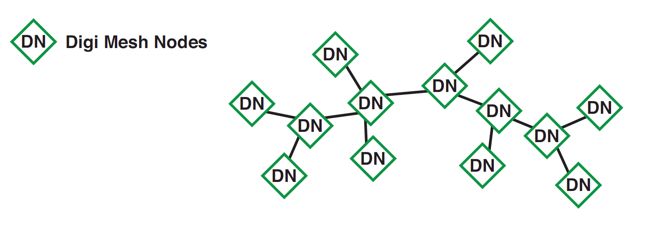

Figure 3.4–3A model of a Digi Mesh network, reprinted with permission by Digimesh

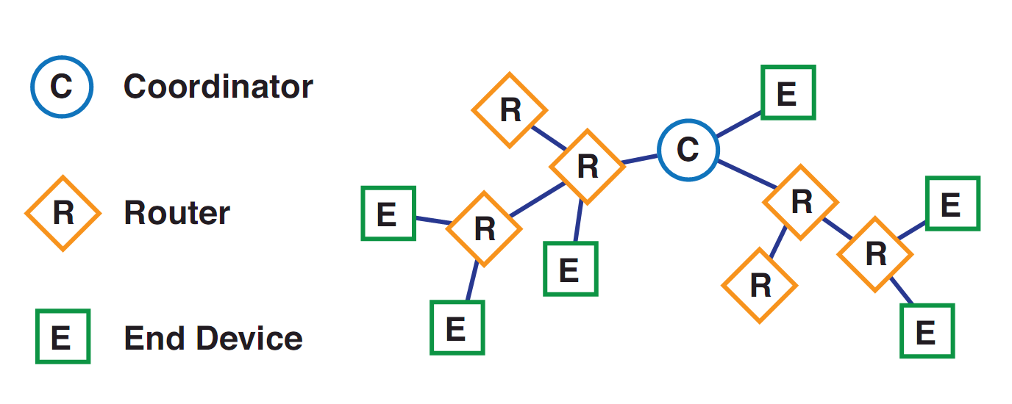

Figure 3.4 – 4*A model of a Zigbee network*, reprinted with p*ermission by Digimesh*

As shown in Figure 3.4-4, Zigbee easily matches the communication requirements established for the device. This shows the coordinator acting very similar to our design for the hub station, and the method it uses to communicate to a device not directly connected to it may also fit the model. In comparison to Digi Mesh, Zigbee is the better option for the device.

Zigbee is a communications standard based on the IEEE 802.15.4 standard. From our research, the standard has several attractive features to the communication expectations for the device. The standard helps define requirements for a small, successful low data-rate system. Relating to Zigbee, it sets down the basic ideas of the Physical Access Layer (PHY) and the Medium Access Control (MAC) layer that Zigbee utilizes (Ergen, Sinem). These two ideas, which will be described in detail, are very appealing to the choice of wireless communication chip that the device utilizes. The PHY is a dictating force behind the design of the chip. It sets the boundaries for what is possible for a small, cheap wireless cheap is able to do. Two main parts are included for developing a device that uses PHY that are also appealing to the communication setup of the device. The PHY dictates that the system must be able to turn the radio on and off. As well determining the quality of the signal, the radio must be able to select different channels. Other attributes are also beneficial to the layout for a system that utilizes the PHY, and some of these attributes are presented along with the beneficial attributes of the MAC in Table 3.4-3.

|  |  |
| --- | --- |
| PHY Characteristics | Benefits |
| Receiver Energy Detection (ED) | Reports energy back as an 8-bit integer from 0x00 to 0xff. Used for channel selection |
| Link Quality Indication (LQI) | Reports quality of a packet. Also as an 8-bit integer from 0x00 to 0xff |
| Clear Channel Assessment (CCA) | Detects amount of energy on a channel and reports whether or not it is busy |
| Presentation Protocol Data Unit | Determines packet details |
| MAC Characteristics | **Benefits** |
| Superframe Structure | Divides data into appropriate channels by also setting beacons |
| CSMA-CA Algorithm | Also helps in setting channels. |
| Communication feedback | Protocol defines how a signal can be acknowledged as being received. |

Table 3.4–3Table of appealing Zigbee characteristics for the TMS

In Zigbee, the PHY characteristics help describe the kind of physical characteristics for the device. Both the MAC and PHY characteristics listed in Table 3.4-3seem to be good tools for use in the device. The protocol includes assessment of channel, link quality, and received energy which are all useful in a meshed network that requires multiple paths of communication. In a mesh network as desired for the device system, several tools like these will help reroute signals around transformers that may be down or for problematic areas that have trouble with transmission or reception. The MAC portion of the Zigbee protocol helps determine the actual handling of information. Some characteristics of MAC, also listed in Table 3.4-3,are beneficial to mesh communication systems. The protocol includes how data will be separated into channels, the kind of packets that are used, and how packets can be confirmed as sent to another Zigbee protocol following device. The Zigbee protocol has some very positive attributes for mesh networking systems.

At this point in the research, a brief comparison of the explored technologies should be covered. There are many existing forms of communicating with other devices. Both wired and wireless systems have attributes that may or may not be beneficial to the communications system. The basic attributes of the communications system as described in Section 3.4.2remain the same. A transformer monitoring system must be able to send data to a central hub, and the devices should still be able to form a communications link at a distance of about one mile. The central hub must be able to receive information from all transformers in its area, and it must be able to compensate for lost transformers or device boxes that are no longer functional. These requirements should be taken into consideration in Table 3.4-4below.

|  |  |  |
| --- | --- | --- |
| Technology | Advantages | Disadvantages |
| DSL | Very fast speeds. Capable of many different connections | Requires monitoring stations not too far from clients. Wired connection, so not able to fully communicate during a fallen line. Resembles a star network |
| Cable Internet | Extremely fast speeds. Like DSL, also capable of many connections. | Similar to DSL. |
| Power Lines | Capable of transmitting at "Broadband" speeds | Resembles star network. Too much for the low power low data rate requirements of the communications system. Hard to test. |
| HomePlug | A commercially available technology that proves the concept of transmitting through lines designed to deliver power | Not made for transmission over high voltage power lines, just individual homes and businesses |
| WiMax | Extremely fast data rates. Able to transmit up to 6 miles. | Not as commercially available as some other technologies. Resembles star network. |
| Bluetooth | Very fast data rates | Very poor range. Not quite designed for the mesh network desired by the device |
| DigiMesh | Mesh network protocol that has long range on certain devices | Not designed for a central hub station |
| Zigbee | Mesh network protocol that also has room for a central hub station. Also able to transmit long distances with certain devices | Not originally intended for communication of up to a mile. |

Table 3.4–4 Comparison of technologies: advantages and disadvantages

The Zigbee model most closely follows the requirements set forth for a device communications system. One of the largest off-the-shelf suppliers of the Zigbee devices is XBee, and these devices may be sold from Digi. From recommendations and other proven examples that we have seen, the team has chosen to use XBee devices. These devices are able to fulfill the requirements. Since the XBee has a stable history regarding wireless applications, we have chosen the XBee Zigbee Pro 2.4 GHz model for all wireless aspects of the device project. The Zigbee designation is the protocol to be followed that allows us to utilize mesh networks. How the device utilizes the Zigbee protocol is explained in further detail in Section 4.4.1. The “Pro” designates XBee models created for long distance communication. The XBee is widely available for consumers, and it is relatively cheap compared to other options. Other devices similar to XBee operate primarily on the 900 MHz and the 2.4 GHz frequencies, which narrow down the choices. However, XBee devices that utilize the Zigbee protocol operate on the 2.4 GHz frequency. This may raise concern for interference that might occur with the communication of a heavily used band. Most consumer devices that operate on the 2.4GHz band, such as cordless phones and Wi-Fi networks, use channels according to the IEEE 802.11 standard. The Zigbee protocol is based off of the IEEE 802.15.4 standard, which uses channels outside of the accepted range of 802.11 devices.

In conclusion, the TMS utilizes a wireless communication setup. The basics of the system consists of a 2.4 GHz XBee model that follows a Zigbee protocol for each box and hub station, and an antenna with the appropriate characteristics as derived in this section. These researched requirements fulfill the demands presented in Section 3.4.2 for a low data-rate high transmission distance communications setup.

**3.5Computer Programming**

The final destination of all the data collected by our device is located inside a central hub computer. On this computer a program takes all of the information and displays it in a nice, neat organized fashion as mention in the objectives for this section. Also mentioned, the program’s ability to keep track of every transformer individually and not allow for data to be mixed or altered was extremely important to keep in mind when designing the device. There were three aspects to the computer program that needed to be researched thoroughly in order to optimize efficiency and achieve the objects and specifications. The first aspect was how the program will interact with the user. This is extremely important to figure out since the computer program is the focal point to the entire device. The second aspect was the computer language used to build the program. It needed to be easy to learn and use, since every member in this group is an electrical engineer and not computer science majors. Though this portion of the computer program was the toughest to overcome due to the reason mentioned previously, we were able to overcome this and accomplish all objectives and specifications that were defined for this section. Finally, the third aspect was the method of implementing the input data. The methods here needed to transfer the data delivered by the wireless component to some location where the program could have read from.

**3.5.1Computer Language**

Determining what computer language to use in a particular project can be hard to formulate especially when programming is a foreign language. Recall that all of us are electrical engineers with very limited amount of programming under our belts. Many forums on the web provide input for this dilemma; however, one in particular asked questions that seem appropriate and useful. A user named Vinnie, from the forum Search-This, brought up several questions that will help us determine which computer language is right and each question will be analyzed in detail (Garcia):

1. “What do you want to build?”
2. “What platform(s) am I going to be running on?”
3. “What do I already know? Do I like it?”
4. “Does the language have features for my project?”

The first question Vinnie asked was, “What do you want to build?” This question has been explained in depth already. We want to build a program that will display a group of transformers in a visual manner, monitor various parameters of the transformer, and alert the user if there is a problem with any of the transformers. Since this project will require the use of GUIs and objects for everything, it is important that the computer language chosen can support this. Java, C, C++, C#, and Visual Basic all have the capability to create GUIs; however, not all of them are object oriented. Making every transformer an object with the same parameter types but different values seems to be the most logical way to creating this project. All of the languages listed are considered object oriented except for C. With one language taken off of the list, it is time to answer the next question.

“What platform(s) am I going to be running on?” Though the question may not seem that important to ask, it can still narrow the list of languages that could be used. Take for instance C#. It is a hybrid of C and C++ and used with XML-based Web services on the .NET platform. Although C and C++ are both multiplatform computer languages, since C# utilizes the .NET platform it can only be run on Microsoft computers. This may seem like a huge problem, but Microsoft still dominates the computer market in the business world. More than likely the power company using this program will already have a Microsoft computer they can use for their central hub. Even if they didn’t the power company probably wouldn’t mind spending a little extra money to ensure they can run our program. Since this question did not provide a language to use the next question needs to be asked.

The next question can be broken up into two parts. First, “What do I already know?” Even though we are electrical engineers, we have all taken some form of computer programming throughout our years in school. All of us are familiar with C and assembly; yet neither of those is on the list. One of the group members however took some classes using Java and Visual Basic. Because of his knowledge of those two, the list of languages to use can be further narrowed. C++ is much like C, but object oriented. Although it bears some resemblance to C, this program language is completely new to us and will therefore be taken off the list. This leaves Java, C#, and Visual Basic on the list. C# remains on the list due to the fact that it was made to counter Java and thus is extremely similar to Java. The second part to the question is, “Do I like it?” Overall, Java seems to be the easiest one to use and thus has created a place in our hearts as one of our favorites. Since C# is much like Java, it has the potential to be great for us to use as Java was. Visual Basic on the other hand fell short on that thought. Though the creation of buttons and other GUI items was extremely easy, the programming as a whole was complicated to understand. With our list further narrowed down to just Java and C#, the final question should help us pick the language we will use to create the program.

“Does the language have features for my project?” The main worry we face is the time it will take to learn and program the language for our project. After shifting through many forums and questionnaires, the majority of the programming community would agree that C# is the easiest to use and learn for basic GUI development. Besides using the .NET framework, it also utilizes Visual Studios. Both of these provide access to technologies that will simplify the development of our program. With all of the questions fully answered, the computer programming language that will allow us to build our program efficiently and professionally is C#.

**3.5.2Program Interactions with User**

A majority of the user’s time will be spent processing the data collected through the program and not physically handling the actual device itself. Due to this reason, the program needs to be astatically pleasing but allow for quick navigation at the same time. Before making a decision on the overall looks of the program, a major question needs to be answered. Do we want the user to have vast amounts of control over the placement of the transformers and their grid system? There are two simple answers to this question – yes or no. Once figured out there are many different avenues this program can take.

One idea we had for this program was to allow the user to build a grid system from scratch as to model the exact transformer grid system currently in place in the real world. For this to work two different modes will need to be available; a build mode for the creation of the grid and a viewing mode for the actual monitoring of the transformers. Having two modes will ensure that the user does not accidently mess up the grid system when trying to monitor the devices. One positive aspect to this is that the user will have complete control over the number of transformers in a grid system. If the power company decides to expand the grid system in real life, then the user will not need us to modify their own grid system. This idea does not seem too hard to accomplish, but there are some problems that derive from this. First, this idea will take more time due to the enormous amounts of coding that is required to achieve such idea. Second, since we are not computer science majors and do not program on a daily basis this idea may be harder for us to accomplish than we think. Finally, letting the user have too much control could be fatal to the overall workings of our system. Though our device might work fine, since the user did not set their program up right our system could fail. The other idea is to limit the user’s control.

The idea of limiting the freedom of the user is another answer to the question proposed earlier. For the most part, this works by having the power company send us their blueprints of their transformer grid system. Once obtained, we would then use the documents to make an exact replica in our program with all of the data already put into the system. The biggest drawback to this idea is that the power companies will need to contact us every time they modify their grid system. Though this method does not allow the user to add any new transformers into the grid, it does keep the coding and navigation of the program simple. All the user will have to do is open up which grid system they want to monitor and that’s it. Remember the more simple this program can be the better, for both the user and us. Although the user will not be able to expand or change the grid system, they still will have the ability to modify each individual transformer.

Both ideas have not gone untouched by other programmers. Take for instance Microsoft Paint, they allow the user tremendous amount of control over the program. This is because paint was made as a simple drawing tool. The user opens up a new document and they are given the freedom to draw various shapes (lines, circles, squares, etc.) and then further modify them by adding color, rotation, and shifts in placement. Our first idea of allowing the users freedom to create their own grid system is like this program. Just like paint, the user will have access to a tool bar that has all of the symbols needed to create a replica of the actual grid system. The second idea is a lot like the first but without the build mode aspect to it. No matter what idea we choose, there is no transformer monitoring software out there like ours. Many programs out today display their information in a table format with tons of numbers and stats shown on the screen. Our program will be custom built to meet the user’s expectations and will display the information in a visual format. Most people react to visual messages faster and in a more concise manner than with lines and lines of numbers and statistics. For this reason, the program for the Transformer Monitoring System will be state of the art and the easiest program on the market to use.

**3.5.3 Methods of Implementing Input Data**

Before the program can use the information provided by the transformer monitoring system, the program needs a way to store the data locally and allow for multiple instances per transformer. It is important to find a way to implement the input data such that it can be constantly updated and put into storage so that the data can be recalled days from now. In general there are two ways that this could be done; either through multiple text files or through the use of a database such as MySQL. Though both ways are perfectly acceptable, there are many flaws that need to be brought up when determining which path to take.

The idea behind using text files to store the data is as follows. The information, already formatted by the receiver, is stored in a text file with the name of the current date. Basically everyday a new text file will be created so that a history of the data will be present if needed. The text files will hold a list of all the transformers’ data, sorted by the serial number given to every transformer monitoring system. Every time new data is received a new line will be created showing the current values. This means that each transformer would have a group of lines representing past and current values of their parameters. Figure 3.5-1 shows what this would look like. Though this method of implementing the input data seems plausible, it is highly unlikely to work properly. This method will cause a lot of organization problems due to the fact that there could potentially be hundreds of text files at any given time. Amount of space used then becomes an issue. Since every text file holds multiple lines of data per transformer and with grids containing hundreds of transformers, the amount of space needed to store the data could end up enormous.

Figure 3.5-1 Representation of storage using text files

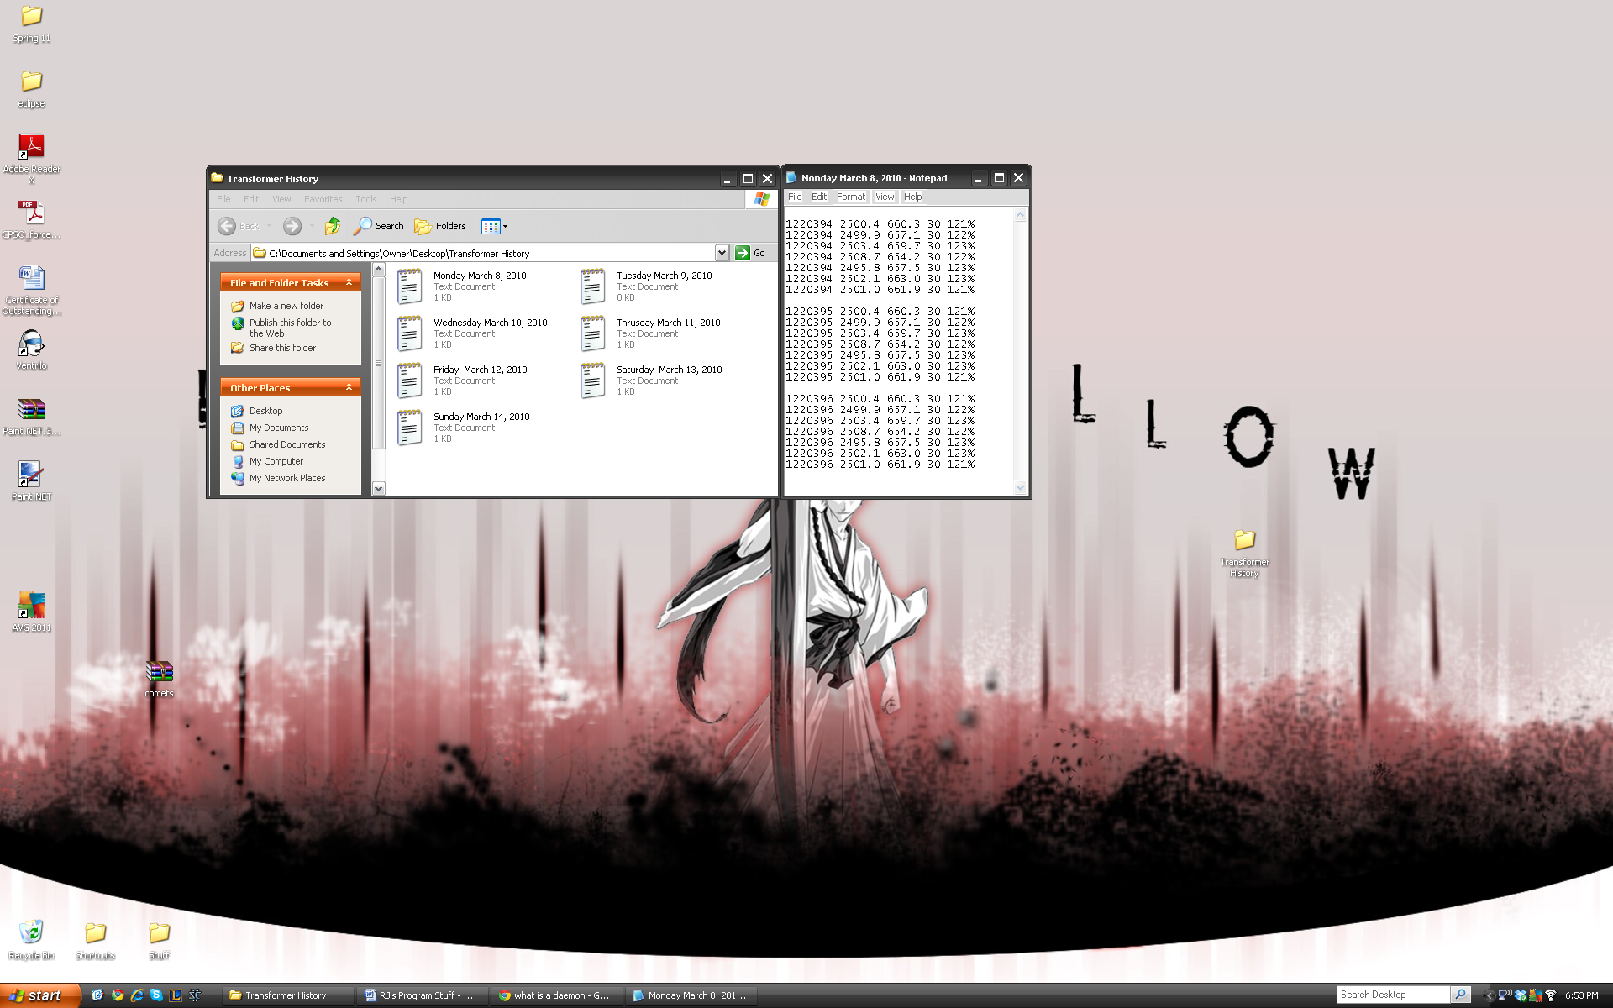

Figure 3.5–1 Organization of information using text files

Another idea in implementing the input data is through the use of databases. As mentioned, every grid system in the United States contains hundreds of transformers and so the quantity of data coming in adds up to a large sum. Databases, by their definition, are intended to organize, store, and retrieve large amounts of data easily; as such they are the perfect match for this type of application. Now that databases are the way to go, the next step is to figure out which database is the best suit for this project. There are many various databases out in the market today (Oracle, Microsoft SQL Database Server, MySQL, SQLite, PostgreSQL, etc) and though each of these databases will work in this application, there are several distinct differences that need to be mentioned. First, there is a difference between SQL Serves and Oracle. Microsoft has been the majority leader in most aspects of the computer world and thus has a huge following of supporters. Oracle on the other hand has a smaller following due to the fact that Linux and UNIX are not as popular. With fewer followers the information about Oracle is sparser than with the information about the SQL Servers. This could cause hassles when problems arise and technical support is needed. Now out of SQL Servers, there are many proponents to each one that will say various things about their competitors (McCown). For instance, MySQL proponents will argue that their servers are very fast and reliable while PostgreSQL is a lot slower than and not as stable as them. Since we have never worked with any of the SQL servers, we cannot say if this is true or not. Due to this, the decision to use any one of the servers is merely based on the thoughts of our professors and colleagues. Many of them have used MySQL and have mentioned wonderful things about the database. With that being said MySQL will probably be selected as our database of choice.

# 4.0 Hardware and Software Design Details

**4.1Power Supply**

**4.1.1Inductive Power Pickup**

The preferred method of getting power to the monitoring system will be through the use of an inductive coil. This will be designed with the following assumption since we are still waiting for a reply email from 3M on product specifications. The magnetic permeability of the Scotchcast 5555 resin is unknown, so the magnetic permeability of air will be used for calculations for an approximation of the coil dimensions. The gauge of solid copper insulated wire to be used for this application is 22 AWG, 25.3 mils in diameter; this is chosen because of the wire being able to handle 4.5 amps for power transmission ([www.interfacebus.com](http://www.interfacebus.com)). Once the general characteristics are found by calculating the equations below, the rest of the power supply can be designed. The decision to connect the coil across the low side 120V side of the transformer is due to the higher currents available there and the reduced thickness of the insulation needed for the coil. These higher currents will create greater magnetic field; this will result in less turns needed for the coil leading to a shorter, easier to mount coil. The currents to be considered are under full load of the 120V power line with Orlando Utilities Commission of 416.7Amps (Casios,Steve). The value of the radius(r) was approximated at .02m account for the diameter of the un-insulated power line and the thickness of the coil’s insulation. The desired voltage of 12V is to allow for significantly lower current then under full load to be present in the line and still be able to power the monitoring system. The length of the

$$β=\frac{µ_{0}I}{2πr}=41.691×{10}^{-4} T$$

$$µ_{0}=permeability of air=4π ×{10}^{-7} H m^{-1}$$

$$I=current in power line=416.7Amps$$

$r=the distance between the center of the power line and coil$ = .02m

$$\left|V_{coil}\right|=N 2πr \frac{Δβ}{Δt}$$

Rearranging the equation to solve for N gives:

$$\frac{{|V}_{coil}|}{2πr}\frac{Δt}{Δβ}=N=191 turns$$

$${|V}_{coil}|=12V$$

$$Δt= \frac{1}{60Hz}=16.6667 mS$$

$$Δβ= β_{final}- β_{inital}=2 β=2(41.691×{10}^{-4} T)$$

Upon solving the equations above; the diameter of the coil being twice the radius equaling .04m or 4cm is now known. The number of turns needed to produce the desired voltage is 191 turns, knowing this and the diameter of typical 22AWG solid copper with TFE 600V insulation is 1.14mm. The length of the coil will be 217.74mm, this is acceptable for the project. Another aspect of the inductor that must be taken into consideration is its self-inductance given by the equation below. After calculating the coil’s inductance, the voltage lost during full load operation can be calculated from the $V_{induced}$ equation.

$$L= \frac{µ_{0}N^{2} A}{I}$$

$$N=number of coil turns=191 turns$$

$$A=cross sectional area of coil=π( 0{.02}^{2})$$

$$I=current present in coil, assumed 1A for peak current in normal operation$$

$$V_{induced}=\frac{L ΔI}{Δt}= .0138V$$

$$ΔI=2\left(1Amp\right)$$

$$Δt= \frac{1}{60Hz}$$

After solving for the voltage lost from self-inductance, it appears that the self-induced voltage can be neglected. This is due to the fact the coil is designed to produce almost twice the required amount of voltage needed for the monitoring system to operate. Since the physical dimensions of the coil are known, the housing structure for the coil can now be designed.

With this project being a prototype and not a mass production unit, the power coil and sensor housings need to be designed in a cost effective manner. The most sensible method to create these housings is to encapsulate the components with a material that is both an insulator and strong enough to provide structural support. Scotchcast™ electrical resin 5555 manufactured by 3M was originally developed for this type of application. It has a dielectric strength of 1300 v/mil, which can be layered to provide enough insulation to be adapted to even the highest voltage power lines and is UL 1446 rated for up to 130◦ C continuous use. Another advantage to using an epoxy resin is they are designed to be able to flow into small spaces forcing out air pockets, which can lead to arcing and premature failure of the device. With the average coating of 13mils the minimum thickness is thin enough to be the insulator between the coils and power line. With the product to encapsulate the components selected, the design of the housing can now be done. The general idea of the housing can be seen below in the housing diagram. It will be of a clam shell design to provide for ease of installation without having to disconnect the power lines. The cut ends at the opening of the clam shell will be of a design that provides a conducting contact with minimal resistance, through a male to female pin connector design. To provide reliability and corrosion resistance this junction will have a layer of common commercially available dielectric grease applied. Opposite to the clam shell opening will be a hinge assembly with the coil wire left uncut. The clam shell housing will be clamped to the power line by two nylon strap with nut and bolt assemblies to minimize arcing from the un-insulated power line.

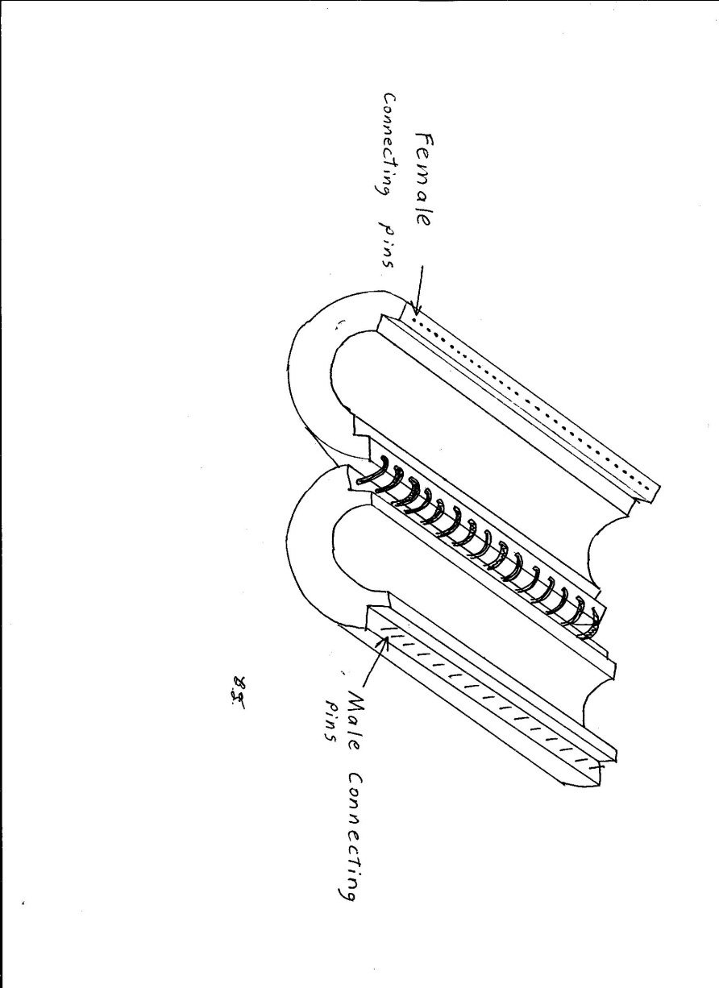

Figure 4.1-1 Diagram of Power Coil

With the power coil housing designed the fabrication process needs to be outlined. The electrical insulating resin can be formed in a few ways. The method that we will be implementing involves creating a mold to be heated. Two molds will be needed, one for the top and one for the bottom of the housing assembly. Each of these molds will consist of an outer and inner mold. The outer mold for both top and bottom assemblies will be made from a single 5mm inner diameter metal pipe cut in half; with the inner mold assemblies made from a metal with an outer diameter slightly larger than the diameter of the power line. A wax/mold release layer will be applied to the outer shell molds, and then heated to the correct temperature. The electrical resin powder will then be poured into the mold and spread to create a layer 3mm thick. With the conducting wire formed into the correct size coil, the coil will be cut on side. The coil will then be placed inside the molds and reheated to the correct temperature for pouring the resin. Once both inner and outer shells are the correct temperature, more resin will then be poured into the mold. The inner mold will then be placed in its correct position to form the cylindrical shape of the housing assembly. Once the resin has cured the shells will be released and ready for the pin connections to be attached.

**4.1.2Implementation of Power Supply**

The power supply unit will be broken up into three distinct steps: rectification, battery backup, and regulation. A block diagram of how the components to the power supply can be seen below. The first step is to rectify the 12VAC power that is coming from the Inductor coil; this will done using a simple rectifier IC and smoothing capacitor. The output of the rectifier circuit will be 10.9VDC and will be used to supply power to the rest of the system. The 10.9VDC is a high enough voltage for the battery charging IC to charge a 7.2V LiPo battery pack. The two voltage regulator circuits will be tapped off the 10.9VDC line and connected in parallel. The reasoning behind this configuration is due to the battery backup. The LT3652 is designed to work in an application where the battery can supply power to the circuit when the supply voltage drops below a specified amount. The battery will only be supplying 7.2VDC, so a parallel connection of the regulator circuits is to ensure enough voltage can reach both the logic board and sensor op-amp blocks.

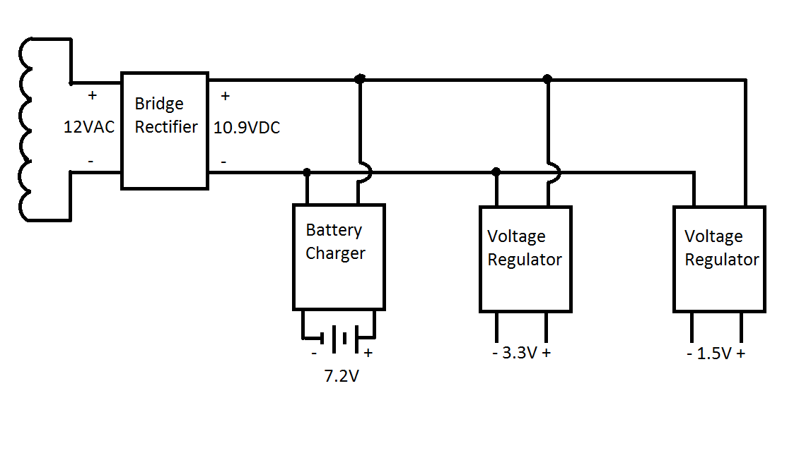

Figure 4.1-2 Block Diagram of Power Supply

**4.1.2.1 Bridge Rectifier**

The first step in creating the power supply is converting the AC power coming from the power coil into DC power required by the system. For this task we will be using the Diodes Incorporated KBP201G bridge rectifier IC. This device is a typical 4 pin full wave bridge rectifier and has a 1.1V forward voltage drop so with a 12V AC input will give us 10.9V Dc output. The rectifier has a 2A average output current capability which is enough to provide current to the battery and logic board. The $C_{smooth}$ equation below gives a value for a smoothing capacitor that will give us an output voltage ripple of 10%; upon solving the equation the value for the capacitor is 7645 µF with a rating of 50V.

$$C_{smooth}=\frac{5 I_{0}}{V_{s} f }$$

$$I_{o}= =output current assuming average of 1Amp$$

$$V_{s}=source voltage of 10.9V$$

$$f=frequency of 60 Hz$$

This circuit will be connected in series with the logic board and battery charger IC. As seen below the leads from the inductive coil will be connected to the Vin pins of the rectifier IC. The Vout pins will then by connected to the primary power and ground layers of the PCB board respectively. The smoothing capacitor will then connected across the two layers to smoothing the DC voltage waveform. The KBP2501 IC was selected due to its characteristics; it has a high operating temperature range of -65 to 150 ◦C and a peak reverse voltage of 100V. It is believed these two attributes will help increase the longevity of the monitoring system as a whole, by supplying a stable DC voltage with minimal voltage spikes.

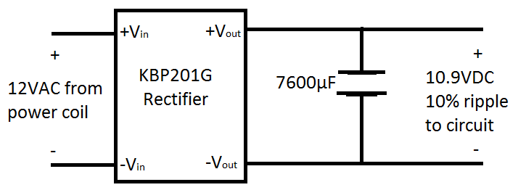

Figure 4.1-3Schematic of KBP201G Rectifier Circuit

**4.1.2.2 Backup Battery Power**

With DC power now entering the system at 10.9V, we will now use that higher voltage for charging the back-up battery through the Linear Technology LT3652 battery charger IC. This device will ensure the battery cells have the correct charging algorithm, to prevent damage to the Lithium Phosphate battery cells. The other advantage to using this device is it will automatically detect a low voltage condition and supply power to the monitoring system if the circuit below is used. Considering this application matches what the device was designed for; the circuit below will be implemented on the logic board, with the part numbers supplied.

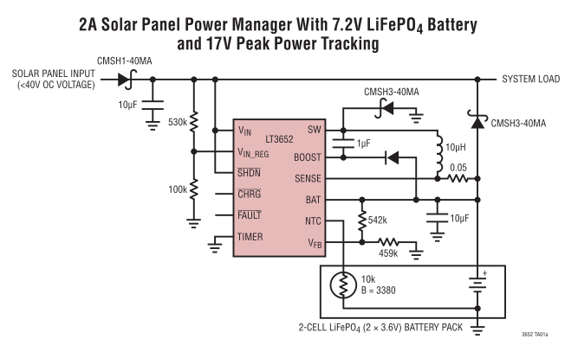

Figure 4.1-4 Linear Technology LT 3652 datasheet diagram

**4.1.2.3 Voltage Regulators**

The monitoring system logic board will require two separate voltages; 3.3V to power the logic board and 1.5V for offsetting the voltage signals coming from the current and voltage sensors. The method of choice for the regulator will be buying the Diodes Incorporated AP1186 regulator instead of designing separate transistor circuits. The AP1186 is an adjustable or fixed output five pin regulator with both 1.5V and 3.3V output settings, though we will be buying the fixed output models. Another feature to this device is the low voltage drop; at 1.5A it only drops 0.5V and has a maximum operating temperature of 150 ◦C. The schematics of both circuits can be found below; the +10.9V source is the positive output for the rectifier circuit. The values of the capacitors are given by the datasheet and the value of the resistor is to make sure Vctrl is at least 1V greater than Vin.

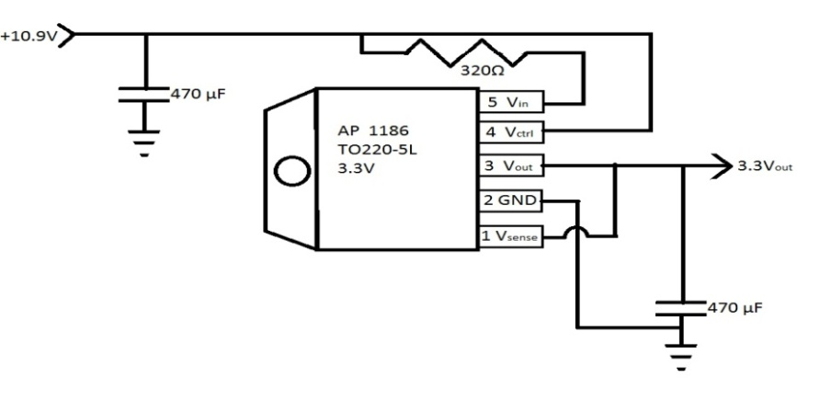

Figure 4.1-5 Schematic of 3.3V Regulator Circuit

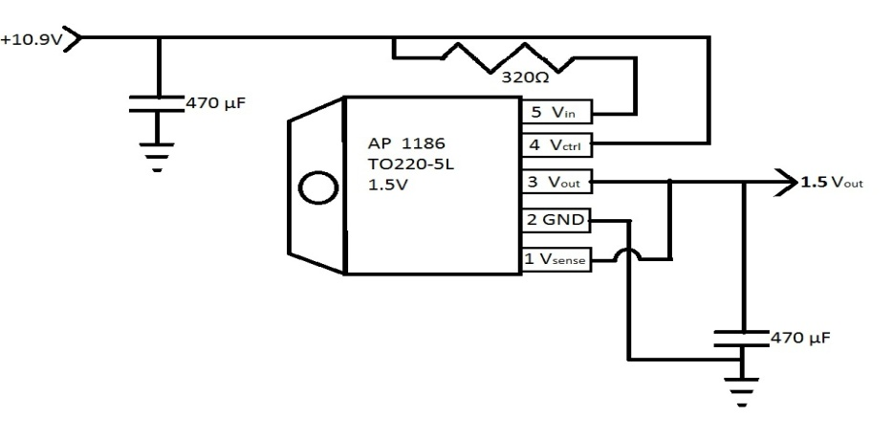

Figure 4.1-6Schematic of 1.5V Regulator circuit.

**4.2Sensor Development**

**4.2.1Implementation of Voltage Sensor**

The basic components need to build the voltage sensor are: a plate, an op-amp, two capacitors, and four resistors. The plate is needed to attract the charge of the electric field from the power line. Capacitors of equal 10 µF values are selected and the resistor values are calculated from the Vbias equation below. The 1.5V power is supplied from the PCB board and connected as seen in the schematic below. The R4 resistor is selected and the R3 resistor is calculated with the Gain equation below. The –Vcc pin of the op-amp is connected to ground and the +Vcc pin is connected to the 10.9V layer on PCB board. This circuit was simulated with LTSpice, see figure below, as an approximation and provides a starting point for the actual circuit to be used, though extensive testing will be needed. This is said because the electric field permittivity of the insulating material is unknown and the circuit values will be based on the measured capacitance of the capacitor plate.

$$V_{bias}= \frac{R1 1.5V}{R1+R2} Gain=1+\frac{R3}{R4}$$

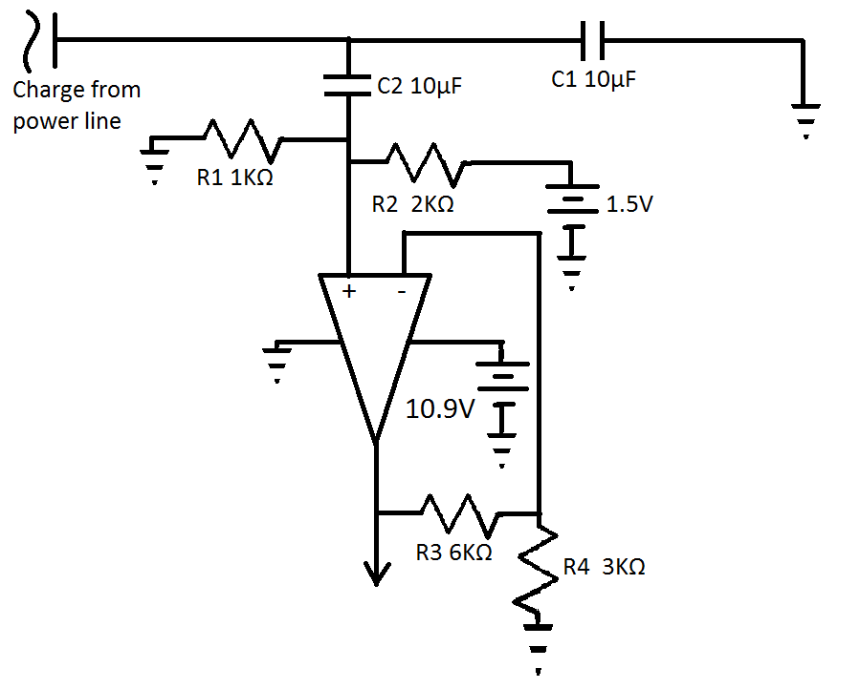

Figure 4.2-1 Schematic of Voltage Sensor

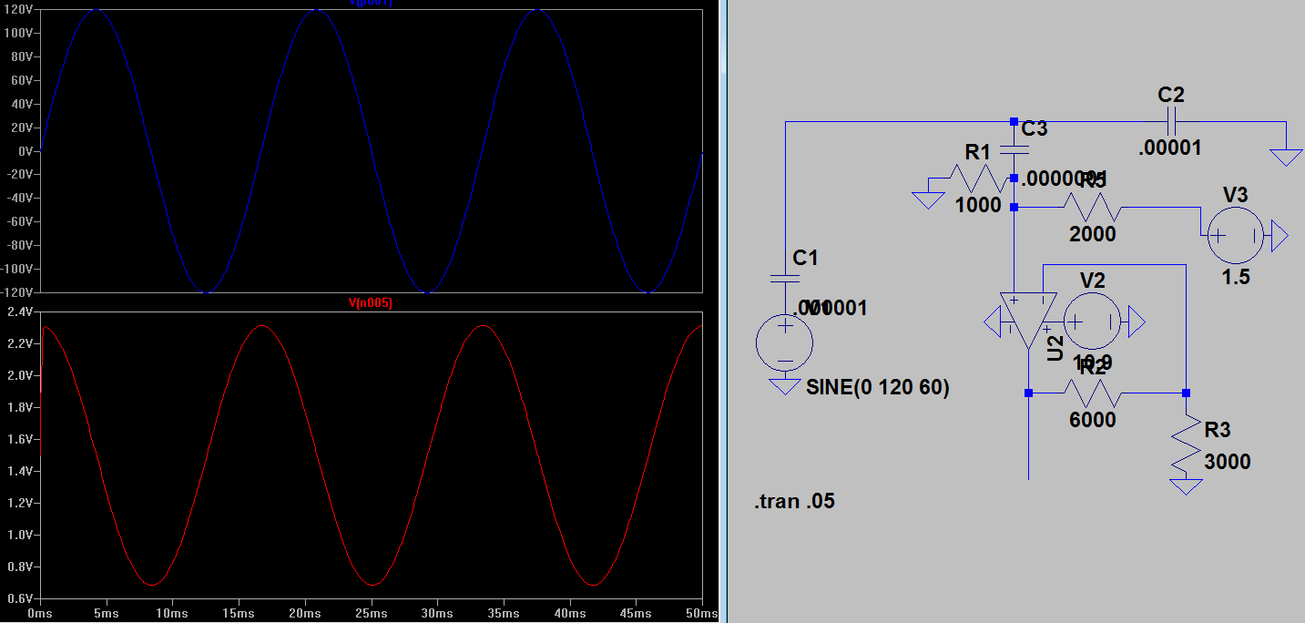

Figure 4.2-2 Simulation Results of Voltage Sensor

With the voltage circuit created, the housing for the plate to attach to the pole must be designed. The approach will be similar to the method used for creating the inductive coil housing. Scotchcast™ 5555 epoxy will be used to insulate the plate from electrical arcing of the power line. Two small lengths metal cylinders about 40mm wide will be used for the casting of this housing; the inner cylinder will have the same diameter as the power line and the diameter of the outer cylinder will be 10mm larger. A notch will be made in the outer ring to accommodate the wire lead from the capacitor plate. With both rings setting on a metal hot plate, the capacitor plate will then be placed at the desired location. The assembly is then heated to 177◦C and the Scotchcast™ will be poured in to melt and form the desired shape. After curing and cooling, the assembly will be cut in half at 90◦ from the location of the capacitor plate. The two halves of the housing assembly will then be ready to attach over the power line and fastened with a nylon strap.

**4.2.2Implementation of Current Sensor**

The method to be implemented for the current sensor will make use of a Rogowski coil. Since one of the advantages of using Rogowski coil is its capacity to measure a broad range of currents, one coil can be designed to measure currents from 50A to 450A. This is done by first solving the magnetic field equation below for 50A and 450A. This yields .5 mT and 4.5 mT respectively. The next step is to find the amount of magnetic flux produced by using the Φ equation, upon solving the values are .06Φm and .54Φm respectively. The last step in finding the voltage in the coil is calculating the Vcoil equation for each case. The area is of the small loops of the toroid and will be selected at π(3mm)2 giving an area of 28.274µm2. The radius of the coil is planned to be 20mm, this gives the total length of the coil to be 125mm. The wired that will be used for this coil is a 26AWG that has a diameter of 0.51mm; using this information we can calculate the maximum number of turns that can be contained in the coil length to be 245 turns. After solving the Vcoil equation, the voltage range that will be present on the coil’s wire leads is 0.4156mV to 3.7mV.

$$β= \frac{µ_{0} I}{2 π r}$$

$$µ=equalvant permeability$$

$$I=current in power line$$

$$r=the distance between the center of the power line and coil,20mm$$

$$Φ= \frac{Δβ}{Δt}$$

$$Δt= \frac{1}{60 Hz} Δβ=2 β$$

$$V_{coil}= NAΦ$$

$$N=number of coil turns$$

$$A=cross sectional area of the small coil loop$$

With the voltage from the coil being so low and the need to get the voltage proportional in the current an integrator must be used. For this project a simple leaky integrator circuit connected to the output of the coil and input of the MSP430 is enough. This type of integrator is chosen because it can introduce the DC offset voltage needed by the micro-controller. The circuit schematic is shown below the equations used for calculating component values. The positive lead of the coil will be connected to +Vin and the negative lead of the coil will be connected to –Vin on the schematic. Since this type of op-amp circuit is frequency depend and only one frequency will be present it would be advantageous to tune this circuit’s resonant frequency to 60Hz. Selecting the capacitor value as 10µF and solving for R1 in the $f_{c}$ equation with $f_{c}$ equal to 60Hz, yields R1 to be 265Ω. Since we need to introduce a DC offset voltage, the ratio equation formula will give a good indication of what value of R2 needs to be if Vout is to be centered around1.5V.In the calculating R2 the average between the two voltage extremes of 2.058mV will be used, giving the value of R2 as 193KΩ. The output of this circuit will then be connected to the MSP430.

$$f_{c}= \frac{1}{2π R1 C}$$

$$\frac{V_{out}}{+V_{in}}= - \frac{R2}{R1}$$

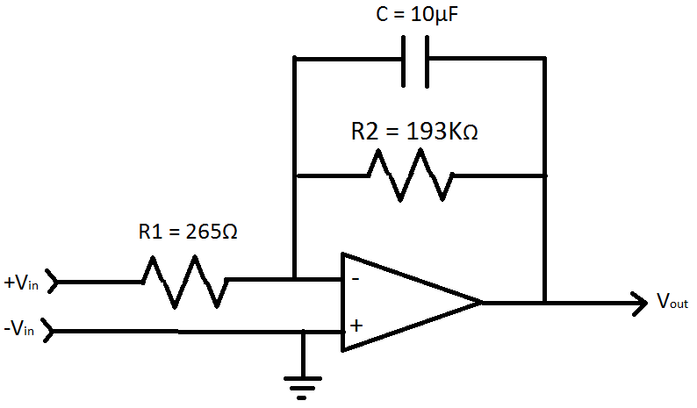

Figure 4.2-3 Current Sensor Schematic

**4.2.3 Implementation of Temperature Sensor**

While researching what type of heat sensor should be used in measuring the transformer’s temperature, an infrared sensor from Pololu: Robotics & Electronics popped up. The MLX90614ESF-AAA Infrared Temperature Sensor 90◦ FOV is a type of non contact sensor that utilizes a high accuracy, high resolution, thermometer with a 90◦ field of view. Since this component is non contact it will further enable the transformer monitoring device to be non intrusive to the existing power system in place. According to Pololu, the component has a measurement resolution of 0.02◦ C and is factory calibrated for a wide -70 to 380◦ C object temperature range. Although the temperatures outside can vary drastically, the range of this component is much greater. This will insure that the temperature sensor will work no matter how hot or cold the transformer actually gets. Another important note is that the component is extremely small and compact; so small in fact that it is tinnier than a quarter. Since the sensor will need to be a part of the extremities of the device, in direct line of sight of the transformer, the smaller the hole needed the better water proof the device will be. No water can be allowed into the device for all of the electrical components of the device will fail. One main concern brought up in the research portion for the temperature sensor, is that infrared sensors generally are costly. A great thing about the MLX90614 is that it cost only $19.95 plus shipping and handling. After talking with representatives from Pololu about student discounted prices, they were willing to offer 20% off of the device. With the discount the component then becomes $15.96 plus shipping and handling. Refer to section 4.3 for how this temperature sensor interactions with the microprocessor. Figure 4.2-6 shows what the MLX90614 looks likes, the size comparison, and an interactive device using it.

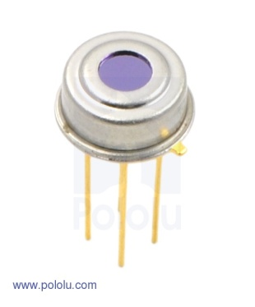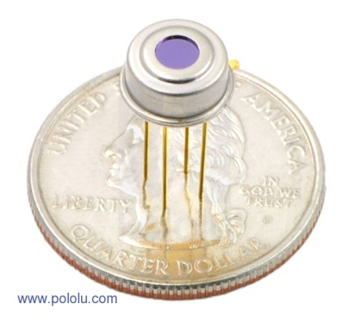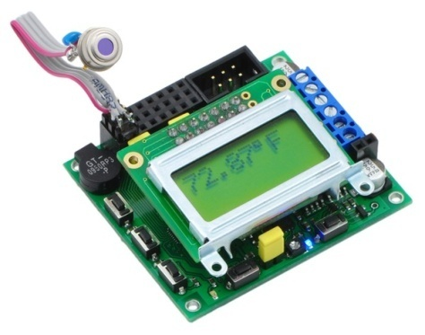

Figure 4.2-4 MLX90614 reprinted with permission by Pololu.com

**4.2.4 Method of Calculating Phase Angle**

Phase angle calculation is simply measuring the time delay between corresponding values of the voltage and current waveforms. The calculations will be implemented on the MSP430 chip. The problem in creating a mathematical formula at this point in time is, the unknown magnetic and electrical permeability of the Scotchcast 5555™. The calculations are dependent on this because the electric permeability will determine the capacitance of the voltage plate sensor and therefore give a phase shift of the voltage sensors’ output. The magnetic permeability will have the same effect on the current sensors’ output. We are still awaiting an email back from 3M the manufacture of Scotchcast 5555™ as to what these permeability’s are. In the case that the permeability’s remain unknown they will have to be calculated from experimental results.

**4.3Logic Circuitry**

**4.3.1Station Identification and Data Updates**

Each processor will contain a unique station ID. This ID will be pre-programmed in the processor’s memory and cannot be changed by the user. This ID will be used by the central hub to identify the transformer that the microprocessor is monitoring. Since the central hub can be configured based on the layout of the power supplier’s grid there is no need to alter the station identifier number inside of the processor. The processor will update the central hub with its parameter values several different ways. The first way it will send updates is by request of the central hub. When the hub requests data, all current parameter values will be sent regardless of whether or not the transformer has reached a caution or critical state. The second way that it will send updates is if a preprogrammed condition is met. Also, the processor will send updates to the main hub at a pre-programmed interval regardless of whether that information was requested and regardless of the state of the transformer. The processor can also receive updates from the central hub to change the interval at which it reports data and the values for the caution and threshold points of the parameters that the transformer monitoring system is observing.

**4.3.2Data Transmission**

The processor will be programmed to report certain situations and send that report to the main control center even if the main control center is not requesting them at the time that those values are exceeded. Several values will need to be stored inside of the processor’s memory. These are the values that the processor will use to determine if something is wrong with the transformer that it is monitoring. These include values for the input and output voltage parameters, input and output current parameters and the temperature parameters that most high power transformers cannot exceed or fall below. Two values will be stored inside of the processor’s memory for each parameter, a caution value and a threshold value. The caution value is a value that the transformer can operate with but is outside of the normal parameter range and indicates that there is a minor issue with the transformer. The threshold value is a value that exceeds the transformer’s operating range for that parameter and indicates that the transformer will fail quickly if it continues to operate under that condition. (See Figure 4.3-1 for a visual explanation of transformer states and threshold and caution values).

The processor will be continuously monitoring these parameters and report any abnormalities. If one of the parameters exceeds its assigned caution value, then the processor will automatically send an update to the XBee transmitter to be forwarded to the main hub. This update will contain all five data parameter values that the system is monitoring, its permanent pre-assigned station ID, and a flag to give the central hub notification to let the operator know that the transformer is currently in a caution state. Once the transformer is in a caution state, the processor will continue to send unrequested updates every minute unless the following conditions occur: all of the parameters fall back into the normal state; one of the parameters exceeds a threshold value; or a signal is received to stop sending data. If a parameter exceeds a maximum threshold value or falls below a minimum threshold value, the processor will then send updates every 5 seconds and a flag indicating that the transformer is now in a state where one of the parameters is exceeding a threshold value. This is considered a warning state. The processor will continue to send those updates every 5 seconds until all of the values fall back to the caution range or the normal range. (See Figure 4.3-2 for a list of conditions that must be satisfied for a state change to occur).

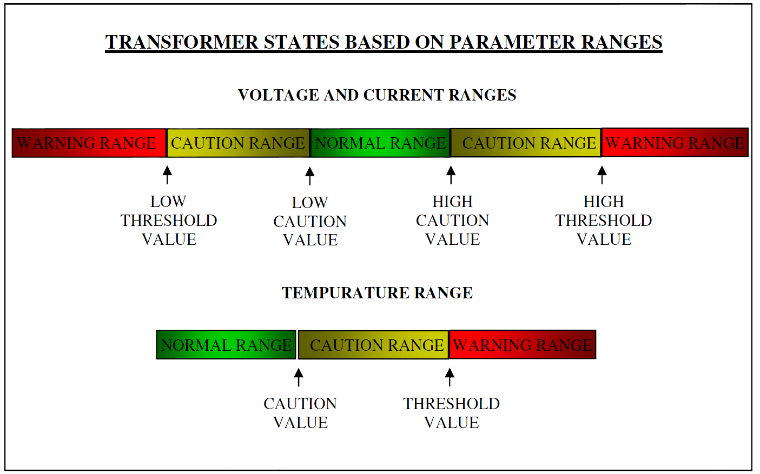

Figure 4.3-1Visual Depiction of Transformer States and How They Are Classified By the Microprocessor

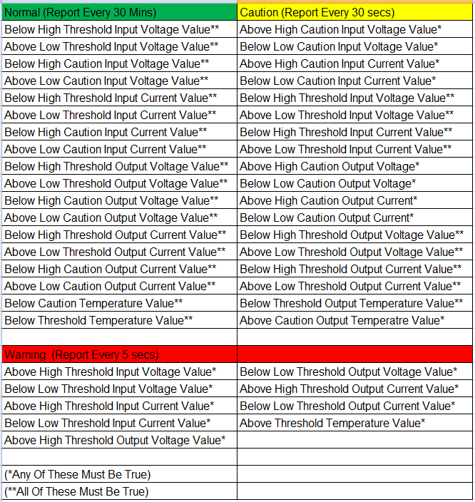

Figure4.3-2Outlining the Transformer States and the Conditions That Must Be Satisfied For Each State

**4.3.3Stored Data**

The processor will store the data for the critical and threshold values for the parameters that it is monitoring inside of its internal memory. The memory will also store the interval at which data is reported for each state and the transformer monitor’s unique station identifier. This data will be pre-programmed into the processor’s memory but will be able to be changed by the user at the central control hub. The pre-programmed data will be based on average values that exceed the specifications of high power line transformers. The user can change these values during installation and after installation. When the userwants to update these values he can do so at the central hub which will then forward the information to the processor through the XBee wireless network.

**4.3.4Microchip Interactions with Hardware**

The microprocessor will need to send requests to and receive data from the infrared temperature sensor via a digital line using the system management bus (SMBus) protocol. SMBus is a dual wire synchronous serial interface. The serial clock (SCL) and the serial data line (SDA) will be attached to two of the digital I/O lines on the microprocessor (See Figure4.3-3). There are two pull-up resistors connecting both the serial clock and serial data lines to the Vcc line. These resisters keep those lines from floating. The devices in aSMBus network are considered either master devices or slave devices. In the transformer monitoring system circuit, the microprocessor will function as a master device while the sensor will function as the slave device. This protocol includes collision detection but since there will only be one master (the microprocessor) and one slave (the temperature sensor) this should not be a factor. This single master to single slave relationship for each transformer monitor network greatly improves the reliability of the transfer of data between the temperature sensor and the microprocessor. The transfer protocols used in SMBus communication are: Quick Command, Send Byte, Receive Byte, Write Byte/Word, Read Byte/Word, Process Call, and Block Read/Write. Each different protocol has a unique set of steps but follows the same general outline (Texas). Figure 4.3-4 is a common SMBus transaction structure

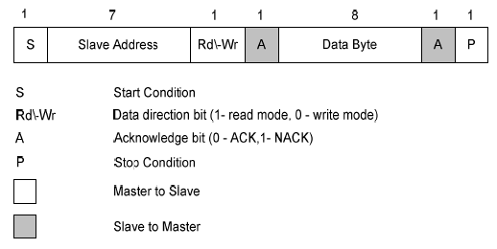

Figure4.3-3–SMBus Protocol reprinted with permission by pololu.com

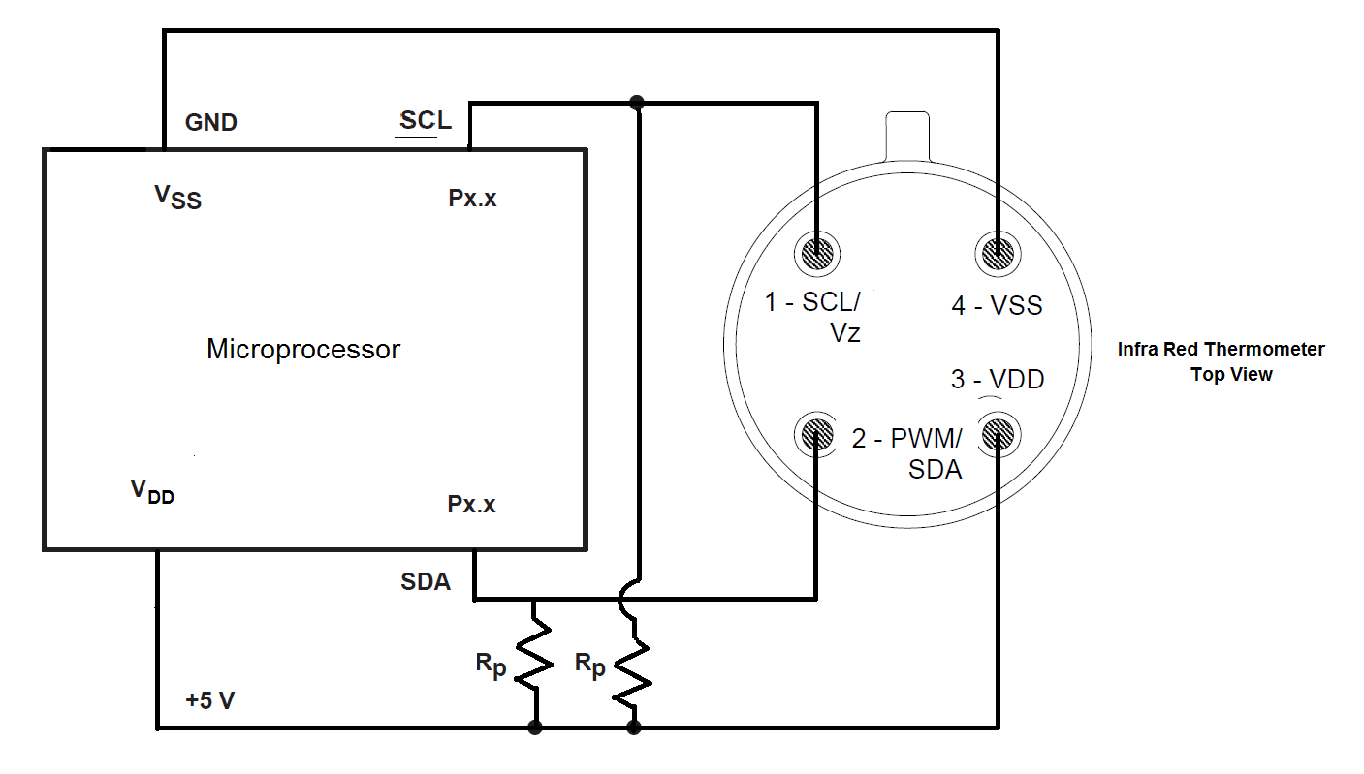Figure 4.3-4 Infrared Temperature Sensor and Microprocessor Interface

The XBee wireless network will require four different pins on the microprocessor. These include two pins that are simply either set to high or low. These pins will represent the high and low bits of the Clear To Send and Ready to Send bits. The other two pins will be for transmitting and receiving digital serial data (XBee Datasheet). The data sent to the XBee will typically consist of the same type for each transmission. It will include the Station ID, the values that are currently being read on all five sensors, the current user-defined, critical and warning values for the parameters monitored, and the time intervals at which the microprocessor sends updates for each state of the transformer. This data will be sent to the XBee either by request or when it reaches the end of a pre-programmed time interval.The data coming from the XBee into the processor can be of two different varieties. The first of which is a command from the main control hub to send an update. Upon receipt of this command the microprocessor will package all the data from its sensors and the data from the memory and send that package as an update to the central hub. The second and more complex type of data that it will receive is a reprogram. This set of data will consist of new values for the thresholds, cautions, and time intervals. The unit will then update its memory with the new data, discarding the old data.

The pins will be connected to the other devices through the printed circuit board ribbon. The voltage on any pin cannot exceed 3.5V. Each device will have its own dedicate pin or set of pins. Figure 4.3-5 specifies the signals that are routed to each pin.

|  |  |
| --- | --- |
| Pin | Device |
| 2 | Transformer Low Line Current Sensor |
| 3 | Transformer Low Line Voltage Sensor |
| 4 | Transformer High Line Current Sensor |
| 5 | Transformer High Line Voltage Sensor |
| 6 | Infrared Temperature Sensor Serial Clock Line (SCL) |
| 7 | Infrared Temperature Sensor Serial Data Line (SDA) |
| 12 | Xbee Clear To Send (CTS) |
| 8 | Xbee Ready To Send (RTS) |
| 9 | Xbee Data Out (DO) |
| 13 | Xbee Data In (DI) |
| 1 | Infrared Temperature Sensor Supply Voltage (3V) |
| 14 | Infrared Temperature Sensor Ground (0V) |
| 10 | Not Connected |
| 11 | Not Connected |

Figure 4.3-5 Microprocessor Pin Connections

**4.3.5Overall Microchip Design**

Texas Instruments has over 400 MSP430 models to choose from (MCU). For this project the MSP430F2013 meets all of the requirements of our project. It has 10 pins that can be used as general purpose digital input/output pins. There are 8 of those pins that can also be used as analog inputs. Figure4.3-6 is a list of the recommended operation conditions of the processor. All of these conditions are within the scope of the requirements for this design.

Figure4.3-6 Recommended Operating Conditions

This device can be easily mounted unto the TI’s MSP 430 USB Stick Development Tool (ez430) and TI’s Graphical Peripheral Configuration Tool (Grace) can be easily used to configure the device (“MSP430 USB”, “GraceBETA”). EZ430 is a tool for conveniently programming an MSP 430 directly from the USB port of a computer. Once the processor is configured with the GRACE development software, the processor can be detached from the USB stick and mounted onto the circuit board of a design (“MSP430 USB”). This will enable fast integration during the design and testing phase of this project.

The F2013 model incorporates many features that will be very useful for the transformer monitoring system (See Figure 4.3-7). The timers will be very useful for keeping track of transmission times and when the processor should retransmit the data that it is monitoring. The 2kB flash memory will be more than sufficient to store the critical, threshold, and time interval values that can be modified be the user at anytime from the central control hub. The onboard analog to digital converters will be used to take the analog signal from the voltage and current sensors and convert it to a quantifiable digital signal that can be read and processed and stored temporarily in the flash memory (See Figure 4.3-8).

Figure 4.3-8 – MSP430F2013 Functional Block Diagram

Each pin on the MSP 430F2013 can perform a variety of functions. For this project, ten of the I/O pins will be connected to the various sensors and the Xbee communications network device. Figure 4.3-9 is a depiction of the capabilities of each pin on the MSP430F2013 processor

**4.4 Wireless Communication Details**

This section covers the information needed for the integration and function of the communications system. It discusses the specific component selection and design details based off of those components. The operation of the wireless communications system can be split up into three parts: a discussion on the wireless protocol and antenna types being used, description of how the chip interacts with the rest of the box, and an explanation of what system has been derived to communicate with the hub software. Each subsection also includes a short summary of how it fits into the budget and the overall design of the device.

**4.4.1 Implementation of Wireless Protocol**

The XBee Zigbee Pro 2.4 GHz model utilizes a Zigbee communications protocol. This section elaborates more on the Zigbee protocol described in Section 3.4.2.2,and it focuses more on the beneficial attributes that Zigbee has on the device project. This includes a discussion of how the data is transmitted, and what happens on either end of XBee devices. The interactivity of the hub station, the device box, and the XBee devices that utilize the Zigbee protocol is described more thoroughly in Sections 4.4.3 and 4.4.4. This section includes a description and selection of the required antenna suitable for the XBee device. Given the general information about the designed communication network for the device, the reader should have a better understanding of the design details described for the interactivity of the XBee with the device box and the hub station.

As shown in Figure 3.4-4, the Zigbee mesh network has three types of nodes. The nodes are: coordinator, router, and end device (digi.com). All of these nodes are connected in what the Zigbee protocol defines as a personal area network (PAN). In this network, the coordinator node connects to routers and end devices that can report back information. The Zigbee PAN allows only one coordinator node, and this node is responsible for many of the organizational functions of the mesh network. For the device, the two main functions of the coordinator node are that it begins the network and allows other devices to join the network it created. This very closely matches the expectations for a monitoring station for the device. The hub station should have the most control in a system, and by assigning it as a coordinator mode, it can initiate the network and set the frequency channel for all of the Zigbee devices. A router node can transmit, receive, and route data. This node matches the expectations for communication portions of the device, because they are expected to route information from transformers not directly communicating with the hub station. The third type of node is the end device node. This acts as a very low power node capable of sleep functions. The end device node is not totally necessary for the device because it is not able to route data. They are primarily designed for battery-powered use. In the case of a very small network where all devices are connected to a hub monitoring station, these kinds of devices would be ideal because they allow for low power consuming sleep modes, making the devicemore energy efficient are marketable. However, the initial design for the device requires that several nodes connected “end-to-end” should be able to route information at any time the hub station requests, so router nodes must always be actively receiving in order to relay information when necessary. Hence, the design incorporates router nodes. For simplicity and consistency across all future devices, this design only includes router nodes and dismisses end device nodes as a future design possibility. A new design of the Zigbee mesh network designed is shown in Figure 4.4-1 below.

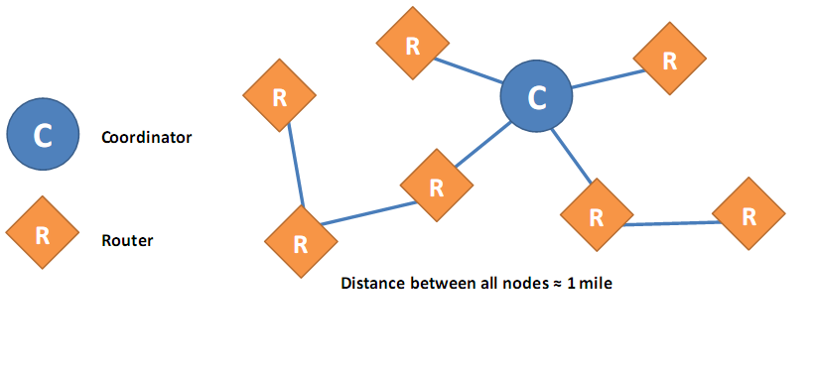

Figure 4.4–1 Zigbee Mesh Networks

As stated, the one coordinator node for the device will initialize the network. It first does this by selecting the channel that the XBee devices will use. The IEEE 802.15.4 standard that the Zigbee protocol is based on has a total of sixteen channels defined for a communications system that uses the 2.4 GHz frequency and that standard. The 2.4 GHz XBee PRO devices that are used in the device support fourteen out the sixteen channels provided by the standard. When the coordinator node connected to the hub station starts for the first time, the device scans the 2.4 GHz frequency and searches for channels that have the least amount of noise. Before the device hub station selects a quiet channel to communicate on, the XBee device continues to search for other XBee networks that may not be transmitting at the time. Other networks that may also exist will send back information to the hub station stating that they exist on a certain band, and they will display a network ID number. The number, referred to as the PAN ID, is either a sixteen or 64 bit number that identifies the network that a number of Zigbee devices are operating on. For the device, new boxes that are deployed to transformers will have a 64 bit identification number unique to every device. This number is hardware specific to the XBee module that was manufactured. A number is also assigned to the XBee device to be used as an address. The address is not constant like the 64 bit number assigned during manufacturing. The 16 bit addresses are used for the transmission and routing of signals along the Zigbee network. Transmission for the Zigbee mesh network used by the device will usually transmit the longer number with the transmission so that the data received may be attributed to a specific device on the network. The initialization of router nodes is explained further in subsequent paragraphs. The XBee module takes care of many of the details such as this for setting up a network (digi.com). The types and formats of information sent between a device box unit and a central hub station can be found in Sections 4.4-3 and 4.4-4.

After the coordinator node is initialized, the router nodes that are supposed to communicate with the device hub station are allowed to join the network. For this discussion, device and router nodes will be used interchangeably. The network will be discovered by a device in a similar way to how the coordinator node gets initialized. Both devices are capable of scanning for existing Zigbee networks. However, router nodes are not able to initialize networks like the coordinator node of the hub station is capable of doing. The router node only sends a ping or beacon on the 2.4 GHz frequency. As stated, the XBee devices used by the device are only capable of operating on 14 channels of the 2.4 GHz frequency. The XBee devices in the device will ping for existing Zigbee networks by searching through every one of the channels available to the XBee devices chosen for the device. The router node will continue to do this as long as it stays inside the acceptable range set by the Zigbee Alliance, the organization in charge of Zigbee protocols and developments. Since XBee chips follow the guidelines from the Zigbee Alliance, the chips are allowed to only scan for existing networks only nine times a minute. This scanning procedure automatically continues for five minutes. The device design believes that these scanning limitations will not affect the installation if the box is used in the proper conditions as stated in the Expectations section. If the router node receives a ping from a Zigbee network, the node does three things. The node will confirm that the network has a positive ID number, that the network allows joining, and that the “stack profile” of the network matches the “stack profile” of the router node. The stack profile is a fixed number used by Zigbee protocol that must be set on all devices that want to join the same network (digi.com). This number will be set on all devices before they are deployed, and this number may change during development of the device.

After the hub station allows the device to wirelessly join the network, the device box is assigned an address used for identification. This identification is only used for communication between Zigbee devices, and it will not be used for identification of device by the hub station program. The numbers used by the hub station program are assigned by the hub station during connection to the network. Since device are utilizing XBee devices, the XBee chip will not lose the PAN ID of the network that it is connected to, and it will not lose the channel that the Zigbee network was operating on in the case of an event that causes the device box to temporarily lose power, despite precautions taken such as the device being supplied by a battery. On the same note, the device router node stays in the network unless the hub station requires it to leave the network. A router node is also allowed to leave the network itself, but this characteristic of the router node will not be used in the device design. This also helps protect against unwanted Zigbee devices that are accidentally, or maliciously, using the same stack profile of the device network. A device connected to the network successfully will be able to route signals from itself to the coordinator node. It is helpful to look at the communication initialization process as a whole. A step by step process of how the device is first initialized with one coordinator node and one router node is shown in Figure 4.4-2below.

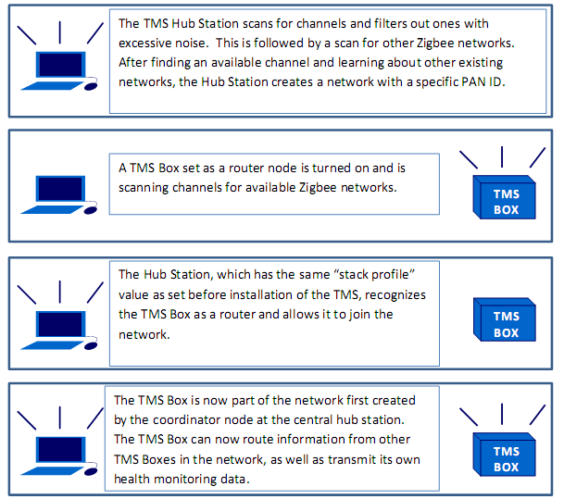

Figure 4.4–2A step-by-step illustration of how the Zigbee network is first initialized.

At this point, it is fitting to discuss the type of security that the Zigbee protocol implements in its devices and what attributes of it that the device implements. Although not a main goal of the communications system for the device, a security method for the system is desired. Information that the power companies wish to keep private should be able to be securely transmitted using the device, so it will implement security measures in relation to the communications system. Zigbee protocol is able to recognize three different types of security (digi.com). The types can also be referred to as levels, since they are either “residential”, “standard”, or “high security”. Residential security simply requires a fixed network key to be set on all devices in the network. Standard security offers more features, and the XBee models that most closely fit the main goals of the communications system are made to utilize standard security, so it is the type of security to be implemented for the device. The XBee models used by the device use the 128-bit Advanced Encryption Standard (AES). The 128-bit AES standard essentially requires that all devices on the network must share an encryption key to be used on the network. These keys are referred to as network keys. This network key must be set on both ends of the XBee devices independently, meaning that the device must have this option set on the microcontroller when it loads.

In addition to encryption, the packet of information sent by any of the Zigbee devices is capable of handling frame counters. The Zigbee protocol uses frame counters to help make the mesh network more secure at any of the nodes. Without having to rely on the central hub station, the network keeps track of the number of information packets received from other nodes on the network. Specifically, the frame counter is a value that begins at 0, and, if it ever happens to reach this point, ends at 4294967295. Every packet of information sent by device A will contain the current frame counter of A. The device B or central hub station that decrypts the packet keeps track of the frame counter. Each device can handle the history of frame counters from other devices around it. If device B receives a packet supposedly from device A, it compares the frame counter that it just encountered. If the frame counter received from A is lower than the last known frame counter, then the message is not decrypted and is thrown out. In addition to 128-bit AES encryption using network keys and the frame counter used by Zigbee, there is another optional measure for securing data on the device mesh network. Application Support Sublayer (APS) is a Zigbee technology that also allows for an extra layer of security. The APS security measures offer the chance to add more keys to the network, and they help keep from unwanted devices from entering the Zigbee network. We believe that the 128-bit AES security measure, along with the simple frame counter, is sufficient for the device design. Future versions of the device may include the extra layer of APS security.

Most requirements for FCC Certification have been met by the manufacturer (digi.com). They state that the external label provided with the device must be attached to the outside of the project box, and that only tested and approved antennas for the device may be used during operation. A list of the antennas, also included in Appendix A, of the datasheet, list dipole, monopole, Yagi, omni-directional, and flat panel antennas. Some antennas have been approved without a required cable loss, but a majority of the devices have a required cable loss to fit within regulations. The team has decided that the antenna is external, because the user’s manual for our device specifically states that the whole antenna should not be located inside a metal enclosure, which, in our case, is the device box unit. For maximum transmission range, the antenna used will be a Yagi 18-element antenna.

The issue may arise in some radio communication devices where board placement of the radio device may affect the performance of the chip. However, the XBee-PRO® RF Modules Manual explicitly states that there are no special and necessary modifications necessary for mounting an XBee card to a board. There is also no need to have a ground plane built on the board, because the XBee device includes a ground plane in its design. It does, however, state the antenna should not be located inside a metal enclosure, and this is accounted for in the selection of an antenna. There are also not to be any stray wires in the area of the board where the base of the antenna is located.

**4.4.2 Flow of Information**

Given the discussion on the basics of how Zigbee communication networks are supposed to be initialized, there should be an explanation of the design process of the actual functions that the device communications system is to function. This section is primarily concerned with the way signals are transmitted throughout the network, and what types of information are to be expected from a device or a central hub station. The actual data to be transmitted is the number associated with the transformer, the current, voltage, phase angle, and the temperature of each transformer. This information is independent of any of the security protocols mentioned by the Zigbee standard. The values associated with those characteristics will be sent from each device and received by the central hub station through a serial port as text. The text information is then able to be transferred and organized by the database. More information on how the data is organized and received by the central hub station may be found in Section 4.4.4. Similarly, more information on what the microcontroller sends to the XBee device to be transmitted is may be found in Section 4.4.3.

The communications system for the device is supposed to report information from a TMS box to the central hub station. At thirty minute intervals, a device will transmit monitoring information. This rate of information continues at thirty minute intervals until a threshold value is reached and detected by the microcontroller. The threshold values are transformer dependent, and they will be values that are considered undesirable for the transformer under normal operating conditions. Two levels of threshold values are to be reported. These levels are “caution” and “warning”. If the transformer reaches a value where it is still operational under the manufacturer’s instructions, but not considered ideal, then the transmitter will send an updated string to the hub station every three minutes. The “warning” condition is met when the transformer reaches a value that is considered dangerous to the transformer. This occurs when any of the values falls or rises outside of the conditions stated by the manufacturers for maximum or minimum operating values. It is important to note that the string format does not change for data transmission if a certain threshold value is reached that triggers a “caution” or “warning” mode. The computer program, which sets the values, will take the transmission from the network and compare the received values to what is saved in the database. This means that the computer will have to tell itself that a threshold value is reached. The microcontroller on-board the device will also recognize this threshold value has been reached and it will initiate the “warning” or “caution” mode to make the interval between signal transmissions shorter. There is no change in the format of the transmitted string, and there is no flag that tells the receiving hub station the condition of the transformer. This means that the central hub station is in total control of the values set in the program. For example, if the signal from a device sends data at 30 second intervals, and the computer program does not show that a threshold value has been reached, threshold values or some other attribute of the device need to be changed. This helps narrow down on possible problem areas caused in communication of the device.

Note that the device design incorporates the ability to change threshold values. This is to be done on the Zigbee network and is important in case a device is not installed properly, or that the specifications were not initially programmed in correctly. In this case, the central hub station will transmit new threshold values to a specific device, and the information will be read by the microcontroller results in the appropriate changes being made. The central hub station is also capable of changing the identification number of the transformer. The identification number of the transformer is not the same as the number assigned to the transformer by the Zigbee network. All the possible expectations for the communications system are described in Table 4.4-1. In summary, a device will transmit health information every 30 minutes, increasing with different crossed threshold values. The central hub station may refresh health information from a specific device when required. The hub station may also change threshold values of the transformers when necessary, as well as the transformer identification number.

|  |  |  |
| --- | --- | --- |
| Action Name | Description | It happens when: |
| Refresh | Pings a specific device in the Zigbee network and requires that it report back health monitoring information | An end hub user selects the refresh button for a specific transformer in the computer program. |
| 30 minute update | The device sends health monitoring information to the central hub station | Adevice is connected to the Zigbee network. |
| 3 min/ 30 sec update | The device sends health information in shorter intervals | A threshold value is crossed |
| Attribute change | Threshold value or identification number of a device is changed by the user | End hub user wants to change a threshold value or identification number. |

Table 4.4–1 A list of functions expected of the TMS communications system

The Zigbee protocol is capable of sending information in either broadcast form or node-to-node form, which fits in very well with the expectations of the communications system. During broadcast, a node sends a signal to all other nodes connected to it. Broadcasted messages travel through the network until it reaches all nodes. This means that broadcasted message are able to travel through several different device before reaching the central hub station node. For the device, broadcasting would occur for an event such as when there is a request from the central hub user to refresh all signals. This is a characteristic that may be available in future versions of the device. Thebroadcast transmissions would only occur from the central hub station, and they will only request that the transformers resend information immediately.

The other method of communicating on a Zigbee network is the node-to-node method, also referred to unicast, as opposed to broadcast. With the XBee devices chosen for the device project, there are many different ways to implement this kind of unicast system. The team has decided on a “Many-to-One” routing system. This is in part because of the simplicity of using the firmware that supports this option, and also because there is more opportunity for a successful microcontroller interaction if the commands are kept to a minimum. A Many-to-One (MtO) routing system is based on mesh networks that heavily utilize a central node, much like the central hub station in the device (digi.com). With this kind of setup, the central node sends out beacons to all XBee devices on the network. The XBee devices that receive the signal save the path in memory, so that they may be able to use it again when necessary. This type of communication is really a short form of broadcast with the intention of eventually having all the devices using unicast. The initial broadcast simply helps build the sending structure for the device. In summary, the device network predominantly uses a node-to-node network structure. This structure requires that a broadcasted beacon from a central hub station be emitted so that the device will be able to find a path back to the hub station. These paths are stored in XBee memory to be used again.

**4.4.3 Connectivity with the Device**

The communications components and the microcontroller are very closely intertwined. The XBee interfaces with devices, both the device and the central hub station, with serial communication. This means that the microcontroller chosen for the device had to communicate with a serial or USB port. There are two modes of communicating with the microcontroller. The first is that the XBee device should be able to send data received directly to the microcontroller without the microcontroller having to make any other adjustments to the code it received. Similarly, the XBee device will receive information from the microcontroller and transmit it through the Zigbee network to the central hub station. For larger mesh networks, the API network will need to be implemented for the XBee devices (digi.com). The Application Programming Interface (API) protocol that the XBee devices utilize is a much more advanced method of physically communicating with the device. This kind of technology allows for a more thorough control of the communication setup with regard to node-to-node communication and the types of interactions that the coordinator has with the router nodes. For a demonstration, even if we were given the funding to build two device boxes, we would still not have a network that required API implementation. Even with a network of around five devices, it would be unnecessary to go into as much detail as required for API firmware XBee devices, because the simpler firmware already supports the Many-to-One communication method as described in Section 4.4.2. Because of the impracticality of the technology for the current budget and size of the project, the team will use the standard I/O pins found on the XBee device without advanced protocol controls. This method is known as the Transparent Operation protocol. Using the XBee devices in this way, they behave like serial lines. The built-in firmware of the devices takes care of encoding the data and sending it. As long as the device is powered and connected to the microcontroller properly, it acts simply as a serial cable replacement. This dramatically helps improve the amount of programming on a project that already includes a programmable microcontroller and an in-depth PC GUI.

Information used here on how to interface XBee devices with a computer for initial settings will be the same as for the central hub station. Before connecting any microcontrollers to an XBee device, we must first initially program the device so it will have the correct settings when it is placed in the device with the other circuitry. The XBee development kit comes with a USB cable and adapter board for the XBee devices to be used with during development. The XBee must be connected to the cable, which also supplies the power. After the cable has been connected to the computer, a PC program called X-CTU allows the XBee to be easily programmed (digi.com X-CTU). The Modem Configuration tab allows settings important to the device communications system to be changed. The ID of the network can be changed, as well as the interface data rate with the microcontroller. The data rate for serial communication is expected to change for the MSP430 during the physical development and testing of the device. There are no digital or analog pins that need to be set. The only requirement for the XBee device to interact with the microcontroller inside of the device is for the microcontroller to have control over the communication pins. The pins will be leads available from the wireless section of the circuit board. The wireless section will closely mimic the development board provided in the XBee development kit. The main items needed for microcontroller to serial communication are the four pins listed in Table 4.4-2 below. RTS and CTS may become helpful if the need arises to update XBee firmware.

|  |  |
| --- | --- |
| Abbreviation | Name |
| RTS | Request to Send |
| CTS | Clear to Send |
| RX | Received Serial Data |
| TX | Serial Data to transmit |

Table 4.4-2 The only pins necessary for communication with the microcontroller configuration

The main purpose of the device is to transmit health data. The entire string of data that the MSP430 transmits through the TX pin may be shown in Figure 4.4 - 4. The string includes all sensor information that the microcontroller processed. In addition to sensor information, the microcontroller will also include the transformer identification number and the calculated phase angle of the transformer in the string. The string is followed by a “%” character in order to show that the string of data has ended. Similarly, another string is sent for the high side of the transformer,which is followed by a “$”. These characters show the hub station that the transmission is over. The end character could be beneficial for the development phase of the device.

In addition to transmitting health information, the device is supposed to interpret commands issued by the hub station to change parameters of the device. The parameters to change are the threshold values for voltage, current, and temperature, as well as the caution values for the same parameters. Caution parameters, as opposed to threshold parameters have both low and high values. This also means that the system will never go into “Warning” mode for low values, just “Caution” mode. As stated, any of these parameters should be changeable by a command from the hub station network. In addition, a special character will be placed with the transmission that denotes the side of the transformer the information is coming from. A system has been devised, shown below in Figure 4.4-3, that dictates the format that the microcontroller will receive and process for a certain value. Table 4.4-3beneath Figure 4.4–3, shows the values for all parameters that may be received by the microcontroller for changing.

C:\Users\Jon\Desktop\parameter changing.wmf

Figure 4.4-3 Simple line of text sent from the hub station

|  |  |  |  |
| --- | --- | --- | --- |
| Parameter Signal | Parameter | Parameter Signal | Parameter |
| 1 | Transformer Serial Number | 6 | High Caution Voltage |
| 2 | Threshold Voltage | 7 | Low Caution Current |
| 3 | Threshold Current | 8 | High Caution Current |
| 4 | Threshold Temperature | 9 | Low Caution Temperature |
| 5 | Low Caution Voltage | A | High Caution Temperature |

Table 4.4–3List of parameter signals received that tell microprocessor which values to change

**4.4.4 Connectivity with Computer Program**

As defined in Section 2.3.3, the computer program shall have the ability to read data transmitted to it. This means that a central receive station must exist to convert the wireless signal into acceptable input for a computer. So, for every central hub station that exists, there must be an accompanying circuit, through a serial port, to receive wirelessly transmitted information. The process for programming the receive XBee is very similar to the process described in Section 4.4.3. The same cable connection and the same X-CTU program must work together to change settings for the XBee device (digi.com X-CTU). The data rate that needs to be set is dependent on the data rate decided on for the device box microcontroller during assembly and testing. Like what is shown in Table 4.4-2, the same four pins must also be controllable by the computer. The development board will remain as the hardware interface for the central hub station. In the case of the central hub station, the power is supplied through the USB cable.

To start the proper functions of the hub station, the station will open the COM port that the XBee device is connected to with a communication program such as Putty. Each transformer monitor will transmit health information as text through a simple system. The central processor will round each number to the nearest tenth, and that information will be sent to the XBee. The string of text sent by the processor will be each value followed by a space. The first number in the string will be a number associated with the string, followed by a space. The second number will be the voltage, third number the current, fourth the phase angle, and temperature in Fahrenheit will be the fifth number. An example of how the transmission format has been designed is shown in Figure 4.4-4below.

**C:\Users\Jon\Desktop\toPC.wmf**

Figure 4.4–4Graphical explanation of the transformer monitor output string setup

As shown in the figure, all information to be monitored on the device can be displayed with one string of characters. The string of characters is to be followed by a carriage-return and line-feed. This allows the hub station to receive an ordered set of numbers. The hub station will read in the characters regardless of length. The program will only be able to read to the next piece of data after it reads in a space character. For example, Figure 4.4-4 shows a 1201167 for the transformer number and 165 for voltage. These two pieces of data are only separated by a space. The hub station is able to read these values and process them in a way where the data can be stored correctly into a database.

**4.5Computer Programming**

Since all of the research for this project has been mentioned, it is important to review all of the decisions that were made in order to fully understand the final program. First, the computer language that will be used is C- Sharp (C#). This language has many features that will be discussed in the Interface Methodology using C-Sharp section of 4.5. Second, the user will interact with the program using the first method mentioned in section 3.5.2. Recall that this method gives the user two modes to use; the build mode which allows the user to build their own grid system and the view mode which just monitors the transformers on the workspace. Finally, the last decision that was made is how the data will stored and the path it takes to get to that place. Section 4.5.3 is dedicated to the method of using a type of daemon program that will transfer the data from the wireless to the database. If questions arise about why a certain method was chosen then please refer to section 3.5.

**4.5.1Overall Interface Design**

The overall interface design has three parts to it: the main filing system, the build mode, and the view mode. Both modes have various aspects to it that the others do not have access to. Also the main filing system is nothing more than how the user can save and open files. This portion will also contain the welcome screen and the process for closing the system down. Since the user will encounter the welcome screen first it is only natural that it is mentioned initially.

Once the user has downloaded the program, he/she will see the icon on the left in Figure 4.5-1 on the desktop. From there the user can double click the icon and a welcome screen, as shown on the right of Figure 4.5-1, will pop up. Two reasons exist for this screen, one it introduces the program and two it allows the program to fully load without any interference from the user. Once the program is loaded and the user has pressed the continue button on the welcome screen, the user will then be allowed access to the main workspace. As mentioned earlier in section 3.5, this portion of the program has a lot of similarities to Microsoft Paint. Figure 4.5-2 shows the main workspace area where the user will be able to either create a new grid system in the build mode or open up an already made system for viewing purposes.

**TMS**

Transformer Monitoring

System

**Transformer Monitoring System**

**CONTINUE**

**CANCEL**

**LOADING…**

WELCOME

Version: 1.0

Designer: TMS Inc.

Figure 4.5-1 Desktop Icon and Welcome Screen

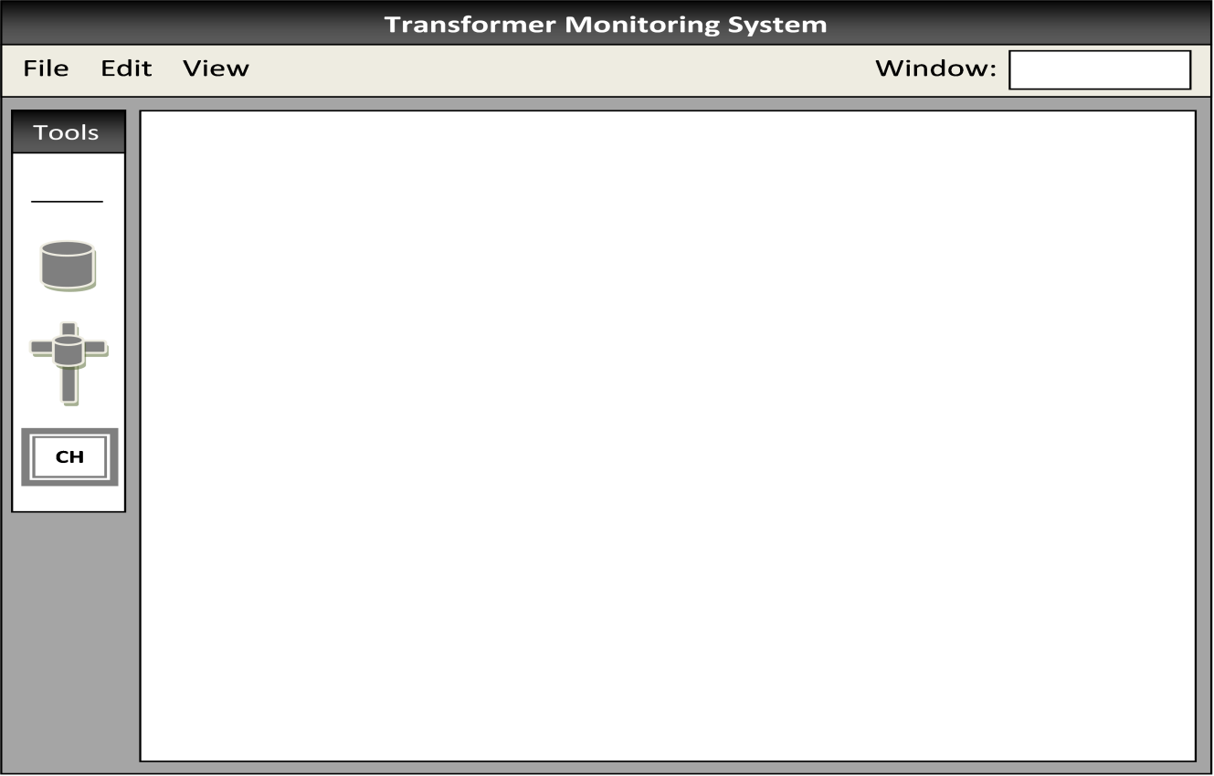Figure 4.5-2 Transformer Monitoring System Workspace

There are four menus that the user can access: File, Edit, View, and Window. File contains the options to create a new grid system, open a pre-existing system, save the current system, and save the current system as. The edit menu has multiple options that the user can pick from when in build mode only. Listed below are the options in edit:

* Undo – Allows the user to undo last action
* Redo – Allows the user to redo last action
* Cut – Allows the user to copy and remove the object selected
* Copy – Allows the user to copy the object selected
* Paste – Allows the user to place the objected copied/cut onto the workspace
* Select All – Allows the user to select every object on the workspace
* Deselect – Removes selection from object

It is important to understand that these options are only available when in build mode. If the user is in view mode, then the edit options will be grayed out and non-selectable. Another menu the user can access is the view menu. This menu only contains the zoom function. Here the user can zoom in up to 200% or zoom out up to 50%. The final menu the user can access is the Window menu. This is where the user can change between build mode and view mode. To keep the user informed at all times what mode they are in, it is displayed on the top right corner of the menu tool bar. Figure 4.5-3 shows what each of the menus will look like once they have dropped down onto the screen.

File

New

Open

Save

Save As

Ctrl+N

Ctrl+O

Ctrl+S

Ctrl+W

Edit

Undo

Redo

Cut

Copy

Paste

Select All

Deselect

Ctrl+U

Ctrl+R

Ctrl+X

Ctrl+C

Ctrl+V

Ctrl+A

Ctrl+D

View

Zoom

50%

75%

100%

150%

200%

Figure 4.5-3 Filing System Menus

Now that the user has opened the workspace, the next option is to either start a new grid using the build mode or monitor a pre-existing grid using the view mode. The build mode is dedicated to giving the user ultimate control over the organization of the grid. This mode has several features to it, such as the tools window. In this toolbar lies four options the user can choose from: the line, ground transformer, pole mounted transformer, and central hub. Basically the user would first place the central hub anywhere on workspace and then place the transformers around it. The idea is that the user would place the transformers in a grid type format, and then use the line tool to connect all of the transformers together with the central hub. To insure that the user connects all of the transformers together, a warning message will be displayed if any transformers are not connected; as well as, if no lines are connected to the central hub. Figure 4.5-4 shows the tools window and all of the elements to it.

Line

Ground

Transformer

Tools

**CH**

Pole Mounted

Transformer

Central

Hub

Figure 4.5-4 Tools Window: Turned Sideways

Once a transformer is placed on the workspace, the user then has the option to double click on it and change certain monitoring properties for that particular device. This is also where the user will connect the virtual transformer to the actual transformer in the real world. Every transformer monitoring device has its own serial number that differentiates it amongst the others. Inside of the transformer monitoring properties window the user will be able to enter in that serial number so that the program can sync with the real transformer. When the serial number is entered all of the current properties for that monitoring device will be shown in the window as presented on the left side of Figure 4.5-5. As it can be seen, this window allows the user to change all of the thresh hold values for the parameters that are being monitored; as well as, the ranges for the caution flags. Thresh hold values are the maximum points where the transformer can no longer operate for that given parameter. For example, if the temperature sensor reads in a temperature of 300 degrees Fahrenheit but the thresh hold value is set to 250; the program will display a warning sign to alert the user. Caution values on the other hand are ranges where the transformer can still operate, but exceed or fall under the manufacturer’s specifications for that transformer. For instance, the manufacturers of the transformer in the above example state that the transformer can only operate effectively from 10 degrees Fahrenheit up to 230 degrees Fahrenheit. The user would enter 10 degrees for the low and 230 degrees for the high. If the temperature the sensors read in fall under 10 degrees or over 230 but remain under the thresh hold temperature value, then a caution sign will be displayed. This feature is meant to catch component failure before it causes full system malfunction. The right side of Figure 4.5-5 shows what the warning and caution messages look like when triggered.

**Transformer Monitoring Properties**

Serial Number:

1201167

Thresh Hold Voltage:

Thresh Hold Current:

Thresh Hold Temperature:

Caution Voltage:

Caution Current:

Caution Temperature:

____155_____

____60______

____250_____

Low __100___ High __145___

Low __20____ High __50____

Low __0_____ High __230___

**CANCEL**

**SAVE**

**CAUTION**

**WARNING**

Figure 4.5-5 Transformer Monitoring Properties and Caution/Warning Signs

**Transformer Monitoring System**

File Edit View Window:

Build Mode

Tools

**CH**

**CH**

**Transformer Monitoring Properties**

Serial Number:

Thresh Hold Voltage:

Thresh Hold Current:

Thresh Hold Temperature:

Caution Voltage:

Caution Current:

Caution Temperature:

____________

____________

____________

Low ________ High ________

Low ________ High ________

Low ________ High ________

**CANCEL**

**SAVE**

Figure 4.5-6 Transformer Monitoring System Build Mode

The final aspect to the overall interface design is the view mode. Like the build mode it has several features to it that are the same, such as the file menu, view menu, and the workspace. This however is all that they share in common. Unlike its counterpart, the view mode grays out the tools window as well as the edit menu. A thought behind this is to not allow the user to add any new transformers or modify the overall grid system in any way while monitoring the transformers. Features like this remove the worry the user has from accidently shifting units around or even deleting things that shouldn’t get removed. Another difference is that the transformers are now color coated based on the working status of that transformers. Green transformers are working properly, yellow transformers have some values in the caution zones, and the red transformers are reaching critical points such as the thresh hold values. In order to see the transformer’s parameter values the user can double click on the transformer. On double click a new window appears with the transformer’s voltage, current, temperature, and phase angle values. Figure 4.5-7 shows the view mode and its contents.

**Transformer Monitoring System**

File Edit View Window:

View Mode

**CH**

**Transformer Parameters**

**T1**

**Voltage:**

**Current:**

**Temperature:**

**Phase Angle:**

00.00.00

**Refresh**

Tools

**CH**

Figure 4.5-7 Transformer Monitoring Properties View Mode

Since our monitoring device will only send information about the transformer in 30 minute cycles it is important to keep a timer. To show when the information was last updated, a time stamp is shown on the right side of the window. Also, if the user wants certain information about the transformer sooner than 30 minutes, then the user can just press the refresh button above the time stamp on the right side. If the user presses this button, then the time stamp will be modified along with all of the readings. The final aspect to this window is the circle next to each of the data types. These circles are meant as a visual indication of the transformer’s current performance / condition. As with transformers on the workspace, these circles are color coated for the same reason. The only difference is that they show which parameter of the transformer is throwing the caution or warning flags. Figure 4.5-8 shows what the window would look like with all of the information inside, while each type of flag has been thrown.

**Transformer Parameters**

**T1**

**Voltage:**

**Current:**

**Temperature:**

**Phase Angle:**

**165**

**72**

**244**

**20**

15.23.45

**Refresh**

Figure 4.5-8 Transformer Parameters Window

**4.5.2Interface Methodology using C-Sharp**

For every interaction the user is allowed to have, lies a method in which to initiate it within the main program. This means that for every button, text field, change in symbol, and any other contact with the user must have a method or set of methods in turn to make them work properly. In order to explain every interaction and the path from window to window, flow charts will be used. The flow chart below represents the various paths the user can take and the general methods used to make the transitions.

**Continue**

**Transformer Monitoring System**

**CONTINUE**

**CANCEL**

**LOADING…**

WELCOME

Version: 1.0

Designer: TMS Inc.

Method: Exit

Exits Program

Method: Load

Shows timed loading bar

Ungrays continue button

Method: Continue

Originally grayed out

Initiates workspace methods

Removes welcome window

Method: Welcome Screen

Shows welcome screen

Uses text fields

Uncontrollable by user

Auto-centered

**Build Mode Selection**

Method: Modes

Drop down box

Shows:

Build Mode

View Mode

Method: File

Drop down box

On mouse over

Color darkens

Shows:

New

Open

Save

Save As

Method: Edit

Drop down box

On mouse over

Color darkens

Shows:

Undo

Redo

Cut

Copy

Paste

Select All

Deselect

Method: View

Drop down box

On mouse over

Color darkens

Shows:

Zoom

50%

75%

100%

150%

200%

Method: Workspace

Shows workspace

Objects only placed inside

Set width and height

Method: Background

Uncontrollable by user

Auto-centered on screen

Main frame of project

Uses text fields

Method: Tools Menu

Text field

Shows build options

Uncontrollable by user

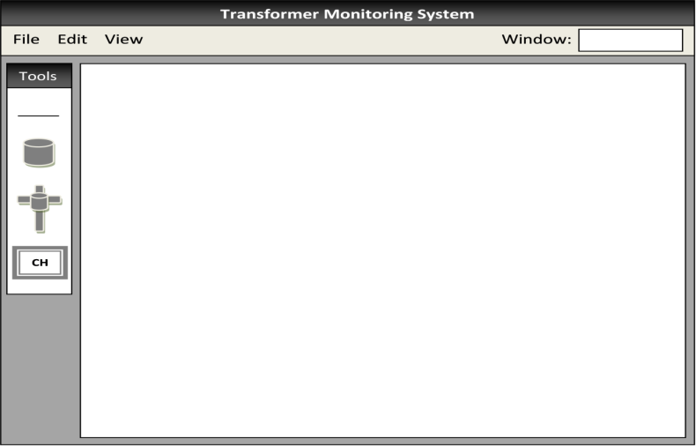

**Transformer Double Click**

Method: Line

On click

Creates new line object

Allows for drag and place

Only drawn on workspace

Method: Ground Transformer

On click

Creates new trans object

Allows for drag and place

Only drawn on workspace

Method: Central Hub

On click

Creates new hub object

Allows for drag and place

Only drawn on workspace

Method: Pole Transformer

On click

Creates new trans object

Allows for drag and place

Only drawn on workspace

Method: Display Ground Trans

Creates a visual ground trans.

Able to move around workspace

Has action when double click

Method: Display Pole Trans

Creates a visual pole trans.

Able to move around workspace

Has action when double click

Method: Display Line

Creates a visual line

Able to move around workspace

Method: Display Central Hub

Creates a visual central hub

Able to move around workspace

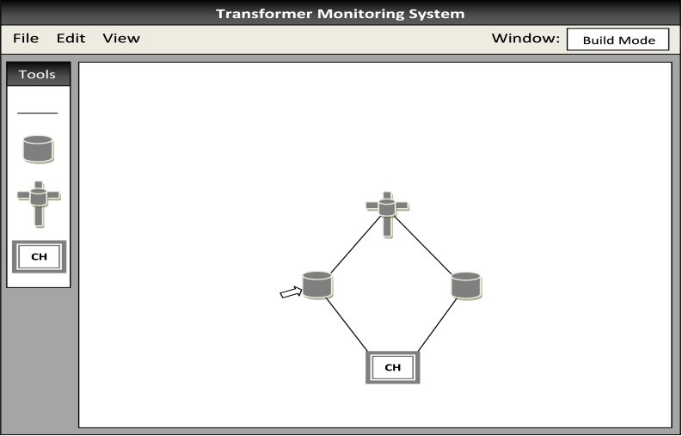

**Transformer Monitoring Properties**

Serial Number:

1201167

Thresh Hold Voltage:

Thresh Hold Current:

Thresh Hold Temperature:

Caution Voltage:

Caution Current:

Caution Temperature:

____155_____

____60______

____250_____

Low __100___ High __145___

Low __20____ High __50____

Low __0_____ High __230___

**CANCEL**

**SAVE**

Method: Property Types

Text field

Grayed out until Serial # entered

Shows:

Thresh Hold Voltage:

Thresh Hold Current:

Thresh Hold Temperature:

Caution Voltage:

Caution Current:

Caution Temperature:

Method: TM Properties

Shows TM Prop Window

Uses text fields & boxes

Allowed movement

Not resizable

Method: Save

Updates all values

Closes TM Prop Window

Method: Cancel

Closes TM Prop Window

w/o any change made

Method: Get X

Each one is a text box

Grabs current value

User can modify value

Each one has own method

Examples:

Get Thresh Hold Voltage

Get Thresh Hold Current

Method: Get Serial

Text box

User enters serial number

Finds transformer properties

for that particular serial number

Calls GetX to show current values

**View Mode Selection**

Method: View Mode

Grays out tools window

Grays out edit menu

Calls method Change Trans

Method: Change Transformer

Changes original transformer

color to either:

Green – Good

Yellow – Caution

Red – Warning

Method: Flag

Two flags

Caution – Values Exceeded

Warning – System Failure

Displays sign to user if thrown

Sounds alarm if thrown

Calls Change Transformer

**Transformer Double Click**

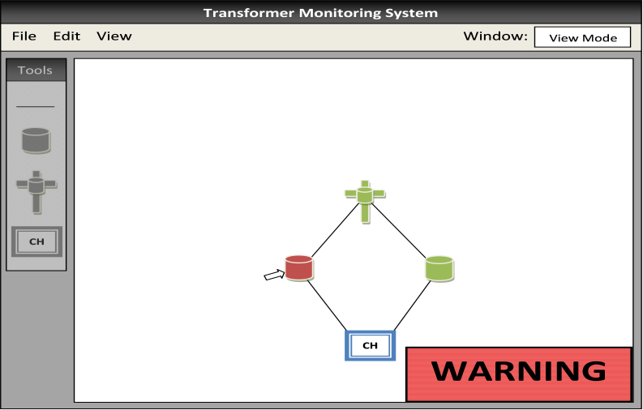

**Transformer Parameters**

**T1**

**Voltage:**

**Current:**

**Temperature:**

**Phase Angle:**

**165**

**72**

**244**

**20**

15.23.45

**Refresh**

Method: Trans Parameters

Shows Trans Para Window

Uses text fields

Allowed movement

Not resizable

Only one interaction w/user

Method: Indicators

Displays a circle graphic

Changes color based on

transformer performance

Method: Display Parameters

Shows all of the current values

for every trans parameter

Method: Trans Name

Tells user which trans was

selected to monitor

Method: Refresh

Only interaction w/user

Button

On click

Sends signal to device

Updates display parameter

Updates time stamp

Method: Time Stamp

Shows time last updated

**4.5.3 Software Data Flow & Security Protocol**

Information that the wireless receiver gathers together is sent through a USB port on the central hub computer. Recall that the best way to store the information is through the use of a database, but the question is how to move the data from the USB port to the database effectively and without any loss of information or security. In order to achieve such desired results another program will be created. Treated as a daemon program, one that sits in the background and always runs; this program will have only one responsibility and that is to transfer the data on the port to the database. The main reason in creating the extra program is to keep the main program isolated from writing data to the database. This safety feature is meant to avoid any lose in data if the main program were to crash. Another safety feature that is built into the program is something called a sentry. A sentry is used to constantly keep a watchful eye out for any problems that might arise with the daemon program. If for some reason the information the daemon program is writing somehow becomes corrupt or if the program itself crashes, then the sentry will tell the main program and warn the user. This will also trigger the program to override the daemon program and take over for the transferring of data to the databases. Once the daemon program gets re-established, it will force the main program to become isolated again and continue its main purpose. Figure 4.5-9 shows the flow of information from the USB to the main computer.

**Data Flow Chart**

**Legend**

Path data takes normally

Path data takes when main program crashes

Path data takes whendaemon program crashes

Daemon

Program

Database

Main

Program

**Sentry**

USB

Figure 4.5-9 Data Flow Chart

# 5.0 Design Summary of Hardware and Software

**5.1 Power Supply**

The power for the logic board, wireless communication, and sensors will be supplied by an inductive coil. This coil will be mounted on the larger current carrying line of the transformer, typically the low side. The power will then pass through a full wave rectifier circuit consisting of the KBP201G IC and a smoothing capacitor. The power output will then be used to power a battery backup device and two voltage regulator circuits. The battery backup circuit entails the use of a LT3652 IC and LiPo battery cells. The voltage regulations circuits will consist of using two AP1186 regulators with one having 3.3V fixed output and the other 1.5V fixed output. The two different levels of voltages will be needed to supply power to various components on the logic board.

**5.2 Sensors**

The system will rely on the use of various sensors to gain the information to relay to the central hub computer. These sensors will consist of capacitive voltage sensors, inductive current sensors, and a infrared temperature sensor. The voltage sensors will be built using a circuit that will detect the amount of charge on a plate that will be located close to the power line. The current sensors will also be built for this project; they will be based on a Rogowski coil concept with an integrator circuit located at the output. Measuring the temperature of the transformer will be made possible through the use of a MLX90614ESF-AAA infrared sensor manufactured by Polou. The current and voltage sensors will have an analog signal output and be connected to the analog to digital convertors of the MSP430. The temperature senor has a digital output and will be connected to the digital input pin of the micro-controller.

**5.3 Microprocessor**

The microprocessor for the device is supposed to be small, low-powered, able to communicate with the communications board, and able to receive all sensor information. It has the capability for compiling all sensor information and transmitting it through the wireless portion of the device. It has the ability to change certain threshold values as instructed by the central hub station. The microprocessor chosen for this design is the Texas Instruments MSP430F2013x20x2. This is a 16 bit, 14 pin microprocessor with onboard memory and 10 bit analog to digital converters. It suits the needs of this project well due to its very low power consumption and its ability to connect to all of the sensors that will need to be used on the transformer monitoring system. This processor is capable of interfacing with the transceiver chosen for this project, the Digi International XBee-Pro ZB. It can store all the necessary variables that it will require to determine the state of the transformer. This microprocessor has many features that usually only comes onboard devices with a large pin count. All these factors make this processor an ideal choice for the transformer monitoring system.

**5.4 Communications**

The communications system of the device is supposed to be low-cost and capable of transmitting small amounts of information over long distances of about a mile. The wireless component chosen is the XBee-Pro ZB model. The ZB represents that the model uses the Zigbee mesh network, and the Pro designation means the device is made for long distances. This model is designed to have the capability of sending data of about one mile and allows for a mesh network to be established. Since the central hub could be located ten miles away from the actual device itself, a mesh network such as Zigbee highly desirable. It works by routing the information from device to device until it reaches the central hub through a device that exists within one mile of the station. All health monitoring information is transmitted as a string at set intervals, and it can send specific values when requested by the central hub. The central hub is also able to send information that changes the values on the microcontroller. Each device will send health information once every 30 minutes under normal situations. Non-normal situations include “Caution” if a transformer reaches values outside the recommended range from the manufacturer and “Warning” if the transformer reaches values outside of the operating range. If a Caution situation is reached, the device transmits this health information every 30 seconds. If a Warning situation is reached, the device transmits the health information every 5 seconds. This information is transmitted using the XBee module connected to an external 18-element Yagi antenna.

**5.5Software**

The software system is designed to relay the information from the wireless receiver to the database and then from the database to the computer screen. In order to move the information off of the receiver port and into the database, a daemon program will be used. Its safety features as well as its ability to withstand almost any computer malfunctions makes it the best choice. A mySQL database will then take information, organize it, and then store it onto the computer for later use. From there the main program will pull the information from storage and will then display the data about each of the transformers in a nice, neat manner the user can easily understand. In order to achieve such desired results the programming language chosen was C-Sharp due to its GUI interface capabilities. Also as another safety protocol, a sentry program will be built into the main program. This sentry will override the process of moving data from the receiver port to the database if the daemon program for some reason crashed. With this safety feature, no data will ever be lost so long as the computer does not shut down or the wireless receiver does not get removed.

# 6.0 Project Prototype Construction

**6.1Mounting**

The general idea is that the monitoring system will be mounted to existing transformers on the power pole. This means that the system must be able to provide flexible mounting options. This must be as flexible as possible because a power pole can have many things mounted to it like: multiple transformers, street lighting, phone system devices and other power connecting devices. The mounting method chosen that will provide this amount of flexibility includes the use of a band clamp. A diagram of this method and an idea of what it will look like mounted on a pole can be found below. The mounting installation procedure will start with the box being attached to the band clamp. The band clamp will then be wrapped around the power pole at a convenient location for that particular pole. The cables to the sensors and power coil can then follow route around any obstacles that may be present between the monitoring box and power lines.

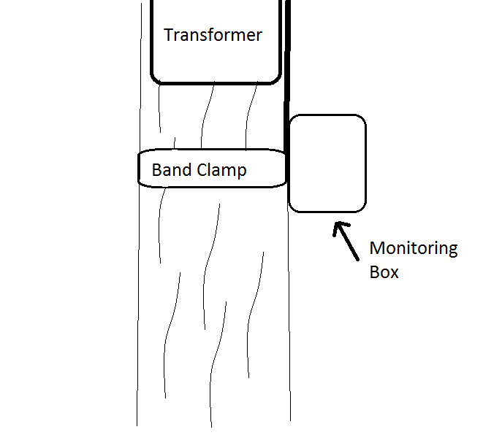

Figure 6.1-1 Diagram of band clamp installation of the monitoring box

**6.2Grounding**

Proper grounding of any electrical device is vital to its functionality and longevity. Without a reliable ground reference the transformer monitoring system cannot function. To ground the transformer monitoring system a path to the earth must be established as a 0V reference for the electricity. This can be accomplished by attaching a grounding wire from the transformer monitoring system to the grounding wire on the utility pole. Most utility poles are already grounded to the earth. This is accomplished by a copper wire that is connected to the static ground and runs the length of the pole to a copper rod. This copper wire is also connected to the chassis of the transformer. The copper rod is usually buried 6-10 feet into the ground (“What’s on”). This can be disadvantageous at times when close to substations. When close to a substation there is always the possibility of earth potential rise (“What is”). This potential rise can cause discrepancies in parameter measurement as well as damage to the microprocessor and sensors. The transformer monitoring system can also be grounded by connection to the neutral power line for 0V reference. This is ideal for applications where grounding to the earth at the location of the utility pole is not an option. However, there are anomalies that cause the voltage of the neutral power line to rise above the 0V reference. This rise in potential has the ability to cause the transformer monitoring system to report inaccurate data.

Some utility poles have a multi grounded neutral. This is a neutral line that provides a return path for the electricity and is grounded to the earth as well. It is attached to the copper grounding wire that runs the length of the utility pole (“What’s on”). Ideally the chassis ground will be kept separate from the microprocessor’s ground. Since the device will be placed very close to high voltage power lines and transformers, grounding the devices separately will be necessary to help shield the transformer monitoring system’s circuitry from the electromagnetic fields generated by the transformer and the high voltage power line. For most scenarios the best method of obtaining a 0V reference for the transformer monitoring system and grounding the chassis will be to connect two wires, one for the chassis and one for the circuit board, to the copper grounding wire that runs the length of the pole. Since most utility poles in the United States that have a transformer have a copper grounding wire already in place, this should not conflict with any local power codes (“How Power”). In the rare case that a transformer is not grounded directly to the Earth it will be just as easy to connect the transformer monitoring system to the neutral transmission wire on the utility pole. Figure 6.2-1 provides a good visual depiction of a typical utility grounding scenario.

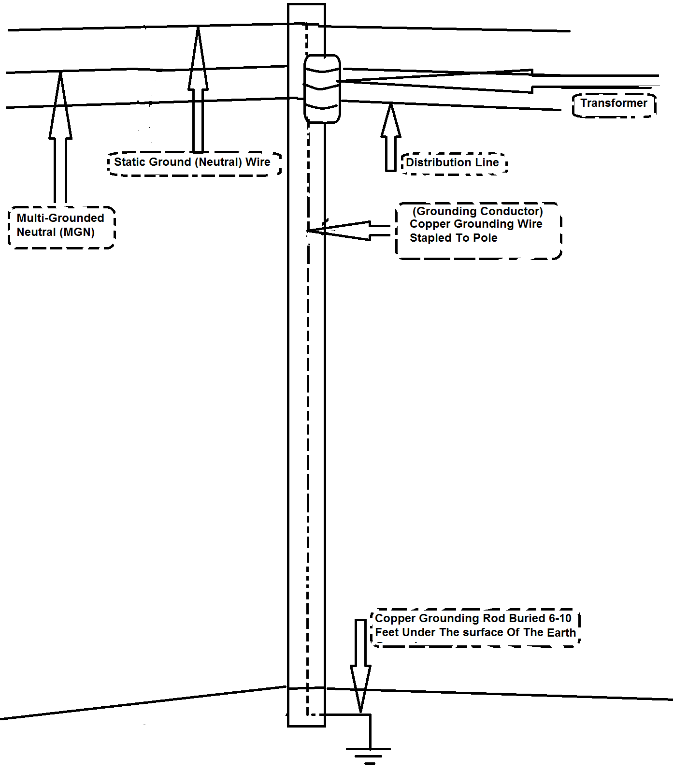

Figure 6.2-1 Utility Pole Grounding

**6.3****Transformer Monitoring System Connectivity**

The transformer monitoring system will consist of a printed circuit board encased inside of a small sealed chassis. There are several external devices and lines that need to connect to the printed circuit board. The four line sensors, the power, the ground, and the XBee antenna all need to connect to the outside of the chassis. These connections will need to be sealed so that the interior of the transformer monitoring system is totally sealed from any external elements (See Figure 6.3-1). The line sensors could be grouped into a single four pin connection or have one connector per sensor. Grouping the sensors together in one connector will save on cost. However, grouping the line sensors together would raise the difficulty of repair. If one line sensor gets damaged or destroyed all of the sensors would need to be replaced. The other option is to have one circular connector for each sensor. This could quadruple the cost of the sensor connectors. However, if one sensor fails, becomes damaged, or becomes destroyed, it will be very easy to disconnect and replace without the need to disconnect any of the other sensors. The ability to easily change sensors vs. the low cost of a single connector is a decision that can largely impact the overall cost of the transformer monitoring system because weather proof circular connectors are somewhat expensive. However, modularity and reparability are very important to power companies. Therefore, the multi connector solution will be optimal for the transformer monitoring system.

The transformer monitoring system will have four single pin receptacle connectors on the chassis that connect to an external line sensor. These receptacles will mate with sealed plugs for a weather tight connection to reduce the possibility of moisture and dust entering the interior of the transformer monitoring system and to keep the connections clean. The transformer monitoring system will be completely exposed to all forms of outdoor temperature changes, weather changes, wind, rain, dust, etc. Therefore, it is vital that the unit is sealed entirely. Circular connectors will be used to give the chassis maximum shielding against electromagnetic interference. The circular connectors will also be effective in reducing wind resistance, allowing the unit to be more aerodynamic and less likely to be affected by high winds. The antenna for the XBee wireless network will need to be mounted externally to avoid the RF shielding that the chassis might produce. The connection between the external antenna and the chassis will need to make a water tight seal. The connections for power and ground will also be single pin sealed connections. The connections on the chassis will be wired directly to the printed circuit board.

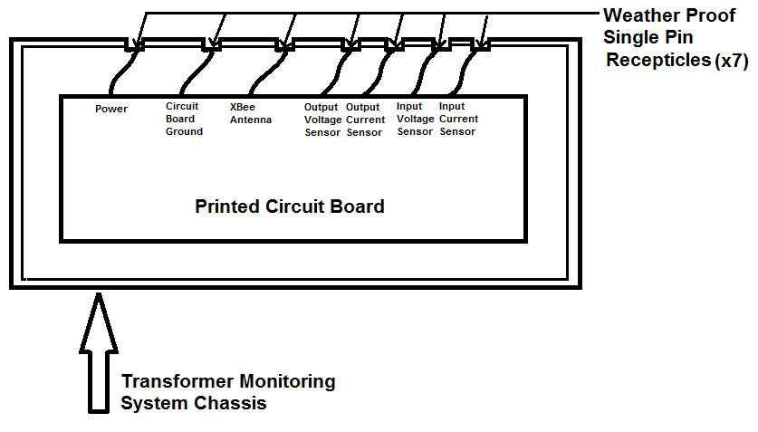

Figure 6.3-1 Printed Circuit Board

**6.4Mounting the Processor to the Printed Circuit Board**

The MSP430F2013 will need to be permanently mounted to a printed circuit board. The dimensions of the chip can be seen in the following two figures below. The board will need enough space to accommodate the area that this chip will consume. The holes for the pins will need to be drilled according to the dimensions shown in Figure 6.4-1 and Figure 6.4-2.

**6.5 PCB Layout and Schematic**

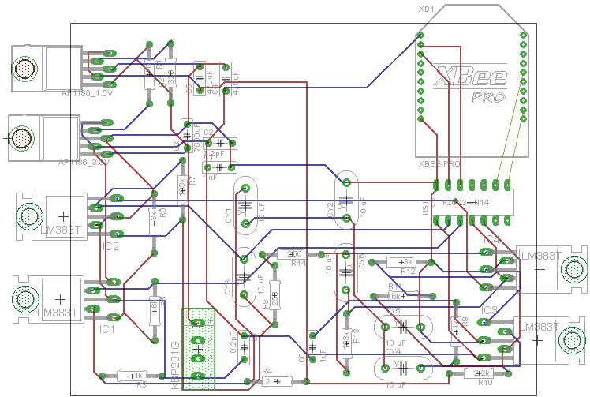

Figure 6.5-1 Transformer Monitoring System PCB Layout

# 

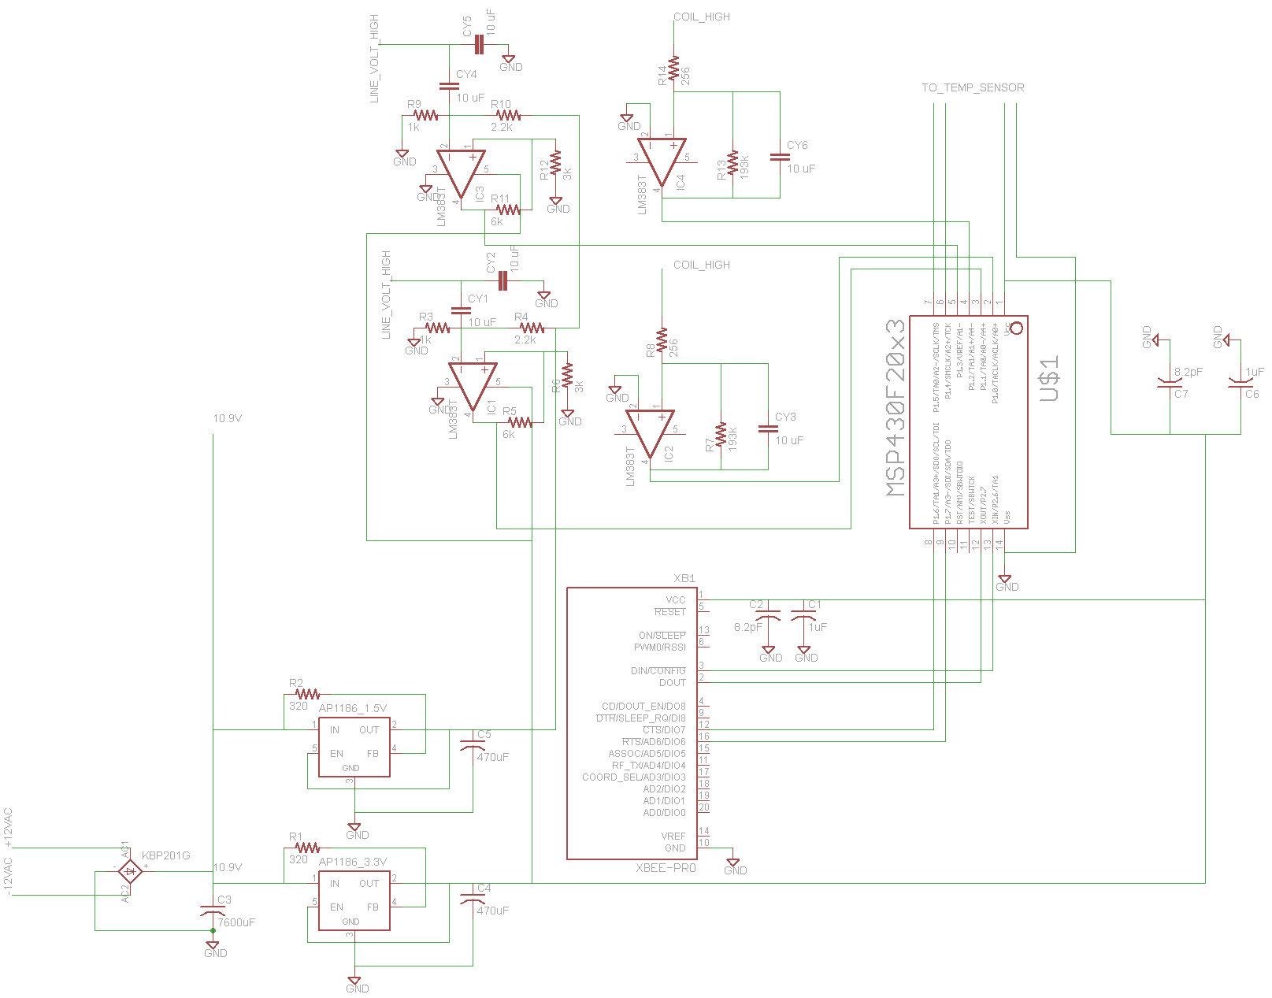

Figure 6.5-2 Transformer Monitoring System Schematic

# 7.0 Project Prototype Testing

**7.1Power Testing**

The prospect of gaining access to a pole mounted transformer with expected load voltages and current does not seem to be obtainable as of now. This creates the need to design a testing platform. To maximize safety and to easily change the conditions, the use of two different conducting wires will be used to simulate the power line.These platforms will be created with the use of either a step-up or a step-down transformer. The components to be tested will then be connected over the output lines of the respective transformer. A sample diagram of the testing platform devices can be seen below. In order to test the power supply and current sensor, there needs to be a conducting wire that is carrying current between 50 to 420 Amps. To test the two ranges of voltage sensors the conducting wire must be able to carry a wide range of voltages from approximately 90V to 260V and 6.5KV to 8KV. For each case, the test platform will be modified accordingly.

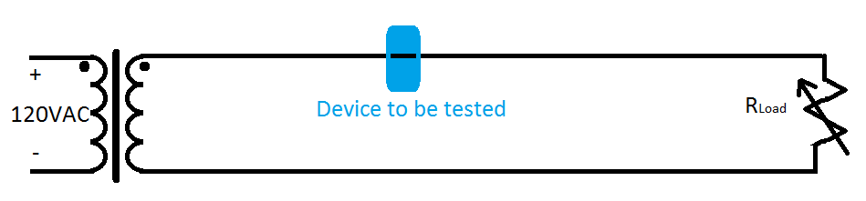

Figure 7.1–1 Diagram of typical layout of the testing platform for current and power supply testing

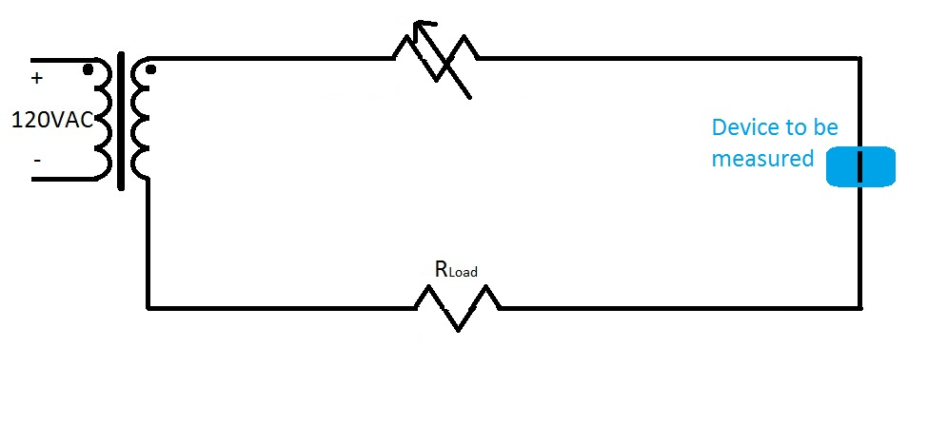

Figure 7.1-2 Diagram of typical layout of the testing platform for the voltage sensor testing

1. With the step-down testing platform unpowered, clamp the power coil over the line with one of the leads connected to an oscilloscope probe
2. Set the variable resistor to maximum resistance and connect an ammeter in series with the load resistor
3. Apply power to the testing platform
4. Fill in the table below by taking measurements of the outputs from the power coil at the corresponding

|  |  |
| --- | --- |
| Current in line (A) | Voltage output of coil (V) |
| 50 |  |
| 100 |  |
| 150 |  |
| 200 |  |
| 250 |  |
| 300 |  |
| 350 |  |
| 400 |  |
| 450 |  |

**Figure 7.1-3Table of coil outputs for a given line current**

1. Turn off the power to the testing platform
2. Connect the power regulation circuit and power up the testing platform again with the load resistor at maximum resistance
3. Connect oscilloscope probes to the coil output and the two outputs of the voltage regulation circuit
4. Fill out the table below making sure the output voltages are within the voltage tolerances

|  |  |  |  |
| --- | --- | --- | --- |
| Current in line (A) | Voltage output of coil (V) | Voltage 3.3V output (V) | Voltage 1.5V output (V) |
| 50 |  |  |  |
| 100 |  |  |  |
| 150 |  |  |  |
| 200 |  |  |  |
| 250 |  |  |  |
| 300 |  |  |  |
| 350 |  |  |  |
| 400 |  |  |  |
| 450 |  |  |  |

**Figure 7.1-4Regulated Voltage output of power supply**

**7.2Sensors Testing**

**7.2.1 Current Sensor**

1. With the step-down testing platform unpowered, clamp on the current sensor coil with an oscilloscope probe connected the current sensor coil leads
2. Set the variable resistor to maximum resistance and connect an oscilloscope probe to measure current in the load resistor
3. Apply power to the testing platform
4. Fill out the table below by lessening the load resistor until the desired current has been reached

|  |  |
| --- | --- |
| Current in Line (A) | Voltage output of the coil (mA) |
| 50 |  |
| 100 |  |
| 150 |  |
| 200 |  |
| 250 |  |
| 300 |  |
| 350 |  |
| 400 |  |
| 450 |  |

**Figure7.2-1 Table of Rogowski coil outputs**

1. Connect the coil leads to the Rogowski coil integrator circuit and another oscilloscope probe to the integrator output
2. Fill out the table below, measuring the output of integrator for the given current loads and recording the time delay between the current in the resistor and the output of the integrator.

|  |  |  |  |
| --- | --- | --- | --- |
| Current in Line (A) | Voltage output of the coil (mA) | Integrator voltage output (mV) | Δt of current in line and voltage output |
| 50 |  |  |  |
| 100 |  |  |  |
| 150 |  |  |  |
| 200 |  |  |  |
| 250 |  |  |  |
| 300 |  |  |  |
| 350 |  |  |  |
| 400 |  |  |  |
| 450 |  |  |  |

**Figure 7.2-2 Table of current sensor outputs**

**7.2.2 Voltage Sensor**

Testing for 120V sensor:

1. With the step-up testing platform unpowered, clamp on the 120V capacitive plate assembly and connect it to the op-amp circuit
2. Connect an oscilloscope probe to measure the voltage waveform the between the variable resistor and the load resistor
3. Connect an oscilloscope probe to measure the output of the voltage sensor op-amp
4. Apply power to the testing platform
5. Starting with the variable resistor set to maximum, fill out the table below measuring the sensor voltage output and time delay

|  |  |  |
| --- | --- | --- |
| Line voltage (V) | Sensor output voltage (mV) | Time delay  Δt |
| 90 |  |  |
| 95 |  |  |
| 100 |  |  |
| 105 |  |  |
| 110 |  |  |
| 115 |  |  |
| 120 |  |  |
| 125 |  |  |
| 130 |  |  |

**Figure7.2-3 Table of 120V sensor outputs**

Testing 7.2KV sensor:

1. With the step-up testing platform unpowered, clamp on the 7.2KV capacitive plate assembly and connect it to the op-amp circuit
2. Connect an oscilloscope probe to measure the voltage waveform the between the variable resistor and the load resistor
3. Connect an oscilloscope probe to measure the output of the voltage sensor op-amp
4. Apply power to the testing platform
5. Starting with the variable resistor set to maximum, fill out the table below measuring the sensor voltage output and time delay

|  |  |  |
| --- | --- | --- |
| Line voltage (V) | Sensor output voltage (mV) | Time delay  Δt |
| 6.5 |  |  |
| 6.6 |  |  |
| 6.7 |  |  |
| 6.8 |  |  |
| 6.9 |  |  |
| 7.0 |  |  |
| 7.1 |  |  |
| 7.2 |  |  |
| 7.3 |  |  |
| 7.4 |  |  |
| 7.5 |  |  |
| 7.6 |  |  |
| 7.7 |  |  |
| 7.8 |  |  |
| 7.9 |  |  |
| 8.0 |  |  |

**Figure 7.2-4 Table of 7.2KV sensor outputs**

**7.2.3 Temperature Sensor**

1. Turn on heat source (Must be able to read and vary the heat)
2. Connect the MLX90614 temperature sensor to an Orangutan SV-168
3. Point lens towards heat source
4. Record the temperature read through the sensor in Figure 7.2-5
5. Calculate the difference between the actual and the experimental
6. Determine whether the difference is significant enough to react

|  |  |  |
| --- | --- | --- |
| Measured Temp (Actual) | Measured Temp (Experimental) | Difference |
| 0◦C |  |  |
| 25◦C |  |  |
| 50◦C |  |  |
| 75◦C |  |  |
| 100◦C |  |  |
| 125◦C |  |  |
| 150◦C |  |  |
| 175◦C |  |  |
| 200◦C |  |  |

**Figure 7.2-5 Table of Temperature Outputs**

**7.3Logic Testing**

**7.3.1 Testing Overview**

It is imperative that the microprocessor be tested once it is programmed and ready to be mounted onto the printed circuit board. Fortunately since the MSP 430 processor that has been chosen for this design is very popular, there are a wide range of simulators that support this device. Simulation is a very cost effective way to determine if a device will work as designed without spending a large amount of money using trial and error while destroying microchips in the process. Once the design is verified in simulation it will be tested on a breadboard.

Testing the microprocessor on a breadboard will allow for any wiring or configuration changes that need to be performed prior to ordering a printed circuit board. The microprocessor will be pre-programmed with a set of caution and threshold values for the parameters that the transformer monitoring system is designed to monitor. It will be programmed with a specific reporting interval time for each transformer state. The microprocessor will then be mounted onto the breadboard and connected to the various components on the transformer monitoring system. The temperature sensor will be mounted to a breadboard and the serial data lines will be connected to two of the digital I/O pins on the microprocessor. Four devices that can supply a voltage that can vary from 0 - 3.5V will be connected to four of the pins that support analog to digital conversion on the microprocessor. The voltages present on the microprocessor pins will be only a small percentage of the actual line voltages so that the values can be measured by a microprocessor. This percentage value will be determined by the design of the line sensors and the microprocessor will have this value stored in its memory in order to convert the values to the actual values on the line. The XBee wireless transceiver will also be connected to four of the pins on the microprocessor that support digital input and output. The microprocessor, the infrared temperature sensor, and the XBee wireless transceiver will all be connected to a 3 volt power supply. The main control hub will also be powered on and initially configured for monitoring the microprocessor. There will be 5 sets of tests to verify correct reporting of data and 2 sets of tests to verify its ability to receive data and commands from the main control hub

**7.3.2 Test Set 1 – Normal State**

The first set of tests will verify that the microprocessor can function properly while the transformer is in a normal state. The voltage on the pins dedicated to the transformer output line current sensor, the transformer output line voltage sensor, the transformer input line voltage sensor, and the transformer input line current sensor will be set to values below the high threshold values and above the low threshold values that are stored inside of the processor’s memory for those parameters. The infrared temperature sensor will be pointed at a surface that has a surface temperature below that of the temperature caution value. Under these conditions the processor should report the values of the parameters being monitored, a flag indicating that the current state of the transformer is normal, and the unique station identifier. It should report these values at a frequency determined by the reporting interval time for the normal state that has been pre-programmed into the processor prior to commencing testing. If all of these test parameters are satisfied then the second set of tests will proceed.

**7.3.3 Test Set 2 – Normal State to Caution State**

The second set of tests will verify that the microprocessor performs as desired when the line sensors and the temperature sensors that it is monitoring indicate that the transformer has transitioned from a normal state into the caution state. For this to happen there will be nine different tests that will be performed. The voltage on the pins dedicated to the transformer output line current sensor, the transformer output line voltage sensor, the transformer input pine voltage sensor, and the transformer input line current sensor will be raised to a value just above the high caution value but below the high warning value and lowered just below the low caution value but above the low warning value that corresponds to each parameter. Also, the surface temperature of the surface that the infrared transformer is currently monitoring will be raised just above the temperature caution value. These caution values are the values that were preprogrammed into the processor prior to commencing testing. For each of the nine scenarios the processor will perform the same functions. Each of these conditions should cause the processor to immediately transmit all of the current parameter values that it is monitoring, transmit a flag indicating that the transformer is now in a caution state, and transmit its unique station identifier. It should also increase its transmit frequency to one data set transmitted every 30 seconds.

**7.3.4 Test Set 3 – Caution State to Warning State**

The third set of tests will verify that the microprocessor performs as desired when the line sensors and the temperature sensors that it is monitoring indicate that the transformer has transitioned from a caution state into the warning state. For this to occur there will be nine different tests that will be performed. The voltage on the pins dedicated to the transformer output line current sensor, the transformer output line voltage sensor, the transformer input pine voltage sensor, and the transformer input line current sensor will be raised to a value just above the high warning value and lowered just below the low warning value that corresponds to each parameter. Also, the surface temperature of the surface that the infrared transformer is currently monitoring will be raised just above the temperature warning value. These warning values are the values that were preprogrammed into the processor prior to commencing testing. For each of the nine scenarios the processor will perform the same functions. Each of these conditions should cause the processor to immediately transmit all of the current parameter values that it is monitoring, transmit a flag indicating that the transformer is now in a warning state, and transmit its unique station identifier. It should also increase the transmit frequency to one data set transmitted every 5 seconds.

**7.3.5 Test Set 4 – Warning State to Caution State**

The fourth set of tests will verify that the microprocessor performs as desired when the line sensors and the temperature sensors that it is monitoring indicate that the transformer has transitioned from a warning state back into the caution state. For this to occur there will be nine different tests that will be performed. The voltage on the pins dedicated to the transformer output line current sensor, the transformer output line voltage sensor, the transformer input pine voltage sensor, and the transformer input line current sensor will be raised to a value just above the high warning value and lowered just below the low warning value that corresponds to each parameter. Also, the surface temperature of the surface that the infrared transformer is currently monitoring will be raised just above the temperature warning value. For testing purposes these events will happen one at a time. These warning values are the values that were preprogrammed into the processor prior to commencing testing. Once a particular parameter value has been raised or lowered to a value extreme enough to indicate that the transformer is in a warning state, it will then be lowered or raised enough to put it back into the caution state. This transition is the main focus of this set of tests. For each of the nine scenarios the processor will perform the same functions. Each of these conditions should cause the processor to immediately transmit all of the current parameter values that it is monitoring, transmit a flag indicating that the transformer is now back in a caution state, and transmit its unique station identifier. It should also decrease the transmit frequency to one data set transmitted every 30 seconds.

**7.3.6 Test Set 5 – Caution State to Normal State**

The fifth set of tests will verify that the microprocessor performs as desired when the line sensors and the temperature sensors that it is monitoring indicate that the transformer has transitioned from a caution state back into the normal state. For this to occur there will be nine different tests that will be performed. The voltage on the pins dedicated to the transformer output line current sensor, the transformer output line voltage sensor, the transformer input pine voltage sensor, and the transformer input line current sensor will be raised to a value just above the high caution value but below the high warning value and lowered just below the low caution value but above the low warning value that corresponds to each parameter. Also, the surface temperature of the surface that the infrared transformer is currently monitoring will be raised just above the temperature caution value but below the temperature warning value. For testing purposes these events will happen one at a time. These caution and warning values are the values that were preprogrammed into the processor prior to commencing testing. Once a particular parameter value has been raised or lowered to a value extreme enough to indicate that the transformer is in a caution state, it will then be lowered or raised enough to put it back into the normal state. This transition is the main focus of this set of tests. For each of the nine scenarios the processor will perform the same functions. Each of these conditions should cause the processor to immediately transmit all of the current parameter values that it is monitoring, transmit a flag indicating that the transformer is now back in a normal state, and transmit its unique station identifier. It should also decrease the transmit frequency to one data set transmitted every 30 minutes.

**7.3.7 Testing procedure for State Changes**

Normal state conditions:

1. With the testing platforms unpowered. Connect the power coil and current sensor to the high current test platform and connect the volt sensor to the high voltage test platform
2. Connect the sensors and power coil to the logic board of the monitoring system
3. Apply power to the test platforms until normal conditions have been met. For the voltage platform, the voltage present in the line should be around 7KV and the current platform should have around 400A present in the line
4. Wait until the monitoring system sends the status message. When the message is sent, start a timer and check for that no caution or warning flags have been set
5. Wait for another message to be sent and check timer, to make sure the system has the correct time interval between sending normal state messages of 30 minutes
6. Leave the power system and testing platform powered for the next section

Caution conditions:

1. With the testing platforms under powered. Increase the voltage in the high voltage platform by decreasing the resistance of the variable resistor until the voltage present in the line is past the caution state value
2. Check the message sent by the monitoring system for a caution voltage flag and start timer
3. Wait for another message to be sent and check timer, to make sure the system has the correct time interval between sending caution state messages of 30 seconds
4. Increase the variable resistor on the high voltage platform until voltage is within normal condition values
5. Increase the line current of the high current testing platform, by decreasing the variable resistor until a caution current value has been met
6. Check the message sent by the monitoring system for a caution current flag and start timer
7. Wait for another message to be sent and check timer, to make sure the system has the correct time interval between sending caution state messages of 30 seconds
8. Bring the current back to normal condition values and wait for a normal condition status message to be sent
9. Decrease the voltage in the high voltage platform by increase the resistance of the variable resistor until a low voltage condition is met
10. Check the message sent by the monitoring system for a caution voltage flag and start timer
11. Wait for another message to be sent and check timer, to make sure the system has the correct time interval between sending caution state messages of 30 seconds
12. Bring the voltage back to normal conditions by decreasing the variable resistor
13. Decrease the current in the current test platform by increasing the variable resistor until a low current condition has been met
14. Check the message sent by the monitoring system for a caution current flag and start timer
15. Wait for another message to be sent and check timer, to make sure the system has the correct time interval between sending caution state messages of 30 seconds
16. Bring the current back to normal conditions by increasing the variable resistor on the current platform

Warning conditions:

1. With the testing platforms under powered. Increase the voltage in the high voltage platform by decreasing the resistance of the variable resistor until the voltage present in the line is past the warning state value
2. Check the message sent by the monitoring system for a warning voltage flag and start timer
3. Wait for another message to be sent and check timer, to make sure the system has the correct time interval between sending caution state messages of 5 seconds
4. Increase the variable resistor on the high voltage platform until voltage is within normal condition values
5. Increase the line current of the high current testing platform, by decreasing the variable resistor until a warning current value has been met
6. Check the message sent by the monitoring system for a warning current flag and start timer
7. Wait for another message to be sent and check timer, to make sure the system has the correct time interval between sending warning state messages of 5 seconds
8. Bring the current back to normal condition values and wait for a normal condition status message to be sent
9. Decrease the voltage in the high voltage platform by increase the resistance of the variable resistor until a low warning voltage condition is met
10. Check the message sent by the monitoring system for a caution voltage flag and start timer
11. Wait for another message to be sent and check timer, to make sure the system has the correct time interval between sending warning state messages of 5 seconds
12. Bring the voltage back to normal conditions by decreasing the variable resistor
13. Decrease the current in the current test platform by increasing the variable resistor until a low current warning condition has been met
14. Check the message sent by the monitoring system for a warning current flag and start timer
15. Wait for another message to be sent and check timer, to make sure the system has the correct time interval between sending warning state messages of 5 seconds
16. Bring the current back to normal conditions by increasing the variable resistor on the current platform

**7.3.8Test Set 6 – Reprogram Variables from the Central Hub**

The sixth test will be used to determine that the processor can be reprogrammed from the central control hub. There are 21 values that the central control hub can change. These values are the high threshold input voltage, low threshold input voltage, high threshold input current, low threshold input current, high threshold output voltage, low threshold output voltage, high threshold output current, low threshold output current, high caution input voltage, low caution input voltage, high caution input current, low caution input current, high caution output voltage, low caution output voltage, high caution output current, low caution output current, temperature caution, temperature warning values. Also the normal state reporting interval, caution state reporting interval, and warning state interval can be changed from the central control hub. A test to change each parameter value will be performed as well as a test to change all parameter values simultaneously. These update commands will be received from the XBee processor and will have originated from the central control hub. To perform the test the central control hub will first send the updated data to the microchip. The microchip will then be removed from the breadboard and will be connected to the ez430 USB stick. The USB stick will be connected to a PC and the proper update of the value being checked will be verified using development software.

**7.3.9 Test Set 7 – Command the Processor to Give a Report (Refresh)**

The seventh test will verify that the microprocessor can receive a command to send an update of all the parameter values that it is monitoring and the current state of the transformer based on its stored values to the central control hub. To test this functionality the microprocessor will receive a command from the XBee wireless transceiver that it should send an update. This update command will be initiated from the central control hub. When the microprocessor receives this update command it will send the threshold, caution, and interval values stored within its memory. Also it will send the current values from all the sensors that it is monitoring, and its unique station identifier. If the processor performs this test and all previous tests correctly it is ready to be permanently attached to the printed circuit board.

**7.3.10 Reprogram and Refresh Procedure**

1. Before starting it is important to have main computer program near device
2. On the central hub computer, double click on the shortcut icon labeled “Transformer Monitoring System”
3. Wait for loading bar to finish
4. Click on the continue button
5. Click on “File”, “Open”
6. Open the testing executable testingDevice.exe which is located inside of the folder “Testing Protocols” within the subdirectory of the main program folder
   1. A question should appear asking if you want to test reprogram or refresh
   2. If reprogram follow steps 7 through 9, else follow remaining steps

Reprogram

1. The main program will then open up a premade grid and will try to send new data to the device.
2. A pop up box will open saying, “Everything sent, please check the device for accuracy and correctness. Hit continue to move on”
3. Before checking the device, hit continue on the computer
   1. Another pop up box will open asking if the values stored are …
4. Confirm the values of the caution and warning conditions match the values that were programmed in step 7
5. Tell the main program yes if the information matches and no if it doesn’t
   1. A log will be made and sent off to us if not

Refresh

1. The main program will then open up a premade grid and will try to ping the device
2. If the device received the ping, then it would send the information right away without any delay in time
3. After a second or two, a pop up box will open showing the data before the ping and the data after the ping as well as the time stamp before and after. It will then ask the user if the data and time stamp were both updated or if they weren’t at all.
4. Answer the question on the screen
   1. A log will be made based on the answer given

**7.4 Wireless Network Testing**

The steps below will help determine problem areas while testing out the devicecommunications system. The communications system may be divided up into three parts for testing. The first part is a series of radio tests, followed by tests for the microcontroller and tests for the computer connectivity. A complete run through of all the following tests should cover and pinpoint any problematic areas related to the communication system for the device.

**7.4.1 Radio Communication Tests**

This test will ensure that both radio devices are working. For a test, two computers with USB connectivity are required. This will ensure that both radios are functional before using them. Simply put, this test just covers a simple run through to make sure both devices are able to connect to computers, and that both devices can communicate with each other.

A detailed list of what is required for the tests in Section 7.4.1 is below:

1. Two (2) personal computers running Windows that have X-CTU, written by Digi for XBee, and the ability to handle a USB connection (digi.com XCTU).
2. Two (2) XBee adapter kits purchased from “ladyada.net”
3. Two (2) XBee modules

Steps for testing the functionality of the XBee module:

1. Plug in the FTDI cables from the one of the XBee adapter kits onto the pins of the one of the XBee devices as shown in Figure 7.4 - 1.
2. Plug in the USB A end of the adapter kit into a computer.
3. Open the X-CTU program on one computer.
4. Under the “PC Settings” tab, set the Baud rate to 9600, set the Flow Control to NONE, set the Data Bits to 8, set the Parity to NONE, set the Stop Bits to 1 (ladyada.net Connecting, Configuring, and Upgrading).
5. Under the “PC Settings” tab, press “Test/Query” to test the functionality of the XBee device.
6. A notification window should appear stating with text stating “Communication with modem..OK”.
7. Repeat steps 3-6 on the other personal computer that is running Windows.
8. If either device does not display the notification in Step 6, then the device is not fully functional

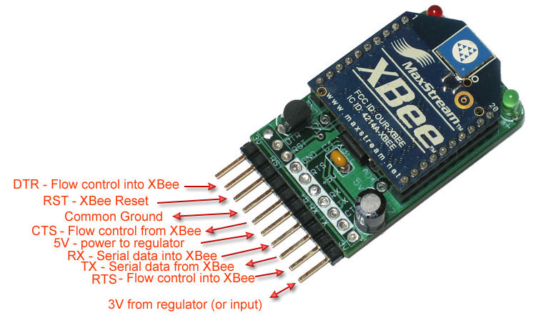

Figure 7.4–1An XBee device mounted to the adapter kits reprinted with permission by ladyada.net.

**7.4.2 Microcontroller Communication**

These tests are made for the scenario where a demonstration will only use one hub station and one device box unit. The steps in this section will test the functionality of the XBee device with the microcontroller.

A detailed list of what is required for the tests in Section 7.4.2 is below:

1. One (1) personal computers running Windows that is connected to an XBee device and is able to access data from it through the COM ports.
2. One (1) XBee module.
3. A working microcontroller connected to an XBee device.

The following steps test for the functionality of the hub station.

1. Repeat the testing Steps 1-6 listed in Section 7.4.1.
2. Connect the computer to the microcontroller in a way where communication can be monitored.
3. Connect the XBee device 3.3 V power pins to an acceptable battery source
4. Connect the XBee device TX and RX serial pins to digital input and output pins, respectively.
5. Text entered in the computer connected to the microcontroller should now appear as text on the hub station.

**7.4.3 Central Hub Station Communication**

Communication tests for the central hub station consist of using the same setup as shown in Figure 7.4-1. These tests are made for the scenario where a demonstration will only use one hub station and device. The steps in this section will test the functionality of the XBee device with the central hub station software.

A detailed list of what is required for the tests in Section 7.4.3 is below:

1. One (1) personal computers running Windows that handle a USB connection and are able to access the COM ports through a program like HyperTerminal
2. One (1) XBee adapter kits purchased from “ladyada.net”
3. One (1) XBee module
4. A working microcontroller connected to an XBee device. The microcontroller should also be connected to a machine capable of displaying information transmitted to it.

The following steps test for the functionality of the hub station.

1. Repeat the testing Steps 1-6 listed in Section 7.4.1.
2. Open HyperTerminal on Windows.
3. When prompted to create a new connection, enter the following text in the field below “Name:”: XBee Central Hub Station Test
4. Click “Ok” to proceed to the next window.
5. On the next window, select the Communications port that the XBee is connected to on the personal computer.
6. Click “Ok” to proceed to the next window
7. On the next window, make the following adjustments where necessary: set “Bits per second:” to 9600, “Data bits:” to 8, “Parity:” to None, “Stop bits:” to 1, and “Flow control” to None.
8. Ensure that the microcontroller using the XBee device has similar settings.
9. After setup is complete, click ”Properties” under “File”.
10. In this window, make sure the following fields are checked: “Send line ends with line feeds”, “Echo typed characters locally”, “Append line feeds to incoming line ends”, and “Wrap lines that exceed terminal width”. Also make sure that the number fields are both set to 0 before hitting OK.
11. Type “ATID” in HyperTerminal to make sure the PAN ID is the same as the microcontroller successfully connected to another XBee device.
12. If the PAN IDs are not the same, press ATID followed by the PAN ID of the microcontroller.
13. Text entered in HyperTerminal should now appear as input on the microcontroller.

**7.5Software Testing**

In order to see if the software is running up to par, there are several testing procedures that need to be followed. As mentioned earlier the software is broken up into three pieces: the filing system, the build mode, and the view mode. Each one of these pieces has their own testing protocol that will ensure they are doing what they are supposed to be doing. Although the welcome screen was not originally grouped with any of the three pieces, it will be grouped under the filing system section in order to test it. Besides those three pieces, there are also the daemon and sentry aspects to this software that needs to be tested. Every procedure is defined below under their respected sub-categories and listed out by numbers for easier usage.

**7.5.1Filing System**

Welcome Screen

1. Double click on the shortcut icon labeled “Transformer Monitoring System”
2. Wait for the loading bar to finish
3. Check to see if the continue button ungrayed once loading finished
4. To check the cancel button, click it then repeat steps 1 to 3
5. Click on the continue button
   1. The welcome screen should exit and the workspace should be present
6. End of Welcome Screen testing

File Menu

1. Move mouse over “File”
2. Check to see if the area around File darkened
3. Click on File
4. Did the File options drop down?
5. Try moving mouse over every option to see if the area around it darkens
6. Click on any of the options or press the combination of keys
   1. All of these should act as they say

Edit Menu

1. Move mouse over “Edit”
2. Check to see if the area around Edit darkened
3. Click on Edit
4. Did the Edit options drop down?
5. Try moving mouse over every option to see if the area around it darkens
6. Click on any of the options or press the combination of keys
   1. All of these should act as they say
   2. As a side note – They will be grayed out if not in build mode therefore to accurately test wait until build mode testing.

View

1. Move mouse over “View”
2. Check to see if the area around View darkened
3. Click on View
4. Did the View options drop down?
5. Try moving mouse over every option to see if the area around it darkens
6. Click on any of the options
   1. These should cause the workspace to get bigger or smaller

**7.5.2Build Mode**

Tools Window

1. Click & hold on the ground transformer icon and drag it onto the workspace
2. Once let go, a ground transformer should be placed onto workspace
   1. To make sure transformers can only be placed on the workspace, try to drag and drop it anywhere not on the workspace
3. Repeat steps 1 and 2 for the pole mounted transformer icon
4. Repeat steps 1 and 2 for the central hub icon
5. In order to connect them click on the line icon
   1. The area around the icon should darken – represents that the wire icon is selected
   2. Should cause the mouse to change shapes into a plus sign
6. Use new mouse to click on the ground transformer in workspace
   1. Must select on transformer since line tool will only work when connecting transformers to each other or central hubs
7. Repeat previous step but click on pole transformer in workspace
   1. Should create a line from the ground transformer to the pole transformer
8. Now click on the pole transformer in the workspace
9. Repeat previous step but click on the central hub in workspace
   1. Should create a line from the pole transformer to the central hub
   2. Every object created thus far should be connected

Edit Menu Advance Features

1. There are six features to the edit menu that can be used while creating the new grid system. To test them all, remember to follow the explicit instructions.
2. Click and drag a new transformer onto the workspace
3. To test undo simply press Ctrl+U or go to “Edit”, “Undo”
   1. When pressed the new transformer should disappear
4. Now press Ctrl+R or go to “Edit”, “Redo”
   1. This should cause the new transformer to reappear in the same location
5. Reselect the transformer and press Ctrl+X or go to “Edit”, “Cut”
   1. The new transformer will disappear again
6. Move the mouse onto the workspace, press Ctrl+V or go to “Edit”,”Paste”
   1. A copy of the transformer that was cut is now placed in the current location of the mouse curser.
7. Reselect the transformer and press Ctrl+C or go to “Edit”, “Copy”
   1. The transformer should still remain on the workspace
8. Move the mouse to a different location on the workspace and press Ctrl+V
   1. A copy of the transformer should appear on the workspace
   2. Notice how there are two transformers now on the workspace, each one are exact copies of one another
9. Without modifying the workspace any further, press Ctrl+A or “Edit”, “Select All”
   1. All of the objects on the workspace should be selected
10. Press Ctrl+D or “Edit”, “Deselect”
    1. All of the selected objects are now deselected

Transformer Monitoring Properties Window

1. Double click on any of the transformers on the workspace
   1. The Transformer Monitoring Properties window should pop up
2. In the serial number text box, enter in 120483
   1. Notice an error message popped up and said serial number not found
3. Click ok and enter in this serial number now, 1201167
   1. This time a bunch of number should appear next to each property type
   2. All of the values can be changed
4. Go to Thresh Hold Voltage, change the number 155 to 160
5. Go to Thresh Hold Current, change the number 60 to 70
6. Go to Thresh Hold Temperature, change the number 250 to 260
7. Go to Caution Voltage, change the Low number 100 to 110 and High 145 to 155
8. Go to Caution Current, change the Low number 20 to 30 and High 50 to 60
9. Go to Caution Temperature, change the Low number 0 to 10 and High 230 to 240
10. Click Save
    1. The properties menu will disappear
11. In order to see if the values were saved, double click the same transformer again
    1. The values for the property types should have changed and the serial number should still be inside of the text box
12. Before closing, change the Thresh Hold Voltage back to 155
13. Click Cancel
    1. The properties menu will disappear again
14. Repeat step 11
    1. This time the value should not have saved and should still be 160

**7.5.3View Mode**

View Mode Features

1. Go to the top right corner of the program and change the window to View Mode
   1. The tools menu should be grayed out
   2. One of the transformers and the central hub should be color coated now
2. Try clicking on any of the Tools listed in the Tools window
   1. Nothing should happen since they are disabled during view mode
3. Go to “Edit”
   1. All of the Edit features should also be grayed out
4. Try clicking on any of the Tools listed in the Edit menu
   1. Nothing should happen since they are disabled during view mode
5. Try moving the transformers or central hub
   1. None of them should move since user control over objects is disabled

Transformer Parameters Window

1. Double click on the green transformer
   1. The Transformer Parameters window should pop up
2. Try to answer the following questions
   1. Are the circles next to the monitoring parameters green?
   2. Does the window show values next to all of the parameters?
   3. Is there a time below the refresh button?
   4. Does the transformer number appear in the top right corner?
3. Press the refresh button
   1. The time stamp should have been modified to the current time
   2. Some values may have changed also

Flag Testing

1. Go to “File”, “Open”
2. Go to the subdirectory where the program is installed
3. Click on the folder labeled “Testing Protocols”
4. Open the file “testingMain.exe”
   1. A full grid system should have appeared
   2. This file is a dummy file that takes information from a prearranged database in order to test the monitoring aspect of this software
   3. Notice all of the transformers are green
5. Wait five seconds after opening the testing file
   1. A transformer should have turned yellow
   2. A pop up box should appear asking if the transformer changed
6. Click yes if it did, no if it didn’t
   1. Another pop up box will appear asking if a caution message appear in the bottom left corner of the program
7. Click yes if it did, no if it didn’t
8. Wait five more seconds
   1. A transformer should turn red now
   2. A pop up box should appear asking if the transformer changed red
9. Click yes if it did, no if it didn’t
   1. Another pop up box will appear asking if a warning message appeared in the bottom left corner of the program and if a siren rang from the speakers of the computer being used.
   2. Once clicked the Transformer Parameters window will appear
   3. Yet another pop up box will appear asking if the circles next to the parameter types are color coated in this order: red, red, orange, green.
10. Click yes if they are, no if they are not
    1. A pop up box then ask if the values next to each of the parameter types read: “165, 72, 244, 20”
11. Click yes if they are, no if they are not
    1. A countdown timer will appear, counting down from 30 seconds
12. Wait for the countdown time to finish
    1. The final pop up box will appear once done, asking if the values next to the parameter types changed to: “150, 60, 230, 0”
    2. As a side note the circles next to the parameter types should all be green again.
13. Click yes if they are, no if they are not.

**7.5.4Daemon and Sentry**

In order to test both of these programs two testing executables will be made. Since the user is not supposed to have any access to either one of these programs, the testing executables will do it all without any user interactions. A log of the testing will be placed inside of the folder and a copy of it will be sent to us to determine if there are any flaws in the program. The first testing executable will be named testingDaemon.exe and will be located inside the folder “Testing Protocols” within the subdirectory of the main program folder. It will try to answer four important questions in order to figure out if it is working properly:

1. Is the daemon program connecting to the wireless receiver?
   1. This question can be confirmed with ease. The testing executable will force the daemon to ping the wireless receiver. If the wireless receiver receives a ping then it will send a ping back to the daemon program. For the two to be communicating with each other then both need to receive the ping. Due to this if the daemon program receives a ping back then the two are connecting with one another and are communicating.
2. Is the data inside of the database being updated by the daemon program?
   1. The testing executable will give the daemon program fake values to store. Then the program will check the database to see if the numbers were added correctly and without any change in values or locations. It is important that there is no lose in accuracy at this transition point. It is also just as important that the overall organization of the data remains intact since a given grid system could potentially have thousands of transformers.
3. Are there any time gaps between transmissions?
   1. In order to test this aspect of daemon program, the testing executable will send data to the daemon program every 20 seconds. It will then keep track of whether the values match at that given time interval. If there is a discrepancy then the testing executable will know that there is a time gap and will log the problem.
4. Does the daemon program still work when the main program crashes?
   1. Since there is no real connection between the main program and the daemon program, the daemon program should work even when the main program crashes. Once all of the other tests are complete, the testing executable will then open a new instance of the main program and cause it to crash. It will then monitor the daemon program and check to see if it is still working properly.

After testing the daemon program, the sentry will need to be tested. The final testing executable will be named testingSentry.exe and will be located inside the folder “Testing Protocols” within the subdirectory of the main program folder. As with the daemon program, it will also try to answer some important questions in order to figure out if it is working properly:

1. Is the sentry accurately checking the database for errors?
   1. The main role the sentry has is to check the database for non-updated information or any information that may have been corrupt / nonrealistic. The testing executable will kill the daemon program and falsify information on the database. It will then wait for a response by the sentry. If no response then the sentry has failed.
2. Is the sentry communicating with the daemon program every minute?
   1. Every minute the sentry will ping the daemon program. The testing executable will check to see if the daemon program pinged back to the sentry. It will then kill the daemon program and see what the sentry does when no ping was received.
3. Does the sentry inform the user when the daemon program failed?
   1. In order to verify this question, the executable will kill the daemon program and wait for the sentry to respond. The sentry should send a message to user tell them that the override procedures have been initiated. If the executable finds that no message appeared, then the event will be logged.
4. Does the sentry start the override procedure if the daemon does not respond?
   1. As mentioned in the earlier question, the executable will kill the daemon program and wait for the sentry to respond. The sentry should start the override procedures which will cause the main program to receive the data from the wireless receiver and place it into the database. The executable will then place false data onto the wireless receiver and check to see if the main program picks up the slack. If not, then the executable will check to see if the problem lies in the sentry method or in the main program method.

# 8.0 Administrative Content

**8.1 Milestone Discussion**

Initial Meeting and Team Assignments and Tasking:On January 12th, 2011 Bradley (Brad) Tanner made an announcement in Senior Design I class proposing his idea for a transformer monitoring system. Jon Rowes, Robert (RJ) Howard, and Charles Payne expressed interest in this project and Senior Design Team 8 was formed. We immediately had an impromptu meeting in the main atrium of the Harris Engineering Corporation Building. The newly formed design team unanimously decided that Brad should be our team leader since the project was his idea and he already had a large amount of insight on how to build it. Brad agreed and suggested that if our project was a success and we were able to patent it and sell it to a power company that we would each take 25% of the earnings. The team unanimously agreed to this. Jon expressed his interest in communications and his desire to design the system that our monitoring system would use to send data back and forth from the field units to the central control hub. RJ expressed his desire to build and design the software for the main control hub and design the graphical user interfaces. He also expressed his desire to oversee temperature monitoring system portion of the transformer monitoring system. He volunteered to compile the final design paper as well. Charles expressed his desire to select and program a microprocessor and he was assigned the responsibility of managing the microprocessor. We all left the meeting very excited to embark on this great adventure of designing a transformer monitoring system.

Initial Group Meeting with Dr. Samuel Richie and Project Approval:On February 4th,2011 Senior Design Team 8 met with the class’s professor, Dr. Richie, to discuss our project choice. We prepared an initial project document with flow charts, tables, goals, and ideas to present to our professor to describe the project. This document contained our project description, specifications, flow chart style schematics, budget, possible sponsorship opportunities and the project milestones we expected to achieve during Senior Design I and Senior Design II. Dr. Richie approved the idea and gave us his permission to proceed with the design of the project.

Progress Energy Symposium and Sponsorship – Overview**:**An important aspect to any senior design project is sponsorship. Due to the high demands placed on full-time college students, it is usually hard for them to find time to work a lot of hours. Therefore, money is usually very tight for students participating in a senior design class. The primary customer for our project is any major power company.

Critical Events in Conjunction with Symposium Participation**:**

In late January, Mr. Robert Rich came to our class and described the 3rd Annual Progress Energy Senior Design Symposium for Renewable and Sustainable Energy. He is the Director of Corporate Affairs for the University Of Central Florida. He explained that this is typically for students that are in the second part of our class that are currently being funded by Progress Energy. However, he also explained that it is open to students in our class that have a project that is of interest to Progress Energy and their corporate vision. Our team could quickly see how our project could easily fit into Progress Energy’s corporate vision and we quickly decided to set-up a meeting with Mr. Rich to talk about the possibility of Progress Energy sponsorship and discuss other possibilities such as a testing facility for our device.

On March 14th, 2011 our team met with Mr. Rich and his assistant Asli. We discussed the general idea of our project and explained how it would work. We explained to Mr Rich our need for funding and a testing facility. He gave us some contacts at Progress Energy and explained some other possibilities. He explained that if we were able to participate in the 3rd Annual Progress Energy Senior Design Symposium for Renewable and Sustainable Energy. We would be the first Senior Design I group to do so. He informed us that he would need to talk to his colleagues and that he would let us know if we could participate in the symposium.

On April 6th, 2011 our team was informed by Robert Rich and his assistant that it would be in our best interest to prepare a display for the 3rd Annual Progress Energy Senior Design Symposium for Renewable and Sustainable Energy in order for Progress Energy to consider us for a sponsorship. Unfortunately the symposium was going to be held just two days after we were informed of our need to attend on April 8th 2011. However, due to the great desire of our team for sponsorship we decided to rally together to make a display and have it ready within the next two days. As instructed by Robert Rich’s assistant Asli, we created a poster outlining our project’s goals and the method’s we would take to achieve those goals. This poster cost our team around $40 and was purchased at FedEx Office. We were unable to use any other professional printing establishments due to the need for a facility open past 9pm. Brad Tanner paid for the poster but the entire team agreed to pay ¼ of the expense in the event that we do not receive reimbursement from our sponsor. We had it professionally printed and we displayed it proudly at the symposium (See Figure 8.1-1). The purchase of the poster for the 3rd Annual Progress Energy Senior Design Symposium for Renewable and Sustainable Energy was one of the main expenses for team 8 for Senior Design I. Several people that came by our display were very encouraging and explained to us that our project is something that could be very beneficial to major power suppliers and could aid in rapid power restoration and the prevention of transformer breakdown. Towards the end of the symposium Progress Energy Florida President and keynote speaker of the symposium Vincent Dolan stopped by our display and we were given the opportunity to explain our project to him. While the symposium gave us no guarantee of sponsorship, we were greatly inspired and encouraged to talk to many prominent central Floridians in the power industry.

Project Status Meeting With Senior Design I Professor Dr. Samuel Richie:

On April 6th our team met together to compile our design paper for the first time. This was requested by our professor so that he could evaluate our progress and provide insight into how we could achieve our project goals. The goal of this meeting was to determine the overall formatting of our paper and discuss how we would insert each of our contributions so that the paper would be unified in design. We were not finished with the portions that we were each working on at the time but this was expected. Robert Howard compiled everyone’s contributions and we submitted the paper to our professor for review.

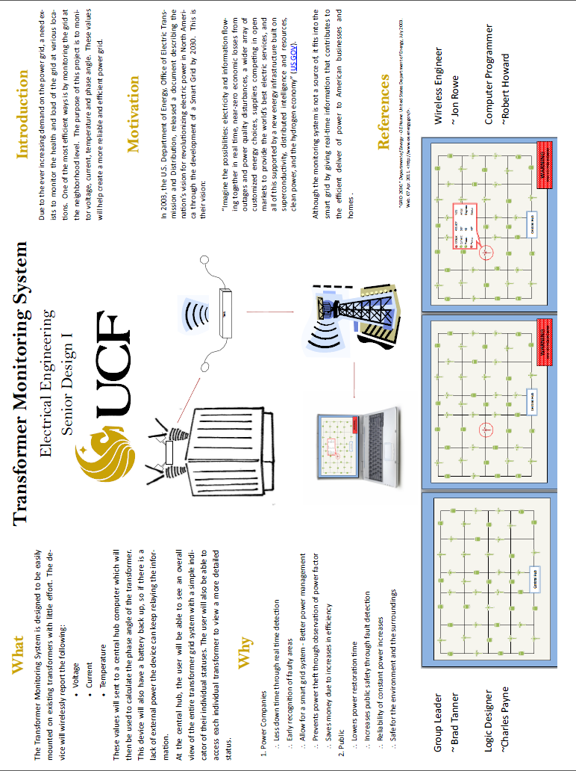On April 11th our team met with Senior Design I Professor Dr. Samuel Richie to discuss the status of our Transformer Monitoring Project. We showed our professor the project documentation that we had to date. We discussed our experience at the 3rd Annual Progress Energy Senior Design Symposium for Renewable and Sustainable Energy. We explained that we still had not received official word from Progress Energy that they would sponsor us but that sponsorship was implicit due to our participation in the symposium. We also explained that we still had not found a facility where we could test our transformer monitoring system on a live high voltage transformer. Dr. Richie stated that he would allow us to use two separate test circuits for our sensors to simulate high current and high voltage. He said he would allow us to have one circuit with high voltage but low current and another circuit with high current but low voltage. This way, we would be able to simulate the various voltage and current conditions to which our transformer monitoring system without the need of a special test facility. This would also be advantageous to Senior Design II because it would allow us to demonstrate our transformer monitoring system during our actual presentation. Otherwise, we would need to make a video recording of the transformer monitoring system performing its functions at an alternate testing facility. Therefore we unanimously agreed that this would be the best way to both test and demonstrate our device.

Figure 8.1-1 Team 8’s Poster for the 3rd Annual Progress Energy Senior Design Symposium

**8.2 Budget and Finance Discussion**

**8.2.1Product Cost**

Due to the fact that Senior Design I is the research and design phase of the project, the team’s expenses have been kept at a minimum for the duration of the semester. One of the main goals of our project is to keep the product cost at a very low price. This is what makes it an optimal solution for power companies, verses the high cost of replacing entire transformers. Therefore, our budget goal is to keep the cost per transformer monitor below $200 per unit. Since the customer will be able to monitor the entire transformer monitoring system on their existing computers at their central control hub, the cost of the system will be primarily based on the number of transformers that they wish to monitor. Figure 8.2-1 is a rough estimate of the cost to build one unit. In a production scenario, the components would be ordered in bulk and would be significantly less expensive than purchasing one of each.

|  |  |
| --- | --- |
| Component | Estimated Cost |
| Processor | $ 10.00 |
| Printed Circuit Board | $ 30.00 |
| Temperature Sensor | $ 10.00 |
| Voltage/Current Sensors | $ 75.00 |
| Wireless Transmitter | $ 35.00 |
| Wire | $ 5.00 |
| Various Discrete Components | $ 10.00 |
| Total Estimated Cost Per Unit | $ 175.00 |

Figure 8.2-1 Product Cost Budget

**8.2.2 Development Cost**

Another budgeting aspect to consider is that of product development. While somewhat hard to quantify, there are costs such as a development board kit, building the circuits with which to test the input and output current and voltage sensors, the purchase of a breadboard, and a computer to serve as a central hub. There is also the possibility that several sensors and microprocessors will have to be purchased in case any of them get destroyed during the testing phase of this project. Therefore Figure 8.2-2 is an estimation of the development costs for the project.

|  |  |
| --- | --- |
| Equipment | Estimated Cost |
| ez430 MSP430 USB Development Stick x 2 | $ 30.00 |
| Bread Board | $ 10.00 |
| Temperature Sensor x 4 | $ 20.00 |
| Wireless Transmitter x 4 | $ 140.00 |
| Wire | $ 5.00 |
| Processor x 4 | $ 40.00 |
| Various Discrete Components x 4 | $ 40.00 |
| Total Estimated Cost Per Unit | $ 285.00 |

Figure 8.2-2 Development Cost Budget

**Appendix A: Copyright Permissions**







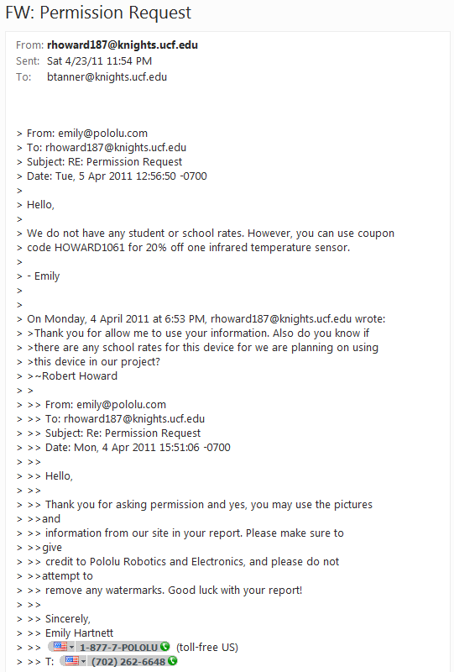

|  |  |
| --- | --- |
| **DIGI White Paper Approval**  **Samuel Rowe <srowe@knights.ucf.edu>** | **Wed, Apr 13, 2011 at 1:56 PM** |
| To: [John.Crockett@digi.com](mailto:John.Crockett@digi.com) | |
| |  | | --- | | Hi John,  I am a student at the University of Central Florida currently enrolled in Senior Design I.  I was told to contact you regarding use of images in a white paper published by Digi.  Our senior design group would like permission to use the figures on pages 2 and 3 from the whitepaper at this location: <http://www.digi.com/pdf/wp_zigbeevsdigimesh.pdf>  The figures are to be included in our group's senior design report.  We will turn in a hard copy to the professor, and a soft copy will be available online by the end of summer.  As an example, a typical senior design report from a previous class may be found here:  <http://www.eecs.ucf.edu/seniordesign/su2010fa2010/gb/public_files/EEL%204914%20-%20Initial%20Documentation%20-%20Richie%20Fixes.pdf>  Thank you,  Jon Rowe  [(321) 696-2345](tel:%28321%29%20696-2345) | | |

|  |  |
| --- | --- |
| **Crockett, John <John.Crockett@digi.com>** | **Wed, Apr 13, 2011 at 2:17 PM** |
| To: Samuel Rowe <srowe@knights.ucf.edu> | |
| |  | | --- | | Hi Jon, feel free to use the images from the whitepaper in your report.    **John Crockett**  **Strategic Marketing Representative**    Digi International®  11001 Bren Road E  Minnetonka, MN 55343    Direct: [952.912.3280](tel:952.912.3280)  Email: [john.crockett@digi.com](mailto:john.crockett@digi.com)    [www.digi.com](http://www.digi.com/)    *Join us at the WaveForum 2011 Developer’s Conference!*  *San Diego, California*  *August 3-5, 2011*  [*www.digi.com/waveforum*](http://www.digi.com/waveforum?utm_source=email-signature)    **From:** [rowesj@gmail.com](mailto:rowesj@gmail.com) [mailto:[rowesj@gmail.com](mailto:rowesj@gmail.com)] **On Behalf Of**Samuel Rowe **Sent:** Wednesday, April 13, 2011 12:57 PM **To:** Crockett, John **Subject:** Permission Request - Senior Design  [Quoted text hidden] | | |

|  |  |
| --- | --- |
| **Jon <rowesj@gmail.com>** | **Wed, Apr 13, 2011 at 4:13 PM** |
| To: "Crockett, John" <John.Crockett@digi.com> | |
| |  | | --- | | We will.  Thank you for permission and the fast reply.  Jon Rowe  [(321) 696-2345](tel:%28321%29%20696-2345) | | |

**LADYADA.NET Approval**

|  |  |
| --- | --- |
| **Adafruit Industries <support@adafruit.com>** | **Fri, Apr 22, 2011 at 1:33 PM** |
| To: Jon Rowe <srowe@knights.ucf.edu> | |
| |  | | --- | | sure, please do  On Fri, Apr 22, 2011 at 1:14 PM, Jon Rowe <[srowe@knights.ucf.edu](mailto:srowe@knights.ucf.edu)> wrote: > From:   Jon Rowe > Email:  [srowe@knights.ucf.edu](mailto:srowe@knights.ucf.edu) > > [[Press / media inquires]] > ------------------------------------------------------ > > To whom it may concern: > > I am a student at the University of Central Florida participating in a > Senior Design course, and we would like to use an image from [ladyada.net](http://ladyada.net/) in > our report. > I may be asking this in the wrong place, but we would like to use the image > found here: <http://www.ladyada.net/images/xbee/pinout.jpg>  The image source > will be cited, along with an email stating approval to use the image. > > Thank you, > Jon Rowe > > ------------------------------------------------------ | | |

**Pending Permissions**





**Request for Network Types Image**

|  |  |
| --- | --- |
| **Samuel Rowe <srowe@knights.ucf.edu>** | **Wed, Apr 13, 2011 at 4:22 PM** |
| To: sales@icpdas-usa.com | |
| |  | | --- | | To whom it may concern:  I am a student at the University of Central Florida currently enrolled in Senior Design I.  Our senior design group would like permission to use the first figure on the webpage at this location: <http://www.icpdas.com/products/GSM_GPRS/zigbee/zigbee_introduction.htm>  The figure will be referenced and is to be included in our group's senior design report.  We will turn in a hard copy to the professor, and a soft copy will be available online by the end of summer.  As an example, a typical senior design report from a previous class may be found here:  <http://www.eecs.ucf.edu/seniordesign/su2010fa2010/gb/public_files/EEL%204914%20-%20Initial%20Documentation%20-%20Richie%20Fixes.pdf>  Thank you,  Jon Rowe  [(321) 696-2345](tel:%28321%29%20696-2345) | | |

**Appendix B: Works Sited**

**Section 2.1 Citations**

"Department of Energy - Task Force." *Department of Energy - OE Home*.Web. 6 Feb. 2011. <http://www.oe.energy.gov/smartgrid_taskforce.htm>.

“GRID 2030” A NATIONAL VISION FOR ELECTRICITY’S SECOND 100 YEARS." *Transforming the Grid to Revolutionize Electric Power in North America*. United States Department of Energy Office of Electric Transmission and Distribution, July 2003. Web. 6 Feb. 2011. <http://www.oe.energy.gov/DocumentsandMedia/Electric_Vision_Document.pdf>.

**Section 3.1 Citations**

"Advantages and Disadvantages of Monocrystalline Solar Panels." Solarpowerfast.com. Web. 10 Apr. 2011. <http://www.solarpowerfast.com/build-solar-panel/monocrystalline-solar-panels/>.

Aerogen 2 Wind Turbine.Advertisement. Better Generation. Web. 22 Apr. 2011. <http://www.bettergeneration.com/wind-turbine-reviews/aerogen-2-wind-turbine.html>.

Buchmann, Isidor. "Nickel-based Batteries."Battery University.Cadex Electronics Inc. Web. 9 Apr. 2011. <http://batteryuniversity.com/learn/article/Nickel_based_batteries>.

China Sungery. How Solar Works. Digital image.Honeybee Solar Inc. Honeybee Solar, 2009.Web. 10 Apr. 2011. <http://honeybeesolar.com/solarfaqs.html>.

Energizer.Alkaline Handbook.Energizer.Energizer.com. 2008.Web. 10 Apr. 2011.

Harris, William.  "How Thin-film Solar Cells Work"  07 April 2008.  HowStuffWorks.com. <http://science.howstuffworks.com/environmental/green-science/thin-film-solar-cell.htm>  10 April 2011.

Rutland 503 Windcharger.Advertisement.Marlec.Web. 22 Apr. 2011.

Wronski, C. R., J. M. Pearce, R. J. Koval, A. S. Ferlauto, and R. W. Collins. "Progress in Amorphous Silicon Based Solar Technology." Rio02.com. The Pennsylvania State University, 6 Jan. 2002. Web. 10 Apr. 2011. <http://www.rio02.com/proceedings/pdf/067_Wronski.pdf>.

**Section 3.2 Citations**

"American Wire Gauge, AWG Cable Size Description for Copper Wire Cable." Interfacebus.com; Hardware Manufacturers, Computer Bus Descriptions, Engineering Design Information.Web. 20 Apr. 2011. <http://www.interfacebus.com/Copper_Wire_AWG_SIze.html>.

Casios, Steve. "Some Questions About the Grid." Message to the author. 14 Apr. 2011. E-mail.

"Contact Temperature Sensors-A Brief Summary of the Different Kinds of Contact Temperature Sensors Organized by Categories with Links to Details Categorized by Sensor Type." *About Temperature & Moisture Sensors Devices & Uses in Measurement*. Temperatures.com. Web. 23 Mar. 2011. <http://www.temperatures.com/csensors.html>.

Dictionary.com, "infrared radiation," in WordNet® 3.0. Source location: Princeton University. http://dictionary.reference.com/browse/infrared radiation. Available: http://dictionary.reference.com. Accessed: April 23, 2011.

"How Sensors Work - Infra Red Temperature Sensor." *Sensors, Sensor, Transducers, Data Systems, The World of Sensors, Transducers and Data Measurement Systems*. Web. 23 Mar. 2011. <http://www.sensorland.com/HowPage022.html>.

"LEM Website - Closed Loop Hall Effect." LEM – Current Transducer, Voltage Transducer, Sensor, Power Measurement.Web. 17 Apr. 2011. <http://www.lem.com/hq/en/content/view/168/155/>.

"Pololu - MLX90614ESF-AAA Infrared Temperature Sensor 90Â° FOV." *Pololu Robotics and Electronics*.Pololu.Web. 23 Mar. 2011. <http://www.pololu.com/catalog/product/1061>.

"Proweb (UK) Ltd." Power Electronic Measurements Ltd. Gloucester House. Web. 22 Apr. 2011.

"Temperature Measuring in Industrial Applications - Delta T." *Delta T | Custom Heating Systems, Industrial Heaters & Temperature Controls*. Delta T. Web. 23 Apr. 2011. <http://www.deltat.com/temperature_measuring_basics.html>.

"Thermography." *Wikipedia, the Free Encyclopedia*. Web. 23 Mar. 2011. <http://en.wikipedia.org/wiki/Thermography>.

"Understanding Contact Temperature Sensors: Thermistors." *Temperature & Force (Strain, Torque) Sensors | RdF Corporation: Specialists in Temperature Measurement*. Rdf. Web. 23 Apr. 2011. <http://www.rdfcorp.com/anotes/pa-ts/pa-ts_05.shtml>.

Wallulis, Karl. "How to Calculate a Temperature Rise for a Transformer | EHow.com." *EHow | How to Videos, Articles & More - Trusted Advice for the Curious Life | EHow.com*.EHow, 14 Dec. 2010. Web. 23 Mar. 2011. <http://www.ehow.com/how_7645358_calculate-temperature-rise-transformer.html>.

Ward, D. A., and J. La T. Exon."Using Rogowski Coils for Transient Current Measurements." Engineering Science and Educational Journal June (1993): 105-13. WWW.Axilane.com. Web. 20 Apr. 2011. <http://www.axilane.com/PDF_Files/Rocoil_Pr7o.pdf>.

**Section 3.3 Citations**

“Excerpts from A Conversation with Gordon Moore: Moore’s Law” 2005 intel.com

<<ftp://download.intel.com/museum/Moores_Law/Video-Transcripts/Excepts_A_Conversation_with_Gordon_Moore.pdf>>

“Microprocessor” 10/15/2009 worldwideinvention.com

<<http://www.worldwideinvention.com/articles/details/127/The-first-microprocessors-emerged-in-the-early-1970s.html>>

“MSP430 Offers the Lowest Power Active Mode and Sleep Modes” ti.com

<<http://focus.ti.com/mcu/docs/mcuorphan.tsp?contentId=61835&DCMP=MSP430&HQS=Other+OT+ulp#active1>>

“MSP430 USB Stick Development Tool” ti.com

<<http://focus.ti.com/docs/toolsw/folders/print/ez430-f2013.html>>

“Grace (BETA) – Graphical Peripheral Configuration Tool” ti.com

<<http://focus.ti.com/docs/toolsw/folders/print/grace.html?DCMP=Grace&HQS=Other+EM+grace>>

“MSP430 LaunchPad Value Line Development kit” ti.com

<<http://focus.ti.com/docs/toolsw/folders/print/msp-exp430g2.html>>

“FPGA Architecture for the Challenge <<http://www.eecg.toronto.edu/~vaughn/challenge/fpga_arch.html>>

“History of FPGAs” <<http://filebox.vt.edu/users/tmagin/history.htm>>

Clive Maxfield, book, "[The Design Warrior's Guide to FPGAs](http://books.google.com/books?id=dnuwr2xOFpUC&pg=PA4&lpg=PA4&dq=FPGA+Market+growth+1990s&source=web&ots=YjFedB35Vp&sig=EH8y56Cih9iNLEqYXkZ63iO46K4&hl=en&sa=X&oi=book_result&resnum=4&ct=result)".Published by Elsevier, 2004. [ISBN 0750676043](http://en.wikipedia.org/wiki/Special:BookSources/0750676043), 9780750676045. Retrieved February 5, 2009

“Difference Between FPGA and Microcontroller” differencebetween.net<<http://www.differencebetween.net/technology/difference-between-fpga-and-microcontroller/>>

Various Locations on Atmel Corporation’s Web-Site, retrieved on 4/14/2010<<http://www.atmel.com>>

**Section 3.4 Citations**

"Band Plan."American Radio Relay League | Ham Radio Association and Resources.Web. 23 Apr. 2011. <http://www.arrl.org/band-plan-1>.

"Basics." The Official Bluetooth® Technology Web Site.Web. 23 Apr. 2011.

<http://www.bluetooth.com/Pages/Basics.aspx>.

"DSL vs Cable - Which High Speed Internet Service Is Faster?" High Speed Internet Service Providers In My Area, Wireless, Satellite, DSL, Cable. 22 Apr. 2011. Web. 23 Apr. 2011. <http://www.high-speed-internet-access-guide.com/dsl-vs-cable.html>.

"Distance Estimates | DSLReports.com, ISP Information." DSLReportsHome : Broadband ISP Reviews News Tools and Forums. Web. 23 Apr. 2011. <http://www.dslreports.com/distance>.

Ergen, Sinem C. "ZigBee/IEEE 802.15.4 Summary." 10 Sept. 2004. Web. 23 Apr. 2011. <http://pages.cs.wisc.edu/~suman/courses/838/papers/zigbee.pdf>.

"Internet Compare Plans | Road Runner High Speed Online | Internet | Bright House Networks | Central Florida."Bright House Networks - TV | Home Phone | Internet | Serving Tampa Bay, Orlando-Central Florida, Indianapolis, Birmingham, Bakersfield and Detroit.Web. 23 Apr. 2011. <http://brighthouse.com/central-florida/shop/internet_plans>.

Mehta, Satish, and Brett Kilbourne. "Broad Over Power Lines A White Paper." Web.<http://www.state.nj.us/rpa/BPLwhitepaper.pdf>.

Rohl, Wonil. "Introduction to WiMAX Technology." 2009. Web. 23 Apr. 2011. <http://media.wiley.com/product_data/excerpt/0X/04706968/047069680X.pdf>.

"Technology - HomePlug Powerline Alliance."Home - HomePlug Powerline Alliance.Web. 23 Apr. 2011. <http://www.homeplug.org/tech/>.

Web. Warburton, F.W.; Tseng-Wu Liao; Hoglund, N.A.; , "Power Line Radiations and Interference Above 15 MHz," Power Apparatus and Systems, IEEE Transactions on , vol.PAS-88, no.10, pp.1492-1501, Oct. 1969 doi: 10.1109/TPAS.1969.292277 URL: http://ieeexplore.ieee.org/stamp/stamp.jsp?tp=&arnumber=4073744&isnumber=4073738

"Wireless Mesh Network: ZigBee® vs. DigiMesh™." Www.digi.com. Digi. Web. 23 Apr. 2011. <http://www.digi.com/pdf/wp_zigbeevsdigimesh.pdf>.

**Section 3.5 Citations**

Garcia, Vinnie. "What Programming Language Should You Use?" Website Promotion, Internet Marketing and Blogging. Search-This, 19 Feb. 2007. Web. 12 Apr. 2011. <http://www.search-this.com/2007/02/19/what-programming-language-should-you-use/>.

McCown, Sean. "The Real Difference between SQL Server and Oracle | Data Management - InfoWorld." Business Technology, IT News, Product Reviews and Enterprise IT Strategies - InfoWorld. InfoWorld, 19 Mar. 2008. Web. 13 Apr. 2011. <http://www.infoworld.com/d/data-management/real-difference-between-sql-server-and-oracle-755>.

"PostgreSQL versus MySQL." Laboratory and Scientific Core Services. 15 Feb. 2005. Web. 13 Apr. 2011. <http://www-css.fnal.gov/dsg/external/freeware/pgsql-vs-mysql.html>.

**Section 4.4 Citations**

"Knowledge Base Article - X-CTU (XCTU) Software - Support - Digi International." Digi International - Making Wireless M2M Easy.Web. 23 Apr. 2011. <http://www.digi.com/support/kbase/kbaseresultdetl.jsp?kb=125>.

"XBee®/XBee - PRO® ZB RF Modules Product Manual." Http://www.digi.com/. Digi, 15 Nov. 2010. Web. 23 Apr. 2011. <http://ftp1.digi.com/support/documentation/90000976_G.pdf>.

This citation is used most frequently when mentioning the Zigbee network.

**Sections 4.3 Citations**

Texas Instruments “MSP430 SMBus Application Report” September 1999. Mixed Signal Products, SLAA073

“MCU Selecttion TOOL” ti.com

<<http://focus.ti.com/en/multimedia/flash/selection_tools/mcu/mcu.html>>

“What’s On a Utility Pole?” myFlorida Public Service Commission. my psc.state.fl.us

<<http://www.psc.state.fl.us/consumers/utilitypole/en/allutilitypoleinfo.aspx>>

“What Is Ground Potential Rise, Earth Potential Rise And What Is A Ground Potential Rise Study?”

<<http://www.esgroundingsolutions.com/about-electrical-grounding/what-is-ground-potential-rise.php>>

“How Power Grids Work” howstuffworks.com

<<http://science.howstuffworks.com/environmental/energy/power9.htm>>

**Section 7.4 Citations**

"XBee®/XBee - PRO® ZB RF Modules Product Manual." Http://www.digi.com/. Digi, Web. 23 Apr. 2011. <http://ftp1.digi.com/support/documentation/90000976_G.pdf>.

This citation is used most frequently when mentioning the Zigbee network.

"XBee Adapter - Simple Wireless Communication." Ladyada.net. 30 Mar. 2011. Web. 23 Apr. 2011. <http://www.ladyada.net/make/xbee/>.

"Xbee Adapter - Connecting, Configuring and Upgrading." Ladyada.net. Web. 23 Apr. 2011. <http://www.ladyada.net/make/xbee/configure.html>.