Senior Design
Group #7

Project Info
Descriptive Title: Reconnaissance and Demolition Super Attack Tank (RADSAT)
Group Members: Jeff Hildebrandt, Bradley Raley, Dylan Lambe, Mick Muzac
Sponsors: Pending
Motivation
The RADSAT is motivated primarily by gaining a new skill set, but also by fun. Since everyone in the group formed around the want to make a robot, making a robot seemed like the obvious choice. We wanted a project that would both teach us skills that we could put on our resume, as well as something that would keep us entertained so we could create the best possible result.
Our group consists of three computer engineers and one electrical engineer. So we decided it would be best if our robot’s functions were mainly software based. While browsing the internet for ideas, we came across a project simply titled “WiFi Robot”. This project consisted of a toy jeep with a router and web-enabled camera mounted on top of it. The router could return the video feed the camera was shooting to the creator’s laptop. The WiFi Robot was also controlled by the same laptop. This project was very intriguing so our group decided to do a variant (more complicated) version of this project.
Goals and Objectives
- Relatively low cost
- Sturdy
- Easy to use
- Responsive
- WiFi Controlled
- Visible video feed
- Some voice control functions
- Far range
- Color recognition
- At least three different colors to be recognized/or shapes
- Possible phone controlled system that you can call and then control from your phone using the number buttons.
Function of the Project
Our project will be a WiFi controlled robot that will be controlled via a laptop and will autonomously be able to recognize and react to the color, which is specified, with a voice command.
Our robot will be built with an RC tank as the base. Mounted on top of the RC tank will be a router and a web-enabled camera. The web enabled camera will send a video feed through the router and onto a server on our laptops. Once we have the video feed we will be able to create a program that will react to certain colors. Depending on the color, which will be specified through a voice command via the laptop, the turret on the tank will follow the color until given a different command. If the specified color isn’t in the current video feed, the turret will search back and forth until the color is found.
From the laptop we will be able to send signals to the router, to the microcontroller, then to the RC tank. This will allow complete control over the tank without any use of the given radio controller. The tank will have as little hardware as possible and most of the computing will be done on the laptop. This will allow us to lower costs of the robot, as hardly any computing will need to be done on the robot itself. The laptop will have a program where you can control the tank with the keyboard, issue commands with voice control, and show the video feed.
The commands that will be issued with voice command will be which color the tank should track. If the color is not currently on screen, the top gun mount (which the camera is mounted on) will scan back and forth for the color and will track once found. From there depending on the reliability of the air-soft gun that comes with the RC tank, the tank will either fire, or follow the color with an issued voice command. You will be able to drive the tank while the top mounted turret follows the specified color.
Specifications and Requirements
- 1 vehicle chassis with 4 wheels or tank treads for zero radius turning.
- Base dimensions of larger than 9 in. by 6 in. and smaller than 24 in. by 16 in.
- Height of 9 to 20 inches.
- Has 1 turret mounted in top that can shoot airsoft BB's between 100 fps and 300 fps.
- Can move at speeds greater than 5 miles per hour.
- Has 1 camera mounted on turret for targeting.
- Turret mount has 2 servos for 2 degree of freedom movement.
- Has 1 wireless router to create its own network with 300 meter radius.
- 1 laptop communicates with it via WiFi.
- Can run at least 10 minutes on 1 charge of 1 rechargeable RC car battery.
- Camera can recognize a minimum of 2 colors or shapes.
- Can accept at least 5 different audio-based (voice or tone) commands.
- Has 1 microphone.
- Total cost of approximately $750.

Block Diagrams
Hardware
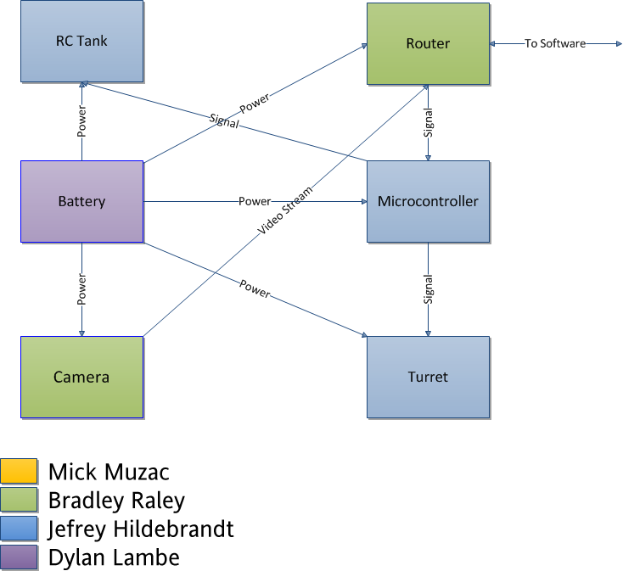
- RC Tank (To be acquired)
  - This will be the base for our robot. Every part of the hardware diagram will be mounted on top of this.
- Router (Acquired, Research)
  - This will transmit the signals back and forth from the laptop to the robot.
- Battery (To be acquired)
  - This will power all boards and devices on the robot. This also includes any power management chips that we will use.
- Microcontroller (To be acquired)
  - Responsible for interpreting and distributing all signals received by the router.
- Camera (To be acquired)
  - A WiFi enabled camera that will send a video stream via the router.
- Turret (To be acquired)
  - The camera will be mounted on top of this, and will be able to rotate and angle itself as well as shoot airsoft bullets.
Software
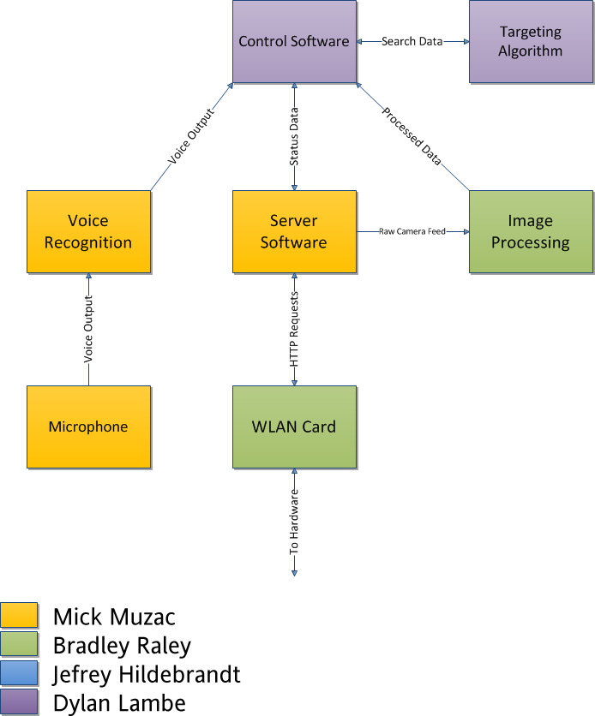
- Control Software (Research)
  - Software responsible for sending control signals to the robot.
- Targeting Algorithm (Research)
  - Responsible for aiming the turret to find and target the specified color or shape.
- Voice Recognition (Research)
  - Will interpret voice commands and the software will react accordingly to it.
- Microphone (Acquired)
  - Used in parallel with the Voice Recognition software.
- Server Software (Research)
  - How the laptop and router will communicate with each other.
- WLAN Card (Acquired)
  - Enables the laptop to receive the wireless signal.
- Image Processing (Research)
  - Will take the video from the webcam and turn it into a form that is easily programmable.
Budget and Financing
For our senior design project, most of the finances and expenses will come out of pocket from each of the group members evenly. We will also be seeking small donations and funding for our project from private outside source(s). The amount of the donation(s) that we expect to receive is roughly $200. With this donation in mind, and due to this fact that we ourselves are all college students on a limited budget, our budget will be relatively limited.
Numbers were discussed and our group came to the conclusion together that each member did not want to spend more than $100-$125 per person. With four group members, and a donation of $200, this gives us a total budget of $600-$700. Based on the size of our project and the equipment we require we should have no issue when it comes to keeping our expenses within budget.
Below is a table summarizing all of the parts and equipment that we believe we will require for our project. The prices were researched and then given a 20% buffer to ensure that we did not underestimate any of the expenses. Items that are already owned (i.e. laptop) have been added to this list but will not be considered in the overall budget.

Item | Projected Cost
RC Tank | $60
Router | $95
Camera | $140
Microcontroller(s) | $20
MISC: (Screws, bolts, etc.) | $25
Laptop | $0
Total | $330

Milestones
The timeline of completing the project was discussed among the group and the following milestones were decided upon.
- February 2012: Create initial design
- March 2012: Complete necessary research
Obtain all necessary parts
- April 2012: Complete final document
- May 2012: Create project prototype
- June 2012: Create the final product
Test all aspects and features of the product
- July: 2012: Correct any hardware or software issues that may have been discovered
Prepare presentation of the project for the review board

