COP 4331C- Fall 2012
Homework 3
Due: November 15, 2012

- No late submissions will be accepted
- Please submit in PDF format through webcourses

Assignment statement:

Each student is required to choose a research paper from the list of recommended conferences or journals provided below by using UCF library resources and prepare a written report.

Recommended conferences and journals:
The papers should be chosen from the following conferences and journals:
- ACM Transactions on Software Engineering and Methodology (TOSEM)
- IEEE Transactions on Software Engineering
- SIGSOFT: Foundations of Software Engineering
- ICSE: International Conference on Software Engineering

- You can search and find papers by accessing the UCF library. Please see the instructions at the end of the homework.
- You can access the UCF Library from any of the labs on campus or you can access off campus by using your library ID number.

- You can determine whether a paper falls within your topic area by using the keywords given in the papers or title of the paper or simply reading and looking through the paper content. If you still cannot determine, please see the TAs for assistance.

- The report should have the following sections:
  - summary of the author’s contributions
  - strengths and weaknesses of the approach
  - suggested improvements

- Please note that the report should be written on your own words, copying sections directly from the research paper is strictly forbidden. The report should be as lengthy as it requires you to present your findings and opinions, longer report does not necessarily mean better!

- The deliverables include
  - The soft copy of the report
  - The web link to the soft copy of the chosen research paper such that TAs can review the paper– please note that the full citation of the paper is must be included in the cover page of the report
    - Full citation includes the following: author names, title of the paper, conference/journal name, page numbers, (volume, no for journals), month, year

Research topics:
The following software engineering areas will be researched by the students:
- Requirements and Specifications
- Design
- Implementation and Integration
- Maintenance
- Testing
- Software Metrics and Configuration Management
Research topic assignments:
The following presents the assignments of research paper areas to each student:

Students | Topic
 | Requirements and Specifications
  Last Name | First Name
  Aguilar | Tony
  Alami | Omar
  Amos | Grant
  Andacht | Michael
  Anderson | Rodney
  Anderson | Christopher
  Arias | Julio
  Augustino | Kevin
  Bak | Joanna
  Banke | Alexander
  Baron | William
  Batten | Brian
  Beaver | Thomas
  Belichki | Sara
  Bijani | Munawar
 | Design
  Buelich | Nicholas
  Burnett | Kyle
  Caskey | Stephen
  Castagna | Michael
  Cervera | Juan
  Chou | Meng
  Claudy | Kyle
  Cools-Lartigue | Jonathan
  Davis | Kristopher
  Delprete | Anthony
  Devlin | Jeffrey
  Dewji | Ally
  Drewes | David
  Duncan | Sarah
 | Implementation and Integration
  Erickson | Devin
  Esposito | Stephen
  Felizola | Mario
  Gajardo | Rene
  Gast | Ronald
  Gau | Daniel
  Goodell | Skyler
  Haggerty | Daniel
  Harris | Brandon
  Heeren | Adam
  Hellmann | Jonathon
  Hoofnagle | Eric
  Horwath | Theodore
  Hunter | Kyle
  Hyman | Matthew
 | Maintenance
  Krause | Christopher
  Krutek | Kevin
  Latsa | Thaddeus
  Lau | Kawai
  Lin | Christopher
  Loppert | Jeffrey
  Margol | Christopher
  Martin | Ian
  Martinez | Lauren
  Meireles | Andre
  Millhouse | Jason
  Morton | Matthew
  Murphy | Michael
  Ochoa | Nathan
  Ollweiler | Thomas
 | Testing
  Orlicki | Steven
  Pineres | Ryan
  Platts | Jordan
  Quintana | Julian
  Rodriguez | Carlos
  Roessler | Zackary
  Ronzo | Aaron
  Salicco | Bryan
  Schindzielorz | Sean
  Scott | Brandon
  Shih | Jason
  Shipman | Jason
  Singleton | John
  Skopec | Zachary
  Smith | Marlon
 | Software Metrics and Configuration Management
  Smith | Aaron
  Sophonwatthanawichit | Vipol
  Srivastava | Nikesh
  Tango | Adam
  Thames | Joshua
  VanDemark | Andrew
  Veazanchin | Sergiu
  Warren | Bryan
  Webb | Bruce
  Weinberg | Michael
  Willey | Jake
  Williams | Keith
  Wright | Alan
  Youker | Scott

Instructions on how to access UCF Library Resources:

Please use the UCF Library to search for articles; there should be no need to pay for any of the articles.

Step by step Instructions to search on the UCF Library:

1) Log into http://library.ucf.edu

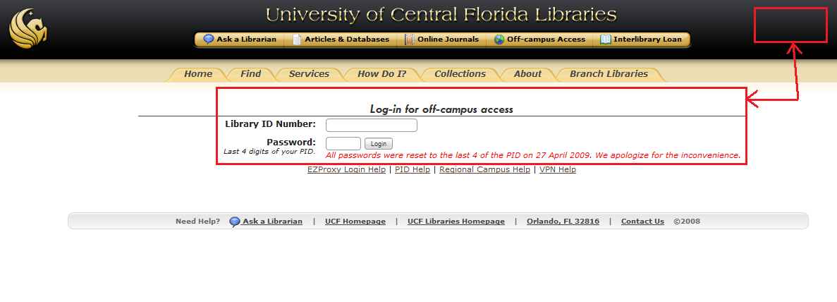
Figure 1
2) Enter your login information in the boxes provided (see Figure 1). Sometimes a login link may appear on the upper right corner. Your login info should be your Library Number (the number identified as Lib in your UCF card) and password of the last 4 digits in your PID (unless you have changed this before).

Note: Your browser most likely will want to add a proxy server to connect to the UCF campus. If it does allow this to occur, otherwise you won’t be able to access the library.

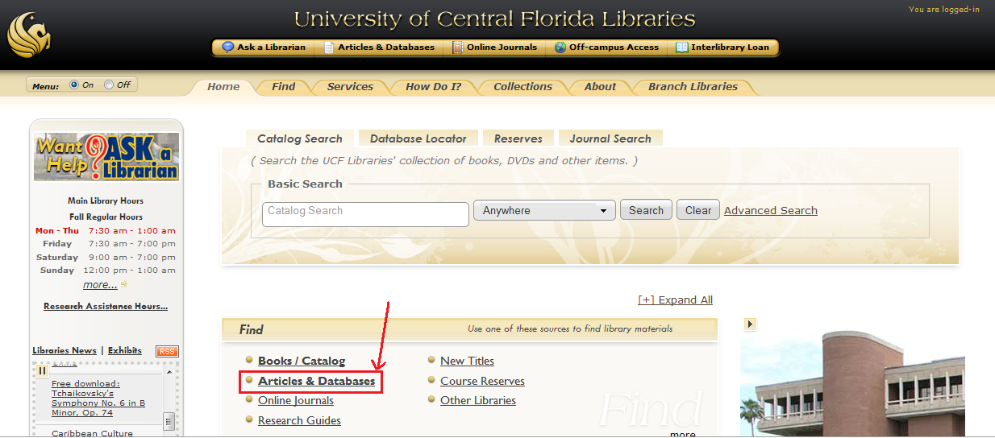
Figure 2

3) As can be seen in Figure 3, here you need to select on the find box the option that says Articles & Databases

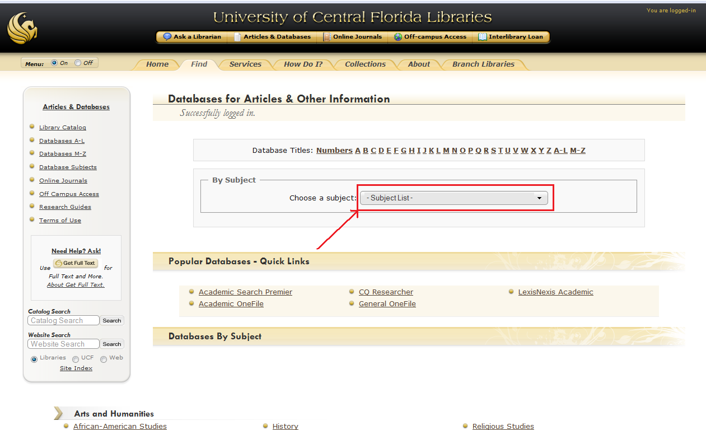

Figure 3

4) Now you can select a subject from the list box in Figure 4.

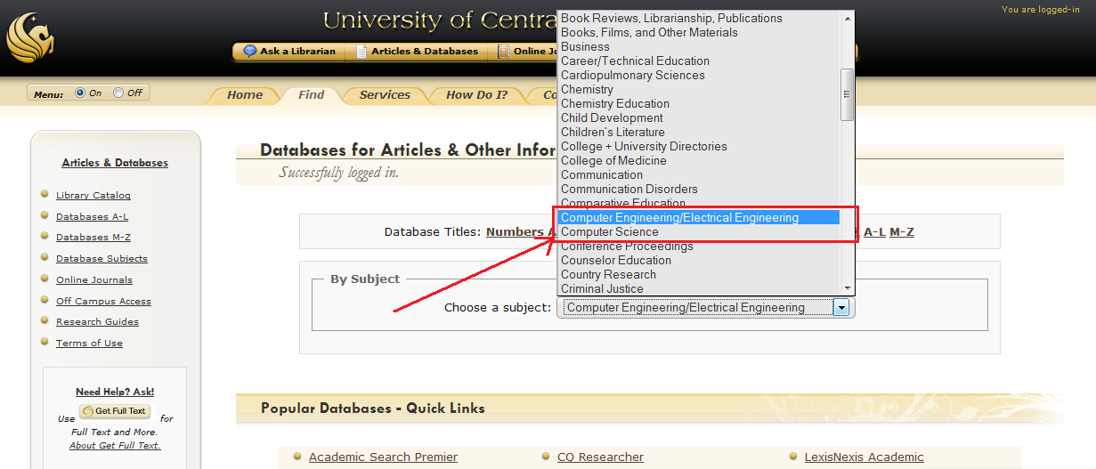

Figure 4

5) The recommendation would be to use either Computer Engineering/Electrical Engineering or Computer Science options (see Figure 4).

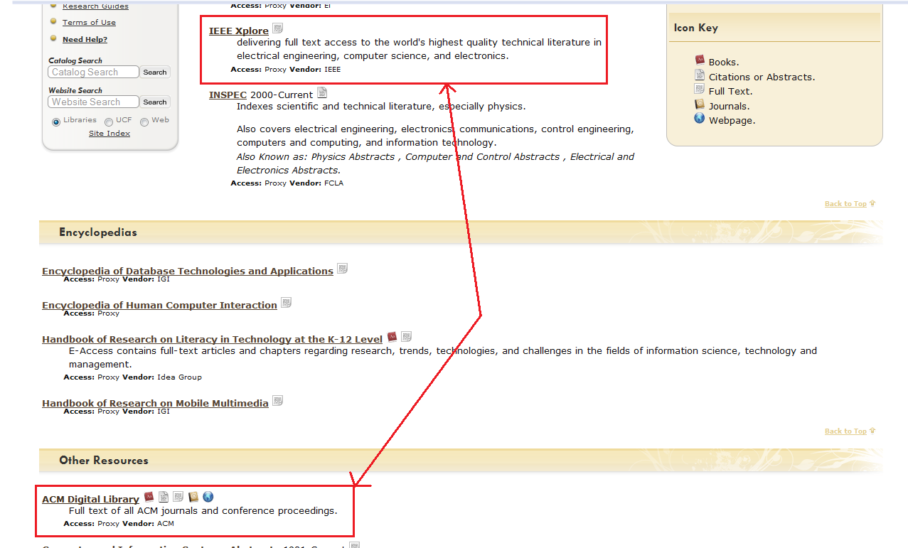

Figure 5

6) Now select your source of preference. Figure 5 shows where the IEEE Xplore and ACM Digital Library are located. Once you click on either link you will be transported to the IEEE/ACM website and from there on you will need to use their search bar (see Figure 6).

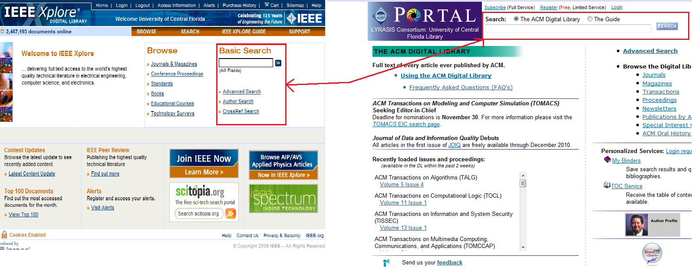

Figure 6

