EEL 4884- Spring 2007
Homework #2
Due: April 11, 2007

- Hard copy of the homework must be submitted to the instructor in class.
- Send the soft copy of your model to the email address of the TA (zub.ahmad@gmail.com)
- No late submission will be accepted

Implement the classes as shown in the following diagram. You can use any language (that supports object oriented programming, like Java/C++) to implement them.

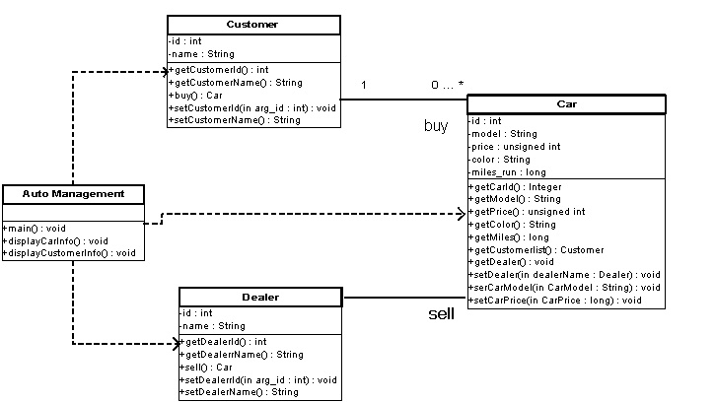

You need to:

- Provide an implementation of all the classes.

- In the main method of the auto management class:

  - Create instances of three car models (Honda, Toyota and Ferrari)
  - Create instances of three dealers.
  - Assign dealers to each car.
  - Create instances of five customers.
  - Let every customer by a car.

- In the displayCarInfo() method, for each car, display all the relevant information.

- In the displayCustomerInfo() method:
  - For each customer display:
    - Customer id and name
    - Car that the customer buys.

