EEL 5881- Fall 2008
Homework #2
Due: November 12, 2008

- A hard copy has to be handed in to the instructor at the beginning of the class period. If and only if you cannot attend the class, you may email the link for the soft copy of the assignment to the instructor in which the assignment can be downloaded.
- No late submission will be accepted.

Problem statement:

Implement the classes as shown in the following diagram. You can use any programming language which supports object oriented programming such as Java/C++ for implementation.

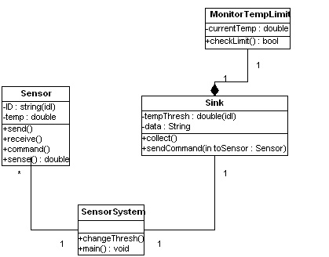

This is similar to the sensor network system described in Homework#1 (you could refer to it for additional understanding).

The following are the detailed instructions of what you are expected to deliver:
- Provide an implementation of all the classes.
- Every class should have a constructor.
- In the constructor function of each class, you need to initialize the private attributes.
- Create multiple ‘Sensor’ objects in one instance of the ‘SensorSystem’ and a ‘Sink’ object.
- The sense() method senses temperature from the surroundings. The sensed information is sent to the sink by the send function.
- Sensors can receive data from others sensors. The information is obtained through the receive method.
- The checkLimit() method checks the currentTemp with the tempThresh and notifies (true/false) if the limit is exceeded or not. If true, then sendCommand should send a notification to the specific sensor to carry out a Beep.
- The SensorSystem is the controlling point of the system. Primary objects (sensors, sink) need to be instantiated here.

