EEL 5881- Spring 2009
Homework #2
Due: April 1, 2009

- A hard copy should be handed in to the instructor at the beginning of the class period if you are attending the class. If and only if you cannot attend the class, you may email the link for the soft copy of the assignment to the instructor in which the assignment can be downloaded.
- No late submission will be accepted.

Problem statement:

Implement the classes as shown in the following diagram. You can use any programming language which supports object oriented programming such as Java/C++ for implementation.

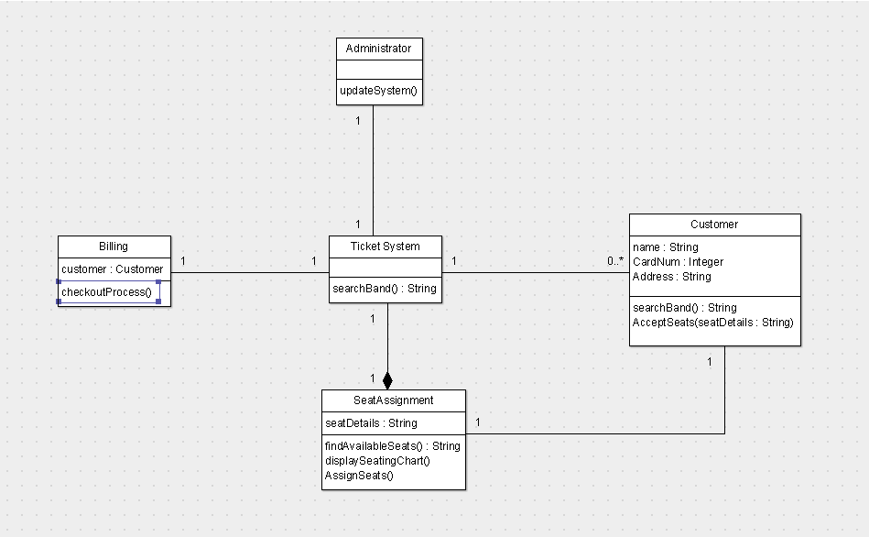

This is similar to the ticket reservation system described in Homework#1 (you could refer to it if needed)

You need to provide an implementation of all the classes.
- Every class should have a constructor.
- In the constructor function of each class, you need to initialize the private attributes.
- Create two different' Customer' objects within a 'Ticket System' where each customer looks for a different band performing.
- Seat Assignment is carried out in the SeatAssignment class which finds the band, displays the seating chart and assigns seats. You may need to provide additional functions to carry out necessary operations or provide most functionality within the declared functions.
- Once seats are assigned and selected, the checkout process should be initiated.

The Ticket System is the primary controlling point of the system. The main objects need to be instantiated here.

